Using UroDapter for home treatment

UroDapter allows bladder instillation without inserting a catheter into the bladder. It was originally designed for use by healthcare professionals, but many women have also been able to use it successfully at home, either by themselves or with the help of a partner.
Although the basic principle is simple, successful home use depends on understanding the key elements of the technique and learning a few practical skills. Finding the urethral opening, choosing a suitable position, and learning the correct placement, direction and pressure can all take some practice. The first attempts may therefore take more time, but the technique usually becomes easier with experience.
There is no single method that works best for everyone. You may need to try different positions and approaches before finding what works best for you. Based on feedback from women using UroDapter for self-treatment at home, the three most commonly successful settings are:
- self-instillation while lying or semi-reclined;
- self-instillation while standing in the shower;
- instillation with the help of a partner.
Read the detailed instructions for your chosen method carefully and take your time to become familiar with the key principles and movements. For the first attempts, it may be useful to practice with sterile saline or another suitable solution recommended by your healthcare professional, rather than using the prescribed instillation solution.
Not every woman will be able to perform UroDapter instillation successfully at home. For some, treatment performed by a healthcare professional may remain the most appropriate option.
Select an image below to choose your approach. Before your first use, read the detailed instructions for that approach. Then use the one-page summary as a reminder. Select any step label in the summary to open its detailed explanation.

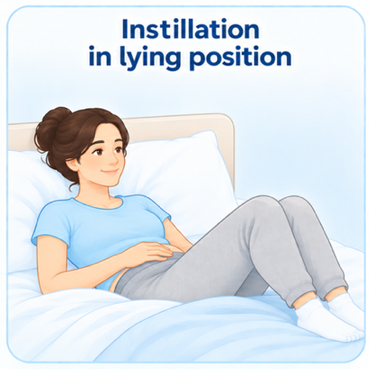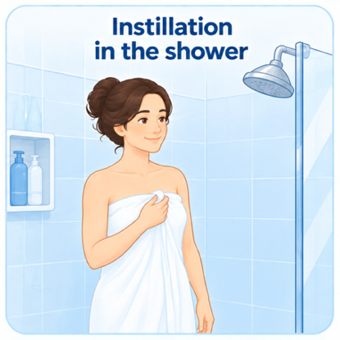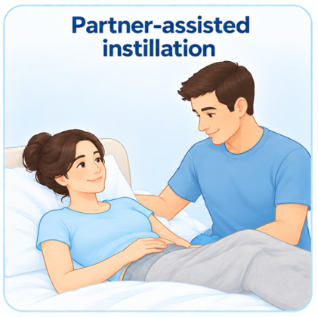

Self-instillation in a lying or semi-reclined position
In this approach, you carry out the instillation yourself while lying down or in a semi-reclined position. The main aim is to find a position that gives you enough access, visibility, reach, and control to place the UroDapter correctly and operate the syringe comfortably. A mirror can be especially helpful while you are learning.

 | Empty your bladder and wash your hands. Keep everything within reach, with good lighting, a mirror if needed, and a comfortable, stable setup. Keep the assembled syringe and the UroDapter clean and sterile.
 | Lie or recline so you can see or reach the urethral area and control the UroDapter and syringe without straining. Adjust your back support, pelvis and legs so you can stay comfortable during the instillation.
 | Gently separate the labia and disinfect the urethral opening and surrounding area with a suitable disinfectant. Avoid contact between unclean surfaces and the cleaned area or UroDapter tip before use.
 | Locate the urethral opening between the clitoris and vaginal opening using a mirror or touch. A mirror is often easiest at first; locating it by touch may become easier with practice.
 | Place the UroDapter over the urethral opening, aligning the syringe with the urethra’s natural direction. Apply gentle, controlled pressure and adjust the angle slightly if needed. Do not force it into position.
 | Relax your pelvic area and gently advance the UroDapter until the collar seals fully around the urethral opening. Keep it aligned with steady inward pressure, without excessive force.
 | Keep the UroDapter steady and maintain the seal while slowly pressing the plunger of the syringe at a controlled pace. The solution should flow with steady pressure; if you feel marked resistance or notice leakage, pause and adjust before proceeding.
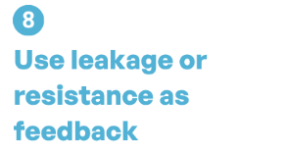 | Leakage usually means the seal, pressure or the angle needs adjustment, while resistance means you should pause rather than push harder. Relax, slightly reduce the pressure if needed, and apply small changes in position or syringe angle until the seal gets secure and flow improves.

Detailed instructions: Self-instillation in a lying or semi-reclined position

Prepare the equipment and environment
Empty your bladder before preparing for the instillation.
Before you begin, wash your hands thoroughly and prepare everything you will need so you can complete the instillation without having to interrupt the procedure.
Have the following ready:
- the syringe containing the prescribed bladder instillation solution, with the UroDapter already attached;
- disinfectant swabs or other suitable disinfectant material within reach;
- a mirror, preferably with magnification, if you use visual guidance to locate the urethral opening;
- good lighting so the area can be seen clearly;
- tissues, paper towels, or another absorbent material in case of minor leakage;
- pillows or cushions if you need them for a comfortable and stable position.
After attaching the UroDapter to the syringe, put the assembled syringe down in a way that keeps the UroDapter clean and sterile until you are ready to use it. Avoid allowing the UroDapter tip to touch non-sterile surfaces.
Place all other items within easy reach before you start. A calm, well-lit environment and having everything prepared in advance can make the procedure easier and help you maintain the correct position once you begin.

Choose and set up your position
Choose a position that gives you clear access to the urethral area and still allows you to hold and control the UroDapter and syringe comfortably.
Successful users have described several workable positions. Some prefer lying almost flat, while others are more comfortable in a semi-reclined position of around 45–65°, and some use a more upright sitting position with the back supported. There is no single correct angle—the best position is the one that gives you enough access, reach, stability, and control.
Make sure you can:
- comfortably separate your legs;
- reach the urethral area without straining;
- see the area with a mirror if you are using visual guidance;
- hold the UroDapter and syringe steadily;
- make small adjustments in direction and position;
- and still reach and depress the syringe plunger.
Use pillows or cushions behind your back if they help you maintain a stable and relaxed position. Some users also find a small cushion under the pelvis helpful, while others prefer to keep the pelvis flat.
You may need a few attempts to find the position that works best for you. Small changes in how far you recline, how you support your back or pelvis, and how widely you position your legs can make a significant difference.
Before continuing, make sure that you can comfortably maintain the position for the full instillation.

Clean and disinfect the area
Have the disinfectant swabs or other disinfectant material prepared and within easy reach. We generally recommend povidone-iodine (Betadine), although another suitable disinfectant may be used if recommended by your healthcare professional. Do not use povidone-iodine if you have a known allergy or sensitivity to iodine or povidone-iodine.
Using one hand, gently part the labia minora to expose the urethral area. Keep the labia apart while, with your other hand, you wipe the urethral opening and the surrounding area carefully with the disinfectant swab a few times.
If the fingers of the hand holding the labia apart remain close to the cleaned area during the process, disinfect your fingers as well before proceeding.
After disinfection, keep the labia apart if possible and avoid touching the cleaned urethral area unnecessarily. Do not allow the UroDapter tip to touch any non-clean surface before placement.

Locate the urethral opening
The urethral opening can be difficult to find at first. Use the anatomical figure below to familiarize yourself with its location: it lies between the clitoris and the vaginal opening.
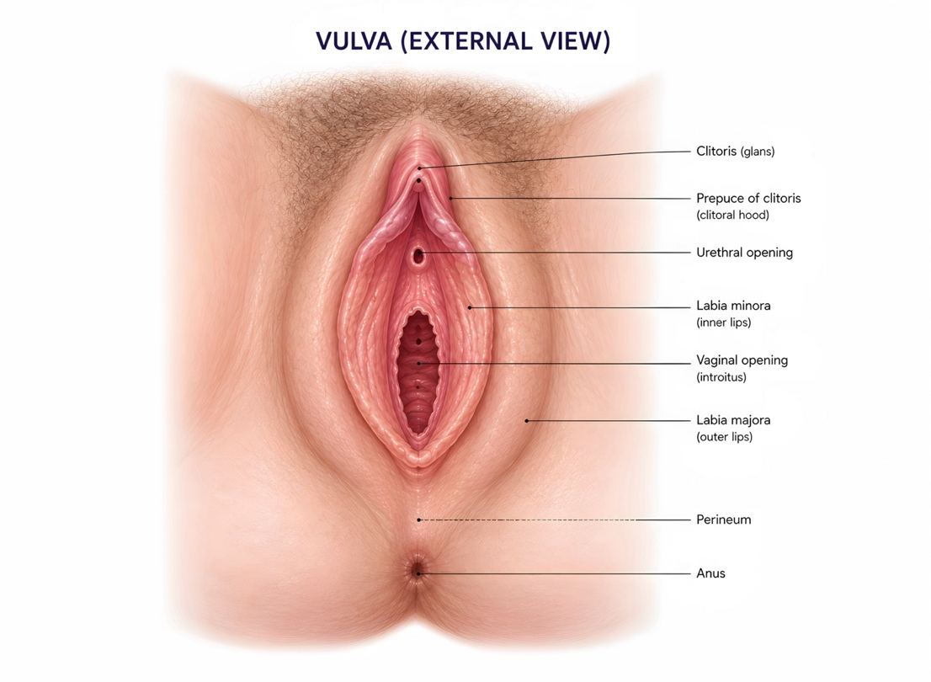

There are two main ways to locate the urethral opening:
A. Using a mirror
This is usually the easiest method while you are learning.
Gently part the labia minora with one hand and keep them open. With good lighting, use a mirror to identify the urethral opening. A magnifying cosmetic mirror may be helpful, especially at the beginning.
Dedicated self-catheterization mirrors are also available. These are designed to provide a clear view of the urethral area while leaving both hands free, and some include built-in lighting or can be attached to the leg. They can be particularly useful if it is difficult to position a standard mirror or obtain a clear view.
You may need to adjust the mirror, your leg position, or the way you hold the labia before you get a clear view. Take your time. Once you have identified the opening repeatedly, it usually becomes easier to recognize.
B. Finding it by touch
With practice, some women learn to locate the urethral opening without mirror.
Keep the labia minora gently separated with one hand. With a clean finger, follow the midline of the vulva and use the surrounding structures to orient yourself.
One practical method is to start near the vaginal opening and move your finger gently upward in the midline toward the clitoris. Another is to start higher, near the clitoral area, and move downward. The urethral opening is located between these two landmarks.
Some women find that differences in the touch of the tissues help them recognize the correct area. This becomes easier with familiarity.
As you become more familiar
Many women begin with visual guidance and later become comfortable locating the urethral opening by touch alone. There is no need to stop using a mirror if it continues to make the procedure easier.
If you are uncertain about the location, return to the mirror rather than continuing without being sure.

Place and align the UroDapter
Once you have located the urethral opening, prepare the UroDapter tip for placement.
If the tip feels dry, lightly moisten it before placement. The aim is simply to make the surface slightly wet so that it can be positioned more comfortably. You can do this by:
- gently pushing out a single drop of the bladder instillation solution through the UroDapter, or
- moistening the tip with a small amount of the povidone-iodine (Betadine) already being used for disinfection.
Place the tip of the UroDapter over the urethral opening and keep the syringe aligned with the natural direction of the urethra. Avoid approaching the opening at a steep or sideways angle.
Gently press the UroDapter into position while keeping the syringe aligned with the urethra. A small scooping or “spooning” movement can help the UroDapter settle into the correct position beneath the pubic bone.
The movement should be controlled and gentle. Do not force the UroDapter against resistance. If the position does not feel right, reduce the pressure, adjust the angle slightly, and try again.
Once the UroDapter is correctly aligned, keep it steady for creating the seal and starting the instillation.

Create and maintain the seal
Before starting the instillation, take a slow, deep breath and consciously relax your pelvic area and urinary sphincter. Try not to tighten the muscles around the urethra, as this can make positioning and instillation more difficult.
Once relaxed, gently but steadily advance the UroDapter tip into the urethral opening until the sealing collar sits fully against the opening and makes even contact all the way around. This requires only a short advancement - typically about 6–8 mm - until the sealing collar makes full contact.
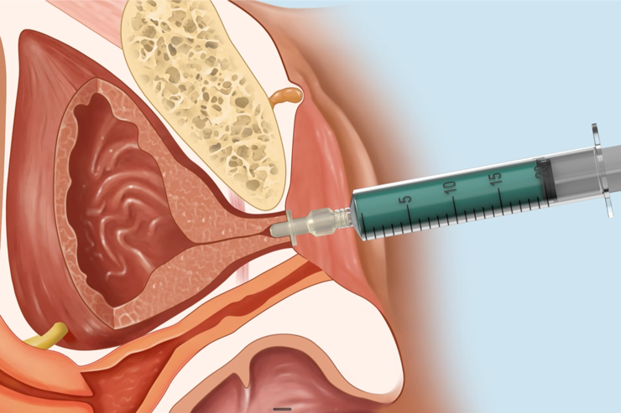
Maintain steady, controlled pressure so the collar stays in full contact with the urethral opening and forms a watertight seal. The pressure should be firm enough to keep the UroDapter securely in position and prevent leakage, but it should not require excessive force or cause significant discomfort. Keep the syringe and UroDapter aligned with the natural direction of the urethra while maintaining this pressure.
Once the seal feels stable, maintain the same pressure and alignment while beginning the instillation.

Instill the solution
Once the UroDapter is correctly positioned and the seal is stable, keep your pelvic area relaxed and maintain the same alignment and steady inward pressure on the adapter.
Slowly press the syringe plunger and instill the solution at a slow-to-moderate, controlled pace.
The fluid should flow smoothly with steady, controlled pressure on the plunger. Some pressure is normally needed, but it should not require forceful pushing. With practice, you will become familiar with the usual amount of pressure needed and will be better able to recognize when resistance increases.
Continue at a pace that allows you to maintain the position, alignment, and seal throughout the instillation until the prescribed volume has been delivered.
Keep the UroDapter pressed steadily into position as you push the plunger, so the seal does not loosen or the adapter slip out.
Once the prescribed volume has been delivered, gently remove the UroDapter. A few drops of solution may leak out after removal; this is usually insignificant and does not necessarily mean that the instillation was unsuccessful.
If you experience leakage or marked resistance during instillation, pause and use the guidance in the next section to adjust the position before continuing.

Use leakage or resistance as feedback
Leakage and resistance are useful signs that the position, pressure or alignment of the UroDapter may need a small adjustment. With practice, these small adjustments usually become easier to recognize and perform.
- If fluid leaks around the UroDapter:
  - Pause the instillation.
  - Keep the pelvic area relaxed and check that the UroDapter has not slipped outward.
  - Re-establish full contact of the sealing collar with the urethral opening and slightly adjust the position or angle if needed before continuing.
- If the solution does not flow easily or you feel resistance:
  - Do not force the syringe plunger.
  - Use enough inward pressure to maintain the seal, but do not keep increasing the pressure if the solution does not flow. Excessive pressure can distort the urethra and make the flow more difficult.
  - If resistance increases, reduce the pressure slightly, relax your pelvic area and urinary sphincter, and reassess the angle of the syringe.
  - Because the angle of the urethra varies from woman to woman, you may need to make small changes to the syringe angle while maintaining gentle inward pressure. Move the syringe slightly until you find the direction in which the solution begins to flow more easily. A better-aligned position is usually indicated when the solution begins to flow more smoothly.
  - If needed, stop, remove the UroDapter, and reposition it before trying again.

If you experience significant pain, persistent resistance, or are unable to establish a comfortable position and smooth flow after repositioning, stop the procedure and seek advice from your healthcare professional before trying again.

Self-instillation while standing in the shower
In this approach, you carry out the instillation yourself while standing in the shower. A slightly bent-knee position can improve access and reach, and the urethral opening is usually located by touch rather than with a mirror. The goal is to find a stable position that allows you to place the UroDapter correctly and control the syringe comfortably.

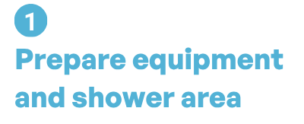 | Empty your bladder and keep everything within reach. Keep the assembled syringe and UroDapter clean and dry, protected from unclean surfaces.
 | Stand with feet comfortably apart and knees slightly bent so you can reach the urethral area and control the UroDapter and syringe without straining. Adjust your posture to stay stable and comfortable throughout the instillation.
 | Wash your hands and external genital area with mild soap and water; rinse well. Gently separate the labia and disinfect the urethral opening and surrounding area. Keep the cleaned area and UroDapter tip away from unclean surfaces.
 | Gently keep the labia apart and use a clean finger to trace up or down the midline between the clitoris and vaginal opening until you find the urethral opening. This usually becomes easier with practice.
 | Keep the labia gently apart and slide the UroDapter down the midline until the tip reaches the urethral opening. Align the syringe with the natural direction of the urethra and use gentle, controlled pressure rather than forcing it.
 | Relax your pelvic area and gently advance the UroDapter until the collar seals fully around the urethral opening. Keep it aligned with steady inward pressure, without excessive force, and maintain a stable position.
 | Keep your pelvic area relaxed and maintain the seal, alignment, and steady inward pressure while slowly pressing the plunger at a controlled pace. If you notice leakage or increased resistance, pause and adjust before continuing.
 | Leakage usually means the seal, pressure, or position needs adjustment, while resistance means you should pause rather than push harder. Relax, slightly reduce the pressure if needed, and apply small changes in position or syringe angle until the seal is stable and the solution flows more smoothly.

Detailed instructions: Self-instillation while standing in the shower

Prepare the equipment and shower area
Empty your bladder before preparing for the instillation.
Before you begin, prepare everything you will need so you can complete the instillation without interrupting the procedure.
Have the following ready:
- the syringe containing the prescribed bladder instillation solution, with the UroDapter already attached;
- liquid soap for washing your hands and the external genital area;
- povidone-iodine (Betadine) swabs or another suitable disinfectant material, prepared and within easy reach;
- a clean towel or other clean surface for items that need to remain dry and protected;
- tissues or another absorbent material if needed after the procedure.
Keep the assembled syringe with the UroDapter in a clean, dry place until you are ready to use it. Keep the UroDapter tip away from touching the shower floor, wall, shelf, or other unclean surfaces, and avoid exposing it unnecessarily to running shower water.
Arrange the equipment so that everything can be reached easily from your standing position without having to leave the shower or interrupt the procedure.

Choose your standing position
Stand in a stable position that gives you comfortable access to the urethral area while still allowing you to control the UroDapter and syringe.
For finding the right position:
- stand with your feet comfortably apart;
- bend your knees slightly;
- turn your feet outward a little, if this improves access and balance;
- keep enough space between your legs to reach the urethral area easily;
- and make sure you can move your hands freely while maintaining a steady posture.
There is no single correct foot or knee angle. The aim is to find a position that gives you good access, enough reach, and sufficient control of the syringe without straining.
You may need a few attempts to find the posture that works best for you. Small changes in how deep you bend your knees, how widely you stand, or how much you turn your feet outward can make the procedure easier.
Before continuing, make sure you feel stable and can comfortably maintain the position for the full instillation.

Wash and disinfect the area
Wash your hands thoroughly first.
Then clean the external genital area with water and a mild liquid soap, including the pubic and perivaginal area. Rinse well.
Next, gently part the labia minora with one hand to expose the urethral area. With the other hand, wipe the urethral opening and the surrounding area carefully with povidone-iodine (Betadine) swabs or another suitable disinfectant material. Do not use povidone-iodine if you have a known allergy or sensitivity to povidone-iodine or any of its ingredients.
If the fingers of the hand holding the labia apart will remain close to the cleaned area during placement, disinfect your fingers as well before proceeding.
After disinfection, keep the labia apart if possible and avoid unnecessary touching of the cleaned urethral area. Do not allow the UroDapter tip to touch any non-clean surface before placement.

Locate the urethral opening by touch
Keep the labia minora gently separated with one hand.
With a clean finger, use the midline of the vulva and the surrounding structures to orient yourself. There are two practical ways to locate the urethral opening:
- start near the vaginal opening and move your finger gently upward in the midline toward the clitoris; or
- start higher, near the clitoral area, and move downward along the midline.
The urethral opening lies between the clitoris and the vaginal opening. Some women find that differences in the touch of the tissues help them recognize the correct area.
Take your time and keep the labia apart while locating the opening. With practice, the position usually becomes easier to recognize by touch.
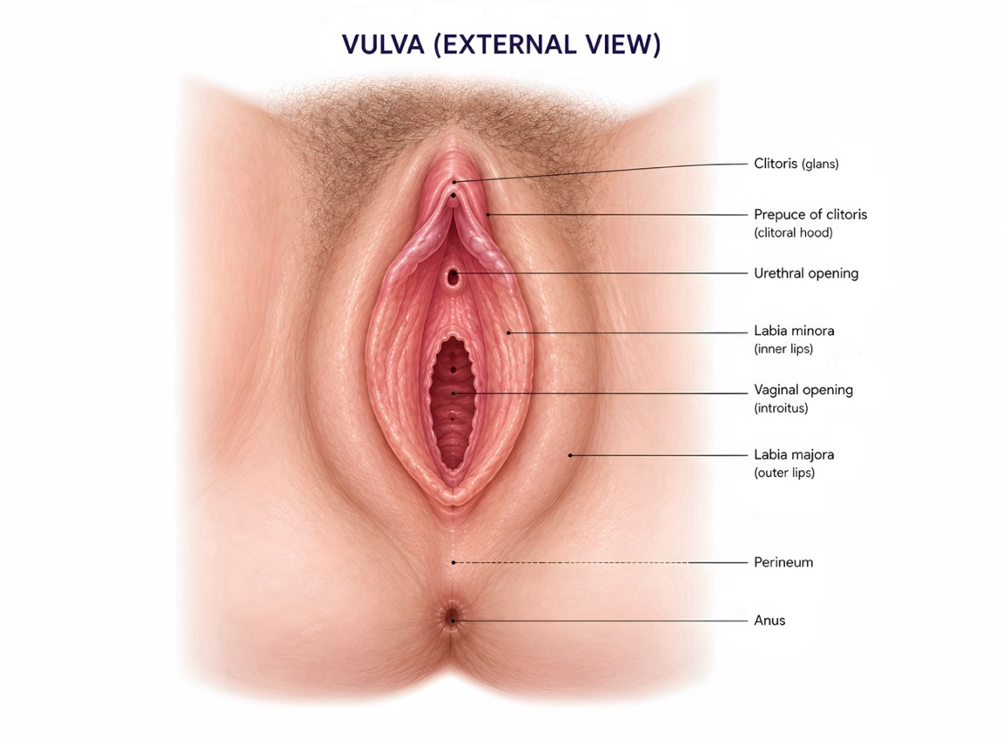

Place and align the UroDapter .
Once you have located the urethral opening by touch, prepare the UroDapter tip for placement.
If the tip feels dry, lightly moisten it by:
- gently pushing out a single drop of the bladder instillation solution through the UroDapter, or
- moistening the tip with a small amount of the povidone-iodine (Betadine) already being used for disinfection.
Then apply the UroDapter in four simple steps:
- Keep the labia gently separated with one hand.
- Bring the UroDapter to the midline, slightly above the urethral opening, near the clitoral area.
- Slide it gently downward along the midline while applying steady inward pressure until the tip reaches and enters the urethral opening.
- Once the tip is in the opening, align the syringe with the natural direction of the urethra and continue with gentle, controlled pressure.
A small scooping or “spooning” movement may help the UroDapter settle into the correct position beneath the pubic bone.
Do not force the UroDapter against resistance. If it does not move into position easily, reduce the pressure, adjust the angle slightly, and try again.

Create and maintain the seal .
Before starting the instillation, take a slow, deep breath and consciously relax your pelvic area and urinary sphincter.
Once relaxed, gently but steadily advance the UroDapter into the urethral opening until the sealing collar sits fully against the opening and makes even contact all the way around. This requires only a short advancement - typically about 6–8 mm - until the sealing collar makes full contact.

Maintain steady, controlled inward pressure so the collar stays in full contact with the urethral opening and forms a watertight seal. The pressure should be firm enough to keep the UroDapter securely in position and prevent leakage, but it should not require excessive force or cause significant discomfort.
Keep the syringe aligned with the natural direction of the urethra while maintaining this pressure. Make sure your standing position remains stable, and your knees stay slightly bent if this helps you maintain access and control.
Once the seal feels stable, keep the UroDapter in the same position and maintain the pressure as you prepare to begin the instillation.

Instill the solution
Once the UroDapter is correctly positioned and the seal is stable, keep your pelvic area relaxed and maintain the same alignment and steady inward pressure on the adapter.
Keep your knees slightly bent and consciously maintain the inward pressure during the instillation. This helps keep the UroDapter securely in position and prevents the seal from loosening or the adapter from slipping outward.
Slowly press the syringe plunger and instill the solution at a slow-to-moderate, controlled pace.
The fluid should flow smoothly with steady, controlled pressure on the plunger. Some pressure is normally needed, but it should not require forceful pushing. With practice, you will become familiar with the usual amount of pressure needed and will be better able to recognize when resistance increases.
Continue at a pace that allows you to maintain the position, alignment, and seal during the instillation until the prescribed volume has been delivered.
Once the prescribed volume has been delivered, gently remove the UroDapter. A few drops of solution may leak out after removal; this is usually insignificant and does not necessarily mean that the instillation was unsuccessful.
If you experience leakage or increased resistance during instillation, pause and use the guidance in the next section to adjust the position and alignment before continuing.

Use leakage or resistance as feedback.
Leakage and resistance are useful signs that the position or alignment of the UroDapter may need a small adjustment. With practice, these small adjustments usually become easier to recognize and perform.
- If fluid leaks around the UroDapter:
  - Pause the instillation.
  - Keep the pelvic area relaxed and check that the UroDapter has not slipped outward.
  - Re-establish full contact of the sealing collar with the urethral opening and slightly adjust the position or angle if needed before continuing.

- If the solution does not flow easily or you feel resistance:
  - Do not force the syringe plunger.
  - Use enough inward pressure to maintain the seal, but do not keep increasing the pressure if the solution does not flow. Excessive pressure can distort the urethra and make the flow more difficult.
  - If resistance increases, reduce the pressure slightly, relax your pelvic area and urinary sphincter, and reassess the angle of the syringe.
  - Because the angle of the urethra varies from woman to woman, you may need to make small changes to the syringe angle while maintaining gentle inward pressure. Move the syringe slightly until you find the direction in which the solution begins to flow more easily. A better-aligned position is usually indicated when the solution begins to flow more smoothly.
  - If needed, stop, remove the UroDapter, and reposition it before trying again.

If you experience significant pain, persistent resistance, or are unable to establish a comfortable position and smooth flow after repositioning, stop the procedure and seek advice from your healthcare professional before trying again.

Partner-assisted instillation
You remain lying or semi-reclined while your partner performs the instillation.
Your role is mainly to stay comfortable and help expose the urethral area if needed. Your partner finds the urethral opening, positions the UroDapter, maintains the seal, and operates the syringe.
Because this is an intimate procedure, you should both feel comfortable and communicate openly. With practice, it usually becomes easier as your partner learns the right angle, pressure, and resistance.

Empty your bladder. Both you and your partner should wash your hands. Keep everything within reach and the assembled syringe and UroDapter clean and sterile. Ensure good lighting and a comfortable setup so your partner can see and work easily.
Choose a lying or semi-reclined position that allows you to stay relaxed. Adjust your legs, upper-body and pelvic elevation as needed so your partner can see and reach the urethral area and control the UroDapter during the instillation.
If comfortable, gently hold the labia apart while your partner disinfects the urethral opening and surrounding area. Both of you should protect the cleaned area and UroDapter tip from unclean hands or surfaces before use.
If comfortable, gently hold the labia apart while your partner locates the urethral opening in the midline between the clitoris and vaginal opening. Take your time and use the anatomical figure for orientation until your partner is confident the correct opening has been identified.
Your partner should place the UroDapter over the urethral opening, align the syringe with the urethra’s natural direction and apply gentle, controlled pressure. Tell them if it feels uncomfortable so they can adjust rather than force it.
Stay relaxed while your partner gently advances the UroDapter until the collar seals fully around the urethral opening. Your partner should maintain steady inward pressure and correct alignment without excessive force, while you communicate if the pressure or position feels uncomfortable.
Stay relaxed while your partner maintains the seal and alignment and slowly presses the plunger. Tell them if you feel discomfort or unusual pressure. If leakage or increased plunger resistance occurs, they should pause and adjust, instead of pushing harder.
Leakage usually means the seal, pressure, or position needs adjustment, while resistance means your partner should pause rather than push harder. Stay relaxed while your partner slightly adjusts pressure if needed and makes small changes in position or syringe angle until the seal is stable and the solution flows more smoothly.

Detailed instructions: Partner-assisted instillation

Prepare the equipment and environment ..
Empty your bladder before preparing for the instillation.
Before you begin, both you and your partner should wash your hands thoroughly. Prepare everything you will need in advance so the instillation can be completed without interrupting the procedure.
Have the following ready:
- the prepared syringe containing the prescribed bladder instillation solution, with the UroDapter already attached;
- disinfectant swabs or other suitable disinfectant material, prepared and within easy reach;
- good lighting so your partner can clearly see the urethral area;
- tissues, paper towels, or another absorbent material in case of minor leakage;
- pillows, cushions, or folded towels if needed to help achieve a comfortable and stable position.
After attaching the UroDapter to the syringe, place the assembled syringe down in a way that keeps the UroDapter clean and sterile until you are ready to use it. Avoid allowing the UroDapter tip to touch non-sterile surfaces.
Arrange the equipment so that your partner can reach everything easily while you remain in position. A calm, well-lit environment and having everything prepared in advance can make the procedure easier and allow both of you to focus on positioning, relaxation, and correct placement of the UroDapter.

Choose and set up your position ..
Choose a lying position, or a semi-reclined position if that is more comfortable, that gives your partner clear access to the urethral area while allowing you to remain stable and relaxed.
Most successful users described performing the instillation while lying. Some preferred slight support under the head or upper body, while others lay almost flat. There is no single correct upper-body angle—the aim is to find a position that gives your partner good visibility and access while allowing you to relax your pelvic muscles comfortably.
Make sure that:
- you can comfortably separate your legs;
- your partner can clearly see and reach the urethral area without straining;
- your partner has enough space to hold the UroDapter and syringe steadily;
- your partner can make small adjustments in angle and position while maintaining control of the syringe;
- and you can remain relaxed and comfortable throughout the instillation.
Some women also find that placing a firm pillow, cushion, or folded towel under the pelvis makes access easier by slightly elevating the hips. Others prefer to keep the pelvis flat. Pelvic elevation is optional and should only be used if it improves access and comfort.
You may need a few attempts to find the position that works best for both of you. Small changes in pelvic elevation, leg position, or upper-body support can make placement easier.
Before continuing, make sure that you can remain relaxed and your partner can comfortably see, reach, and control the UroDapter and syringe for the full instillation.

Clean and disinfect the area ..
Have the disinfectant swabs or other suitable disinfectant material prepared and within easy reach. We generally recommend povidone-iodine (Betadine), although another suitable disinfectant may be used if recommended by your healthcare professional. Do not use povidone-iodine if you have a known allergy or sensitivity to iodine or povidone-iodine.
If comfortable, gently part the labia minora yourself and keep them separated to expose the urethral area. This allows your partner to use both hands more freely for cleaning and, later, for positioning the UroDapter.
Your partner should carefully wipe the urethral opening and the surrounding area with the disinfectant swab a few times.
If your fingers will remain close to the cleaned area while you keep the labia apart, disinfect your fingers as well before proceeding. If your partner needs to touch the area directly during placement, the fingers that may come close to the urethral opening should also be disinfected.
After disinfection, keep the labia apart if possible and avoid unnecessary touching of the cleaned urethral area. Do not allow the UroDapter tip to touch any non-clean surface before placement.

Locate the urethral opening ..
Before the first few treatments, use the anatomical figure below to familiarize yourselves with the location of the urethral opening.
The urethral opening is located in the midline between the clitoris and the vaginal opening. It may be small and is not always immediately obvious, especially if your partner has never identified it before.

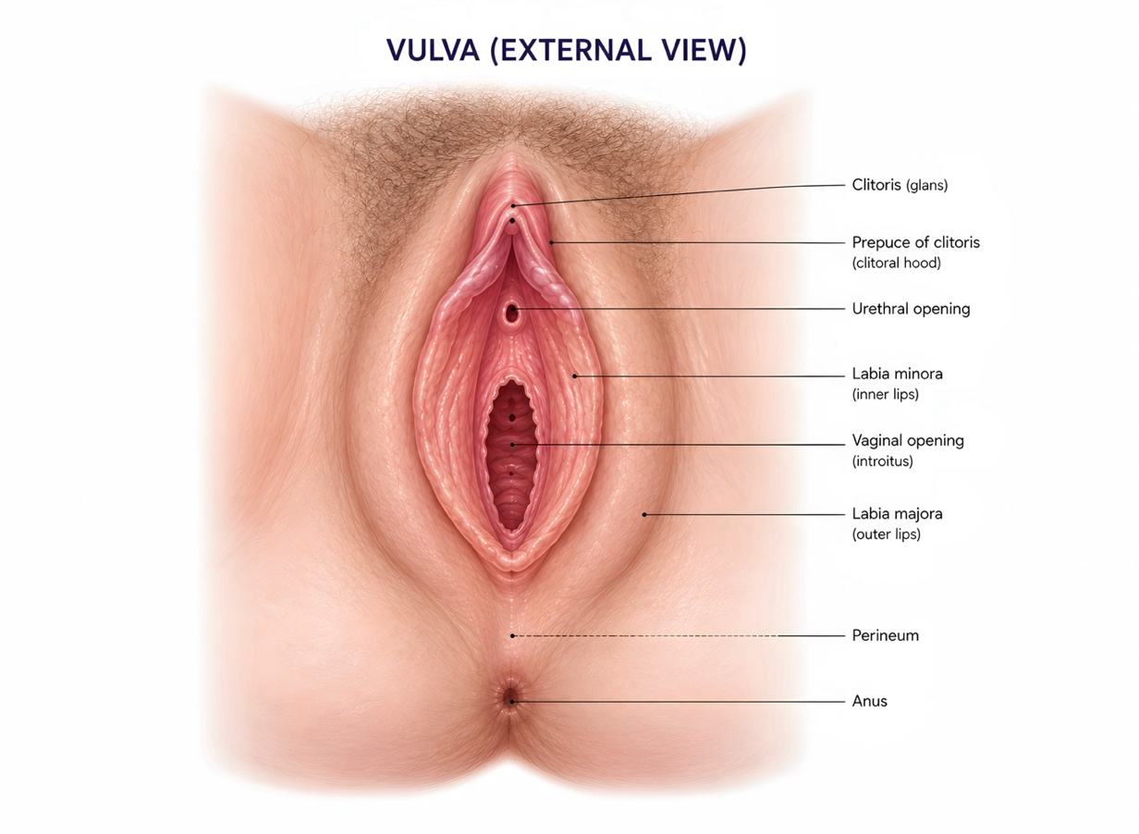

If comfortable, gently part the labia minora yourself and keep them separated. With good lighting, your partner should look for the urethral opening between the clitoris above and the vaginal opening below.
Take your time and use the anatomical figure to help your partner identify the correct opening. The exact appearance varies from woman to woman, so the opening may not look exactly like the illustration.
Once your partner has identified the urethral opening several times, it usually becomes much easier to recognize during future treatments.
Do not proceed with placement until your partner is confident that the correct opening has been identified.

Place and align the UroDapter ..
Once your partner has identified the urethral opening, prepare the UroDapter tip for placement.
If the tip feels dry, lightly moisten it before placement. The aim is simply to make the surface slightly wet so that it can be positioned more comfortably. You can do this by:
- gently pushing out a single drop of the bladder instillation solution through the UroDapter; or
- moistening the tip with a small amount of the povidone-iodine (Betadine) already being used for disinfection.
If comfortable, continue to keep the labia gently separated so your partner has a clear view of the urethral opening.
Your partner should place the tip of the UroDapter over the urethral opening and keep the syringe aligned with the natural direction of the urethra. Avoid approaching the opening at a steep or sideways angle.
Using gentle, controlled pressure, your partner should guide the UroDapter into position. A small scooping or “spooning” movement can help the adapter settle into the correct position beneath the pubic bone.
The movement should remain gentle and controlled. More pressure is not necessarily better. If your partner feels resistance or the UroDapter does not move comfortably into position, they should reduce the pressure, adjust the angle slightly, and try again rather than forcing it.
You can also help by telling your partner if the position feels uncomfortable or if a small change in direction feels better.
Once the UroDapter appears correctly positioned and aligned, your partner should keep it steady in preparation for creating the seal and beginning the instillation.

Create and maintain the seal ..
Before starting the instillation, take a slow, deep breath and consciously relax your pelvic area and urinary sphincter. Try not to tighten the muscles around the urethra, as this can make positioning and instillation more difficult.
While you remain relaxed, your partner should gently but steadily advance the UroDapter into the urethral opening until the sealing collar sits fully against the opening and makes even contact all the way around. This requires only a short advancement - typically about 6–8 mm - until the sealing collar makes full contact.
Your partner should maintain steady, controlled inward pressure so the collar stays in full contact with the urethral opening and forms a watertight seal. The pressure should be firm enough to keep the UroDapter securely in position and prevent leakage, but it should not require excessive force or cause significant discomfort.
At the same time, the syringe and UroDapter should remain aligned with the natural direction of the urethra. If the position feels uncomfortable or the pressure feels excessive, tell your partner so they can make a small adjustment before continuing.
Once the seal feels stable, your partner should maintain the same pressure and alignment while beginning the instillation.
Practical tips from experienced users
- Slow, even breathing can make it easier to relax the pelvic floor.
- Try to avoid tightening the muscles around the urethra when the adapter is in the urethral opening.
- A stable seal should feel firm, but not forceful.
- If maintaining the seal requires increasingly strong pressure, the angle or position may need adjustment.

Instill the solution ..
Once the UroDapter is correctly positioned and the seal is stable, keep your pelvic area relaxed and continue breathing slowly and evenly.
Your partner should maintain the same alignment and steady inward pressure on the UroDapter while slowly pressing the syringe plunger. The solution should be instilled at a slow-to-moderate, controlled pace.
The fluid should flow smoothly with steady, controlled pressure on the plunger. Some pressure is normally needed, but it should not require forceful pushing. With practice, your partner will become familiar with the usual amount of pressure needed and will be better able to recognize when resistance increases.
During the instillation, tell your partner if you feel increasing discomfort, unusual pressure, or if the position no longer feels right. Your partner should not compensate by simply pushing harder on the syringe or increasing the pressure of the UroDapter.
Your partner should keep the UroDapter pressed steadily into position until the prescribed volume has been delivered.
Once the instillation is complete, your partner should gently remove the UroDapter. A few drops of solution may leak out after removal; this is usually insignificant and does not necessarily mean that the instillation was unsuccessful.
If leakage or marked resistance occurs during the instillation, pause and use the guidance in the next section to adjust the position, pressure, or alignment before continuing.

Use leakage or resistance as feedback ..
Leakage and resistance are useful signs that the position, pressure, or alignment of the UroDapter may need a small adjustment. With practice, these small adjustments usually become easier for both of you to recognize and perform.
- If fluid leaks around the UroDapter:
  - Pause the instillation.
  - Keep your pelvic area relaxed and let your partner check that the UroDapter has not slipped outward.
  - Your partner should re-establish full contact of the sealing collar with the urethral opening and, if needed, make a small adjustment in position, angle, or inward pressure before continuing.

- If the solution does not flow easily or your partner feels increased resistance on the plunger:
  - Do not force the syringe plunger.
  - Your partner should use enough inward pressure on the UroDapter to maintain the seal but should not keep increasing the pressure if the solution does not flow. Excessive pressure can distort the urethra and make the flow more difficult.
  - If resistance increases, your partner should reduce the inward pressure slightly while you consciously relax your pelvic area and urinary sphincter.
  - Your partner should then reassess the syringe angle. Because the angle of the urethra varies from woman to woman, small changes in direction may be needed while maintaining steady, controlled inward pressure.
  - Your partner should move the syringe slightly until the solution begins to flow more smoothly with the usual amount of controlled pressure on the plunger.
  - If needed, stop, remove the UroDapter, and reposition it before trying again.
If you experience significant pain, or if your partner continues to feel resistance despite repositioning and adjustment, stop the procedure and seek advice from your healthcare professional before trying again.

