Lab02: PL Resolution

- Check list:
Criteria | Evaluate
Read the input data and successfully store it in some data structures | 100%
The output file strictly followsthe lab specifications | 100%
Implement the propositional resolution algorithm | 100%
Provide a complete set of clauses and exact conclusion | 100%
Five test cases: both input and output files | 100%
Discussion on the algorithm’s efffiency and suggestions | 100%

- Brief description of main functions:
- input_file, output_file: Too basic so I am not going to explain here.
- Knowledge: Structure used to represent input, include KB and alpha.
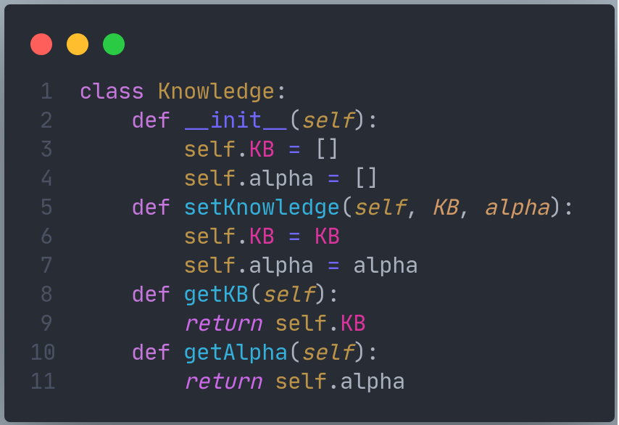
- Library: copy for deepcopy list, product of itertools for better loop!
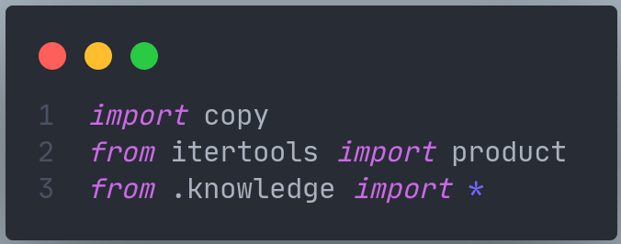
- is_meaningless: Function check clause is meaningless so it can be discard, check by if exist (A != B and A == -B with A, B in clause) then True.
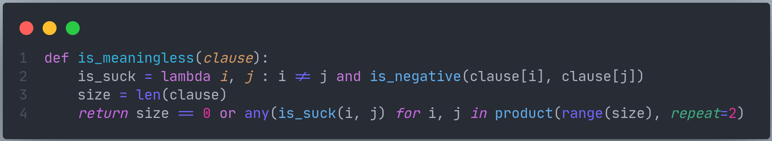
- is_stop: Function check list clause is contain empty clause to end PL_resolution algorithm.
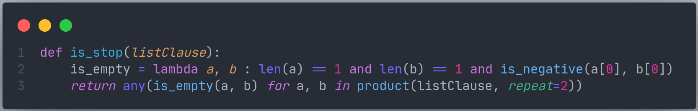
- PL_resolve: Function return resolve of 2 clause, remove opposing literal pair and duplicate literals.
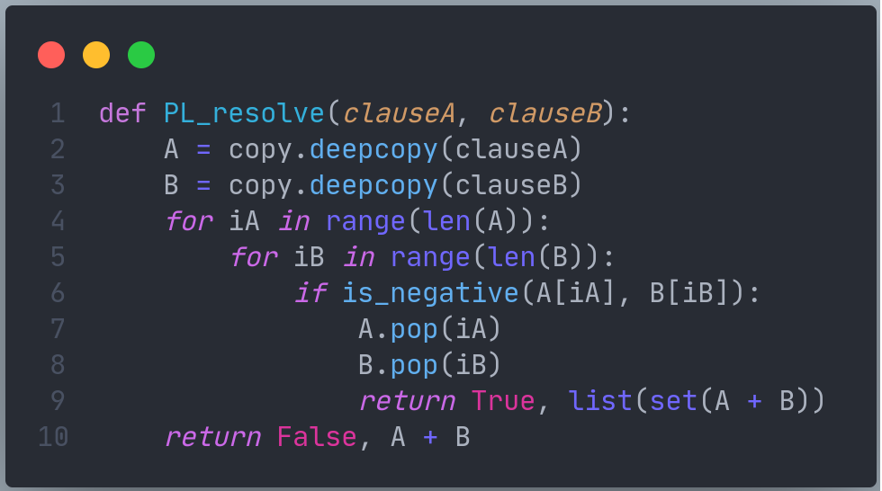
- new_list: Function create new list clause from old list clause, new list will contain resolve of each pair of clause in old list if it can resolve, not meaningless and not in new list or old list.
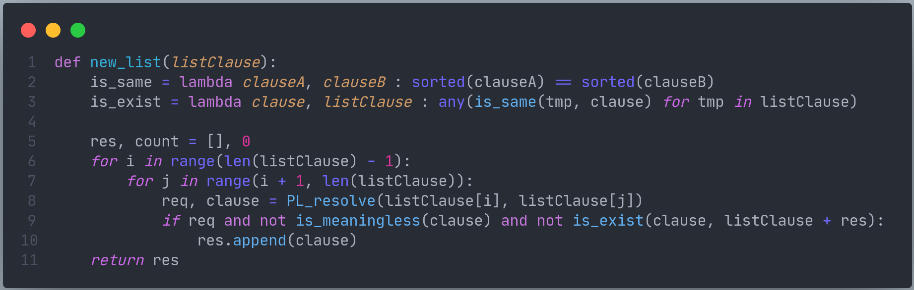
- negative_alpha: Function return negative of alpha using De Morgan law and Distribution law
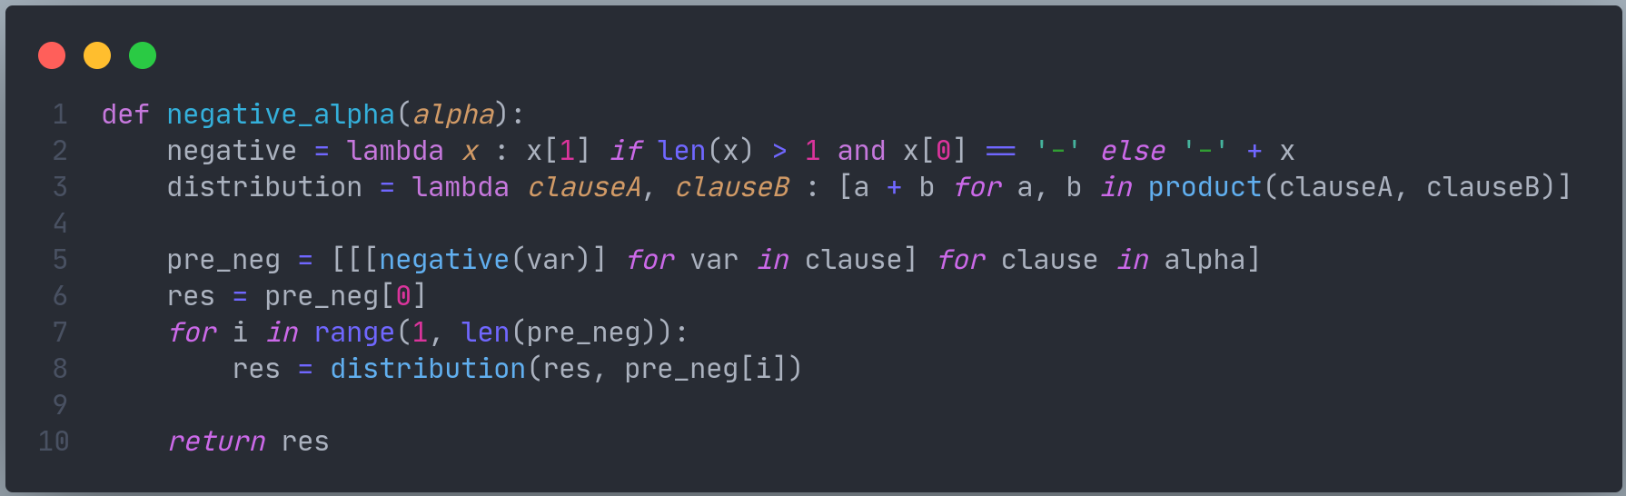
- PL_resolution: Function return sorted output of PL resolution follow pseudo code of Lecture07-LogicalAgents page 53.
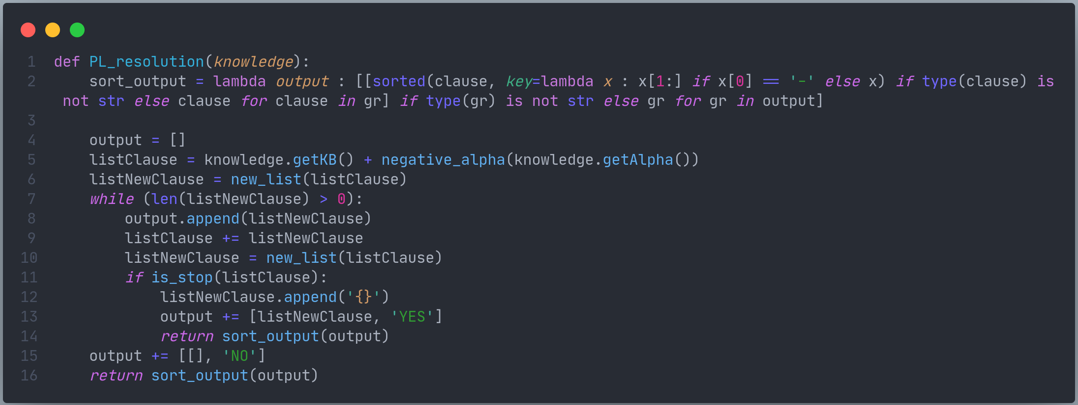
- main: Main function will read 5 file input in inputs folder and using PL resolution to check whether KB entails alpha then write output to outputs folder.
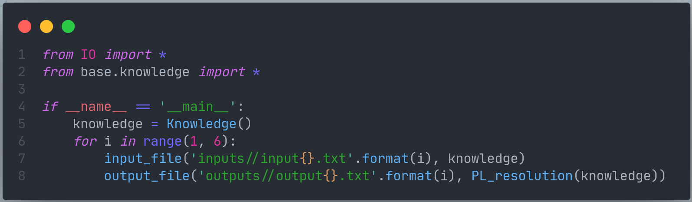
- Discussion on the algorithm’s efffiency and suggestions:
- PL resolution is not optimize since many resolution steps are pointless and numbers of clauses (numbers of literals also) is very large, so deciding entailment might be done in exponential time.
- Suggestions: Use Forward-chaining or Backward-chaning instead, deciding entailment can be done in linear time.

