**Verkefni 1 HBV601G**

**Sigurjón Ólafsson Þorsteinn Sigurðsson Jón Guðjónsson Ari Sigþór Eiríksson**

KT 291072-5699 KT 180297-2359 KT 140789-2679 KT 160897-2529

**Project Vision**

**Template fyrir project vision**

**1.**

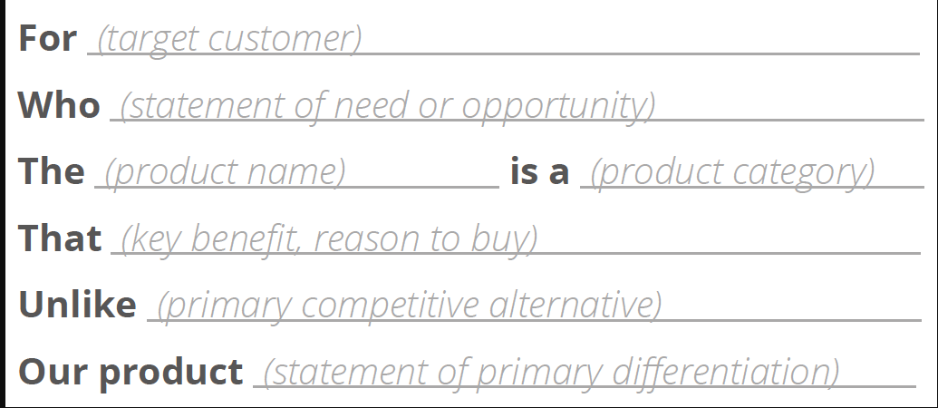

**2.Product backlog (prioritized user stories**)

**3.User Story estimates (three-point estimates of expected cases, using basic PERT formula)**

**4.Project schedule (dates for sprints, milestones, Ass. 2 submission and Ass. 3 code exchange)**