General description

- The main objective of this task is to develop a gym application.
- The application should enable gym trainees and trainers to register their profile, giving trainees the option to select one or more trainers.
- Users should be able to log their activities and view them both as trainers and as trainees.
- The application should also provide the functionality to modify profile information and activate or deactivate profiles.
- To access the application (except Registration page), login credentials will be required for both trainers and trainees.
- For each trainer calculated info their trainings duration on weekly base.

Component diagram
I) On premise version
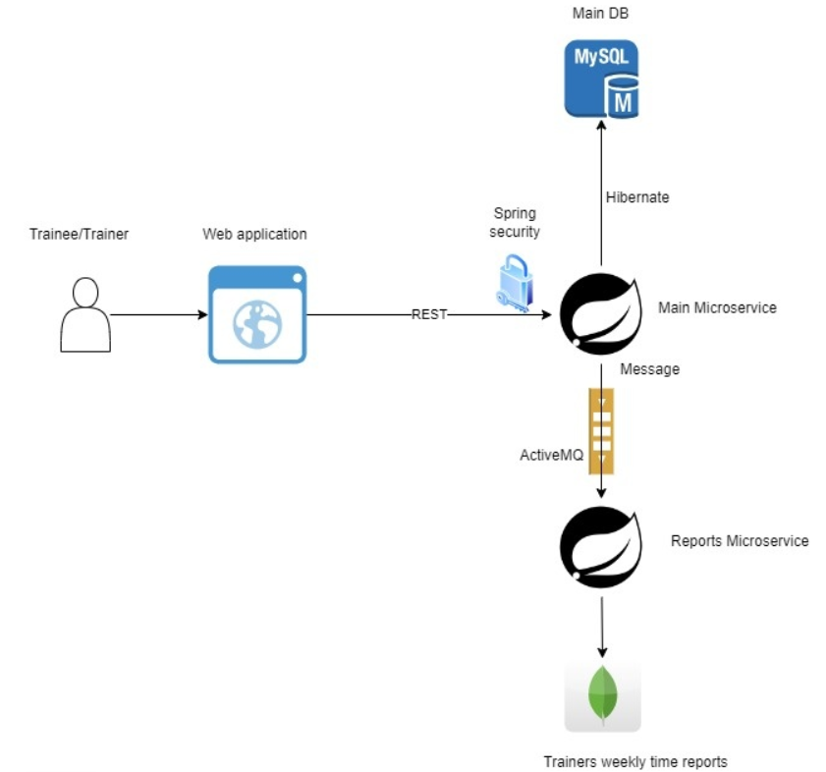

II) Cloud version
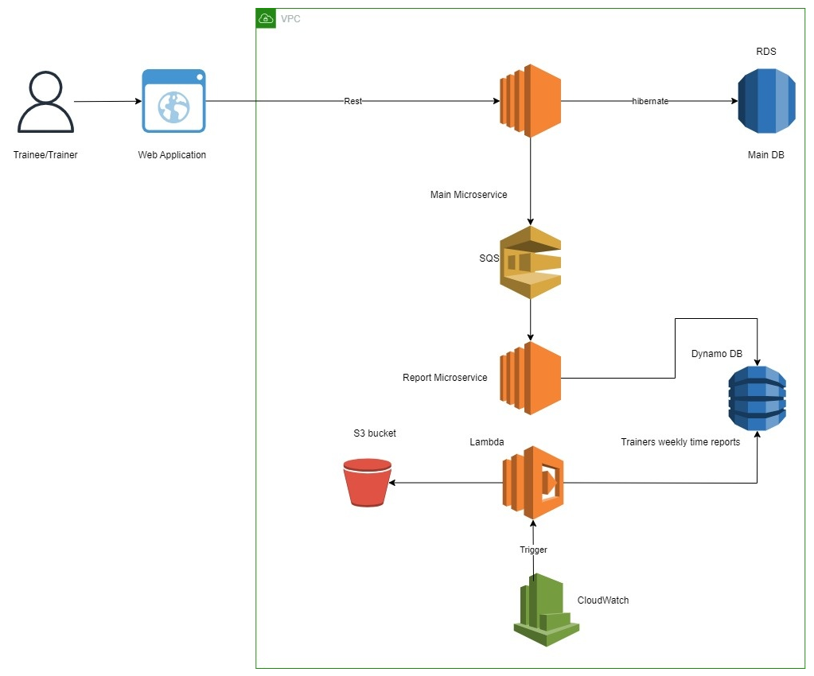

DB Schema

I) RDNMS
- User
  - ID (PK)
  - First Name (String, Required)
  - Last Name (String, Required)
  - Username (String, Required)
  - Password (String, Required)
  - Is Active (Boolean, Required)
- Trainee
  - ID (PK)
  - User Id (FK, Required)
  - Date of Birth (Date, Nullable)
  - Address (String, Nullable)
- Trainer
  - ID (PK)
  - User Id (FK, Required)
  - Specialization Id (Training type Id) (FK, Required)
- Trainee2Trainer
  - ID (PK)
  - Trainee Id (FK, Required)
  - Trainer Id (FK, Required)
- Training
  - ID (PK)
  - Trainee Id (FK, Required)
  - Trainer Id (FK, Required)
  - Training Name (String, Required)
  - Training Type Id (FK, Required)
  - Training Date (Date, Required)
  - Training Duration (Number, Required)
- Training Type
  - ID (PK)
  - Training Type Name (String, Required, from List: fitness, yoga, Zumba, stretching, resistance)

II) Table Diagram
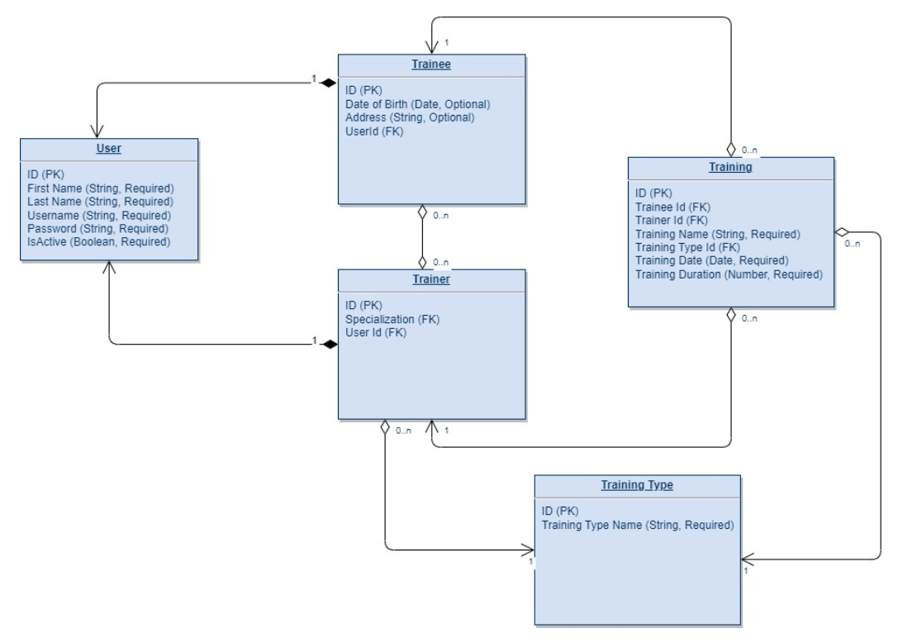

III) MongoDB
- Trainings Summary Duration
  - Trainer Username (ID)
  - Trainer First Name
  - Trainer Last Name
  - Trainee Status (Active, Inactive)
  - Years List
  - Months List
  - Trainings summary duration

Lambda logic description

Scope:
An idea is to implement AWS Lambda function that triggered on weekly base by CloudWatch trigger.
The AWS Lambda function should implement the follow logic:
- Connect to Dynamo DB - Trainings Duration Summary table.
- Extract data from the table.
- Generate report in csv format with follow structure:
  - Trainer First Name.
  - Trainer Last Name.
  - Current month trainings duration summary time.
- Upload the result file to the S3 bucket.
Notes:
- Report should contain both active and inactive trainers.
- Report name should be as a template "Trainers_Trainings_summary_YYYY_MM".
- Inactive trainer with training duration summary equals to 0 should not be included into the report.

Dynamo DB table Trainings duration summary structure
- Trainer Username (ID)
- Trainer First Name
- Trainer Last Name
- Trainee Status (Active, Inactive)
- Years list
  - Months List
    - Trainings duration summary

REST API Endpoints
- Trainee Registration
  - Request
    - First Name (required)
    - Last Name (required)
    - Date of Birth (optional)
    - Address (optional)
  - Response
    - Username
    - Password
- Trainer Registration
  - Request
    - First Name (required)
    - Last Name (required)
    - Specialization (required)
  - Response
    - Username
    - Password
- Login
  - Request
    - Username (required)
    - Password (required)
  - Response
    - 200 OK
- Change Login
  - Request
    - Username (required)
    - Old Password (required)
    - New Password (required)
  - Response
    - 200 OK
- Get Trainee Profile
  - Request
    - Username (required)
  - Response
    - First Name
    - Last Name
    - Date of Birth
    - Address
    - Is Active
    - Trainers List
      - Trainer Username
      - Trainer First Name
      - Trainer Last Name
      - Trainer Specialization
- Update Trainee Profile
  - Request
    - Username (required)
    - First Name (required)
    - Last Name (required)
    - Date of Birth (required)
    - Address (required)
    - Is Active (required)
  - Response
    - Username
    - First Name
    - Last Name
    - Date of Birth
    - Address
    - Is Active
    - Trainers List
      - Trainer Username
      - Trainer First Name
      - Trainer Last Name
      - Trainer Specialization
- Delete Trainee Profile
  - Request
    - Username (required)
  - Response
    - 200 OK
- Get Trainer Profile
  - Request
    - Username (required)
  - Response
    - First Name
    - Last Name
    - Specialization
    - Is Active
    - Trainees List
      - Trainee Username
      - Trainee First Name
      - Trainee Last Name
- Update Trainer Profile
  - Request
    - Username (required)
    - First Name (required)
    - Last Name (required)
    - Specialization (read only)
    - Is Active (required)
  - Response
    - Username
    - First Name
    - Last Name
    - Specialization
    - Is Active
    - Trainees List
      - Trainee Username
      - Trainee First Name
      - Trainee Last Name
- Get not assigned on trainee active trainers.
  - Request
    - Username (required)
  - Response
    - Trainer Username
    - Trainer First Name
    - Trainer Last Name
    - Trainer Specialization
- Update Trainee's Trainer List
  - Request
    - Trainee Username
    - Trainers List (required)
    - Trainer Username (required)
  - Response
    - Trainers List
    - Trainer Username
    - Trainer First Name
    - Trainer Last Name
    - Trainer Specialization
- Get Trainee Trainings List
  - Request
    - Username (required)
    - Period From (optional)
    - Period To (optional)
    - Trainer Name (optional)
    - Training Type (optional)
  - Response
    - Training Name
    - Training Date
    - Training Type
    - Training Duration
    - Trainer Name
- Get Trainer Trainings List
  - Request
    - Username (required)
    - Period From (optional)
    - Period To (optional)
    - Trainee Name (optional)
  - Response
    - Training Name
    - Training Date
    - Training Type
    - Training Duration
    - Trainee Name
- Add Training
  - Request
    - Trainee username (required)
    - Trainer username (required)
    - Training Name (required)
    - Training Date (required)
    - Training Type (required)
    - Training Duration (required)
  - Response
    - 200 OK

Screens
- Home Page
  - Logo
  - Header
    - Home Page
    - Registration form for trainee
    - Registration form for trainer
    - Login
  - Static text
  - Footer
    - About us
    - Contact us
    - Terms of use
- Trainee registration screen
  - Header
  - Registration form for trainee
    - First Name (input field required)
    - Last Name (input field required)
    - Date of Birth (input field optional)
    - Address (input field optional)
    - Send button
    - Username (text label hidden till response)
    - Password (text label hidden till response)
  - Footer
- Trainer registration screen
  - Header
  - Registration form for trainee
    - First Name (input field required)
    - Last Name (input field required)
    - Specialization (combo box required)
    - Send button
    - Username (text label hidden till response)
    - Password (text label hidden till response)
  - Footer
- Login Form
  - Header
  - Login Form
    - Username
    - Password
    - CAPTCHA
  - Footer
- Trainee profile screen
  - Header
  - Trainee details (read only)
    - First Name
    - Last Name
    - Username
    - Date of Birth
    - Address
    - Is Active
    - Trainers List
      - Trainer's First Name
      - Trainer's Last Name
      - Trainer's Specialization
    - View Trainings button
    - Update Trainee profile button
    - Delete Trainee profile button
    - Change Password button
  - Footer
- Trainer profile screen
  - Header
  - Trainer details (read only)
    - First Name
    - Last Name
    - Username
    - Specialization
    - Is Active
    - Trainees List
      - Trainee's First Name
      - Trainee's Last Name
    - View Trainings button
    - Update Trainer profile button
    - Change Password button
  - Footer
- Change password
  - Header
  - Change Password Form
    - Username (input field required)
    - Old Password (input field required)
    - New Password (input field required)
    - New Password Confirmation (input field required)
  - Footer
- Update Trainee Profile
  - Header
  - Update Profile Form
    - First Name (input field)
    - Last Name (input field)
    - Date of Birth (input field)
    - Address (input field)
    - Is Active (radio button)
    - Trainers List multiple choose list of active trainers not assigned on trainee.
      - Trainer's First Name
      - Trainer's Last Name
      - Trainer's Specialization
    - Send button.
  - Footer
- Update Trainer Profile
  - Header
  - Update Profile Form
    - First Name (input field)
    - Last Name (input field)
    - Is Active (radio button)
    - Send button.
  - Footer
- Trainings Log for trainee
  - Header
  - Trainings form
    - Search by trainer name (input field, optional)
    - Search by specialization (combo box, optional)
    - Search by date from/to (calendar, optional)
    - Trainings list
      - Training date
      - Training name
      - Training type
      - Trainer's name
      - Training duration
    - Search button
  - Footer
- Trainings Log for trainer
  - Header
  - Trainings form
    - Search by trainee name (input field, optional)
    - Search by date from/to (calendar, optional)
    - Trainings list
      - Training date
      - Training name
      - Training type
      - Trainee's name
      - Training duration
    - Search button
  - Footer
- Add Training for Trainee
  - Header
  - Add Training Form
    - Training date (calendar)
    - Training name (input field, required)
    - Training type (combo box, required)
    - Trainer's name (combo box, required)
    - Training duration (input field, required)
  - Footer

