Project Plan

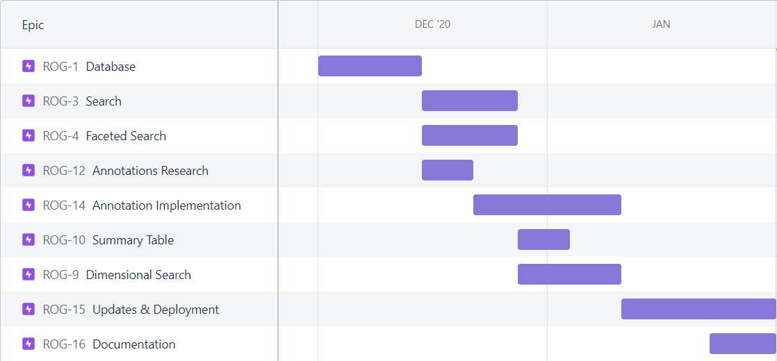

* ROG-1 Database 2020/12/01 - 2020/12/14
* ROG-3 Search 2020/12/15 - 2020/12/27
* ROG-4 Faceted Search 2020/12/15 - 2020/12/27
* ROG-12 Annotation Research 2020/12/15 - 2020/12/21
* ROG-14 Annotation Implementation 2020/12/22 - 2021/01/10
* ROG-10 Summary Table 2020/12/28 - 2021/01/03
* ROG-9 Dimensional Search 2020/12/28 - 2021/01/10
* ROG-15 Updates & Deployment 2021/01/11 - 2021/01/31
* ROG-16 Documentation 2021/01/23 - 2021/01/31