Overview
The purpose of this document is to explain the technical implementation of the project “Last orders”. It will describe the system architecture, logic and decisions made during development.
This game is a bar keeper simulator where the player must mix drinks to match the order using the ingredients and tools available. The drink is scored via accuracy to the recipe where the steps chosen to match the recipes and if they are in the correct order. This accuracy then affects the tip percentage of the drink and also the reputation of their bar. A higher reputation gives more time for orders before they expire and a tip bonus. Each order has an NPC type that determines what they would value for the order e.g. time or accuracy or a combination.
This game has been designed primarily for PC but can also be exported for WebGL to reach a wider audience. The development of this game used Unity 2021 and Visual Studio 2026.

Technical architecture

System architecture overview
The overall system is connected with a game state manager singleton to ensure data is protected and accessible from any system in the game. This singleton has sub-managers for the economy, night, orders and upgrades. This system design was chosen to encapsulate each logical part of the game to allow for quicker development of each individual system as they don’t interact much except through a few key functions. The order manager manages the order generation and completion. It also calculates the accuracy of the submitted drink and passes this over to the economy manager. The economy manager manages the money the player has including the rent check at the end of the night which would signal a loss. The night manager handles the games flow from starting a night to ending it. This manager holds the timer for the night and signals to the game state manager when one is over. The inputs are handled with a drink assembly controller which a runtime script that holds the current drinks steps that have been completed and then passes these over to the order manager when it is submitted.

Architecture diagram
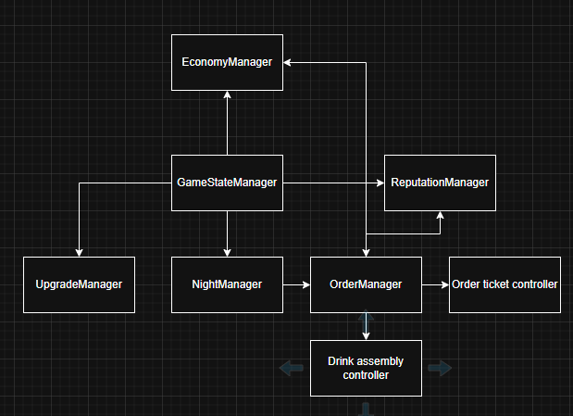

Core systems breakdown

Drink assembly system
This system handles the flow of data for the current drink being ‘made’ by the player. It holds the current steps that have been completed and adds new steps when they are completed. This system exists to have a ready data set to send to the order manager for assessment. This was chosen to be a different system as all the UI elements needed to be linked to the system and as the order manager is part of the game state manager singleton it moves between scenes so these references would be lost. It also serves to segment the logic of the system and make it easier to test as changes in one system won’t affect the other.
This system receives button inputs from the UI in the scene and then is sent when the button on the drink is pressed as it is the player adding it. Each button has a drink ingredient attached to it and then the corresponding step is added to the list of completed steps. For the more complex interactions from the player such as the shake or stir the data is sent over without interaction on the drink button but the player is locked into the interaction until it is completed.
The system produces a list of steps which it sends over to the order manager for assessment. This then affects the tip amount and reputation gain/loss.

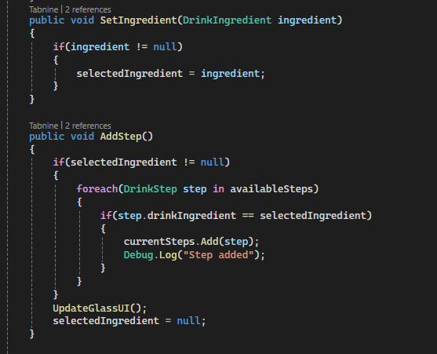
The system follows an input -> processing -> state update -> UI synchronisation loop, with external validation handled by the order manager.
This system had no performance concerns as it is not very resource intensive. It is quite scalable as only new buttons need to be added to have new ingredients however this could be done in a better way than having each as a variable maybe using a MVVM design in the future.
This method was chosen as it simplifies the interactions with the order manager and allows for quick iterative development and testing of the drink assembly that can be changed at any time without effecting the main game systems.

Order management system
This system handles when orders should be generated and how. The system follows a wave-based system and minimum number of active orders to ensure pressure is kept on the player at all times. This is done with a coroutine to ensure the system has time delays while still being able to run other functionality. The order is generated with a NPC type attached. When the order is generated an event is invoked to signal the ticket manager to instantiate a new ticket object. This system also includes the drink evaluation logic to calculate the accuracy percentage of the player submitted drink.

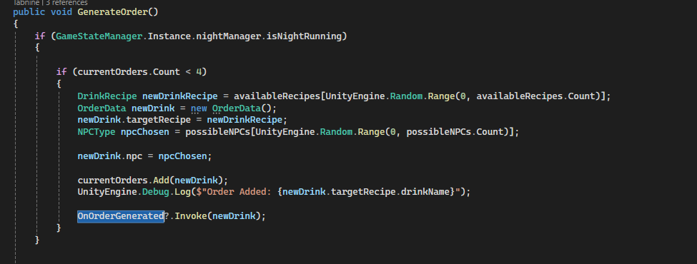
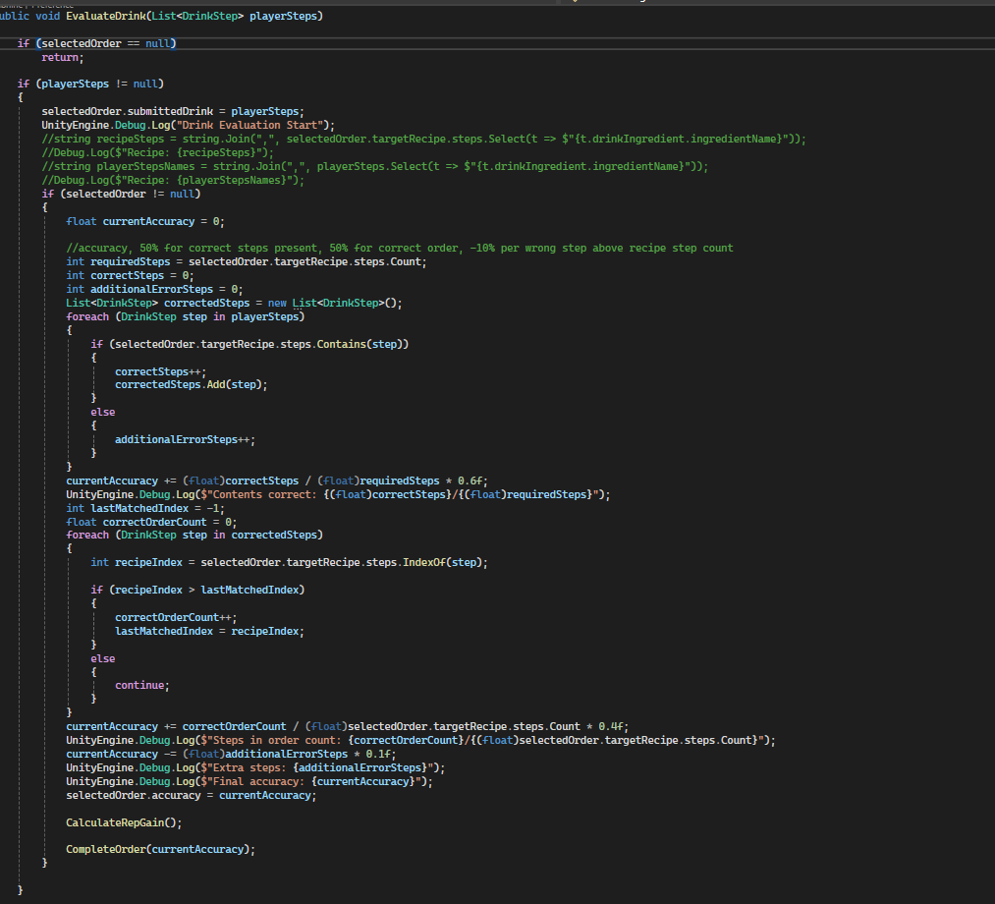

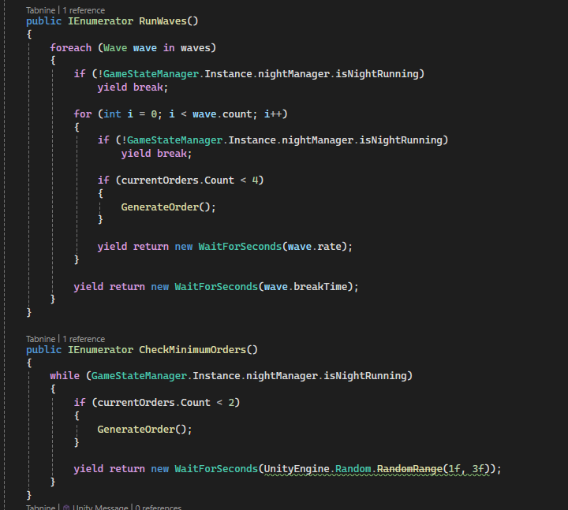
The only performance concerns were to do with the coroutines. There were concerns over improper management of them for example having too many running at once or never stopping. This was addressed with a single point of execution that is only run once at the start of the night and a simple condition to keep running it or not which is tied directly to if the night is running.
This method is very scalable as it only needs a list of the available orders and NPC types to start generating orders. This means that you only need to add the scriptable objects to the lists to have them included in the possible generations.
This method was chosen to keep as much pressure on the player as possible while having a single point of access to the generation of orders so that the correct number were produced.

Feedback and economy
The feedback and economy management systems are used to give feedback visually to the player and to keep track of the players money. The economy manager handles all the money transactions in the game and handles the main loss logic where the player can’t afford the rent. The feedback system gives text-based feedback in the form of customer feedback as well as the monetary amount received and if they gained or lost reputation.

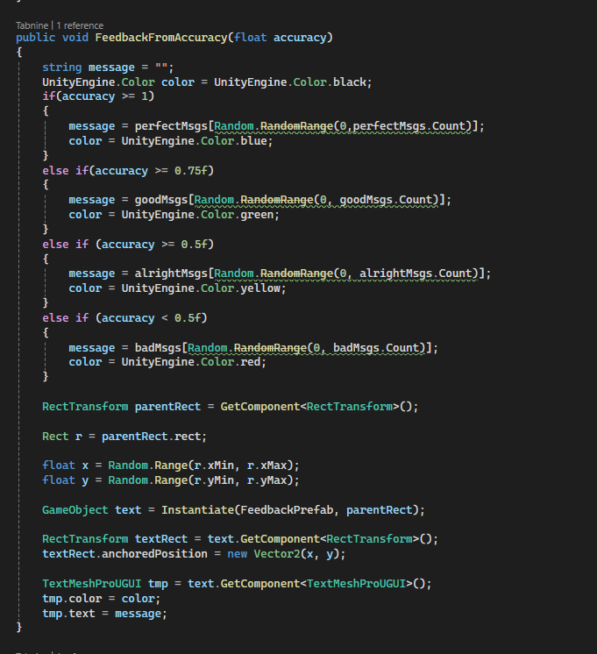
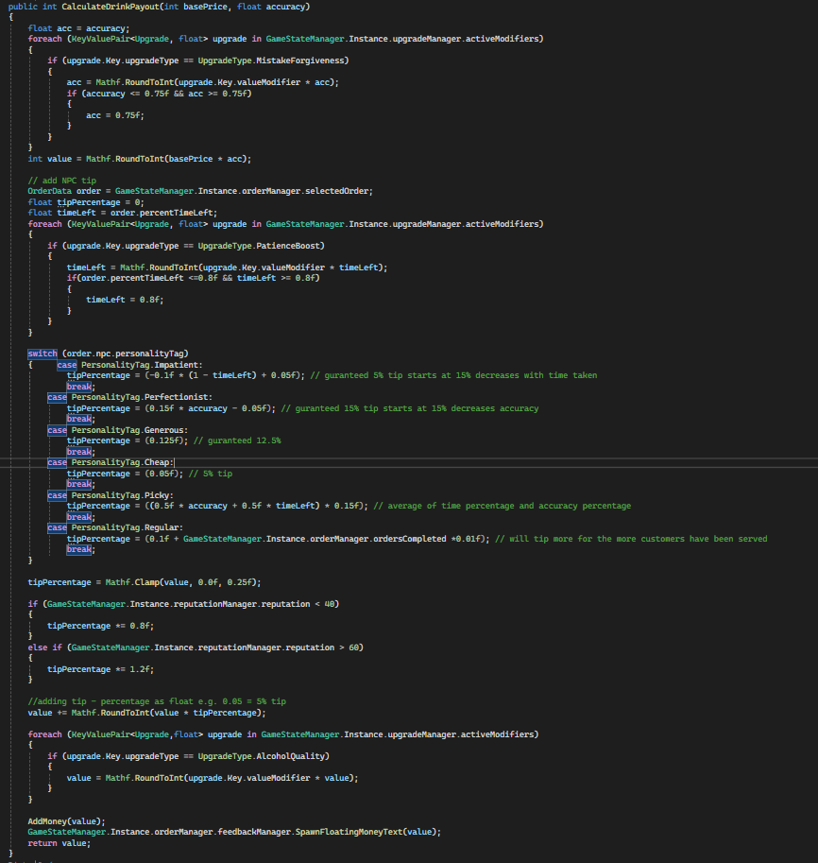
There weren’t any performance concerns for this system as it is not computationally intensive.
This system is also very scalable as the feedback system only needs a new function if the data is different and new text variations need to be added to the respective lists. The economy manager is also very scalable as it is accessible through the game state manager singleton and controls exactly how the data is used.

Key algorithms/ mechanics

Scoring
This algorithm is used to evaluate the players accuracy in making an order. It takes into account the matching ingredients and the matching order they player added them in. The 2 below functions calculate the accuracy then use that to calculate the payout of the drink. This is done by using the accuracy and time taken to complete it in conjunction with the NPC type attached to the order.
There were no performance concerns for this system as it is just basic calculations on a larger scale. This system is quite scalable as new NPC types can easily be added to the switch case statement with a new algorithm to calculate the tip percentage. The values can also be easily edited to balance the game more.
This method was used as it assesses the players performance in the game in multiple aspects and reward those that are excelling without punishing poorly performing players too much.

Upgrades
This system has different upgrades with an Enum to select the type. This is then used in multiple parts around the game to alter values with the modifier set in the upgrade. For example, when the time for the ticket is generated, an upgrade can be applied to increase it by 10%. These are purchased in the hub and handled with the upgrade manager that holds a Dictionary of the active upgrades with the key being the upgrade scriptable object and the value being the type of upgrade.
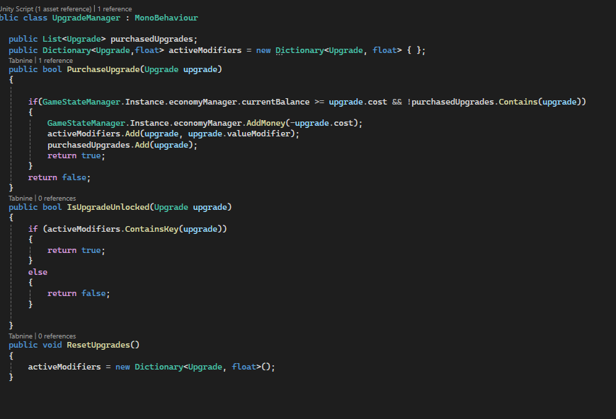
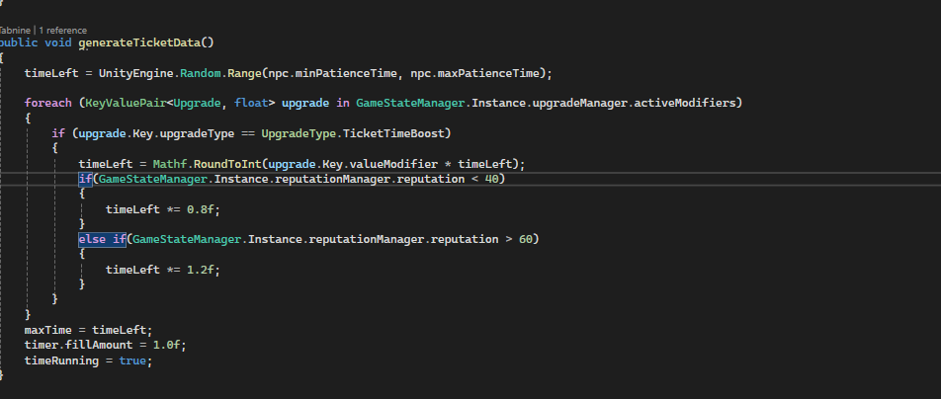
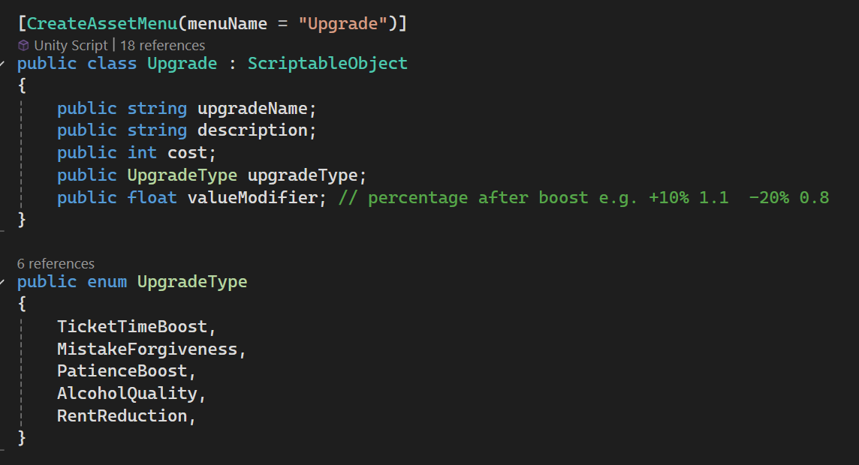
This system is also not too complex as it just applies a basic multiplier to certain values. However, ensuring that all the values were modified was done carefully but more easily due to a lot having single points where they are added due to the system architecture. This system is quite scalable too as it just requires new types of upgrades to be added. However, having to edit all the places where that upgrade is applied limits the scalability.
This method was used as it was quite simple to implement and didn’t require many changes to the original architecture. This meant that new upgrade types could be added at different points in development when they were planed and designed.

Tools and technologies
Unity was selected as the engine for the development of this project due to the team’s existing proficiency which allowed for rapid prototyping. This also enabled more time to be allocated to refinement, usability testing and achieving MAP-level polish rather than overcoming technical barriers.
Unity’s component-based architecture and real-time editor allowed for fast iteration of gameplay systems. This was important given the agile development approach where features needed to be implemented, tested, refined and discussed weekly.
Unity also provides built in systems for physics, input handling and UI, reducing the need to develop low-level functionality from scratch. This allowed the team to focus on core gameplay mechanics and user experience features.
Unity’s extensive asset store also allowed for rapid integration of assets accelerating development time. As this team has minimal experience with 3D modelling software and due to the limited time of the development all the in game assets were sourced from the asset store.
Unity supports deployment across multiple platforms providing flexibility for future expansion into new markets.

Git was used to version control this project where once a feature was developed and play tested it would be uploaded so that the team could provide feedback and work on other features that required them.

Performance considerations
For the performance of this game a low poly cartoon style was used to allow for lower spec machines to run the game as there is less complexity with geometry and lighting. A minimal environment was set up to reduce memory usage where if the player could not see the object it was removed. Minimal unity update loops were used as not many were needed. The game mainly runs in a flow from one system to another. In an optimisation pass some update functions were removed as they were not needed or could be called as a separate function. There are not physics interactions either to reduce the number of calculations per second.

Testing

Iteration and improvements
During the testing it was found that there was some confusion with what ingredient was selected. To aid this we added a simple effect that raises the bottle selected by a small amount to signal to the player that it is selected. Additionally, during testing some players were confused about what they had added to the drink and if they should restart as they had forgotten. To aid in this an icon-based queue was added as a UI element to show what order they had added steps in and could inform them whether to restart or not.
Through the development of this project the timing of orders was changed. In the beginning phases it was just a simple random time until the next order (20-30 seconds) this was fine for prototyping but as we play tested the product, we felt it was a bit slow and didn’t have much pressure for the player. This was changed to a wave-based system to improve this. Additionally, through the development of this project the reputation system was added to add an additional layer of reward for players.

Limitations and future work
Due to the project development running over a relatively short period of time, less development could be completed that required for the full game. We instead planned development around the core game features to give players the best idea about what the game is about.
In the future, we plan on developing the progression further with more visual upgrades and drink recipes to unlock. These recipes would then be switched every x number of nights to ensure players are still challenged. Some visual improvements could also be made with having NPC models to order at the bar and improving the 3d environment further. Additionally, a story mode could be added as currently the game is an endless mode. This would add more structured progression for the players. A tutorial would also need to be developed as currently none exists other than written instructions included on the game’s page.

