Hanna Bohannon

NoSQL

**PART 1**

• Create a new collection in Atlas named employees.

~Query~

db.employees.insertMany([

{

name : "Alison Davidson",

age : 46,

address : "874 W. Oak Place",

city : "Gary",

state : "Indiana",

positionName : "Customer Support",

remote : "Yes",

fullTime : "Yes"

},

{

name : "Henry Chapelton",

age : 41,

address : "9324 E. Vista Way",

city : "Tempe",

state : "Arizona",

positionName : "Customer Support",

remote : "No",

fullTime : "Yes"

},

{

name : "Alex Miller",

age : 38,

address : "244 Price Road",

city : "Mesa",

state : "Arizona",

positionName : "Customer Support",

remote : "No",

fullTime : "No"

},

{

name : "Carly Nielson",

age : 34,

address : "678 W. Westward Road",

city : "Phoenix",

state : "Arizona",

positionName : "Office Manager",

remote : "No",

fullTime : "Yes"

},

{

name : "Tom Talbot",

age : 32,

address : "12 Oakland Way",

city : "Chandler",

state : "Arizona",

positionName : "Inventory Manager",

remote : "No",

fullTime : "Yes"

},

{

name: "Mary Crawley",

age : 41,

address : "1010 Granite Way",

city : "Charlotte",

state : "North Carolina",

positionName : "Human Resources",

remote : "Yes",

fullTime : "Yes"

},

{

name : "Daisy Baxter",

age : 34,

address : "990 E. 84th St",

city : "Tempe",

state : "Arizona",

positionName : "CEO",

remote : "No",

fullTime : "Yes"

},

{

name : "William Coyle",

age: 30,

address : "874 W. Oak Place",

city : "Phoenix",

state : "Arizona",

positionName : "Intern",

remote: "No",

fullTime: "No"

},

{

name: "Edith Bates",

age : 31,

address : "990 E. 84th St",

city : "Chandler",

state : "Arizona",

positionName : "Customer Support",

remote : "No",

fullTime : "Yes"

},

{

name : "Gwen Harding",

age : 35,

address : "234 W. 48th. St",

city : "Phoenix",

state : "Arizona",

positionName : "Office Assistant",

remote : "No",

fullTime : "Yes"

}]);~Query 1 Image~

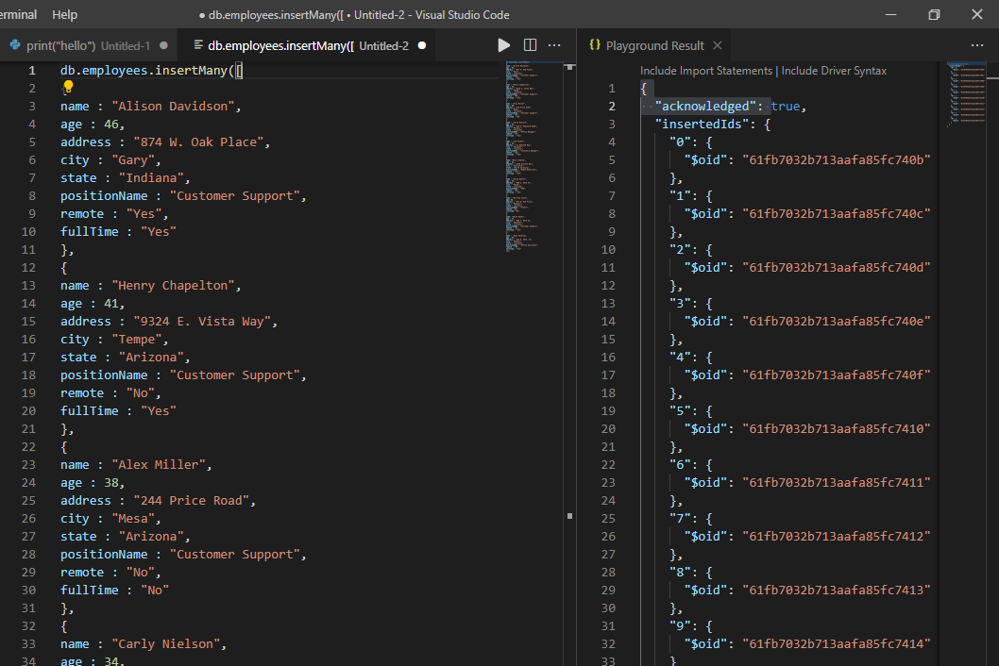

~Find Query~

db.employees.find()

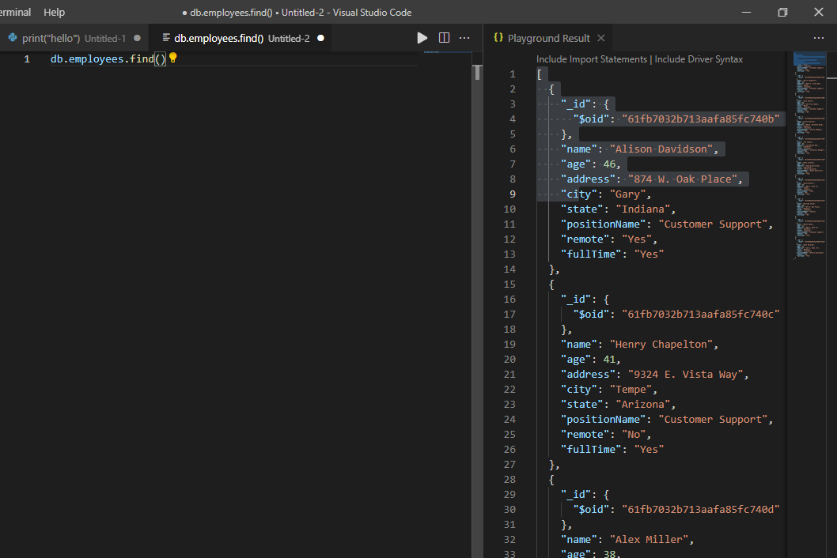

**The Position Name, Remote, and Full Time fields should be within an embedded document called position.**

position : {"positionName", "remote", "fullTime"}

Update addresses:

• Alison Davidson now lives at 777 E. 1st St. # 120 Tempe, AZ

~Query~

db.employees.updateOne({ name : "Alison Davidson"}, {$set : { address : "777 E. 1st St. # 120"}});

~Query Image~

~Atlas Image~

• Mary Crawley now lives at 8322 W. Vista Pl. Scottsdale, AZ

~Query~

db.employees.updateOne({ name : "Mary Crawley"}, {$set : { address : "8322 W. Vista Pl."}});

~Atlas Image ~

**Removing the state field:**

~Query~

db.employees.updateMany({}, {$unset : {state : ""}});

~Query Image~

**Efficient searching using the "position" field** (remember that field includes a document with three other fields).

~Query~

db.employees.createIndex({position : 1});

~Query Image~

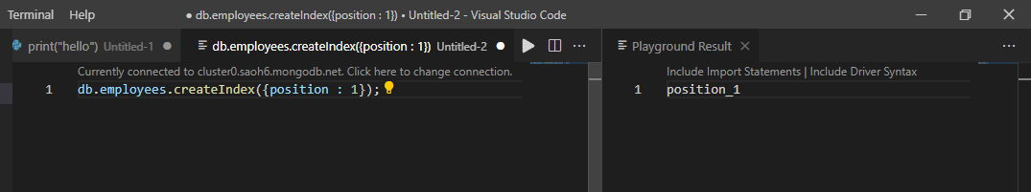

~Query~

db.employees.updateMany({}, { $rename : {positionName : "position "}});

db.employees.updateMany({}, { $rename : {remote : "position"}});

db.employees.updateMany({}, { $rename : {fullTime : "position"}});

**Part 2**

**Create a new collection named songs.**

~Query~

db.songs.insertMany([

{

songId: 1,

Title: " Girls Just Want To Have Fun ",

Artist: " Cyndi Lauper ",

Album: " She's So Unusual ",

releaseYear: 1983

},

{

songId: 2,

Title: " Hips Don't Lie ",

Artist: " Shakira feat. Wyclef Jean ",

Album: " Oral Fixation Vol. 2 ",

releaseYear: 2006

},

{

songId: 3,

Title: " Poker Face ",

Artist: " Lady Gaga ",

Album: "The Fame ",

releaseYear: 2008

},

{

songId: 4,

Title: " Wannabe ",

Artist: " Spice Girls ",

Album: "Spice ",

releaseYear: 1996

},

{

songId: 5,

Title: " California Gurls ",

Artist: " Katy Perry feat. Snoop Dogg ",

Album: " Teenage Dream ",

releaseYear: 2010

},

{

songId: 6,

Title: " Bye, Bye, Bye",

Artist: " NSYNC ",

Album: " No Strings Attached ",

releaseYear: 2000

},

{

songId: 7,

Title: " I Will Always Love You ",

Artist: " Whitney Houston ",

Album: " I Will Always Love You: The Best of Whitney Houston ",

releaseYear: 2012

},

{

songId: 8,

Title: " Baby One More Time ",

Artist: " Britney Spears ",

Album: " Baby One More Time ",

releaseYear: 1999

},

{

songId: 9,

Title: " Vogue ",

Artist: " Madonna ",

Album: " I'm Breathless ",

releaseYear: 1990

},

{

songId: 10,

Title: " Rolling in the Deep ",

Artist: " Adele ",

Album: "21 ",

releaseYear: 2011

},

{

songId: 11,

Title: " 1234",

Artist: " Feist ",

Album: " The Reminder ",

releaseYear: 2007

},

{

songId: 12,

Title: " Elastic Heart ",

Artist: "Sia ",

Album: " The Hunger Games: Catching Fire Soundtrack ",

releaseYear: 2015

}

]);

~Query Image~

~find Query Image~

db.songs.find()

~Atlas Image~

**The artist, album, and releaseYear fields should be an embedded document named details.**

~Query~

db.songs.createIndex({details : 1})

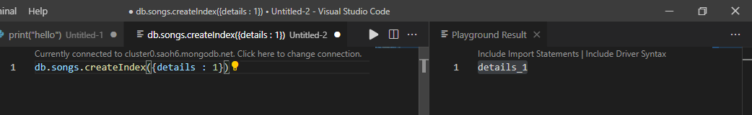

("releaseYear", "album", "artist")

db.songs.insertMany([ { details: { Album: "", releaseYear: "", Artist: "" } } ]);

Changes to be made:

**The title field needs to be renamed to songTitle, so it is clearer to the developers working with the data.**

~Query~

db.songs.updateMany({}, {$rename:{"Title":"songTitle"}}, true);

~Query Image~

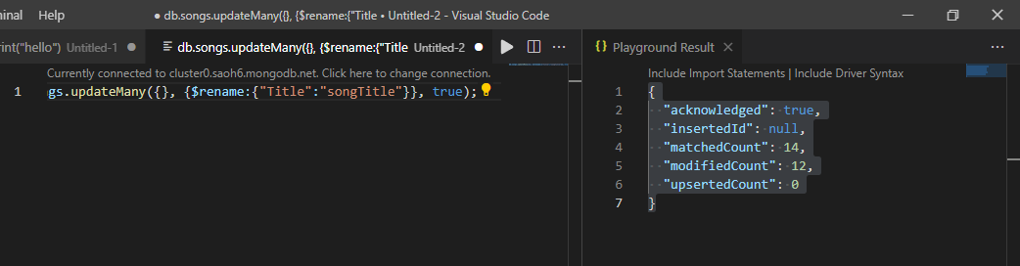

~Atlas Image~

**Artist field to be outside the details document but then  
Embed the album and releaseYear should stay within the artist.**

db.songs.insertMany([ { artist: { album: "", releaseYear: "" } } ])