

School of Computer Science Engineering and Information Systems
Department of Information Technology
Fall 2026-27
Operating Systems Lab BITE303P
PROJECT REPORT
AI-Enhanced Database-Backed Filesystem with Adaptive Storage Optimization

Submitted by
Harshit Choudhary 24BIT0237
Shravya Jain 24BIT0231
Arnav Aditya 24BIT0213

Under the Guidance of
Dr. G.N. VIVEKANANDA
Associate Professor, SCORE
VIT, Vellore.

Fall 2026-27
DECLARATION

We hereby declare that the project report titled “AI-Enhanced Database-Backed Filesystem with Adaptive Storage Optimization” submitted in partial fulfillment of the requirements for the course BITE303P – Operating Systems Lab is a record of original work carried out by us.
We affirm that this work has been developed independently and has not been submitted, either in part or in full, to any other course, institution, or university for the award of any degree or certification.
We further declare that:
- All sources of information used in this project have been properly acknowledged and cited in accordance with academic standards.
- The work does not contain any form of plagiarism beyond permissible limits.
- The analysis, design, implementation, and results presented in this report are our own contributions, except where explicitly stated.
- Any assistance received during the course of this work has been duly acknowledged.
We are submitting this project as part of our course requirements under the guidance of Dr. G.N. Vivekananda.

Signature of Student(s)

TABLE OF CONTENTS
S.No. | Contents | Page No.
1 | Abstract | 5
2 | CHAPTER 1: INTRODUCTION | 6
3 | CHAPTER 2: LITERATURE SURVEY | 8
4 | CHAPTER 3: PROPOSED TECHNIQUE | 12
5 | CHAPTER 4: RESULTS AND DISCUSSION | 17
6 | CHAPTER 5: CONCLUSION AND FUTURE WORK | 22
7 | References | 23

ABSTRACT
A filesystem normally decides what to keep in memory and what to read ahead with fixed rules. A fixed rule suits some programs and hurts others. This project asks whether a filesystem can learn the access pattern from its own reads and adapt to it.
We built a Linux user-space filesystem with FUSE in C++. File data is stored in fixed 4,096-byte blocks in one image file, and all metadata, together with a log of every block access, is stored in SQLite. Two scikit-learn models are trained in Python while the filesystem runs. A decision tree, retrained every 256 reads on the last 2,048 reads, predicts the next four block reads; Python writes the tree out as text and the filesystem follows it to prefetch those blocks. A linear regression learns from measured read times how to divide the cache memory between file data and block mappings. Three versions are compared: A with no prediction, B with a hand-written predictor, and C with the two models.
On four workloads with a cache of 6% of the data, version C had the lowest average read latency when reads came back to back: 87 microseconds against 148 with no prediction on sequential reads (41% lower), and 125 against 347 on a repeating pattern (64% lower). It wasted no prefetches on the sequential, random and repetitive workloads, where the hand-written predictor wasted about 2,050 per run on random reads. The learned memory split reduced block-mapping queries by 11% on random and 48% on mixed workloads without a measurable change in latency. The model is weakest when the pattern changes often: on the mixed workload it served 24% of reads from prefetch against 42% for the hand-written predictor.

CHAPTER 1: INTRODUCTION

1.1 Motivation
Reading from a disk is far slower than reading from memory, so every filesystem keeps recently used blocks in a cache and tries to read blocks before they are asked for. How well this works depends on the policy: which blocks to keep, which to read ahead, and how much memory to give to each kind of cached data. These policies are normally fixed rules chosen by the designer (Silberschatz et al.; Arpaci-Dusseau and Arpaci-Dusseau).
Real workloads differ. A backup reads files front to back, a database reads scattered blocks, and an application starting up reads the same blocks in the same odd order every time. A read-ahead rule built for the first is useless for the third and wasteful for the second. Recent work has shown that machine learning can find such patterns in memory accesses and in storage systems (Hashemi et al.; Akgun et al.). This motivated us to build a filesystem in which the policy is learned from the filesystem’s own history, and to measure on the running system whether that helps.

1.2 Scope
The project covers a single-machine, user-space filesystem and the policies inside it. It applies to any setting where storage is much slower than memory and access patterns repeat. Its boundaries are:
• Included: creating, reading, writing, truncating, renaming and deleting files; directories; block allocation; SQLite metadata; an access log; a block cache and a mapping cache; prediction and prefetching; a learned division of cache memory; a workload generator and evaluation.
• Not included: kernel development, distributed or network storage, permissions and ownership, timestamps, links, crash consistency for data blocks, and large or deep neural networks.
• Principle: the learned parts only change speed. Every version returns the same bytes, and correctness never depends on a prediction.

1.3 Problem Statement
Fixed caching and prefetching policies do not adapt to the workload, which leads to avoidable disk reads on some workloads and wasted work on others. The problem addressed is to design and implement a database-backed filesystem that learns the block-access pattern from its own access history, uses it to prefetch blocks and to divide cache memory, and to determine by measurement whether this performs better than a baseline with no prediction and a baseline with hand-written prediction.

1.4 Objectives
1. Design and implement a Linux user-space filesystem with block-based storage and SQLite metadata.
2. Record every block read and write as an access log.
3. Predict the next block reads with a lightweight machine-learning model.
4. Use feedback: retrain on what was really read, and learn from measured read times.
5. Adapt the memory given to the block cache and the metadata (mapping) cache from measured cost.
6. Evaluate against two baselines on four workloads and report only what was measured.

1.5 Organization of the Report
Chapter 2 surveys related work on filesystems, caching, prefetching and learned storage policies, and states the gap this project addresses. Chapter 3 describes the system: its architecture, its modules, the two learning algorithms, the workloads used as data, and the tools. Chapter 4 gives the experimental setup, the results and their analysis. Chapter 5 concludes and lists future work.

CHAPTER 2: LITERATURE SURVEY

2.1 Overview
File systems have long organised a disk into fixed-size blocks and placed related blocks near each other to cut seek time (McKusick et al.), or written all changes sequentially as a log (Rosenblum and Ousterhout). Both designs, and the textbook treatment of file systems, caching and page replacement (Silberschatz et al.; Arpaci-Dusseau and Arpaci-Dusseau), rely on policies that are fixed when the system is built.
Storing file-system metadata in a database is an old idea: the Inversion file system was built on top of the POSTGRES database and gained transactions from it (Olson). SQLite is today a widely deployed embedded database engine that provides such transactions in a single file (Gaffney et al.). A file system can be written as an ordinary program with FUSE; a study of FUSE found that its cost ranges from imperceptible to as high as 83% depending on the workload, even when optimised (Vangoor et al.).
Cache replacement has moved from plain LRU towards policies that adapt. LRU-K takes the last K references to a page into account (O’Neil et al.), LIRS uses the distance between references (Jiang and Zhang), and ARC continually balances recency against frequency using lists of recently evicted pages, with no tuning parameter (Megiddo and Modha). Prefetching and caching compete for the same buffers, and have been studied together (Cao et al.); informed prefetching used hints disclosed by applications and a cost-benefit analysis to decide where each buffer does the most good (Patterson et al.).
Read-ahead in Linux detects sequential access with heuristics that have had to be redesigned as workloads changed (Wu et al.). Other work looks for patterns that are not sequential: C-Miner mines frequent sequences to find correlated blocks (Li et al.), DiskSeen uses the history of disk accesses (Ding et al.), and Leap detects majority trends in page accesses to prefetch remote memory (Al Maruf and Chowdhury).
More recently, machine learning has been applied to these decisions. Recurrent neural networks have been shown to predict memory accesses with better precision and recall than traditional prefetchers on benchmark traces (Hashemi et al.). An LSTM trained offline has been used to design a cheap online cache-replacement predictor (Shi et al.), and imitation learning has been used to approximate the optimal replacement policy (Liu et al.). Learning Relaxed Belady applies machine learning to cache replacement in content distribution networks (Song et al.). Learned index structures replace B-trees with models and were reported to be up to 70% faster while using an order of magnitude less memory on several data sets (Kraska et al.). In storage, LinnOS uses a light neural network to predict the speed of each I/O on flash devices (Hao et al.), and KML puts machine learning in the operating system to tune read-ahead and NFS read sizes, improving I/O throughput by as much as 2.3 times and 15 times in its two case studies (Akgun et al.). The models in this project are built with scikit-learn (Pedregosa et al.).

2.2 Review of Existing Methods

Hashemi et al., “Learning Memory Access Patterns” (2018)
The authors treat prefetching as a sequence-prediction problem, relate existing prefetchers to n-gram models, and use recurrent neural networks as a replacement. On a suite of benchmark data sets the networks give better precision and recall than traditional prefetchers. The paper calls itself a first step towards practical neural prefetching; it does not build a running system.

Akgun et al., “Improving Storage Systems Using Machine Learning” (2023)
KML is an architecture for running machine-learning models inside the operating system. It was applied to two cases, tuning read-ahead and NFS read sizes. The prototype used less than 4 KB of kernel memory, had a CPU overhead below 0.2%, and improved I/O throughput by as much as 2.3 times and 15 times in the two cases. It tunes parameters of existing mechanisms; it does not predict individual blocks.

Megiddo and Modha, “ARC: A Self-Tuning, Low Overhead Replacement Cache” (2003)
ARC balances recency and frequency continually and online, using a learning rule driven by the pages it recently evicted, and needs no workload-specific tuning. It is a hand-designed adaptive policy, not a trained model, and it manages one cache, not the division of memory between two.

Patterson et al., “Informed Prefetching and Caching” (1995)
Applications disclose their future accesses as hints. The system estimates the effect of each possible use of a buffer on execution time and applies cost-benefit analysis to divide buffers between prefetching and caching. It depends on applications being modified to give hints.

Li et al., “C-Miner: Mining Block Correlations in Storage Systems” (2004)
C-Miner uses frequent sequence mining to discover blocks that tend to be accessed together, and evaluates prefetching and data layout directed by those correlations. It is concerned with finding correlations between blocks; it does not address how memory should be divided between caches.

Kraska et al., “The Case for Learned Index Structures” (2018)
The authors argue that an index is a model that maps a key to a position, and replace B-trees with learned models, reporting up to 70% higher speed and an order of magnitude less memory on several real data sets. It concerns read-mostly indexes over sorted keys, not file-system block mappings that change with every write.

2.3 Comparative Analysis
Table 2.1: Related works
Paper | Technique used | Data set | Advantages | Limitations
Hashemi et al. (2018) | Recurrent neural network over memory-access sequences | Benchmark memory traces | Better precision and recall than traditional prefetchers | Evaluated on traces only; too costly for a running system
Akgun et al. (2023) | Small neural networks inside the OS (KML) | Read-ahead and NFS workloads | Up to 2.3x and 15x I/O throughput, very low overhead | Tunes parameters; does not predict blocks
Megiddo and Modha (2003) | Adaptive replacement using lists of evicted pages | Workload traces | Self-tuning, low overhead, no parameters | Hand-designed rule; one cache only
Patterson et al. (1995) | Application hints with cost-benefit buffer allocation | I/O-intensive applications | Weighs prefetching against caching by estimated time | Applications must be changed to give hints
Li et al. (2004) | Frequent sequence mining of block accesses | Storage-system traces | Finds non-sequential correlations | Does not address how cache memory is divided
Kraska et al. (2018) | Models in place of B-tree indexes | Real-world key sets | Up to 70% faster, far less memory | Read-mostly sorted data only
This project | Decision tree for prefetching and linear regression for the cache split, both trained online | Four synthetic workloads replayed on the running filesystem | A working filesystem; learns from its own reads; silent when there is no pattern | Weak when the pattern changes often; small evaluation

2.4 Research Gap
• The learned approaches reviewed above are mostly evaluated on traces or simulations, or tune a parameter of an existing mechanism. None of them is a complete, mountable filesystem in which the learned policy can be switched on and off against baselines.
• Policies that adapt the cache (ARC) or weigh prefetching against caching (informed prefetching) do so with hand-written rules or with hints from applications, not with models trained on the system’s own access history.
• Prefetching, cache sizing and metadata-index caching are usually studied one at a time. In a filesystem whose metadata is in a database, the block cache and the mapping cache compete for the same memory.
This project therefore builds a small but complete database-backed filesystem and measures, on the running system, whether simple models trained online on its own access log can (a) predict block reads well enough to prefetch them and (b) learn how to divide memory between the two caches from measured cost. It makes no claim of novelty beyond that; the aim is a working system and an honest measurement.

CHAPTER 3: PROPOSED TECHNIQUE

3.1 System Architecture
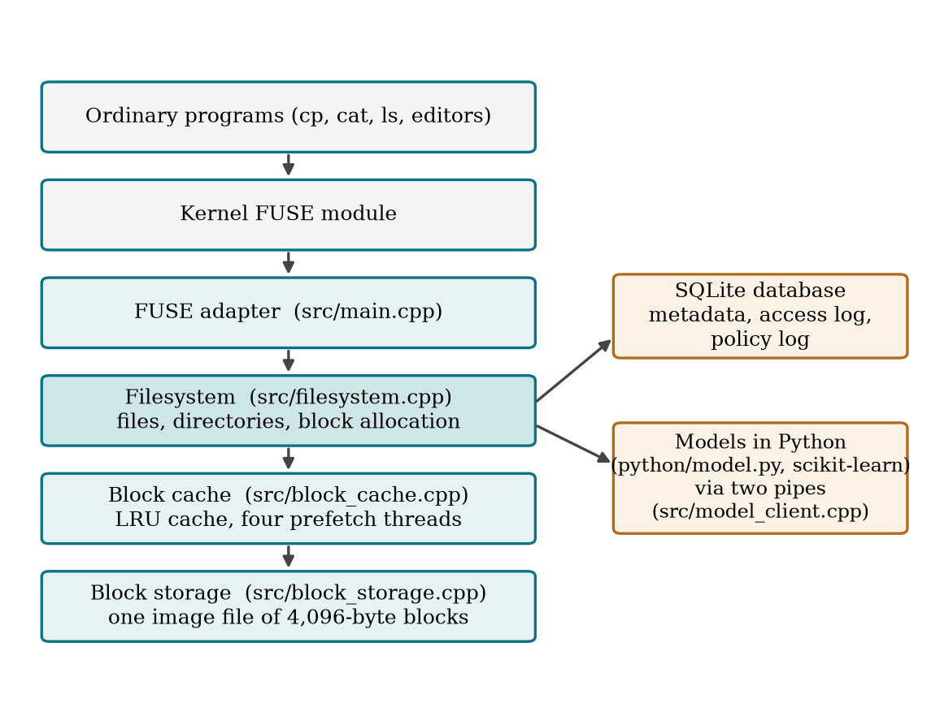
Figure 3.1: Architecture of the filesystem
Figure 3.1 shows the layers. An ordinary program makes a system call; the kernel passes it through FUSE to the adapter, which calls the filesystem layer. The filesystem keeps names, sizes, block mappings and free blocks in SQLite, and reaches file data through an LRU block cache on top of one image file. In version C the filesystem also runs a Python program that holds the two models and talks to it through two pipes.
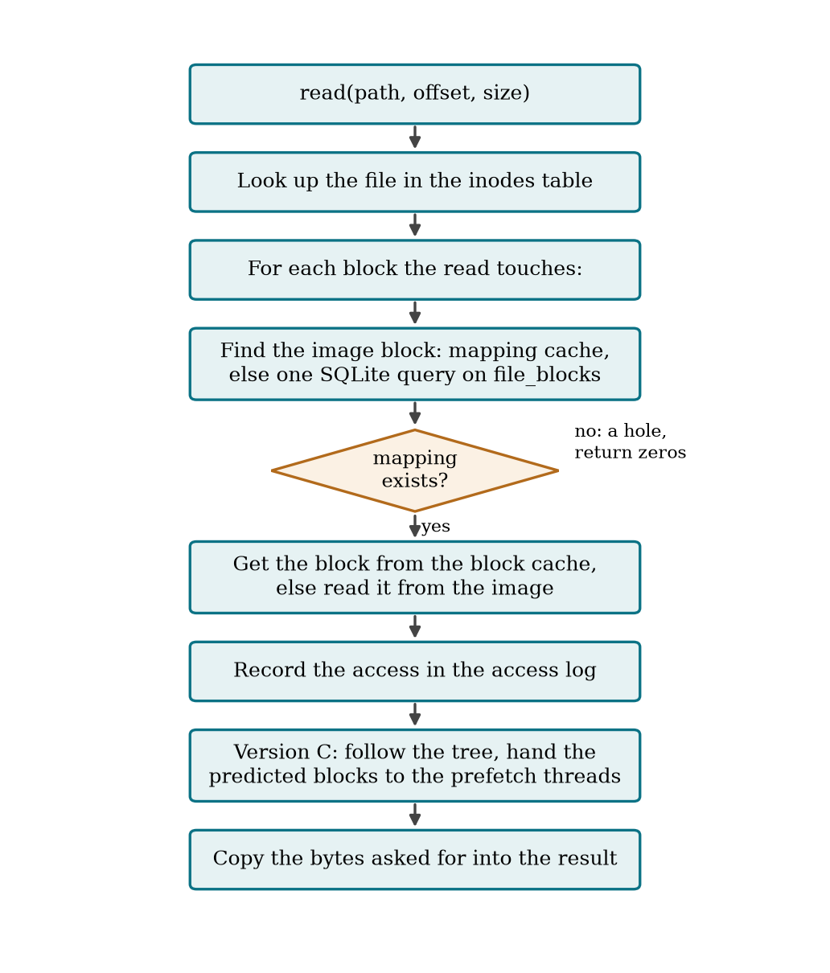
Figure 3.2: Workflow of a read
Figure 3.2 shows the path of a read. Writes follow the same path in reverse and run inside one SQLite transaction, so a write that fails, for example because the image is full, leaves the metadata unchanged.

3.2 Module-wise Description
Table 3.1: Modules of the system
Module | File | What it does
Block storage | src/block_storage.cpp | Reads and writes whole 4,096-byte blocks of one preallocated image file, optionally with O_DIRECT
Block cache | src/block_cache.cpp | LRU cache of blocks; four prefetch threads load predicted blocks; counts hits, misses, used and wasted prefetches
Filesystem | src/filesystem.cpp | Files and directories, block allocation, the mapping cache, the access log, and the three versions
Hand-written predictor | src/predictor.cpp | Version B only: a stride detector per file and a table of which block followed which
Model client | src/model_client.cpp | Version C: starts the Python program, reports reads and measurements, follows the tree it receives
Models | python/model.py | Version C: the decision tree for prediction and the linear regression for the memory split
FUSE adapter | src/main.cpp | One callback per file operation; turns errors into errno values; the command line
Benchmark | tools/bench.cpp, python/evaluate.py | Generates the workloads, measures one run, and produces the tables and charts

In the terms of the template: data collection is the access monitoring in the filesystem, which appends every block read and write to an in-memory buffer and writes it to the access_log table in batches; preprocessing turns consecutive reads into jumps; model building is the periodic training in python/model.py; and evaluation is done by the benchmark.

3.3 Algorithms Used

3.3.1 Caching
Both caches use least-recently-used replacement inside one memory budget, the same idea as LRU page replacement. A predicted block that is already cached is marked as recently used so that it is not evicted just before it is needed. Each cache also keeps a short list of the keys it evicted most recently; a miss on such a key is a miss that a little more memory would have avoided, an idea used by ARC (Megiddo and Modha).

3.3.2 Predicting reads with a decision tree
A jump is the difference between one read and the next: how many files along and how many blocks along. The model predicts jumps, not blocks, so that what is learned on one file applies to all files. For each read the inputs are the file number, the block number and the two jumps that led to the read; the outputs are the next four jumps. The model is a DecisionTreeRegressor from scikit-learn (Pedregosa et al.).
every read:
append (file, block) to the list of recent reads (keep the last 2,048)
after 16, 32, 64, 128 reads and then every 256 reads:
X = for each recent read: [file, block, last jump, jump before that]
y = for each recent read: the four jumps that followed it
tree = DecisionTreeRegressor(min_samples_leaf = 2).fit(X, y)
send the tree to the filesystem, one line of numbers per node

filesystem, on every read:
leaf = follow the newest tree for [file, block, last jump, jump before that]
if every training example in the leaf continued the same way (a pure leaf):
prefetch the four blocks the leaf predicts
A leaf holds at least two past examples. If they disagree, the reads had no pattern the tree could find and nothing is prefetched; this is what keeps the model silent on random reads. Asking the Python program for a prediction on every read was tried first and took about 100 microseconds per read, longer than a cached read, so prediction was moved into the filesystem, which follows the tree it is sent.

3.3.3 Learning the memory split
After every 128 block reads the filesystem measures, for that stretch, the time that a little more memory would have saved each cache (misses on recently evicted keys, multiplied by the measured time of a disk read or of a database query) and the average time of a read. These are sent to the second model and stored in the policy_log table.
every 128 reads, given (share, data cost, mapping cost, read time):
pressure = (data cost - mapping cost) / (data cost + mapping cost)
record for the previous move: [move, pressure * move] -> change in read time
if fewer than 8 moves are recorded, or one time in ten:
move = a random choice of -5%, 0, +5%
else:
line = LinearRegression().fit(recorded moves, changes in read time)
move = the choice the line predicts will speed reads up most
answer with the new share, kept between 50% and 95%
This is the feedback loop of the system: each decision is judged by the read times that followed it, and the judgement changes later decisions. Weighing buffers by their estimated effect on time follows the spirit of informed prefetching (Patterson et al.), but here the weights are learned from measurements.

3.4 Dataset Details
No external data set is used. The models are trained on the filesystem’s own access log while it runs. For evaluation, a workload generator replays four synthetic patterns.
Table 3.2: Dataset information
Attribute | Description | Type
Dataset source | Generated by tools/bench.cpp; the models train on the access log recorded by the filesystem | Synthetic
Number of records | 8,192 block operations per run; 72 runs (3 versions, 4 workloads, 2 think times, 3 seeds) | Integer
File layout | 8 files of 512 blocks of 4,096 bytes (16 MiB) | Fixed
Workloads | sequential; random; repetitive (a fixed random order of 600 blocks, repeated); mixed (phases of 512 operations, one operation in ten a write) | Categorical
Features for the tree | file number, block number, the last two jumps (file and block parts) | Numeric
Targets for the tree | the next four jumps (file and block parts) | Numeric
Features for the split | direction of the last move, and that direction multiplied by the pressure | Numeric
Target for the split | relative change in average read time after the move | Numeric

3.5 Tools and Technologies
Table 3.3: Tools and technologies
Purpose | Tool
Operating system | Linux (developed on WSL2, kernel 6.6)
Filesystem implementation | C++17, libfuse 3
Metadata database | SQLite 3
Machine learning | Python 3, scikit-learn
Build and tests | CMake, CTest
Evaluation and charts | Python, matplotlib
Version control | Git

CHAPTER 4: RESULTS AND DISCUSSION

4.1 Experimental Setup
Table 4.1: Experimental setup
Item | Value
Machine | WSL2 Linux 6.6, 20 logical CPUs, virtual disk
Data | 8 files of 512 blocks (16 MiB)
Cache budget | 1,024 KiB, about 6% of the data, shared by both caches
Run length | 8,192 block-sized operations
Repetitions | 3 seeds per configuration; the median is reported
I/O | image opened with O_DIRECT, so each cache miss is a real device read
Think time | 0 and 200 microseconds between operations
Models | started untrained for every run

The benchmark calls the filesystem library directly. FUSE adds the same cost per request to every version, so leaving it out makes the differences between policies easier to see. The mounted filesystem is tested separately.

4.2 Results

4.2.1 Working implementation and tests
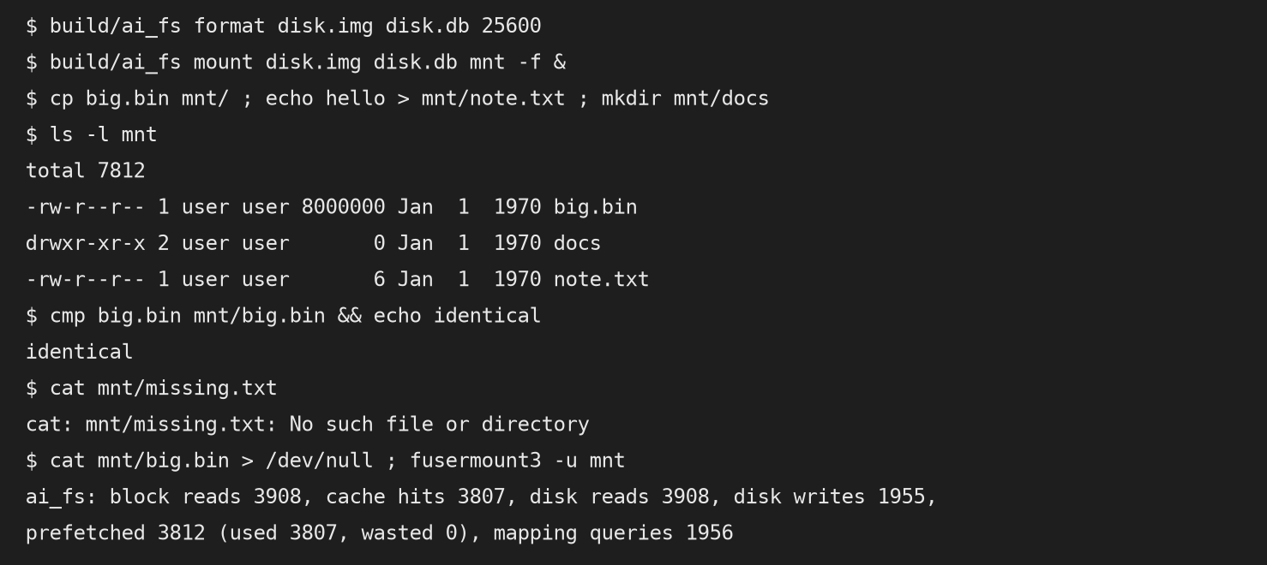
Figure 4.1: The mounted filesystem used with ordinary commands (paths shortened)
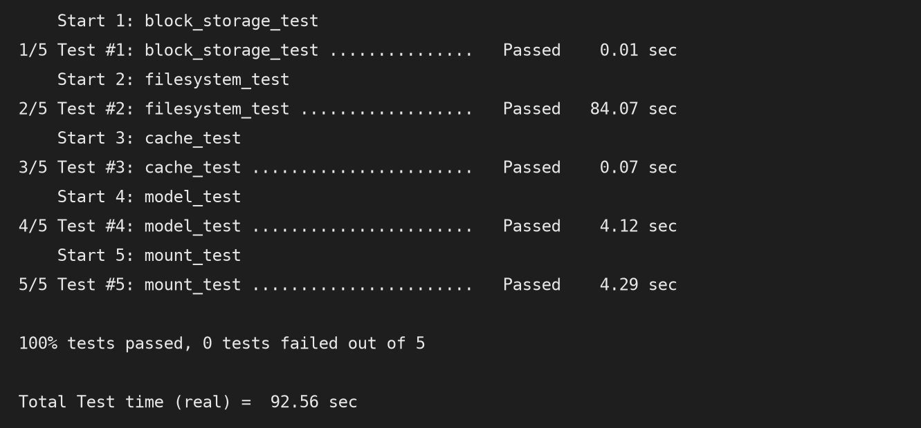
Figure 4.2: Output of the test suites
Figure 4.1 shows a session on the mounted filesystem: a file is copied in and compared byte for byte, a missing file gives the usual error, and on unmount the filesystem reports that 3,812 blocks were prefetched, 3,807 of them were used and none was wasted. Figure 4.2 shows the five test suites passing. There are 57 test cases in C++ and 11 in Python; the filesystem tests are run once for each of the three versions, and one of them performs 600 random operations and compares every byte with a copy held in memory.

4.2.2 Read latency
Table 4.2: Average read latency in microseconds (median of 3 runs)
Workload | Think 0: A | B | C | Think 200: A | B | C
sequential | 148 | 116 | 87 | 414 | 81 | 76
random | 329 | 321 | 282 | 543 | 547 | 469
repetitive | 347 | 195 | 125 | 524 | 178 | 139
mixed | 252 | 275 | 212 | 497 | 333 | 351

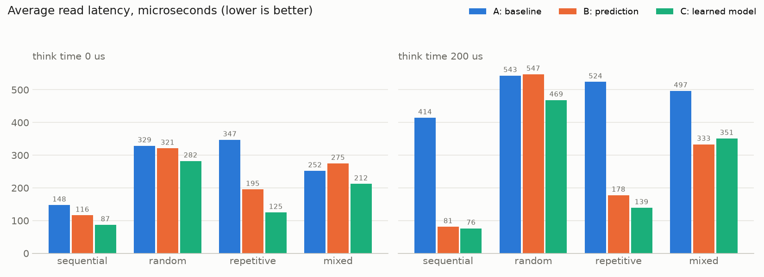
Figure 4.3: Average read latency of the three versions
Table 4.2 and Figure 4.3 give the main result. With reads back to back, version C is fastest on all four workloads.

4.2.3 Prediction quality
Table 4.3: Prefetching with no think time
Workload | Reads served from prefetch: B | C | Wasted prefetches: B | C
sequential | 99.7% | 99.6% | 0 | 0
random | 1.1% | 0% | 2,047 | 0
repetitive | 76.8% | 82.5% | 169 | 0
mixed | 42.1% | 23.6% | 1,510 | 422

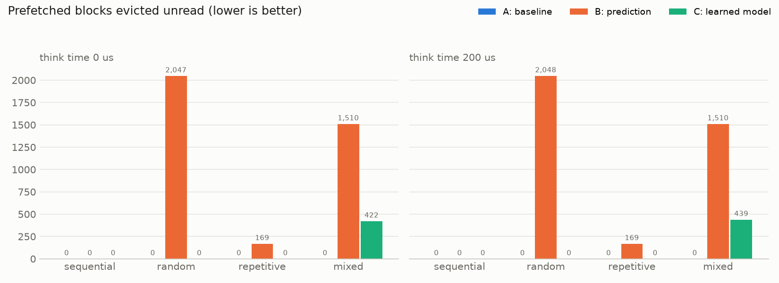
Figure 4.4: Prefetched blocks that were never used
Table 4.3 and Figure 4.4 show how good the predictions are. The tree’s own accuracy figure, the running share of reads that were its first guess, ended at 1.00 on sequential and repetitive reads, 0.35 on mixed and 0 on random.

4.2.4 The learned memory split
Table 4.4: Block-mapping queries per run with no think time, and where the split ended
Workload | A (fixed 90/10) | C (learned) | Final share for file data in the 3 runs
sequential | 8,192 | 287 | 95%, 95%, 50%
random | 5,313 | 4,725 | 50%, 50%, 50%
repetitive | 559 | 559 | 50%, 50%, 50%
mixed | 4,660 | 2,443 | 50%, 50%, 50%

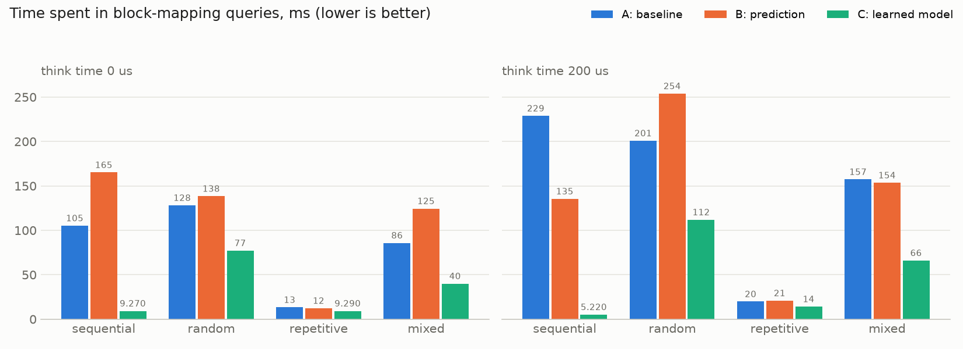
Figure 4.5: Time spent in block-mapping queries
Table 4.4 and Figure 4.5 show the effect on the metadata index. The large drop on sequential reads comes from loading 32 mappings in one query when a predicted block is looked up, which is fixed code and not learned. On random and mixed reads the saving also comes from the learned split.

4.3 Performance Metrics
Table 4.5: Metrics measured in every run
Metric | Meaning
Read and write latency | Average, median and 99th percentile time of one operation
Throughput | Operations per second of time spent inside the filesystem
Cache hit rate | Share of block reads found in the block cache
Prefetch precision | Share of prefetched blocks that were read before being evicted
Reads served by prefetch | Share of block reads that found a prefetched block
Wasted prefetches | Prefetched blocks evicted without being read
Disk I/O | Blocks read from and written to the image
Memory | Bytes held by the two caches at the end of the run
Metadata-index overhead | Number of block-mapping queries sent to SQLite and the time spent in them
Model accuracy | Running share of reads that were the tree’s first guess

Throughput with no think time was 6,776, 8,601 and 11,479 operations per second for versions A, B and C on the sequential workload, and 2,882, 5,116 and 7,996 on the repetitive workload.

4.4 Analysis
• Sequential and repetitive reads. C reduces read latency by 41% and 64% against no prediction, and by 25% and 36% against the hand-written predictor. It predicts four blocks ahead where B predicts two, so more prefetches finish before the block is needed. On the repeating order it also predicts more reads than B, because the two jumps given to the tree let it tell apart blocks that have more than one possible follower.
• Random reads. C made no predictions, because no leaf of the tree was pure, while B wasted about 2,050 prefetches per run and read 28% more blocks from the image. C’s lower latency on this workload cannot be credited to prediction; timings on the test machine shift with what else is running, and this row should be read as no reliable difference.
• Mixed workload. This is the model’s weak case. The pattern changes every 512 operations and the tree learns a new pattern only at its next training and only after seeing it twice. It served 24% of reads from prefetch against B’s 42%. It was still faster than B with no think time (212 against 275 microseconds) because it issued far fewer wrong prefetches, but slower with 200 microseconds of think time (351 against 333).
• Memory split. The model learned to give the mapping cache more memory when reads are scattered, cutting mapping queries by 11% on random and 48% on mixed reads against version A. The price was a lower block-cache hit rate on random reads (4.2% against 5.6%). Timed side by side over 12 runs each, read latency with and without the split differed by 1 to 2 microseconds, inside the spread between runs. On the repetitive workload, where neither cache was short of memory, the split drifted to 50% and left about 400 KiB of the budget unused; this is a weakness of the model.
• Where the model runs. In two earlier designs all prediction was done in Python, and sequential latency was 141 microseconds (a small neural network) and 163 (the decision tree), against 87 now. Moving prediction next to the read path mattered more than the choice of model.
• Comparison with existing methods. The results cannot be compared numerically with the papers in Chapter 2, which use different systems and workloads. The comparison made here is with the two baselines built into the same filesystem.
• Limits. Three runs per configuration, one machine, one cache size and synthetic workloads. The settings of the models were chosen by trying a few values on these same workloads. Differences of 10% or less should be read as no difference.

CHAPTER 5: CONCLUSION AND FUTURE WORK

5.1 Conclusion
We built a working Linux filesystem in user space with block storage and SQLite metadata, and three versions of its storage policy. Version C trains two scikit-learn models on the filesystem’s own history while it runs: a decision tree that predicts the next block reads and a linear regression that divides cache memory between file data and block mappings.
• The decision tree learned sequential and repeating access orders from the reads alone and made no predictions on random reads.
• With reads back to back, version C had the lowest read latency on all four workloads, 41% and 64% below no prediction on sequential and repetitive reads.
• It wasted far fewer prefetches than the hand-written predictor, but predicted fewer reads when the pattern changed often.
• The learned memory split reduced metadata queries on scattered reads but did not change read latency measurably.
• Prediction had to run inside the filesystem to be useful; asking a separate Python process on every read was slower than not predicting at all.

5.2 Future Work
• Retrain sooner when predictions start to miss, to follow changing workloads better.
• Evaluate on traces from real applications and on more than one machine and cache size.
• Save the trained tree with the filesystem so that a remount does not start from the log.
• Learn the parts that are still fixed, such as how many mappings to load per query and how far ahead to prefetch.
• Stop the split model from moving memory when neither cache is short of it.
• For real deployment: journal data blocks for crash consistency, add permissions and timestamps, and allow more than one reader at a time.

REFERENCES
Akgun, Ibrahim Umit, et al. "Improving Storage Systems Using Machine Learning." ACM Transactions on Storage, vol. 19, no. 1, 2023, pp. 1-30.
Al Maruf, Hasan, and Mosharaf Chowdhury. "Effectively Prefetching Remote Memory with Leap." USENIX Annual Technical Conference, 2020, pp. 843-857.
Arpaci-Dusseau, Remzi H., and Andrea C. Arpaci-Dusseau. Operating Systems: Three Easy Pieces. Version 1.10, Arpaci-Dusseau Books, 2023.
Cao, Pei, et al. "A Study of Integrated Prefetching and Caching Strategies." ACM SIGMETRICS Conference on Measurement and Modeling of Computer Systems, 1995, pp. 188-197.
Ding, Xiaoning, et al. "DiskSeen: Exploiting Disk Layout and Access History to Enhance I/O Prefetch." USENIX Annual Technical Conference, 2007.
Gaffney, Kevin P., et al. "SQLite: Past, Present, and Future." Proceedings of the VLDB Endowment, vol. 15, no. 12, 2022, pp. 3535-3547.
Hao, Mingzhe, et al. "LinnOS: Predictability on Unpredictable Flash Storage with a Light Neural Network." USENIX Symposium on Operating Systems Design and Implementation, 2020, pp. 173-190.
Hashemi, Milad, et al. "Learning Memory Access Patterns." International Conference on Machine Learning, Proceedings of Machine Learning Research, vol. 80, 2018, pp. 1919-1928.
Jiang, Song, and Xiaodong Zhang. "LIRS: An Efficient Low Inter-reference Recency Set Replacement Policy to Improve Buffer Cache Performance." ACM SIGMETRICS Conference on Measurement and Modeling of Computer Systems, 2002, pp. 31-42.
Kraska, Tim, et al. "The Case for Learned Index Structures." ACM SIGMOD International Conference on Management of Data, 2018, pp. 489-504.
Li, Zhenmin, et al. "C-Miner: Mining Block Correlations in Storage Systems." USENIX Conference on File and Storage Technologies, 2004.
Liu, Evan Zheran, et al. "An Imitation Learning Approach for Cache Replacement." International Conference on Machine Learning, Proceedings of Machine Learning Research, vol. 119, 2020, pp. 6237-6247.
McKusick, Marshall K., et al. "A Fast File System for UNIX." ACM Transactions on Computer Systems, vol. 2, no. 3, 1984, pp. 181-197.
Megiddo, Nimrod, and Dharmendra S. Modha. "ARC: A Self-Tuning, Low Overhead Replacement Cache." USENIX Conference on File and Storage Technologies, 2003, pp. 115-130.
Olson, Michael A. "The Design and Implementation of the Inversion File System." USENIX Winter 1993 Conference, 1993, pp. 205-218.
O’Neil, Elizabeth J., et al. "The LRU-K Page Replacement Algorithm for Database Disk Buffering." ACM SIGMOD International Conference on Management of Data, 1993, pp. 297-306.
Patterson, R. Hugo, et al. "Informed Prefetching and Caching." ACM Symposium on Operating Systems Principles, 1995, pp. 79-95.
Pedregosa, Fabian, et al. "Scikit-learn: Machine Learning in Python." Journal of Machine Learning Research, vol. 12, no. 85, 2011, pp. 2825-2830.
Rosenblum, Mendel, and John K. Ousterhout. "The Design and Implementation of a Log-Structured File System." ACM Transactions on Computer Systems, vol. 10, no. 1, 1992, pp. 26-52.
Shi, Zhan, et al. "Applying Deep Learning to the Cache Replacement Problem." IEEE/ACM International Symposium on Microarchitecture, 2019, pp. 413-425.
Silberschatz, Abraham, et al. Operating System Concepts. 10th ed., Wiley, 2018.
Song, Zhenyu, et al. "Learning Relaxed Belady for Content Distribution Network Caching." USENIX Symposium on Networked Systems Design and Implementation, 2020, pp. 529-544.
Vangoor, Bharath Kumar Reddy, et al. "To FUSE or Not to FUSE: Performance of User-Space File Systems." USENIX Conference on File and Storage Technologies, 2017, pp. 59-72.
Wu, Fengguang, et al. "On the Design of a New Linux Readahead Framework." ACM SIGOPS Operating Systems Review, vol. 42, no. 5, 2008, pp. 75-84.

