

School of Computer Science Engineering and Information Systems
Department of Information Technology
Fall 2026-27
Operating Systems Lab BITE303P
PROJECT DESIGN AND PROGRESS REPORT (REVIEW I)
AI-Enhanced Database-Backed Filesystem with Adaptive Storage Optimization

Submitted by
Harshit Choudhary 24BIT0237
Shravya Jain 24BIT0231
Arnav Aditya 24BIT0213

Under the Guidance of
Dr. G.N. VIVEKANANDA
Associate Professor, SCORE
VIT, Vellore.

Fall 2026-27

TABLE OF CONTENTS
S.No. | Contents | Page No.
1 | 1. System Architecture | 2
2 | 2. Module Design | 3
3 | 3. Algorithms and Flowcharts | 4
4 | 4. Database Design | 5
5 | 5. Implementation Progress | 6
6 | 6. Screenshots | 6
7 | 7. Challenges Faced | 8
8 | 8. Module Division among Team Members | 8
9 | References | 9
This report describes the design of the system and the state of the implementation at the first milestone of the project: the repository at commit 0c39aef (12 October 2026), at which the storage and metadata layers were complete and tested and the remaining layers were designed but not yet built.

1. SYSTEM ARCHITECTURE
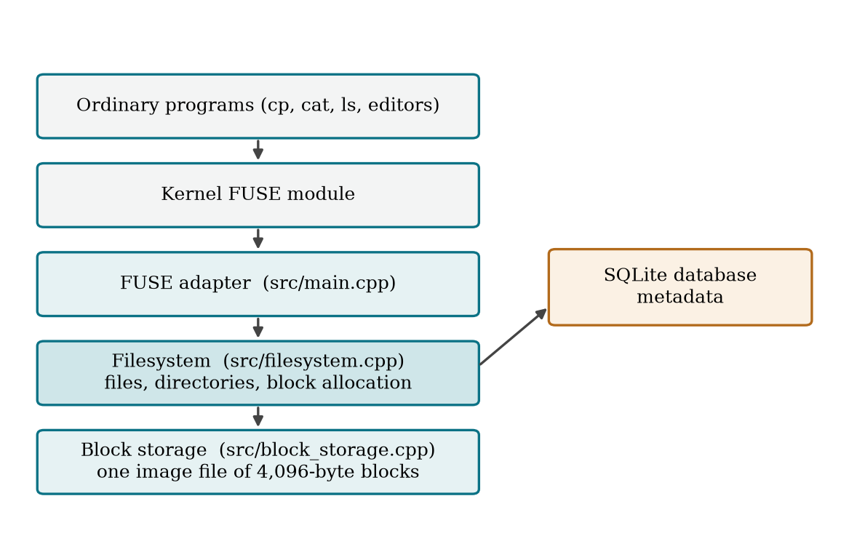
Figure 1.1: Architecture of the filesystem at the first milestone
Figure 1.1 shows the layered design. Storage and metadata are built first as a library; FUSE is added on top as a thin adapter, so that the same code is used by the tests and by the mounted filesystem. File data lives in one preallocated image file of fixed 4,096-byte blocks, and everything else lives in SQLite, which was chosen because it gives transactions in a single file (Gaffney et al.). Keeping metadata in a database follows the approach of the Inversion file system (Olson), and running the filesystem as a user program follows FUSE (Vangoor et al.).
The layers still to be built at this point sit between the two that exist and above them: a block cache between the filesystem and the storage, access monitoring and prediction inside the filesystem, and the FUSE adapter on top.

2. MODULE DESIGN
Table 1.1: Modules and their status at the first milestone
Module | Responsibility | Status
Block storage | Create and open an image file; read and write whole blocks by number; optional O_DIRECT mode | Done, tested
Metadata (SQLite) | Tables for inodes, block mappings and free blocks; transactions | Done, tested
Block allocation | Take the lowest free block; return blocks on delete | Done, tested
Files and directories | Create, list, stat, read, write and remove, as a library | Done, tested
FUSE adapter | Mount the library so that ordinary programs can use it | Designed
Access monitoring | Log every block read and write | Designed
Block cache and mapping cache | LRU caches in one memory budget (Version A) | Designed
Prediction and prefetching | Predict the next blocks and load them early (Version B) | Designed
Adaptive policy and evaluation | Feedback, adaptive cache and index, workload generator (Version C) | Planned

3. ALGORITHMS AND FLOWCHARTS
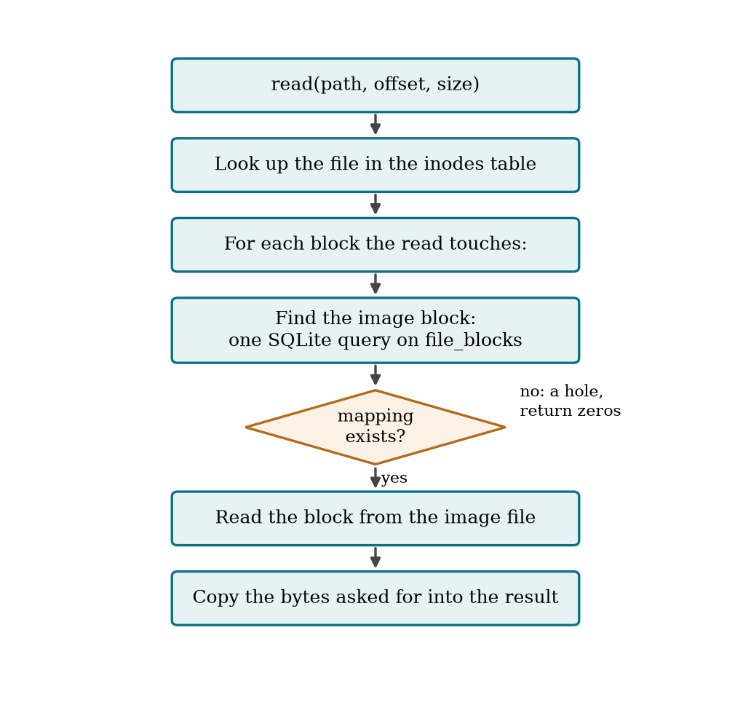
Figure 1.2: Flowchart of a read at the first milestone
Figure 1.2 shows how a read is served. The file is found by walking the path through the inodes table. For each block the read touches, one query on file_blocks gives the image block that holds it. A block with no mapping is a hole and reads as zeros.

3.1 Writing
write(path, offset, data):
begin a SQLite transaction
for each block the write touches:
if the block has no mapping:
take the lowest block from free_blocks and record the mapping
start from a block of zeros
else if the write covers only part of the block:
read the existing block
copy the new bytes in and write the block to the image
if the file grew, update its size in inodes
commit; on any failure roll back, so the metadata is unchanged

3.2 Deleting
remove(path):
refuse if it is a directory that still has entries
begin a transaction
move the file's blocks from file_blocks back to free_blocks
delete its row from inodes
commit

3.3 Planned: caching and prediction
The cache will use least-recently-used replacement, the same idea as LRU page replacement (Silberschatz et al.). For prediction, the plan is to record accesses and predict the next blocks with a lightweight model, starting with simple detectors of sequential and repeating access, of the kind used by Linux read-ahead (Wu et al.) and by correlation mining (Li et al.), and then to compare a learned model against them (Hashemi et al.; Akgun et al.).

4. DATABASE DESIGN
Table 1.2: SQLite tables at the first milestone
Table | Columns | Purpose
inodes | id (primary key), parent, name, is_dir, size; (parent, name) unique | One row per file or directory; the root has id 1
file_blocks | inode, idx, block (unique); primary key (inode, idx) | Which image block holds block idx of a file; a missing row is a hole
free_blocks | block (primary key) | Blocks not yet allocated

Two more tables are planned: an access log of every block read and write, to be used for prediction, and a log of policy feedback.

5. IMPLEMENTATION PROGRESS
Four of the nine modules in Table 1.1 were complete and tested at this milestone. The source was 1,030 lines of C++ in src, include and tests. The foundation, that is storage, metadata, allocation and file operations, works as a library; the mount, the caches and the learning parts were still to come.
Table 1.3: Tests passing at the first milestone
Test suite | What it covers
block_storage_test | Creating and opening images, rejecting bad images, reading and writing blocks, blocks out of range, data surviving a reopen, O_DIRECT mode
filesystem_test (18 cases) | Formatting, creating files and directories, bad paths, reads and writes across block boundaries, holes, overwrites, freeing and reusing blocks, a failed write leaving metadata unchanged, contents surviving a reopen

6. SCREENSHOTS
The figures below are the output of the code at commit 0c39aef, built and run again for this report.
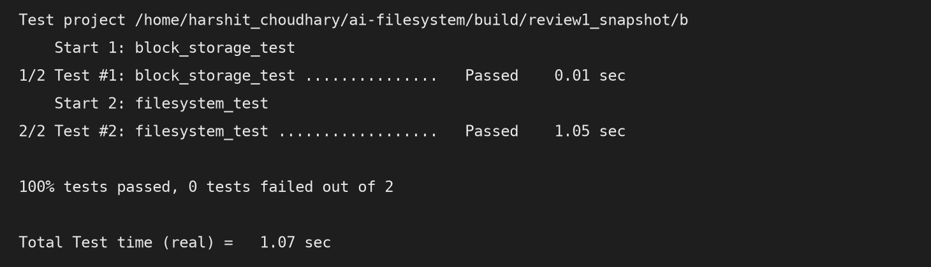
Figure 1.3: Both test suites passing at the first milestone
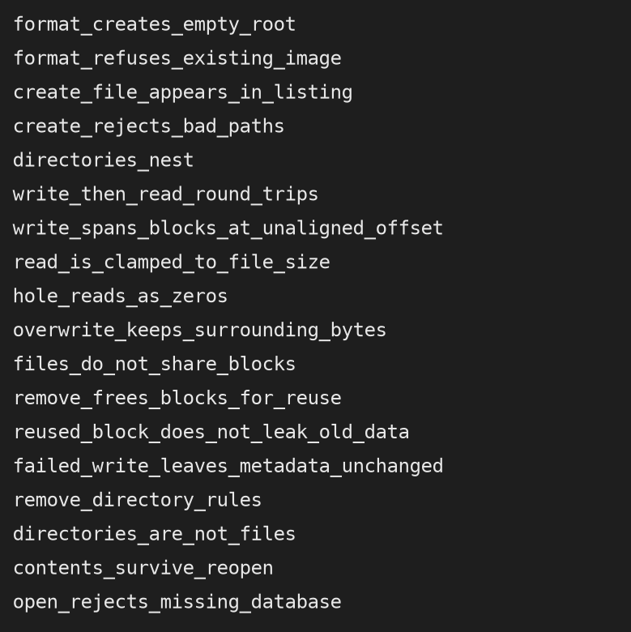
Figure 1.4: The filesystem test cases as they run

7. CHALLENGES FACED
• Direct I/O. Opening the image with O_DIRECT bypasses the kernel’s page cache, which is needed so that our own cache is the only one measured, but it requires buffers aligned to the block size and is not available on every filesystem. It was made an optional mode, and a test checks that direct and buffered access see the same data.
• Keeping metadata and data consistent. A write that runs out of space part-way must not leave a file whose size or mappings are wrong. Every write runs in one SQLite transaction, and a test fills the image and checks that the metadata is unchanged after the failure.
• Reused blocks. A block freed by one file and given to another still holds the old file’s bytes. A newly allocated block is therefore started from zeros, and a test checks that old data cannot be read through a new file.
• Holes. A file can be written at a high offset without the blocks before it existing. Such blocks have no mapping and must read as zeros without being allocated.
• Testing without mounting. Building the storage and metadata as a library first made it possible to test every operation directly, before any FUSE code existed.

8. MODULE DIVISION AMONG TEAM MEMBERS
Table 1.4: Module division among team members
Team member | Register number | Responsibility
Harshit Choudhary | 24BIT0237 | [to be filled in by the team]
Shravya Jain | 24BIT0231 | [to be filled in by the team]
Arnav Aditya | 24BIT0213 | [to be filled in by the team]

REFERENCES
Akgun, Ibrahim Umit, et al. "Improving Storage Systems Using Machine Learning." ACM Transactions on Storage, vol. 19, no. 1, 2023, pp. 1-30.
Gaffney, Kevin P., et al. "SQLite: Past, Present, and Future." Proceedings of the VLDB Endowment, vol. 15, no. 12, 2022, pp. 3535-3547.
Hashemi, Milad, et al. "Learning Memory Access Patterns." International Conference on Machine Learning, Proceedings of Machine Learning Research, vol. 80, 2018, pp. 1919-1928.
Li, Zhenmin, et al. "C-Miner: Mining Block Correlations in Storage Systems." USENIX Conference on File and Storage Technologies, 2004.
Olson, Michael A. "The Design and Implementation of the Inversion File System." USENIX Winter 1993 Conference, 1993, pp. 205-218.
Silberschatz, Abraham, et al. Operating System Concepts. 10th ed., Wiley, 2018.
Vangoor, Bharath Kumar Reddy, et al. "To FUSE or Not to FUSE: Performance of User-Space File Systems." USENIX Conference on File and Storage Technologies, 2017, pp. 59-72.
Wu, Fengguang, et al. "On the Design of a New Linux Readahead Framework." ACM SIGOPS Operating Systems Review, vol. 42, no. 5, 2008, pp. 75-84.

