**GPT4能力测试**

#### 项目地址：<https://github.com/abi/screenshot-to-code>

GPT4作为基座，dalle3作为生图工具

**效果测试：**

**google首页**

**原始图片**

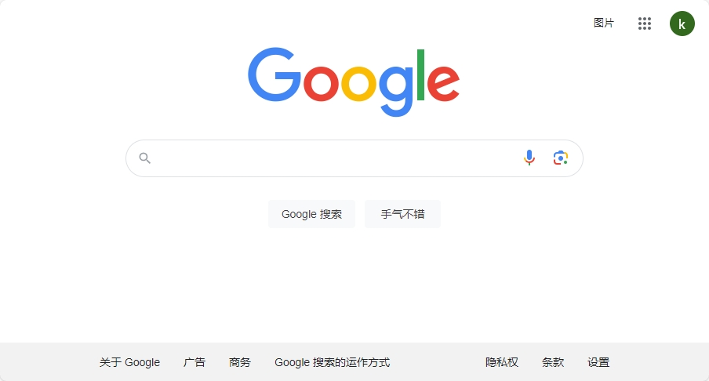

**转换效果**

**Desktop**

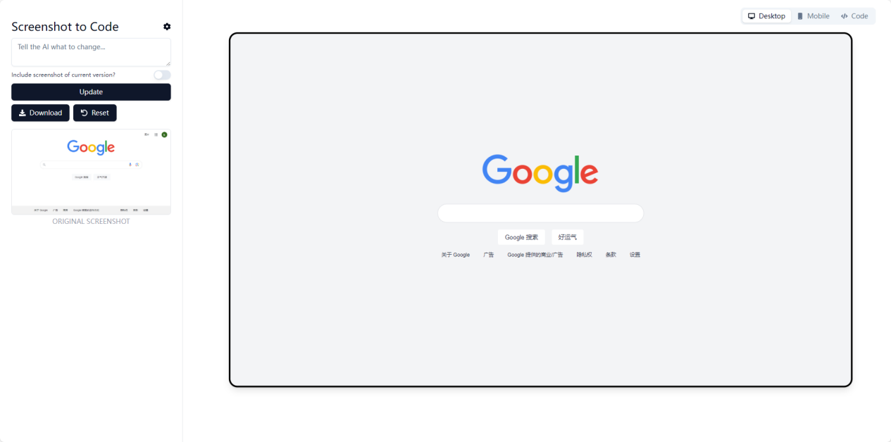

**Mobile**

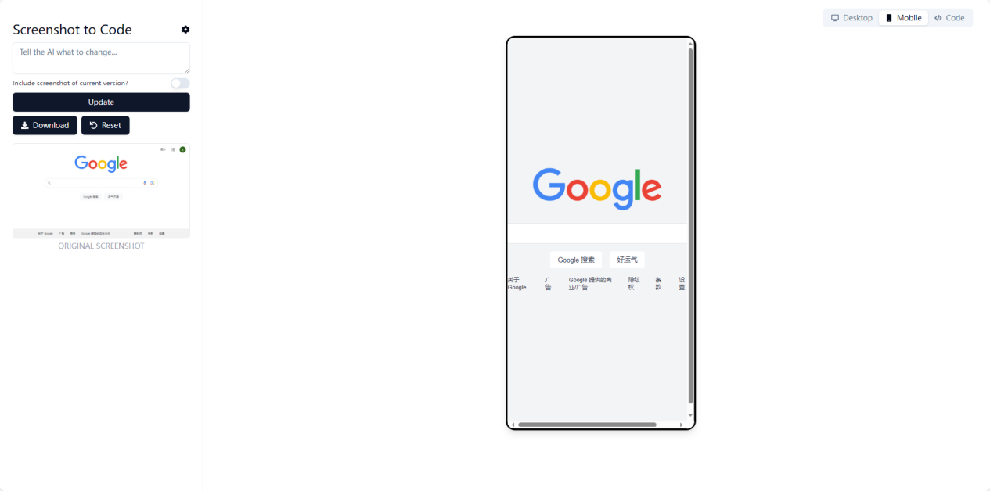

**Code**

|  |
| --- |
| HTML <html lang="zh"> <head>  <meta charset="UTF-8">  <meta name="viewport" content="width=device-width, initial-scale=1.0">  <title>Google</title>  <script src="https://cdn.tailwindcss.com"></script>  <style>  body {  font-family: 'Arial', sans-serif;  }  #searchBar {  width: 482px;  height: 44px;  border: 1px solid #dfe1e5;  box-shadow: none;  border-radius: 24px;  margin: 0 auto;  padding: 0 20px;  }  #searchBar:focus {  outline: none;  box-shadow: 0 1px 6px rgb(32 33 36 / 28%);  border-color: rgba(223,225,229,0);  }  .searchIcon {  color: #9aa0a6;  position: absolute;  top: 11px;  left: 20px;  }  .micIcon {  color: #9aa0a6;  position: absolute;  top: 11px;  right: 20px;  }  </style> </head> <body class="bg-gray-100">  <div class="flex flex-col items-center justify-center h-screen">  <div class="mb-6">  <img src="https://www.google.com/images/branding/googlelogo/2x/googlelogo_color_272x92dp.png" alt="Google logo" width="272" height="92">  </div>  <div class="relative mb-4">  <input id="searchBar" type="text" class="pl-10 pr-10 w-full">  <i class="fas fa-search searchIcon"></i>  <i class="fas fa-microphone micIcon"></i>  </div>  <div class="flex space-x-4 mb-4">  <button class="bg-white text-sm text-gray-700 font-normal py-2 px-4 rounded focus:outline-none hover:shadow-md">Google 搜索</button>  <button class="bg-white text-sm text-gray-700 font-normal py-2 px-4 rounded focus:outline-none hover:shadow-md">好运气</button>  </div>  <div class="flex justify-center space-x-8 text-xs text-gray-700 mb-4">  <a href="#" class="hover:underline">关于 Google</a>  <a href="#" class="hover:underline">广告</a>  <a href="#" class="hover:underline">Google 提供的商业/广告</a>  <a href="#" class="hover:underline">隐私权</a>  <a href="#" class="hover:underline">条款</a>  <a href="#" class="hover:underline">设置</a>  </div>  </div> </body> </html> |

**问题**

* 右上角的几个元素并没有呈现，搜索、语音、相机标签没有
* 下面的（关于google等）位置不正确
* 背景色不对，准确来说，除了网上拉取的google图标图片颜色正确，其他颜色都不对

**b站首页**

**原始图片**

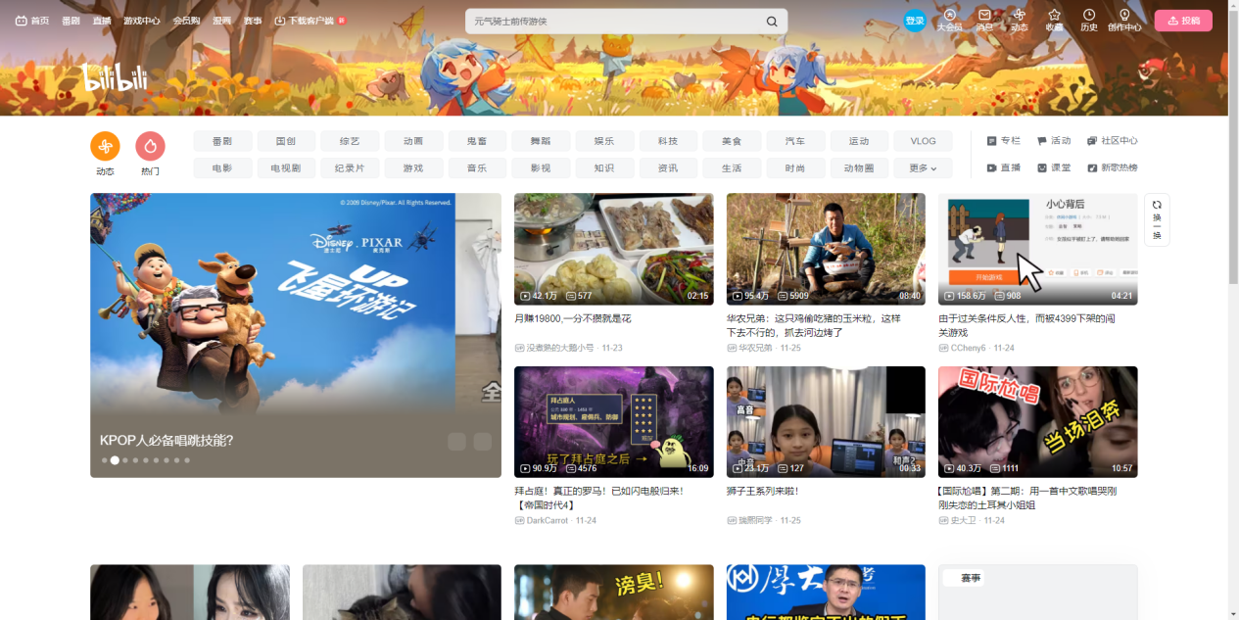

**Desktop**

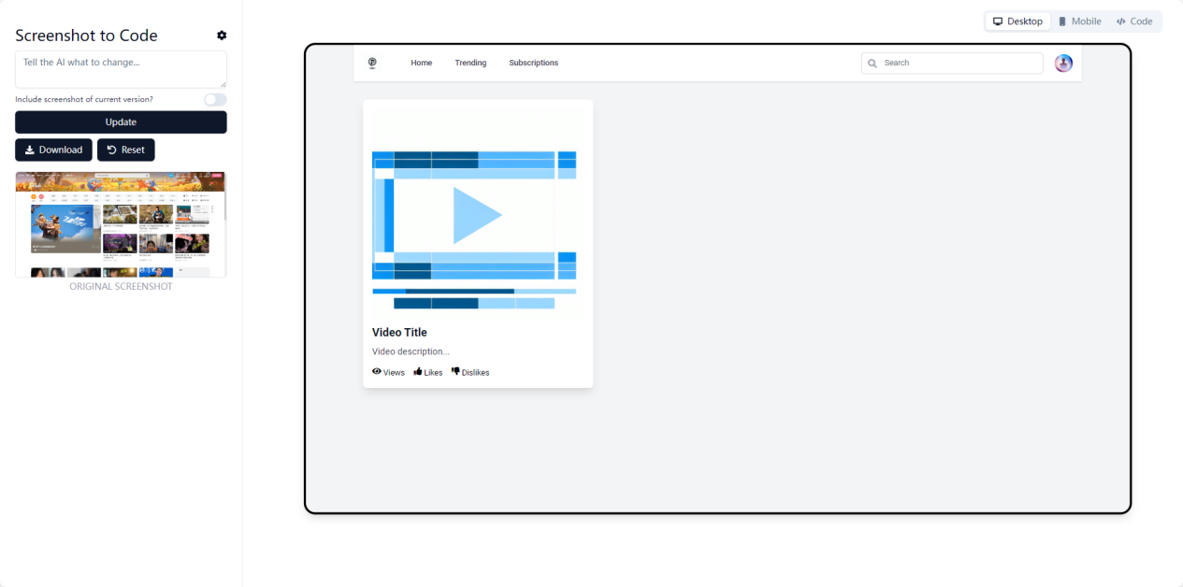

**Mobile**

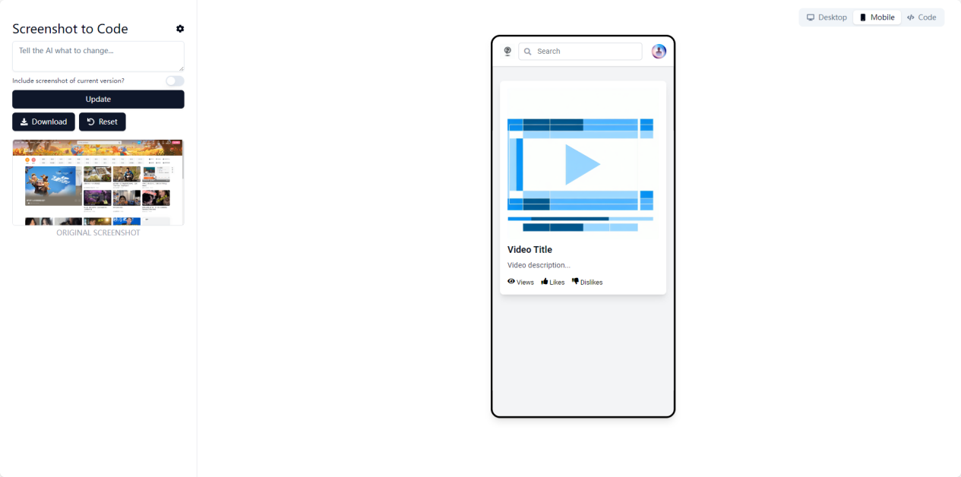

**Code**

|  |
| --- |
| HTML <html lang="en">  <head>  <meta charset="utf-8"/>  <meta content="width=device-width, initial-scale=1.0" name="viewport"/>  <title>  Video Platform  </title>  <script src="https://cdn.tailwindcss.com">  </script>  <link href="https://fonts.googleapis.com/css2?family=Roboto:wght@400;500;700&amp;display=swap" rel="stylesheet"/>  <link href="https://cdnjs.cloudflare.com/ajax/libs/font-awesome/5.15.3/css/all.min.css" rel="stylesheet"/>  <style>  body {  font-family: 'Roboto', sans-serif;  }  </style>  </head>  <body class="bg-gray-100">  <div class="container mx-auto">  <!-- Header -->  <header class="bg-white shadow">  <div class="flex items-center justify-between h-16 px-4">  <!-- Logo and search bar -->  <div class="flex items-center">  <div class="flex-shrink-0">  <img alt="Logo placeholder" class="h-8 w-8" height="32" src="https://oaidalleapiprodscus.blob.core.windows.net/private/org-vm2q5YZLrXYBZ2jXWL9dWms1/user-4egTlY0bRoZpBpKGLYSYLflY/img-rMh5aDRyahniZfGiGlW2b96y.png?st=2023-11-28T10%3A48%3A48Z&amp;se=2023-11-28T12%3A48%3A48Z&amp;sp=r&amp;sv=2021-08-06&amp;sr=b&amp;rscd=inline&amp;rsct=image/png&amp;skoid=6aaadede-4fb3-4698-a8f6-684d7786b067&amp;sktid=a48cca56-e6da-484e-a814-9c849652bcb3&amp;skt=2023-11-28T08%3A10%3A14Z&amp;ske=2023-11-29T08%3A10%3A14Z&amp;sks=b&amp;skv=2021-08-06&amp;sig=DvfSs8PlYSGe80oE/OuMGeU8e3yREsDCojVYCTjQktI%3D" width="32"/>  </div>  <div class="hidden md:block">  <div class="ml-10 flex items-baseline space-x-4">  <!-- Navigation Links -->  <a class="text-gray-700 px-3 py-2 rounded-md text-sm font-medium" href="#">  Home  </a>  <a class="text-gray-700 px-3 py-2 rounded-md text-sm font-medium" href="#">  Trending  </a>  <a class="text-gray-700 px-3 py-2 rounded-md text-sm font-medium" href="#">  Subscriptions  </a>  <!-- More items... -->  </div>  </div>  </div>  <div class="flex-1 flex justify-center px-2 lg:ml-6 lg:justify-end">  <div class="max-w-lg w-full lg:max-w-xs">  <label class="sr-only" for="search">  Search  </label>  <div class="relative">  <div class="absolute inset-y-0 left-0 pl-3 flex items-center pointer-events-none">  <i class="fas fa-search text-gray-400">  </i>  </div>  <input class="block w-full pl-10 pr-3 py-2 border border-gray-300 rounded-md leading-5 bg-white placeholder-gray-500 focus:outline-none focus:placeholder-gray-400 focus:border-blue-300 focus:shadow-outline-blue sm:text-sm" id="search" placeholder="Search" type="search"/>  </div>  </div>  </div>  <!-- Profile dropdown -->  <div class="ml-3 relative">  <div>  <button class="max-w-xs flex items-center text-sm rounded-full text-white focus:outline-none focus:shadow-solid">  <img alt="User profile placeholder" class="h-8 w-8 rounded-full" height="32" src="https://oaidalleapiprodscus.blob.core.windows.net/private/org-vm2q5YZLrXYBZ2jXWL9dWms1/user-4egTlY0bRoZpBpKGLYSYLflY/img-tdnDr0XqfBjALPcv1p60L5cC.png?st=2023-11-28T10%3A48%3A45Z&amp;se=2023-11-28T12%3A48%3A45Z&amp;sp=r&amp;sv=2021-08-06&amp;sr=b&amp;rscd=inline&amp;rsct=image/png&amp;skoid=6aaadede-4fb3-4698-a8f6-684d7786b067&amp;sktid=a48cca56-e6da-484e-a814-9c849652bcb3&amp;skt=2023-11-27T17%3A18%3A29Z&amp;ske=2023-11-28T17%3A18%3A29Z&amp;sks=b&amp;skv=2021-08-06&amp;sig=rBc8BO00HSlmpFYEfXFmpIR8DoquNIE4b2IIkfquPOA%3D" width="32"/>  </button>  </div>  </div>  </div>  </header>  <!-- Main content -->  <main class="mt-8">  <div class="grid grid-cols-1 md:grid-cols-2 lg:grid-cols-3 gap-4 px-4">  <!-- Video cards -->  <!-- Repeat for each video card -->  <div class="bg-white p-4 rounded-lg shadow-lg">  <img alt="Video thumbnail placeholder" class="rounded w-full" height="168" src="https://oaidalleapiprodscus.blob.core.windows.net/private/org-vm2q5YZLrXYBZ2jXWL9dWms1/user-4egTlY0bRoZpBpKGLYSYLflY/img-xZJqocexxhvCkYKblZkUVC2O.png?st=2023-11-28T10%3A48%3A45Z&amp;se=2023-11-28T12%3A48%3A45Z&amp;sp=r&amp;sv=2021-08-06&amp;sr=b&amp;rscd=inline&amp;rsct=image/png&amp;skoid=6aaadede-4fb3-4698-a8f6-684d7786b067&amp;sktid=a48cca56-e6da-484e-a814-9c849652bcb3&amp;skt=2023-11-28T02%3A51%3A53Z&amp;ske=2023-11-29T02%3A51%3A53Z&amp;sks=b&amp;skv=2021-08-06&amp;sig=seo/UKWeF2DvB4ziAndMTSSSAS6X6H1dr4aaX9WxpaQ%3D" width="300"/>  <div class="mt-2">  <div class="text-gray-900 font-bold text-xl mb-2">  Video Title  </div>  <p class="text-gray-700 text-base">  Video description...  </p>  </div>  <div class="mt-4 flex items-center">  <div class="flex text-sm">  <i class="fas fa-eye mr-1">  </i>  <p>  Views  </p>  </div>  <div class="flex text-sm ml-4">  <i class="fas fa-thumbs-up mr-1">  </i>  <p>  Likes  </p>  </div>  <div class="flex text-sm ml-4">  <i class="fas fa-thumbs-down mr-1">  </i>  <p>  Dislikes  </p>  </div>  </div>  </div>  <!-- ... other video cards ... -->  </div>  </main>  </div>  </body> </html> |

**问题**

* 元素不齐
* 性能羸弱

**知乎热搜页**

**原始图片**

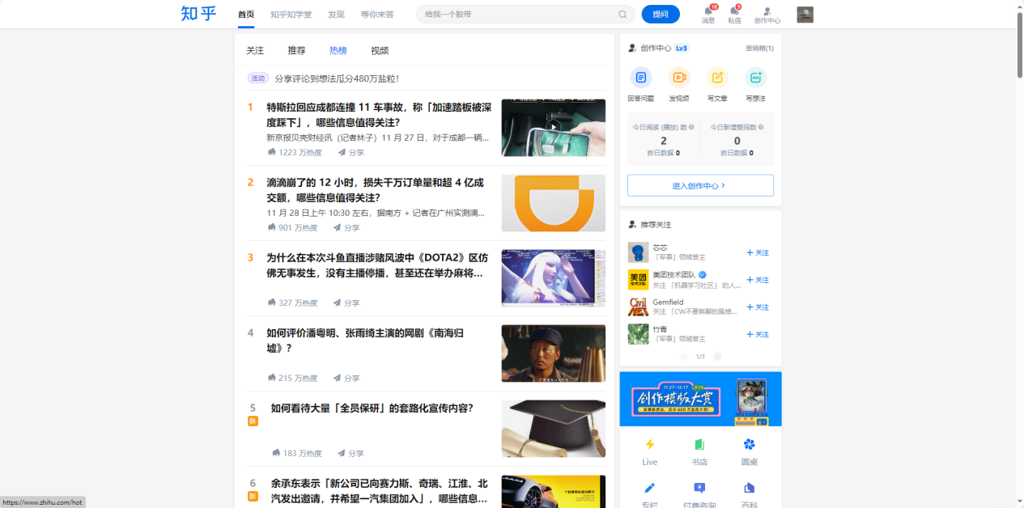

**Desktop**

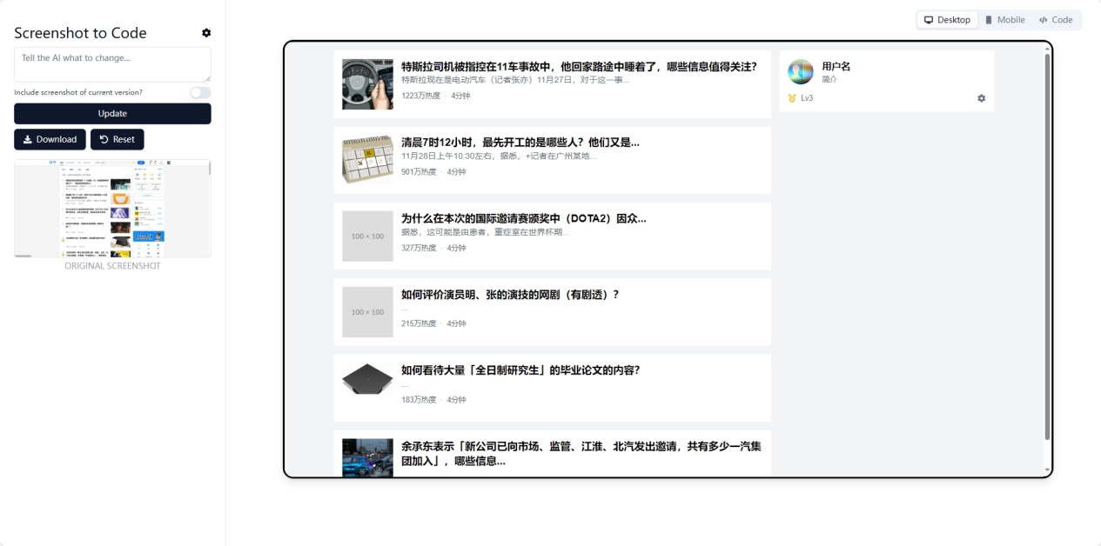

**Mobile**

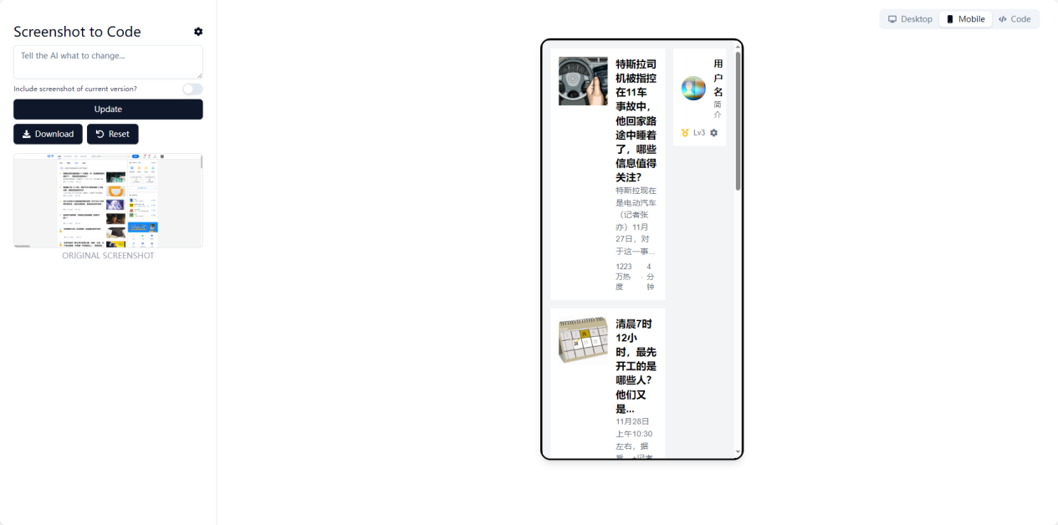

**Code**

|  |
| --- |
| HTML <html lang="zh-Hans">  <head>  <meta charset="utf-8"/>  <meta content="width=device-width, initial-scale=1.0" name="viewport"/>  <title>  Web Page  </title>  <script src="https://cdn.tailwindcss.com">  </script>  <link href="https://cdnjs.cloudflare.com/ajax/libs/font-awesome/5.15.3/css/all.min.css" rel="stylesheet"/>  <style>  body {  font-family: 'PingFang SC', 'Helvetica Neue', 'Helvetica', 'Arial', sans-serif;  }  </style>  </head>  <body class="bg-gray-100">  <div class="container mx-auto px-4">  <div class="grid grid-cols-3 gap-4">  <!-- Left Column -->  <div class="col-span-2">  <!-- News Item 1 -->  <div class="flex items-start space-x-4 p-4 bg-white mt-4">  <div class="flex-shrink-0">  <img alt="Placeholder image of a car dashboard with a hand holding a smartphone" class="w-24 h-24" height="100" src="https://oaidalleapiprodscus.blob.core.windows.net/private/org-vm2q5YZLrXYBZ2jXWL9dWms1/user-4egTlY0bRoZpBpKGLYSYLflY/img-cLgwdiFsIZoz6e4QDDXzCwRM.png?st=2023-11-28T11%3A01%3A20Z&amp;se=2023-11-28T13%3A01%3A20Z&amp;sp=r&amp;sv=2021-08-06&amp;sr=b&amp;rscd=inline&amp;rsct=image/png&amp;skoid=6aaadede-4fb3-4698-a8f6-684d7786b067&amp;sktid=a48cca56-e6da-484e-a814-9c849652bcb3&amp;skt=2023-11-28T05%3A34%3A42Z&amp;ske=2023-11-29T05%3A34%3A42Z&amp;sks=b&amp;skv=2021-08-06&amp;sig=pJQHR%2BfqIp8l7rc94ATrOX9RYn2cCB5NUhVvKkbhLcM%3D" width="100"/>  </div>  <div class="flex-grow">  <h2 class="text-xl font-semibold">  特斯拉司机被指控在11车事故中，他回家路途中睡着了，哪些信息值得关注？  </h2>  <p class="text-gray-500">  特斯拉现在是电动汽车（记者张亦）11月27日，对于这一事...  </p>  <div class="flex items-center text-gray-500 text-sm mt-2">  <span>  1223万热度  </span>  <span class="mx-2">  ·  </span>  <span>  4分钟  </span>  </div>  </div>  </div>  <!-- News Item 2 -->  <div class="flex items-start space-x-4 p-4 bg-white mt-4">  <div class="flex-shrink-0">  <img alt="Placeholder image of a calendar with the date November 28 marked" class="w-24 h-24" height="100" src="https://oaidalleapiprodscus.blob.core.windows.net/private/org-vm2q5YZLrXYBZ2jXWL9dWms1/user-4egTlY0bRoZpBpKGLYSYLflY/img-79fzIDrBOD9H5ijLut2YBuxq.png?st=2023-11-28T11%3A01%3A16Z&amp;se=2023-11-28T13%3A01%3A16Z&amp;sp=r&amp;sv=2021-08-06&amp;sr=b&amp;rscd=inline&amp;rsct=image/png&amp;skoid=6aaadede-4fb3-4698-a8f6-684d7786b067&amp;sktid=a48cca56-e6da-484e-a814-9c849652bcb3&amp;skt=2023-11-28T01%3A00%3A51Z&amp;ske=2023-11-29T01%3A00%3A51Z&amp;sks=b&amp;skv=2021-08-06&amp;sig=Ow8DgsQ6P8n0yWy9w4oslVh0ChLJLTouNBovStWjbz4%3D" width="100"/>  </div>  <div class="flex-grow">  <h2 class="text-xl font-semibold">  清晨7时12小时，最先开工的是哪些人？他们又是...  </h2>  <p class="text-gray-500">  11月28日上午10:30左右，据悉，+记者在广州某地...  </p>  <div class="flex items-center text-gray-500 text-sm mt-2">  <span>  901万热度  </span>  <span class="mx-2">  ·  </span>  <span>  4分钟  </span>  </div>  </div>  </div>  <!-- News Item 3 -->  <div class="flex items-start space-x-4 p-4 bg-white mt-4">  <div class="flex-shrink-0">  <img alt="Placeholder image of a character from the game DOTA2" class="w-24 h-24" src="https://placehold.co/100x100"/>  </div>  <div class="flex-grow">  <h2 class="text-xl font-semibold">  为什么在本次的国际邀请赛颁奖中（DOTA2）因众...  </h2>  <p class="text-gray-500">  据悉，这可能是由患者，重症室在世界杯期...  </p>  <div class="flex items-center text-gray-500 text-sm mt-2">  <span>  327万热度  </span>  <span class="mx-2">  ·  </span>  <span>  4分钟  </span>  </div>  </div>  </div>  <!-- News Item 4 -->  <div class="flex items-start space-x-4 p-4 bg-white mt-4">  <div class="flex-shrink-0">  <img alt="Placeholder image of a man looking confused" class="w-24 h-24" src="https://placehold.co/100x100"/>  </div>  <div class="flex-grow">  <h2 class="text-xl font-semibold">  如何评价演员明、张的演技的网剧（有剧透）？  </h2>  <p class="text-gray-500">  ...  </p>  <div class="flex items-center text-gray-500 text-sm mt-2">  <span>  215万热度  </span>  <span class="mx-2">  ·  </span>  <span>  4分钟  </span>  </div>  </div>  </div>  <!-- News Item 5 -->  <div class="flex items-start space-x-4 p-4 bg-white mt-4">  <div class="flex-shrink-0">  <img alt="Placeholder image of a graduation cap" class="w-24 h-24" height="100" src="https://oaidalleapiprodscus.blob.core.windows.net/private/org-vm2q5YZLrXYBZ2jXWL9dWms1/user-4egTlY0bRoZpBpKGLYSYLflY/img-uUl0Sunj70T1YyXJUUntTtEC.png?st=2023-11-28T11%3A01%3A21Z&amp;se=2023-11-28T13%3A01%3A21Z&amp;sp=r&amp;sv=2021-08-06&amp;sr=b&amp;rscd=inline&amp;rsct=image/png&amp;skoid=6aaadede-4fb3-4698-a8f6-684d7786b067&amp;sktid=a48cca56-e6da-484e-a814-9c849652bcb3&amp;skt=2023-11-27T15%3A53%3A16Z&amp;ske=2023-11-28T15%3A53%3A16Z&amp;sks=b&amp;skv=2021-08-06&amp;sig=z94rmRu0hR2N/m1IehhqHHeQ02MdbI5rJlXx/YEDCNc%3D" width="100"/>  </div>  <div class="flex-grow">  <h2 class="text-xl font-semibold">  如何看待大量「全日制研究生」的毕业论文的内容？  </h2>  <p class="text-gray-500">  ...  </p>  <div class="flex items-center text-gray-500 text-sm mt-2">  <span>  183万热度  </span>  <span class="mx-2">  ·  </span>  <span>  4分钟  </span>  </div>  </div>  </div>  <!-- News Item 6 -->  <div class="flex items-start space-x-4 p-4 bg-white mt-4">  <div class="flex-shrink-0">  <img alt="Placeholder image of a car accident" class="w-24 h-24" height="100" src="https://oaidalleapiprodscus.blob.core.windows.net/private/org-vm2q5YZLrXYBZ2jXWL9dWms1/user-4egTlY0bRoZpBpKGLYSYLflY/img-FO3WUy06l7EygWtcEjtGT7Wl.png?st=2023-11-28T11%3A01%3A19Z&amp;se=2023-11-28T13%3A01%3A19Z&amp;sp=r&amp;sv=2021-08-06&amp;sr=b&amp;rscd=inline&amp;rsct=image/png&amp;skoid=6aaadede-4fb3-4698-a8f6-684d7786b067&amp;sktid=a48cca56-e6da-484e-a814-9c849652bcb3&amp;skt=2023-11-27T16%3A27%3A56Z&amp;ske=2023-11-28T16%3A27%3A56Z&amp;sks=b&amp;skv=2021-08-06&amp;sig=ndw3DcodP31hpj6CrEOGIentncnhWvmz%2BQYJA4pEVZY%3D" width="100"/>  </div>  <div class="flex-grow">  <h2 class="text-xl font-semibold">  余承东表示「新公司已向市场、监管、江淮、北汽发出邀请，共有多少一汽集团加入」，哪些信息...  </h2>  <p class="text-gray-500">  ...  </p>  <div class="flex items-center text-gray-500 text-sm mt-2">  <span>  ...  </span>  <span class="mx-2">  ·  </span>  <span>  ...  </span>  </div>  </div>  </div>  </div>  <!-- Right Column -->  <div class="col-span-1">  <!-- User Profile -->  <div class="bg-white p-4 mt-4">  <div class="flex items-center space-x-4">  <div class="flex-shrink-0">  <img alt="Placeholder image for user profile" class="rounded-full w-12 h-12" height="50" src="https://oaidalleapiprodscus.blob.core.windows.net/private/org-vm2q5YZLrXYBZ2jXWL9dWms1/user-4egTlY0bRoZpBpKGLYSYLflY/img-bi55ecfL54BeNZUfFSgbBaLA.png?st=2023-11-28T11%3A01%3A18Z&amp;se=2023-11-28T13%3A01%3A18Z&amp;sp=r&amp;sv=2021-08-06&amp;sr=b&amp;rscd=inline&amp;rsct=image/png&amp;skoid=6aaadede-4fb3-4698-a8f6-684d7786b067&amp;sktid=a48cca56-e6da-484e-a814-9c849652bcb3&amp;skt=2023-11-28T09%3A35%3A37Z&amp;ske=2023-11-29T09%3A35%3A37Z&amp;sks=b&amp;skv=2021-08-06&amp;sig=o8Wzl%2BD4FXg0uPipIZMv4sbHXW8HMyuAL/XNjPrsno0%3D" width="50"/>  </div>  <div class="flex-grow">  <h3 class="text-lg font-semibold">  用户名  </h3>  <p class="text-gray-500 text-sm">  简介  </p>  </div>  </div>  <div class="flex items-center justify-between mt-4">  <div class="flex items-center">  <i class="fas fa-medal text-yellow-400">  </i>  <span class="text-gray-500 text-sm ml-2">  Lv3  </span>  </div>  <div class="flex items-center">  <i class="fas fa-cog text-gray-500">  </i>  </div>  </div>  </div>  <!-- Other Widgets -->  <!-- ... -->  </div>  </div>  </div>  </body> </html> |

**总结**

* 元素基本不全，提升空间非常大
* 颜色基本不对，提升也很大
* 文字识别性能比较差，不确定是拉取了网络知识还是OCR能力很弱
* 没有JS函数部分
* 比较抽象的说，能识别出网页目的，视频还是搜索等
* 亮眼的是，能够找到一些网上的公开资源利用，比如Google图片、CSS样式等，而不是手动实现