Translate Zipkin-Log to Shiviz-Log
Step 1 - Setup System
At first you should setup the train ticket system with Zipkin.
- Move all the directory whose name is start with “ts-” to your server.
- Move pom.yml and docker-compose.yml to your server
- Enter the directory where pom.yml is located
- Run the following 3 commands:
mvn clean package
docker-compose build
docker-compose up
- Waiting for the boot of the system.
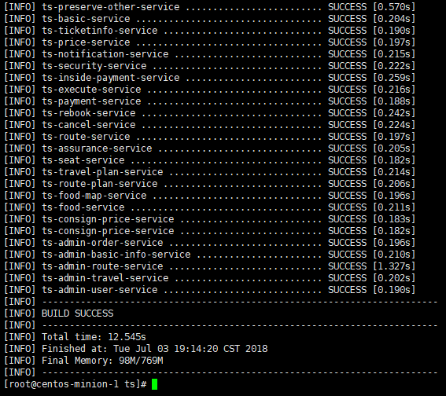
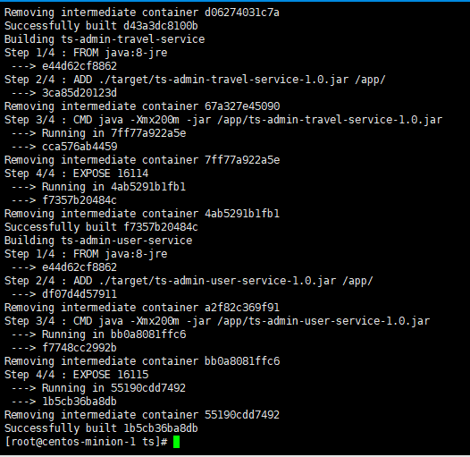
Step 2 - Collect Log in Zipkin
You could do some ticket operation and then collect log from Zipkin listening on port 9411.
In our example, we click FlowOne, then Login, Search for a ticket, and then Select a contacts, confirm a ticket. 10.141.212.21 is my address of train ticket.
After these operation, we visit 10.141.212.21:9411 Zipkin page and click the traces you want to convert. We have an example locates at train_ticket\Json2Shiviz\example\zipkin_log\case1\success\example.json
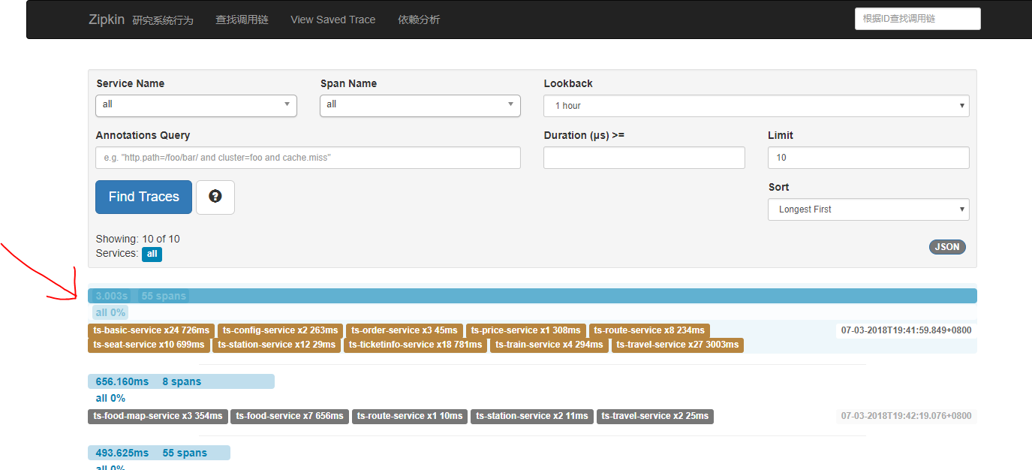
Then download the Zipkin-Trace log.
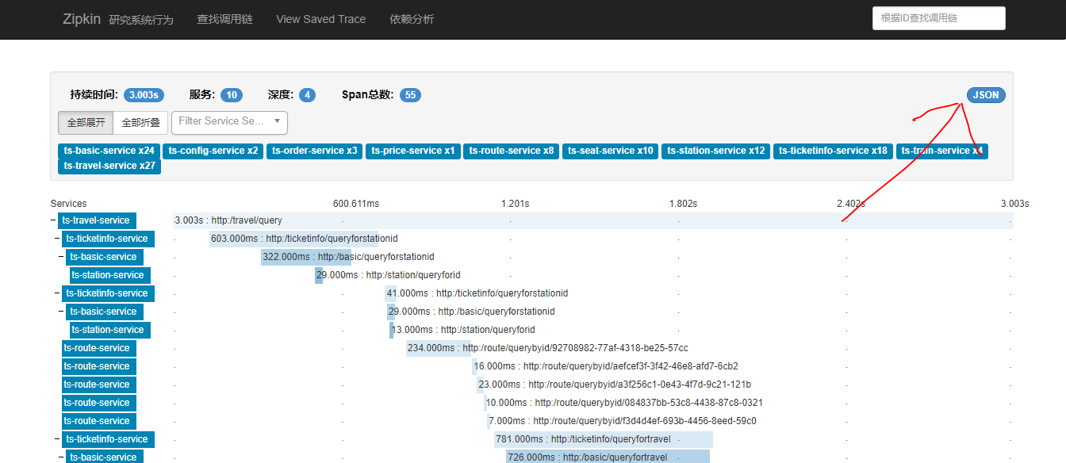
Step 3 – Translate to Shiviz-Format
Put the JSON file of zipkin in the directory train_ticket\Json2Shiviz\example\zipkin_log\case1\success
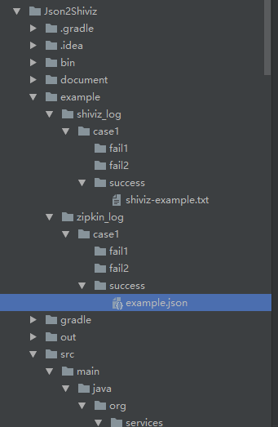
Run train_ticket\Json2Shiviz\src\main\java\org\services\analysis\TraceTranslator
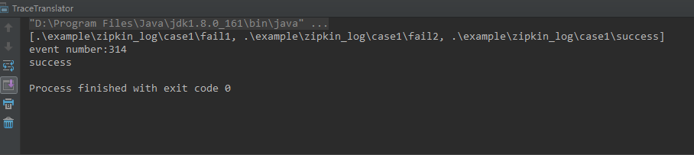
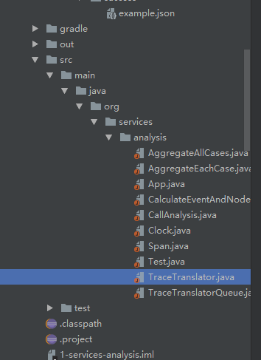
You will see the result at train_ticket\Json2Shiviz\example\shiviz_log\case1\success
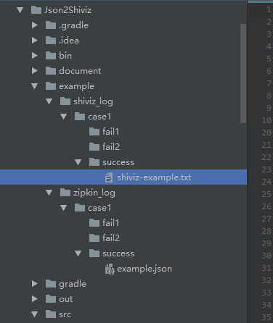
Step 4 – Display in Shiviz
Visit https://bestchai.bitbucket.io/shiviz/ , and then Input regular expression and Shiviz Log
The regular expression locates in train_ticket\Json2Shiviz\document\regular_expr
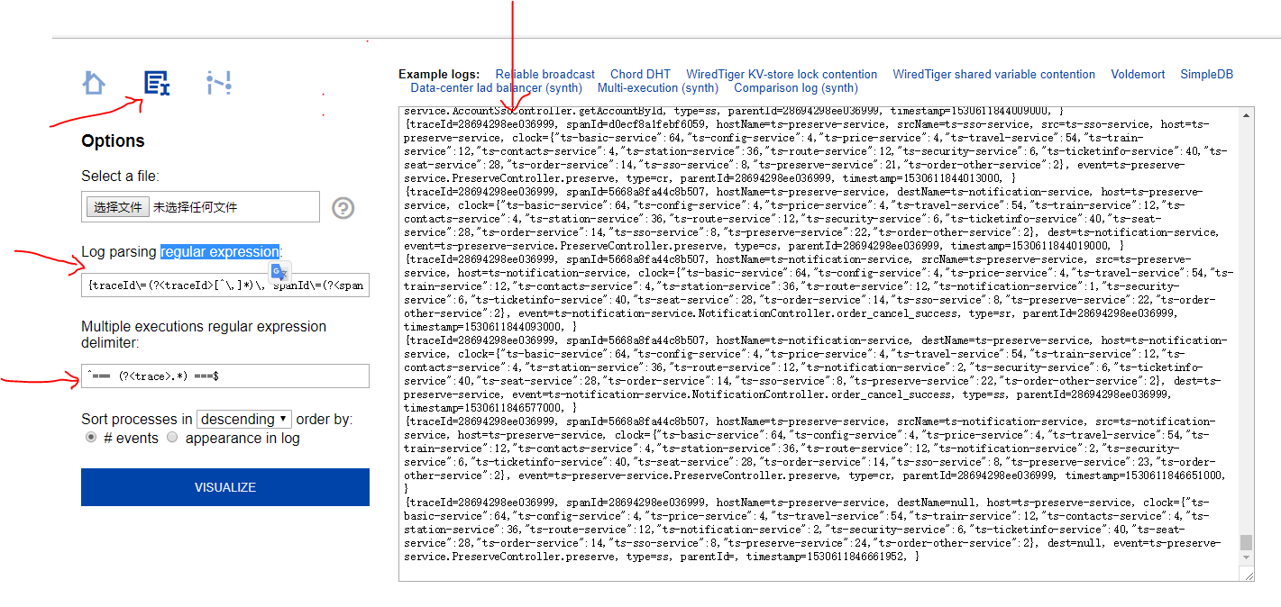
Then click Visualize, you will see the trace of Shiviz.
