ReadMe

Take add2 as an example:

Note:

The green ones represent the commands which you need to key on XTerm window

1. Run python script main.py to execute the parser: python3 main.py



Then you will see Command>

2. Read the circuit: read ./ckt/add2/add2.v

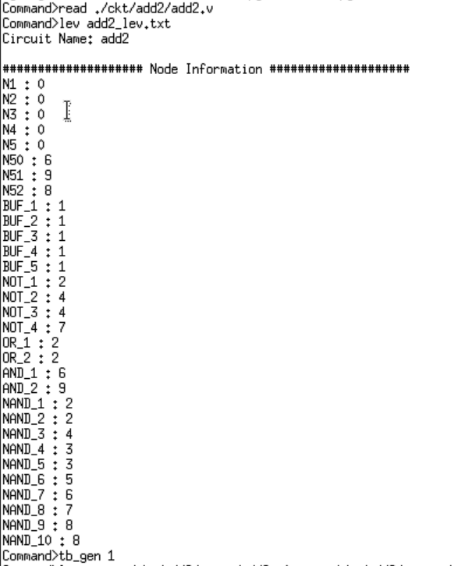

3. Do levelization and create levelization output file: lev add2_lev.txt



4. Generate testbench and input file for Modelsim: tb_gen 1

(You can specific how many test patterns you want to generate. Here, we generate 1 test pattern)

(Test patterns are stored in the folder named **input**)



5. Execute run.do

Do NOT quit or close the current XTerm window. Open another XTerm window, go to the corresponding circuit folder **./ckt/add2**: sh run.sh



Then it will call the Modelsim, do the simulation, and create the output files stored in the folder named **gold**.

Click **Yes** to exit the Modelsim.

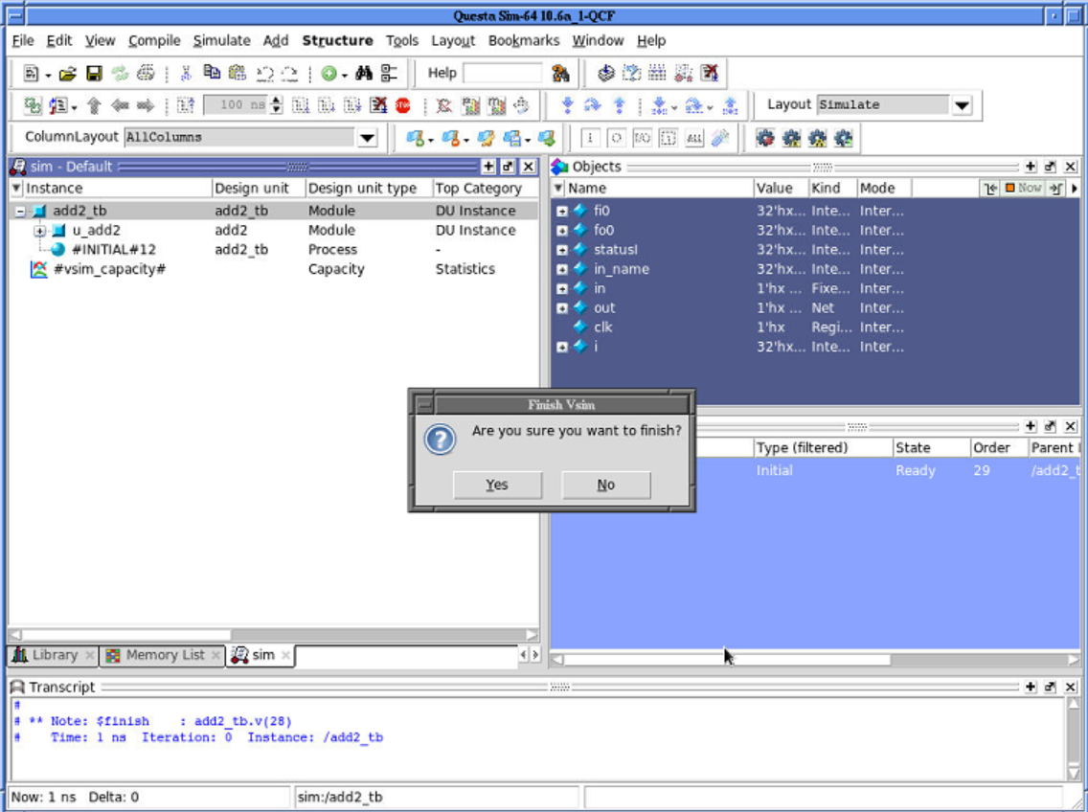

6. Back to the first XTerm window, do logicsim: logicsim ./ckt/add2/input/add2_t0.txt ./ckt/add2/output/add2_t0_out.txt

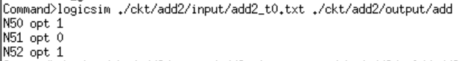

(This command will do simulation in our code and generate the output file in the folder named **output**)

7. Compare the result from our simulator (1st file) and Modelsim simulation (2nd file): check ./ckt/add2/output/add2_t0_out.txt ./ckt/add2/gold/add2_t0_out.txt

