Intro to High Performance Computing, Assignment 1: Serial Optimisations - Andrew Smith
A good workman uses good tools. Therefore it is prudent to first experiment with compilers and their optimisation flags, to see if there are gains to be made. Figure 1 shows the results of such experiments, for both gcc and icc compilers, using “1024 1024 100” as arguments “nx ny niters”.
As is clearly shown, the “-Ofast” setting makes considerable gains in runtime, gcc’s running 6 times faster than without optimisation, and icc’s “-fast” being fastest of all by far (0.18s). The native flag did not result in more efficient runtime, this probably because the compilation location is different to the runtime location, thus the ‘native’ location is not in fact used at runtime.

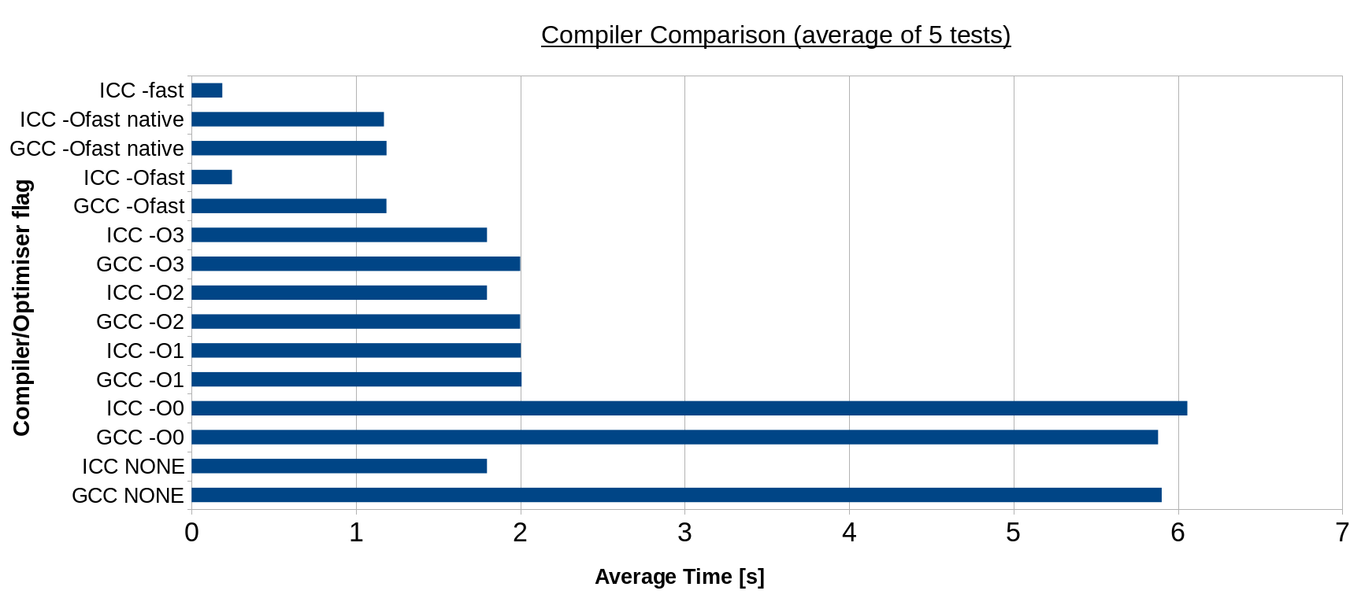Figure 1: Comparison of compilers: gcc Vs icc

With the best apparent tool chosen, the program to be optimised must next be characterised. It may then become evident which part of the program is the most expensive, i.e. that which should be attended to first. This characterisation was undertaken by “grof” profiler (see figure 1).
Figure 2: gprof profiling result for stencil (no compiler optimisation)
As the results show, 99.87% of the computation time is taken by the function ‘stencil’ which is called 200 times. It is clear that efficiencies should be first found within this function for maximal gains in runtime efficiency.

