**Manual ‘ColorFabUI’ v.1**

1. Save ‘ColorFabUI’ scripts into a project folder.
2. Open Blender, using ‘Administrator mode’

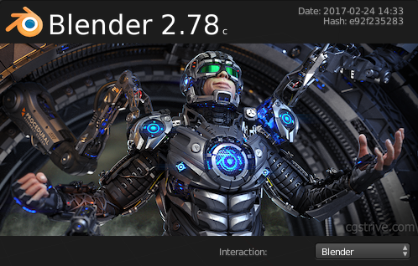

1. Save Blender workspace into the same folder of ColorFabUI. This is allows the ColorFabUI script to access other script (call external script).

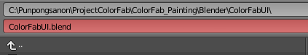

1. Open Text Editor and load a script ‘ColorFabUI.py’ into Text Editor

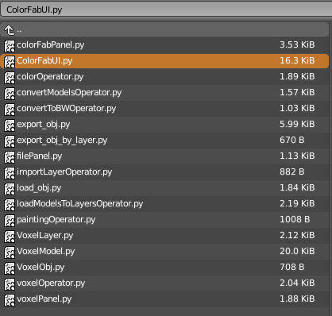

1. Then ‘run script’



1. Return to ‘3D editor view’ you will see the misc. menu;

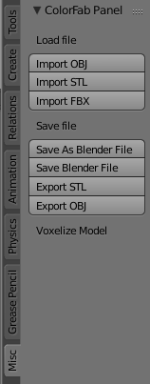

1. The additional menu will display after the model was loaded into the program. So, we load the model into the editor (either ‘OBJ’, ‘STL’, or ‘FBX’).

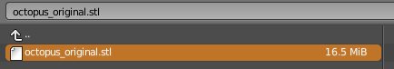

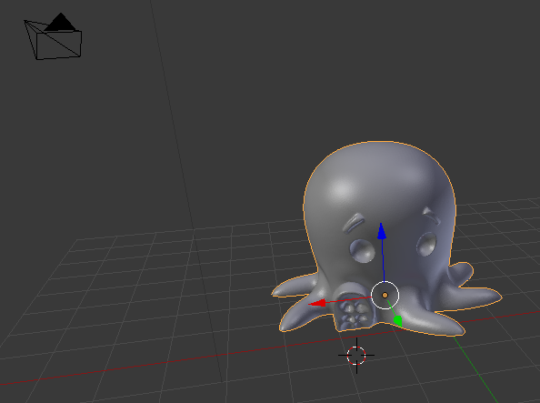

1. Process the Voxelization by setting the resolution and ‘preview’.

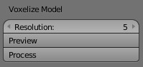

1. If the resolution is preferred, then ‘process’.

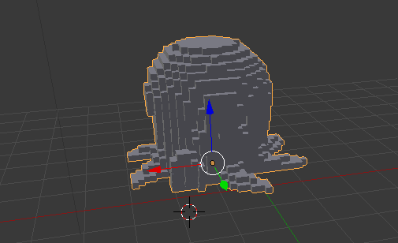

1. After hit ‘process’ the object will never return to the 3D model state (but will stayed as the Voxelization)
2. At this point, save the model as ‘OBJ’ file only by hitting ‘Export OBJ’.

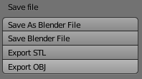

1. The file should be in the same folder as ‘ColorFabUI.py’ script for convenience.



1. Then we will decide the voxel with materials. We enter the file name which we just save in the previous step into dialog.



1. Then assigned the number of materials (excluded the inner). For example, RGB, we set ‘3’. The voxel size for each block mean the number of outer geometric voxel, and depth mean the thickness of geometric voxel for each color voxel.

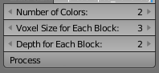

1. When ready, hits ‘process’. The model for each ‘material’ will store in the Blender folder (not in the one that scripts store). In this case, 4 materials are R,G,B and W (inner).



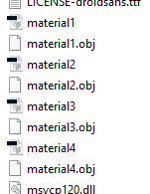

1. We can send the models to print by converting its back to ‘.stl’. Note that, you may need to repair the coordinate by processing with NetFabb. You can also hit ‘convert all’. Our script will convert all files into ‘.stl’ file, ready for print.

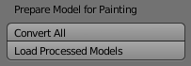

1. You do not have to move the model back from ‘Blender Foundation’ path to our ColorFabUI script. However, you have to select the model, and hit ‘Load Processed Models’.



1. After that, delete the previous model and select a new model.

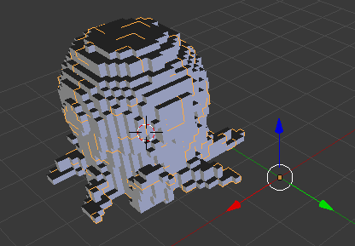

1. Then, the program will separate the voxel in to each individual voxel. So that, we can directly select the voxel and paint. We use the first layer. The following layer is actual layer for each material. We use the first layer as the mask of all other correspondence layer.



1. We then hits ‘Prepare colors for painting’. The software will create material (color instant) for each material.



1. The error will appears (sometime) however it is actually work. The material will set.

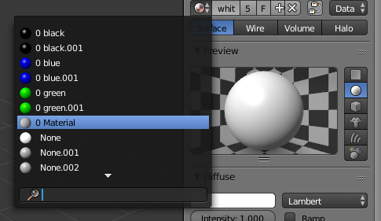

1. Then the object will separate into each individual voxel and ready for paint.

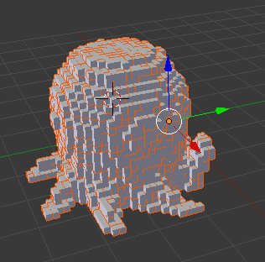

1. We can select on each individual voxel and set the color.

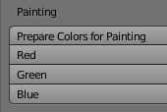

1. When ready, we hit the button ‘Process Model for Projection’



1. This process will match the correspondence color with the material. If the color is matched, the color will turn to black otherwise it will turn to white.

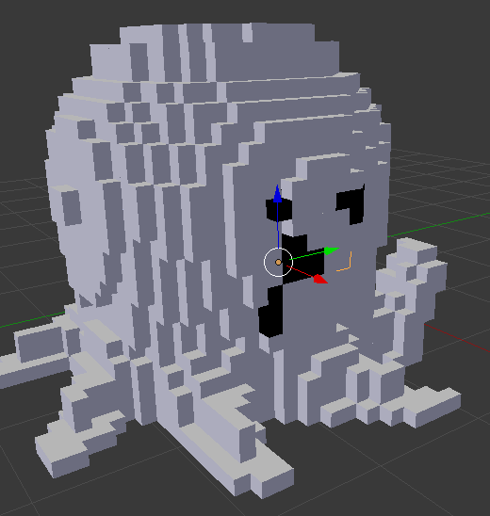

1. Then, we can setup the projection by hit the ‘setup projection’ button. The software will setting up the projection screen and the camera.
2. We can rotate the object to the different viewpoint by hits the rotate camera.