FloatMAC-P: Pipelined IEEE-754 Single-Precision
Floating-Point Multiply-Accumulate Unit
Suhani Gupta
Department of Electronics and Communication Engineering, ABES Engineering College, Ghaziabad, India
Project Report | HDL Design and Simulation using Xilinx Vivado

Abstract
This project presents FloatMAC-P, a modular Verilog RTL implementation of a pipelined floating-point multiply-accumulate (MAC) datapath. The unit computes y = (A × B) + C using 32-bit IEEE-754 single-precision operands. The architecture separates unpacking, multiplication, exponent alignment and addition, normalization, rounding, and packing. Functional and throughput testbenches were used to verify the connected design for the tested scenarios. Recorded simulation summaries report 12 passing top-level functional checks and 7 passing throughput checks. Synthesis reported 1,243 Slice LUTs, 345 Slice Registers, and 2 DSP blocks for the stated target device. Timing analysis showed negative setup slack at the 10 ns constraint, so timing closure has not been achieved. The report documents the design, verification approach, and implementation results without treating estimates as physical measurements.

Index Terms
IEEE-754, floating-point arithmetic, multiply-accumulate, Verilog HDL, pipelining, FPGA, Vivado.

I. Introduction
Multiply-accumulate operations are common in digital signal processing, including filtering, transforms, and numerical computation. A floating-point MAC multiplies two operands and adds a third while retaining a floating-point representation. Compared with integer arithmetic, the datapath must manage sign, exponent, significand alignment, normalization, and rounding.
FloatMAC-P explores a modular RTL structure for this operation. Its purpose is to demonstrate the main floating-point processing stages and a pipeline-based organization that can be simulated and evaluated in Vivado.

Project Objectives
- Implement the operation y = (A × B) + C using 32-bit floating-point operands.
- Separate the datapath into understandable Verilog modules.
- Verify module and top-level behavior with simulation testbenches.
- Review FPGA resource utilization, timing, and estimated power.

II. Background and IEEE-754 Representation
IEEE-754 single precision uses a 32-bit word divided into one sign bit, eight exponent bits, and 23 fraction bits. For normalized values, the leading significand bit is implicit, giving 24 bits of significand precision. The exponent field uses a bias of 127.
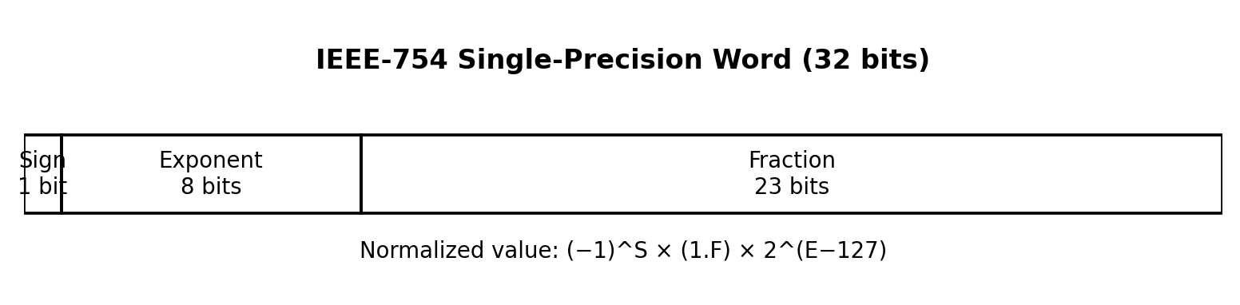
Fig. 1. IEEE-754 single-precision bit-field layout.

A. Value Representation
For a normalized value, the represented number is (−1)^S × (1.F) × 2^(E−127), where S is the sign bit, E is the stored exponent, and F is the fraction. The bias is subtracted to obtain the unbiased exponent.

B. MAC Operation
The core operation is:
y = (A × B) + C
The multiplier combines the signs, exponents, and significands of A and B. The addition stage aligns the product with C by shifting the significand associated with the smaller exponent. The aligned values are added or subtracted according to their signs. The intermediate result is then normalized, rounded, and packed into a 32-bit output.

C. Scope of IEEE-754 Handling
IEEE-754 also defines signed zeros, subnormal values, infinities, NaNs, overflow, underflow, and rounding behavior. The existence of a 32-bit format does not by itself prove that every special case is implemented. This report therefore describes the format and the tested design behavior without claiming exhaustive IEEE-754 compliance.

Design Inputs and Output
- Inputs: 32-bit operands A, B, and C; clock; reset.
- Output: 32-bit floating-point result.
- Operation: one multiply followed by addition of the third operand.

III. RTL Architecture
The design is divided into arithmetic and data-formatting blocks. This modular organization helps isolate errors during simulation and makes each stage easier to inspect.
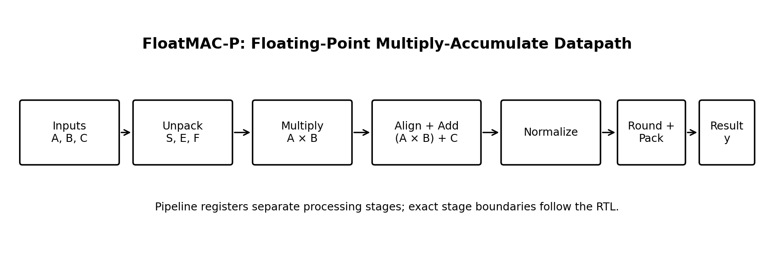
Fig. 2. High-level FloatMAC-P datapath.

A. Main RTL Modules
Module | Function
FLOAT_UNPACK | Extracts sign, exponent, and fraction fields from each input.
FLOAT_MULTIPLIER | Calculates the product sign, exponent, and significand.
FLOAT_ADDITION | Aligns exponents and combines the product with operand C.
FLOAT_NORMALISE | Adjusts significand position and exponent.
FLOAT_ROUND | Applies the implemented rounding logic to the intermediate result.
FLOAT_PACK | Combines sign, exponent, and fraction into the output word.
REG_STAGE1–REG_STAGE5 | Hold intermediate values between pipeline stages.
Top-level wrapper | Connects the datapath and exposes clock, reset, inputs, and output.

B. Data Path Summary
The inputs are unpacked before arithmetic. The product is generated and aligned with C; the combined result is normalized and rounded before packing. Pipeline registers preserve intermediate fields between stages. Exact signal widths and stage placement are defined by the RTL source.

Design Tools
The project uses Verilog HDL and Xilinx Vivado for RTL simulation, synthesis, and timing analysis. The target part recorded for synthesis is xc7a100tcsg324-1.

IV. Pipeline Organization
Pipelining places registers between portions of a datapath so intermediate values are captured on clock edges. The intention is to reduce the amount of combinational logic traversed in one cycle and allow independent operations to overlap.
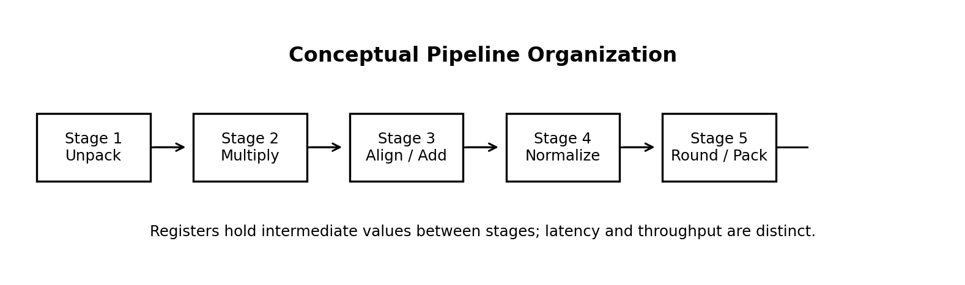
Fig. 3. Conceptual pipeline stages; refer to RTL for exact register boundaries.

A. Pipeline Registers
The project includes register-stage modules REG_STAGE1 through REG_STAGE5. Every field belonging to one input transaction—such as sign, exponent, significand, and rounding information—must remain aligned as it passes through the stages. A field delayed by the wrong number of cycles can cause the output to combine values from different transactions.

B. Latency and Throughput
Latency is the time from sampling an input transaction to observing its corresponding output. Throughput is the rate at which new operations can be accepted or completed once the pipeline is operating steadily. A multi-cycle latency does not necessarily prevent the unit from accepting a new operation every cycle.
A waveform was previously interpreted as suggesting approximately five clock cycles of latency. At a 10 ns period, five cycles correspond to about 50 ns; however, the exact latency should be measured from the final RTL and testbench using a consistent sampling convention.

C. Reset and Interface
The wrapper exposes clock and reset inputs along with the three operands and result. Reset behavior should be verified at the register boundaries. The current interface does not use valid/ready handshaking, so tests should clearly define when inputs are sampled and when outputs are expected.

Pipeline Checks
- Verify reset and pipeline fill behavior.
- Use different operands on consecutive cycles to test transaction alignment.
- Measure latency separately from steady-state throughput.
- Compare each output with a reference result for the matching input triple.

V. Verification Methodology
Verification combines module-level simulation with top-level testing. Module-level benches help isolate arithmetic errors; top-level tests check the connected MAC datapath. A separate throughput testbench checks consecutive operations through the pipeline.

A. Recorded Simulation Results
Testbench | Passed | Failed
Top-level functional test | 12 | 0
Throughput test | 7 | 0
These are recorded results for the scenarios present in the corresponding testbenches. They should be rerun if the RTL or tests have changed. The counts do not establish exhaustive correctness for every possible IEEE-754 input.

B. Verification Approach
- Check sign and exponent extraction in the unpacking stage.
- Check multiplication and the resulting sign, exponent, and significand.
- Check exponent alignment and addition/subtraction behavior.
- Check normalization, rounding, and final packing for the supported cases.
- Test back-to-back transactions to reveal pipeline alignment errors.
- Inspect waveforms as well as console PASS/FAIL summaries.

C. Reference Comparison
Expected values should be produced by a trusted IEEE-754 reference calculation or independently verified bit patterns. The comparison method must match the implementation's rounding policy. Corner cases such as subnormals, infinities, NaNs, overflow, and underflow should be included only as supported and tested by the RTL.

Verification Limitations
Simulation confirms only the behavior exercised by the selected tests. The available summaries are useful evidence of functional and throughput checks, but additional directed and randomized tests would be needed for broader confidence.

VI. Synthesis and Implementation Results
The following values are the recorded tool results for the stated target and constraints. They are implementation estimates, not physical measurements.
Metric | Recorded result
Target FPGA part | xc7a100tcsg324-1
Clock constraint | 10 ns (100 MHz target)
Slice LUTs | 1,243
Slice Registers | 345
DSP blocks | 2
Bonded IOBs | 132
Worst Negative Slack (WNS) | −0.886 ns
Total Negative Slack (TNS) | −13.883 ns
Setup endpoints failing | 30 of 247
Worst Hold Slack (WHS) | +0.119 ns
Failing hold endpoints | 0
Total on-chip power estimate | 0.138 W
Dynamic / static power estimate | 0.047 W / 0.091 W
Power confidence | Low

A. Timing Interpretation
Negative WNS means that at least one checked setup path exceeds its timing budget. Negative TNS indicates an aggregate setup shortfall across failing paths. The recorded 30 failing setup endpoints show that the design did not meet the 10 ns setup requirement. Positive hold slack and zero failing hold endpoints indicate that the reported hold checks passed, but they do not resolve setup violations.

B. Power Interpretation
The 0.138 W total power value is a low-confidence tool estimate. It depends on implementation details and activity assumptions and must not be described as measured board power.

Result Summary
Resource utilization was obtained, and simulation summaries were positive for the tested cases. However, timing closure at 100 MHz has not been achieved. Further critical-path analysis and optimization are required before claiming operation at the target frequency.

VII. Limitations and Future Work

A. Current Limitations
- Setup timing fails under the recorded 10 ns clock constraint.
- The power estimate is marked low confidence and has not been measured on hardware.
- Exact latency must be confirmed against the final RTL and testbench.
- The recorded test counts cover selected scenarios, not all IEEE-754 corner cases.
- Special-value and exception behavior should be claimed only where implemented and tested.

B. Engineering Considerations
Floating-point arithmetic requires consistent handling of sign, exponent, and significand fields. Width errors or incorrect exponent bias correction can produce incorrect results. Pipeline debugging also requires each intermediate value to be delayed consistently; waveform inspection and distinct consecutive input patterns help locate misalignment.

C. Recommended Improvements
- Inspect worst setup paths and identify the dominant combinational logic and routing delay.
- Review stage boundaries and balance logic across pipeline registers.
- Expand directed and randomized tests for exponent differences, cancellation, and rounding boundaries.
- Document the supported IEEE-754 cases and rounding policy explicitly.
- Repeat simulation and synthesis after RTL changes and compare results against a fixed baseline.
- Record the Vivado version, source revision, constraints, and tool reports for reproducibility.

VIII. Conclusion
FloatMAC-P implements a modular, pipelined RTL structure for the operation (A × B) + C using IEEE-754 single-precision operands. The architecture separates unpacking, multiplication, addition, normalization, rounding, and packing. Recorded simulations report 12 passing top-level functional checks and seven passing throughput checks for the tested scenarios.
Synthesis reported 1,243 Slice LUTs, 345 Slice Registers, and two DSP blocks. The timing report showed WNS of −0.886 ns and TNS of −13.883 ns, so the design did not meet the 10 ns setup constraint. The most important next steps are critical-path optimization and broader verification of supported floating-point corner cases.

IX. Reproducibility and Repository
Project repository: https://github.com/HCL-ABES-3rdYear/Suhani-Gupta-FloatMAC-P

Suggested Reproduction Steps
- Open the project in Vivado and confirm the target part and source files.
- Run the module-level testbenches, followed by the top-level functional testbench.
- Run the throughput testbench and save the simulation log and waveform.
- Run synthesis and export the utilization report.
- Apply the 10 ns clock constraint and inspect timing summary and critical paths.
- If running power analysis, document activity assumptions and retain the tool's confidence rating.
- Rerun affected tests and reports whenever the RTL changes.

References
[1] IEEE, IEEE Standard for Floating-Point Arithmetic, IEEE Std 754-2019, 2019.
[2] AMD Xilinx, Vivado Design Suite User Guide: Synthesis (UG901).
[3] AMD Xilinx, Vivado Design Suite User Guide: Design Analysis and Closure Techniques (UG906).
[4] D. Goldberg, “What Every Computer Scientist Should Know About Floating-Point Arithmetic,” ACM Computing Surveys, vol. 23, no. 1, pp. 5–48, 1991.

Project Metadata
Project title: FloatMAC-P — Pipelined IEEE-754 Single-Precision Floating-Point MAC
Domain: VLSI / Digital Design | Tools: Verilog HDL, Xilinx Vivado
Repository: HCL-ABES-3rdYear/Suhani-Gupta-FloatMAC-P
Note: No dataset file was available for independent inspection; no dataset-derived statistics are reported.

