**On UBUNTU machine Install JAVA**

**sudo add-apt-repository ppa:openjdk-r/ppa**

**sudo apt-get update**

**sudo apt-get install -y openjdk-8-jdk**

**Tomcat Installation and Configuration**

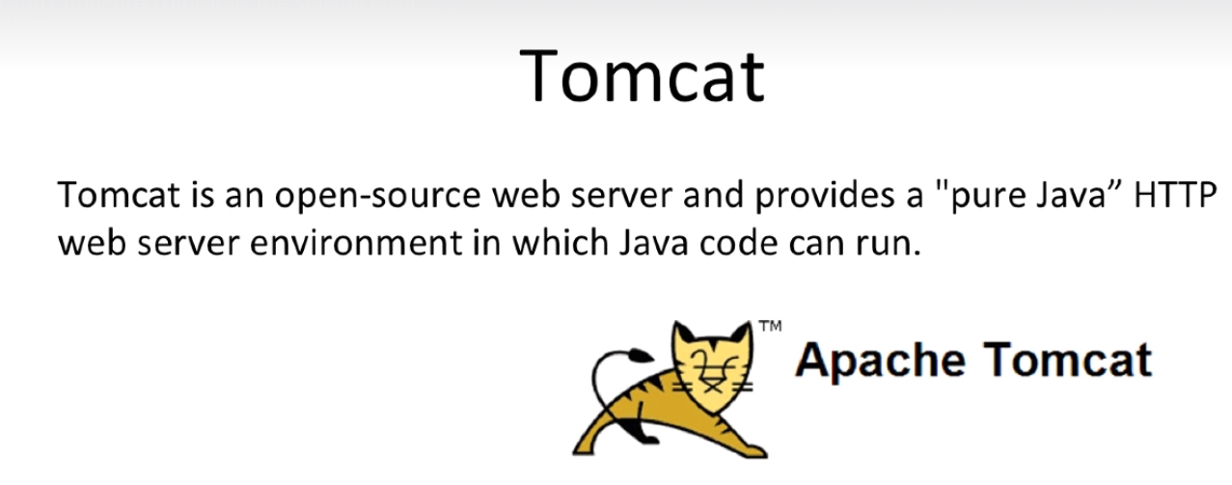

Go to [www.google.com](http://www.google.com) search for download tomcat, you can download link

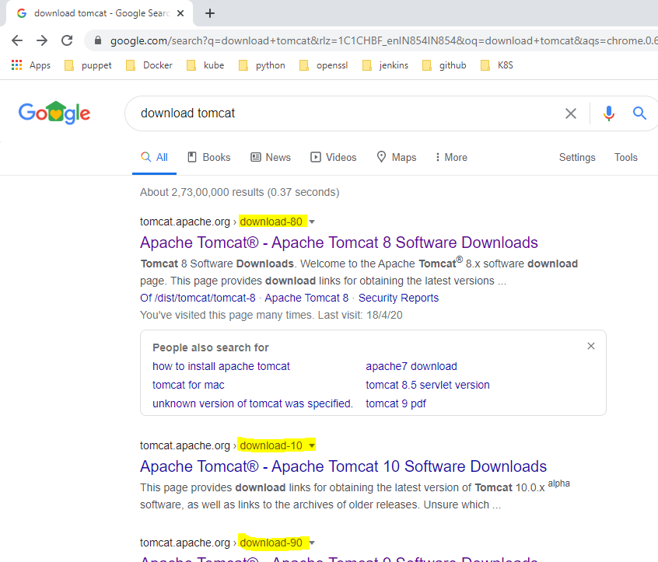

The current stable version is 8.5.54 download the tar.gz . Extract the tar.gz and copy any where. Tomcat is ready.

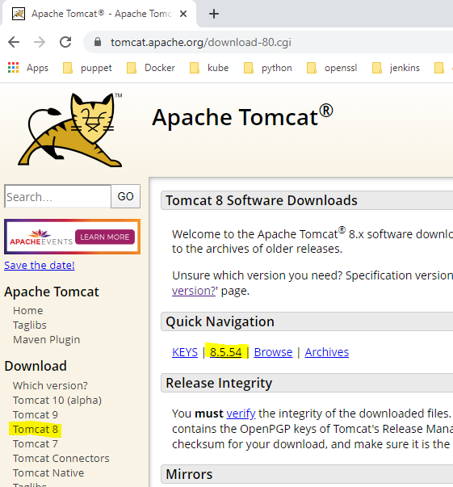

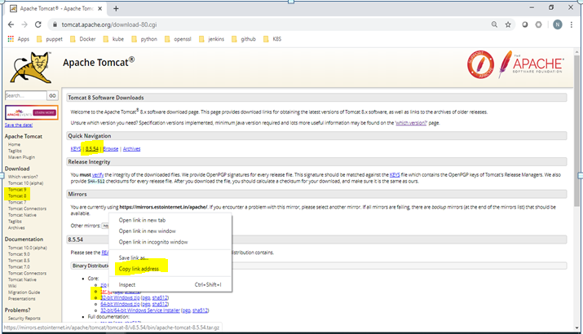

Copy link address as shown in above screenshot

Login to UBUNTU Machine & below commands

NOTE: be root user to do all below tasks. You may see the permission issues if not.

cd /tmp ; wget (paste the copied link here) , i.e it looks like below

cd /tmp ; wget <https://mirrors.estointernet.in/apache/tomcat/tomcat-8/v8.5.54/bin/apache-tomcat-8.5.54.tar.gz>

This will download the tomcat binary to UBUNTU machine under /tmp direcotry, and then we can extract the tar file

cd /tmp ; tar xzf apache-tomcat-8.5.54.tar.gz -C /opt/

The above command will extract the tomcat binary to /opt/ directory

Now you can goto /opt/apache-tomcat-8.5.54/bin & run startup.sh to start tomcat server

cd /opt/apache-tomcat-8.5.54/bin

./startup.sh

Note: ensure that 8080 port is not occupied on your machine since tomcat by default uses 8080 port number.

We can access the tomcat once it is started using http://IP:8080

Setting UP Jenkins in TOMCAT Server:

We need to download the jenkins.war file from official Jenkins website

Goto link <https://www.jenkins.io/download/>

Download the war file under LTS section

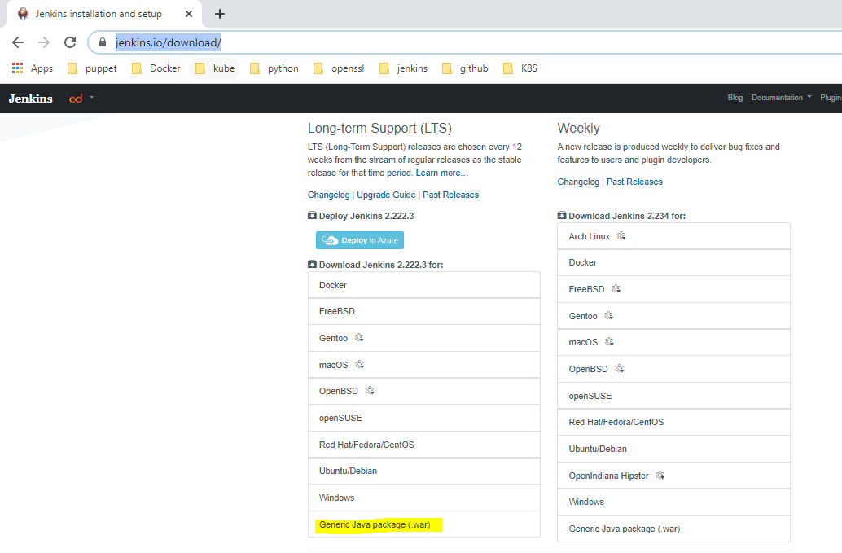

On downloads page right click on Generic Java package(war) & copy link address

Login to UBUNTU machine follow as below in screen shot.

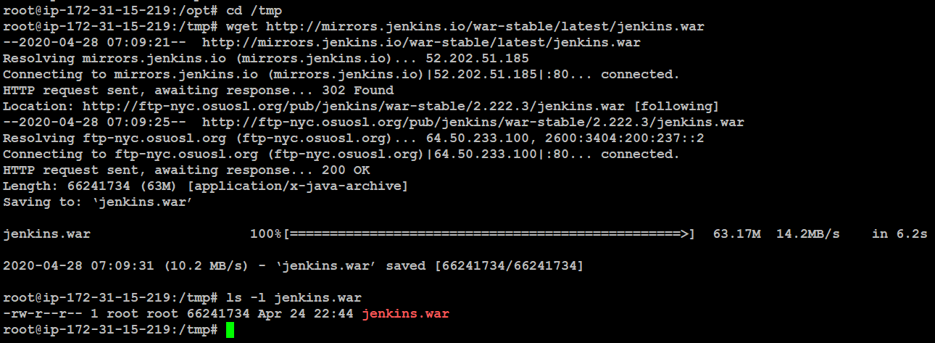

Ensure Jenkins war file successfully downloaded on to your machine.

Deploy Jenkins war file to tomcat Server:

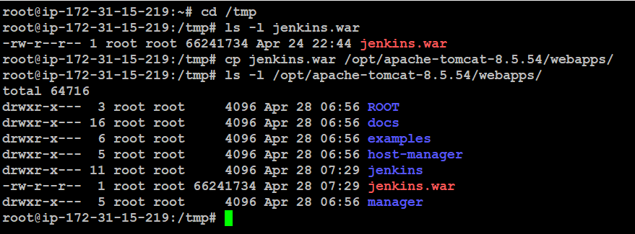

Restart Jenkins

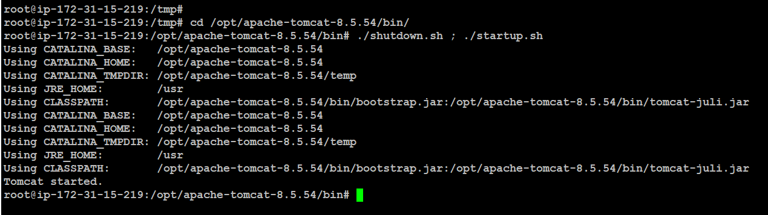

This concludes deploying Jenkins to tomcat Server; we can access Jenkins from below URL

<http://IP:8080/jenkins>

