**GA360 Integration**

Adding Google Analytics to Aurora B2B Store, using Google Tag Manager

Requirements Outline

Provide the reporting and tracking abilities on AuroraB2B Stores that allows them to track and understand the customer's behaviour, what they are looking for, and whether business is addressing their needs.

**Implementation Guide:**

We need the below things for implementation of GA360 on AuroraB2B store

Google analytics – Analytics Tool

Google tag manager – Tag Management.

GTM configuration script tag – Integrate GTM code snippet in Aurora B2B.

Firstly, we need to create account on both Google Analytics and google tag manager.

Google Analytics – [Click here](https://teams.microsoft.com/l/file/611EDE70-7F71-43C9-95F5-B727E51AB01A?tenantId=189de737-c93a-4f5a-8b68-6f4ca9941912&fileType=docx&objectUrl=https%3A%2F%2Fhclo365.sharepoint.com%2Fsites%2Finnovationfactory%2FShared%20Documents%2FGoogle%20Analytics%20360%20Integration%2FGoogle%20Analytics_CreateAccount_Steps.docx&baseUrl=https%3A%2F%2Fhclo365.sharepoint.com%2Fsites%2Finnovationfactory&serviceName=teams&threadId=19:2f9390ba8ee248eba516c36b7287dcc4@thread.tacv2&groupId=633ba5ef-06b3-46a7-ae83-2044288cf9e5) to get the steps for account creation

Google Tag Manger – [Click here](https://teams.microsoft.com/l/file/83B5F016-61A6-4BE2-BE69-77CFE58410DC?tenantId=189de737-c93a-4f5a-8b68-6f4ca9941912&fileType=docx&objectUrl=https%3A%2F%2Fhclo365.sharepoint.com%2Fsites%2Finnovationfactory%2FShared%20Documents%2FGoogle%20Analytics%20360%20Integration%2FGTM%20Account%20creation%20Steps.docx&baseUrl=https%3A%2F%2Fhclo365.sharepoint.com%2Fsites%2Finnovationfactory&serviceName=teams&threadId=19:2f9390ba8ee248eba516c36b7287dcc4@thread.tacv2&groupId=633ba5ef-06b3-46a7-ae83-2044288cf9e5) to get the steps for account creation

Once the account creation is done then we have to add the GTM Configuration script tag in the gtmService.js file and initialize the same as below.

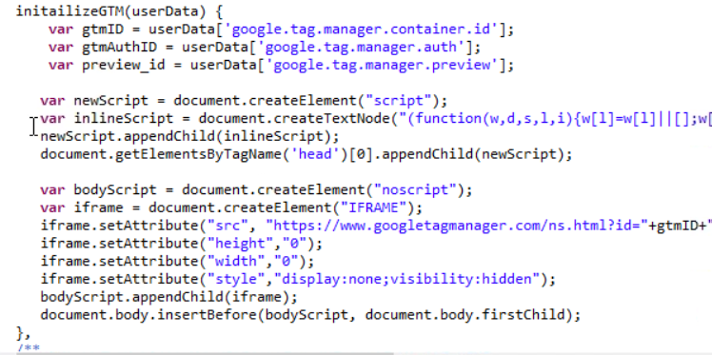

The gaDataService.js have the below functions apart from the page load and navigation events.

1. Breadcrumb related functions:

These functions are used to get the details of the current page. This can be product name or the current navigation page.

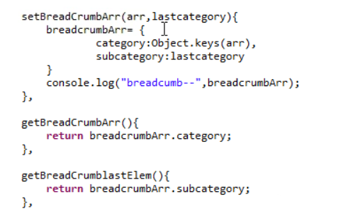

1. User details related functions.

These functions are used to set and get the logged in user details.

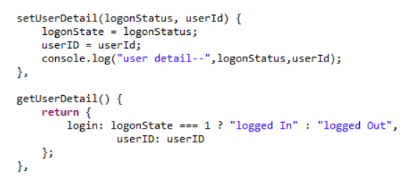

1. Purchase details and product details related functions.

The below functions are used to get the product details and purchase details of any order.

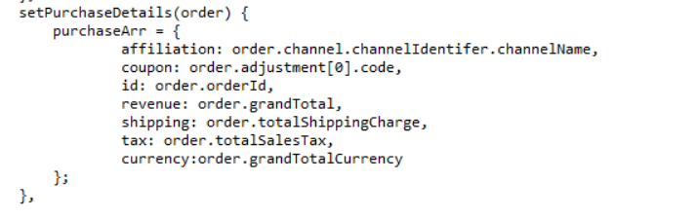

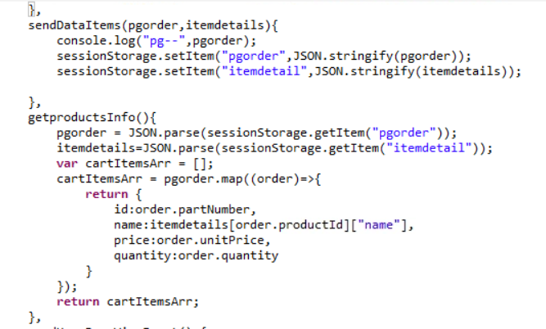

**Google Tag Manger**

Please refer [the pdf](https://teams.microsoft.com/l/file/D0E1FF5C-5842-4A0D-A7F8-2791AE617F58?tenantId=189de737-c93a-4f5a-8b68-6f4ca9941912&fileType=pdf&objectUrl=https%3A%2F%2Fhclo365.sharepoint.com%2Fsites%2Finnovationfactory%2FShared%20Documents%2FGoogle%20Analytics%20360%20Integration%2FGoogle%20Tag%20Manger%20configuration%20sheet.pdf&baseUrl=https%3A%2F%2Fhclo365.sharepoint.com%2Fsites%2Finnovationfactory&serviceName=teams&threadId=19:2f9390ba8ee248eba516c36b7287dcc4@thread.tacv2&groupId=633ba5ef-06b3-46a7-ae83-2044288cf9e5) for the creation on tags, triggers and variables in google tag Manager.

**Aurora B2B Store**

Created the two files for GA360 and kept inside

“**crs-web/WebContent/AuroraB2BStorefrontAssetStore/gtm**” folder

1. gtmService.js - specific to GTM configurations and initializing the GTM for AuroraB2B.
2. gtmDataService.js - Files that includes various methods to record the google analytics for various page load, product details checkout etc.

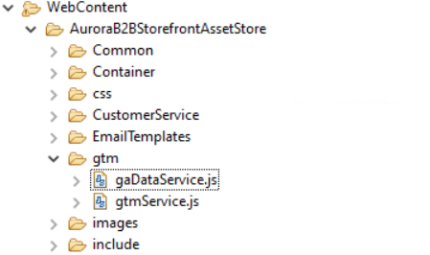

1. **Include both the files in common JS to Include file to initialize GTM**

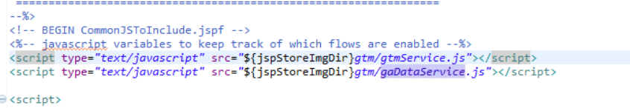

In gtmService.js, initailizeGTM () method is written.

The initializeGTM Method has all the configurations related to the GTM account created.

Its added in a script tag in the common js file to be included.

Once this is done then we need to send different event from different pages.

1. **Pageview event**

In this, we will be sending page related information to GA.The measurePageview() method defines in gtmService.js file. Its responsible for adding object (required information which we want to send) in data layer.

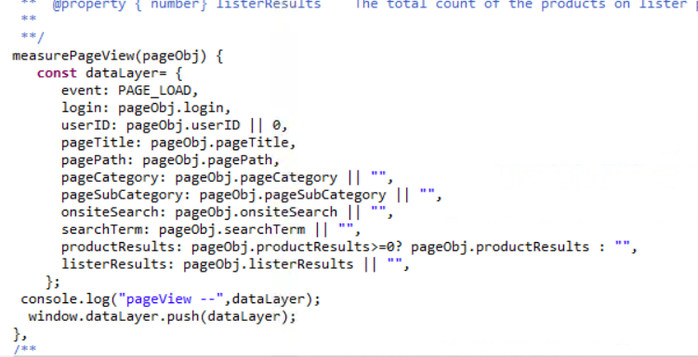

We have sent the pageview event from following pages

* Home Page
* Lister page
* Search Page
* PDP Page
* Content Page
* Checkout Page

The methods are defined in the gaDataService.js file and we are calling those methods from the different pages with required arguments.

For Example:

**Home Page (HomePageContainer.jsp)**

In HomePageContainer Page, need to call the SendHomePageViewEvent() method whose definition is in gaDataService.js file.

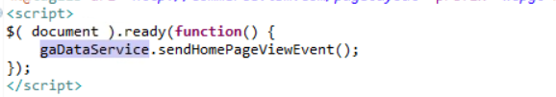

**Lister page and search Page (CatalogEntryList_UI.jspf)**

We will be sending sendListerPageViewEvent() method for Lister page and sendSearchPageViewEvent() method for search page.

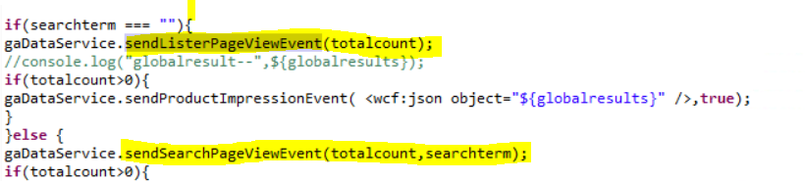

**Page Detail page (ProductPageContainer.jsp)**

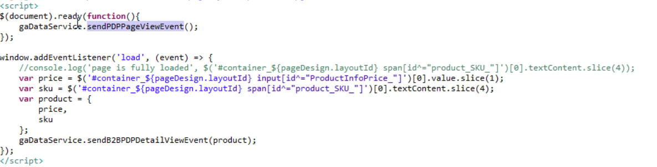

**Checkout Page (ShoppingDetailsDisplay.jsp)**

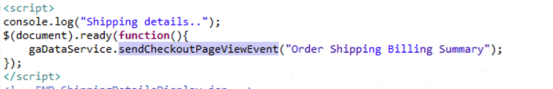

**We have called the above function at below pages as well for recording the checkout process.**

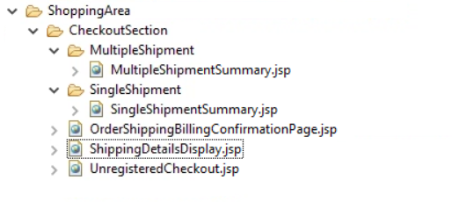

1. **Form Completion Event**

In gaDataService.js file, we have defined the common method with required parameters for form Completion Event.

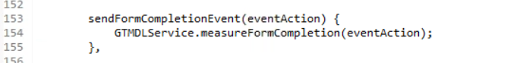

This methods call the measureFormCompletion() method of gtmService.js for adding the object in datalayer.

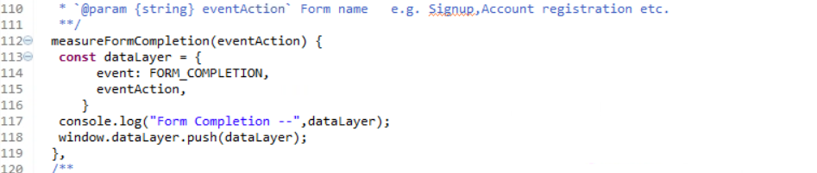

We have called the sendFormCompletionEvent from the following the forms:

* SignIn
* Register

Sign In:

Called sendFormCompletionEvent() with formName as parameter in Sign In method of GlobalLoginSignIn_UI.jspf file

gaDataService.sendFormCompletionEvent('Sign In');

Register

Called sendFormCompletionEvent() with Register as parameter in handleSubmit() method of LogonForm.js file

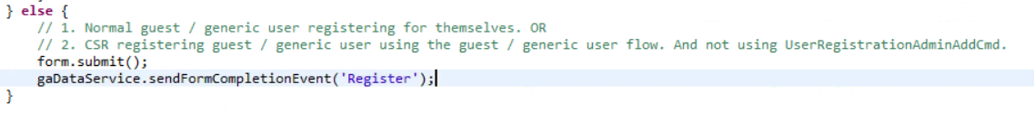

1. **Navigation Click**

In gtmService.js file, we have defined the common method with required parameters for navigation click Event.

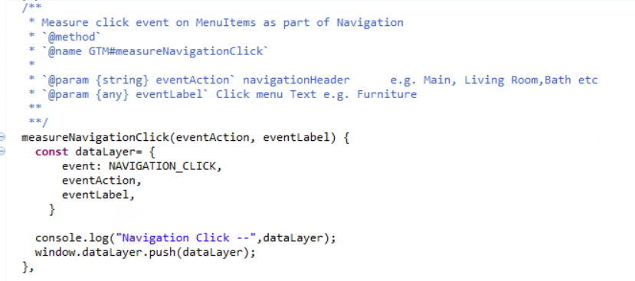

This function is called at the places where the user navigates in the application.

Basically all the dropdown links and header section.

The below code is placed in the DepartmentDropDown.jsp page.

The function is called on click of the links and the department name is sent as the parameter.

onclick="GTMDLService.measureNavigationClick('Main', '${department.name}')"

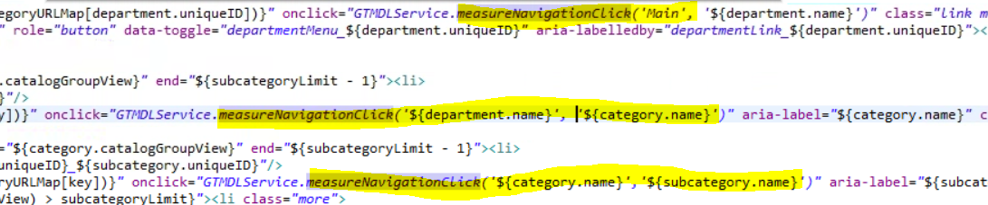

1. **Product Impression**

Product Impression is how many products visible on the page when user visited the page.

In gtmService.js, we have defined the method which will data the product data to data layer.

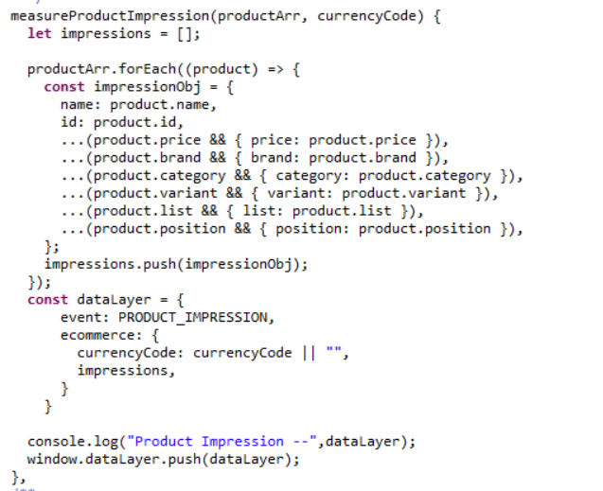

This method is getting called from sendproductImpressionevent() method of gaDataService.js file which will send the array of products to GTM service.

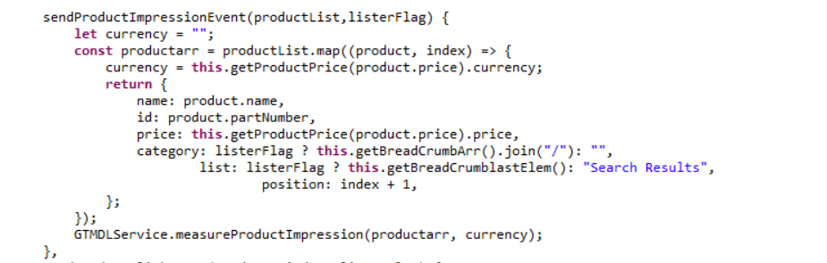

This common method is called from Lister page where products are getting rendered.(CatalogEntryList_UI.jspf)

If there is not category, then it means are products are rendered as part of search Result otherwise as part of selected Category.

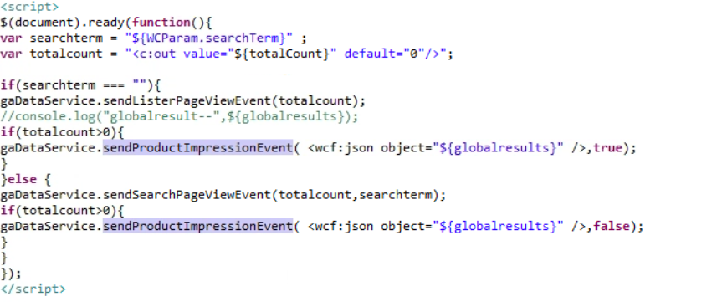

1. **Product Click**

Product click is the event which we sent when user clicks on a product from lister page.

In gtmService.js, we have defined the method which will send the product data to data layer.

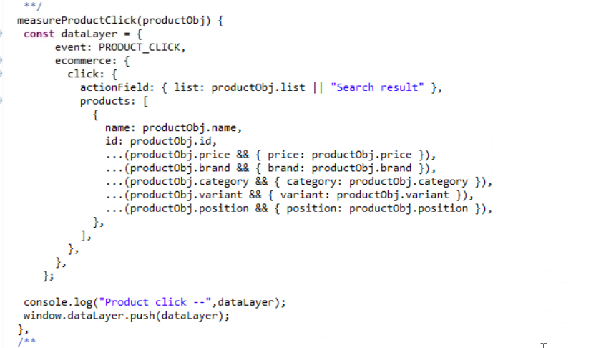

This method is getting called from sendProductClickEvent () method of gaDataService.js file which will send the clicked product info to method of gtmService.js.

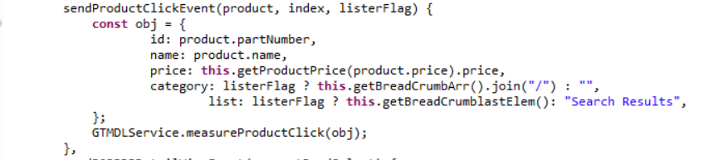

This common method is called from CataogEntryDisplay_GridView_UI.jspf where products are getting rendered.

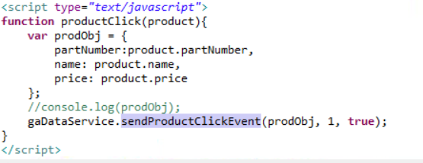

1. **Product Detail View**

The product detail View will be sent when user view the detail page of product.

The Method which will add product data to data layer is defined in gtmService.js.

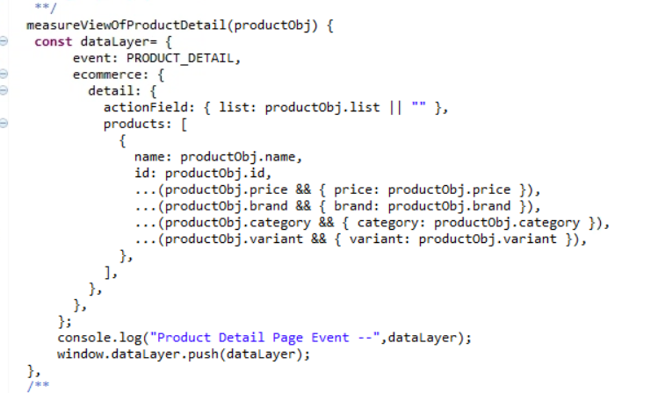

This method is getting called from sendPDPDetailViewEvent() in gaDataService.js file which provide product object to the above method.

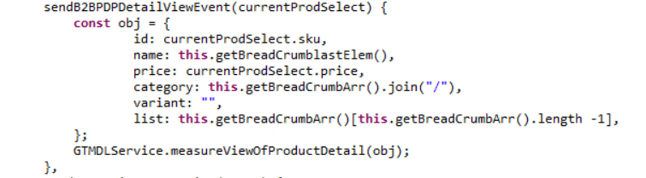

This method is called from product detail page ie.ProductPageContainer.jsp

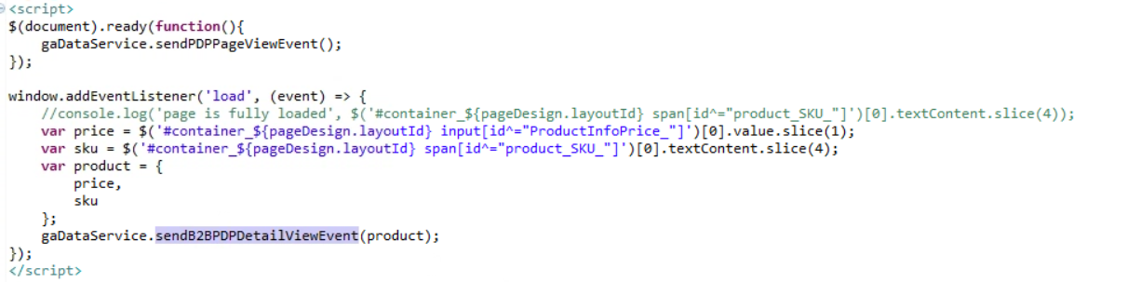

1. **Add to Cart**

We send the AddToCart event when user clicks on add to cart button and order is added in cart. We send the product information which is added in cart for datalayer.

The Main method which takes product object and send data to datalayer is defined in gtmService.js

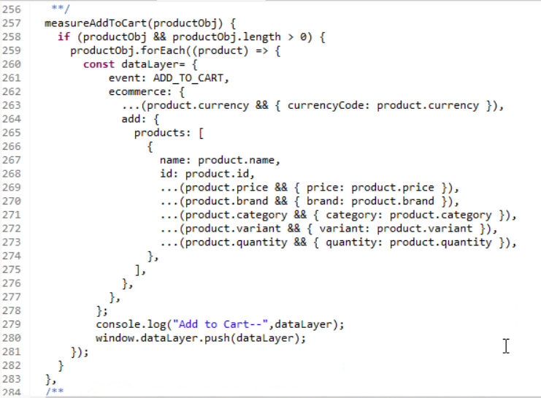

This method is called from gaDataService.js where we do the manipulation on data and get the required info of the product and pass it to above method for adding in datalayer.

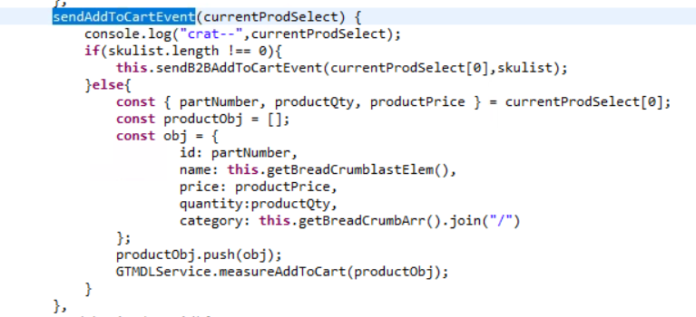

This method is called from detail page i.e. MiniShopCartDisplay_UI.jspf where add to cart button is present. We pass selected product object which is added in the cart.

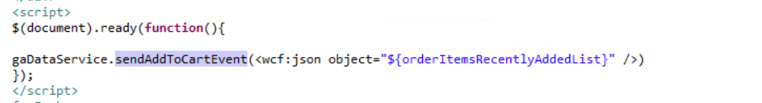

1. **Remove from Cart**

We need to call this event when user remove some item from the cart.

The main method is defined in gtmService.js where object structure is defined and it will add the object to data layer.

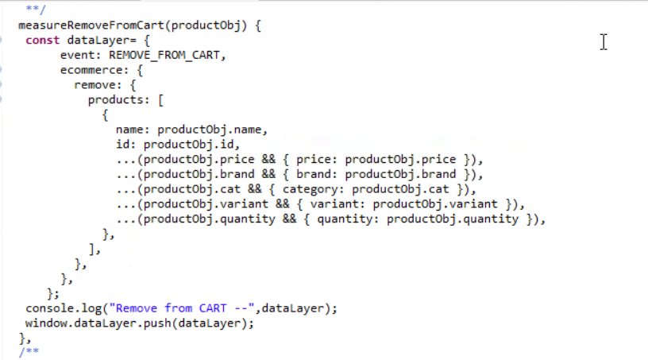

This method is called from gaDataService.js which send the removed product object to the above method.

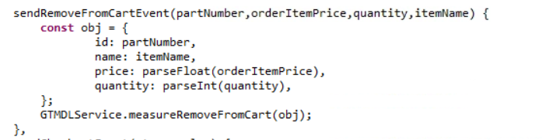

This method is called with item object from cart page where remove button is present. We called the above method on click of remove cart button.



1. **Checkout**

We send the checkout information when user enters in checkout process. We need to send this event in each step completed by the user.i.e shipping and Biling and payment Info.

The main method of checkout is defined in gtmService.js file which add product data and step number and step value to data layer.

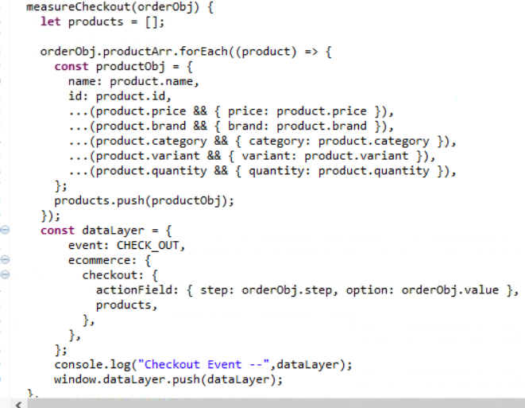

This Method is getting called from gaDataService.js which will form the data for the above method.

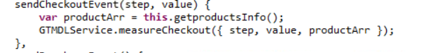

We pass the information to this method from checkout file.

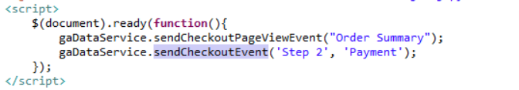

1. **Purchase**

When send this event when user has completed the checkout process and placed an order and get confirmation page.

The main method is defined the gtmService.js which adds the purchase order object to datalayer.

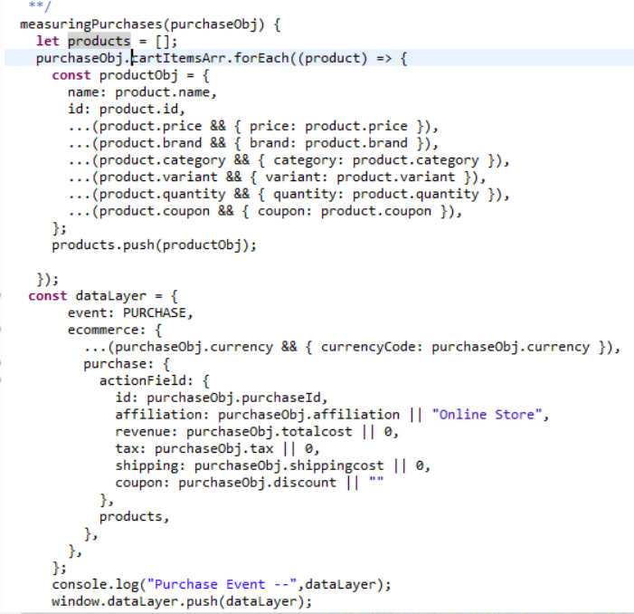

This method is getting called from gaDataService.js which the object for the above method.

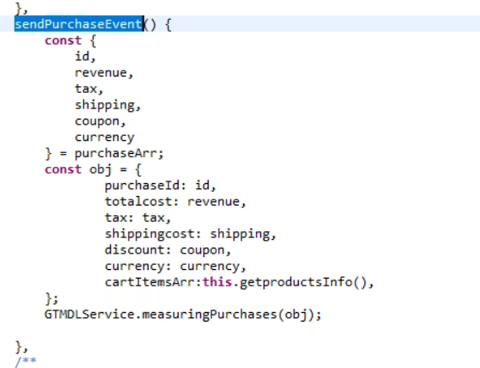

The Cart information and added items information is passed from the checkout page when order is confirmed. The below changes are made in the OrderConfirmationPage.

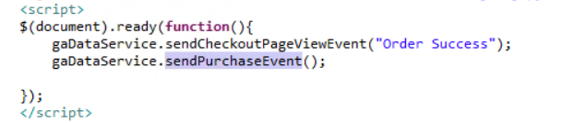

1. **Promotion View**

This pageview event is called when promotions are visible on the page opened by user. We send the promotion information rendered on the page.

The main method is defined in gtmService.js which will send promotion data to data layer.

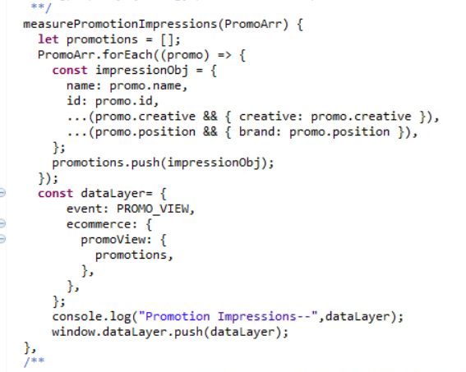

This method is called from gaDataService.js from where we are sending the data to above method.

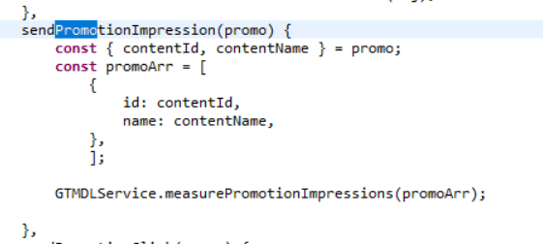

We are accessing this function where we see the promotions on the page. We pass the content id and Content name to the function.

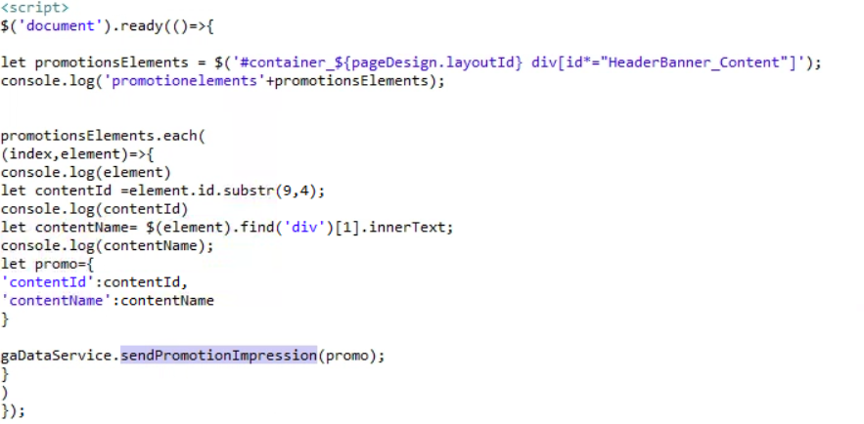

1. **Promotion Click**

Promotion Click is not applicable to Aurora B2B as there are no onclick events.