Enable the Google CDN for HCL Commerce Applications

Steps to enable Google Cloud CDN (Content Delivery Network) for Custom Origin:

**Prerequisite**

* Google Cloud Account
* Externally accessible websites

**Steps**

* Register for a Google Cloud Account (Billing)
* Create new HTTP(S) Load Balancer
* Enable CDN
* Add the DNS entry for the host (GFE IP)

Register for a Google Cloud Account

* Go to google cloud platform <https://console.cloud.google.com/>
* Select the Project.
* You should be either a project owner or editor, or you should have both of the following Compute Engine IAM roles.
* Create and modify load balancer components-> Network Admin role
* Create and modify NEGs-> Compute Instance Admin role
* From the Hamburger Menu go to Network Services -> Cloud CDN

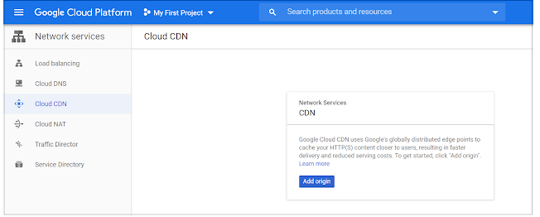

Create new HTTP(S) Load Balancer

Create and configure a load balancer with a custom origin.

* Defining the internet endpoint in an internet NEG.
* Adding an internet NEG as the backend to a backend service.
* Defining which user traffic to map to this backend service by configuring your external HTTP(S) load balancer's URL map.
* Allow listing the necessary IP ranges. (GFE)

From the Hamburger Menu go to Network Services -> Cloud CDN

Click Add origin on the screen and click on Continue on the Next screen. Select “Use a custom origin” and click on “Create a load balancer.

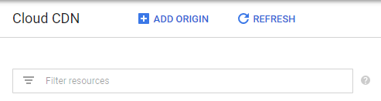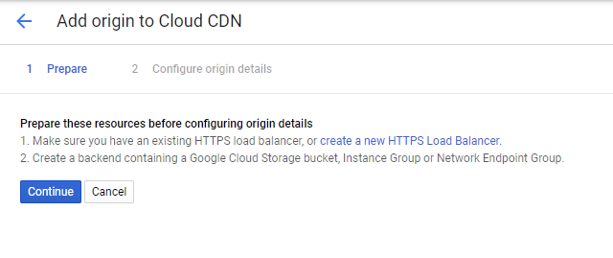

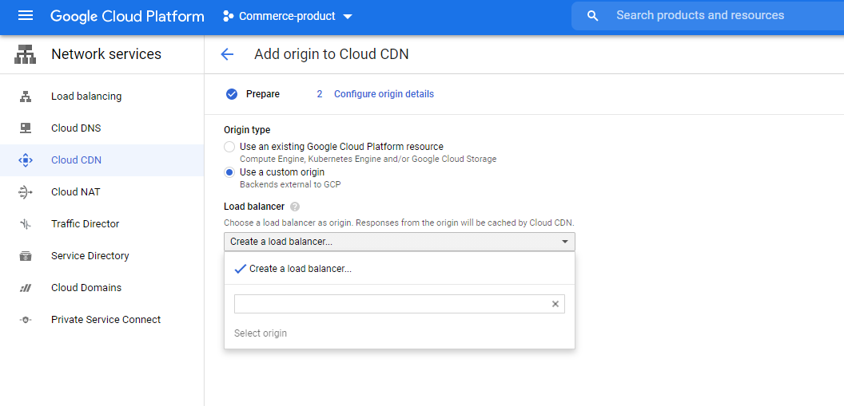

Enter a unique name for the load balancer. Click on back-end configuration and create a backend service.

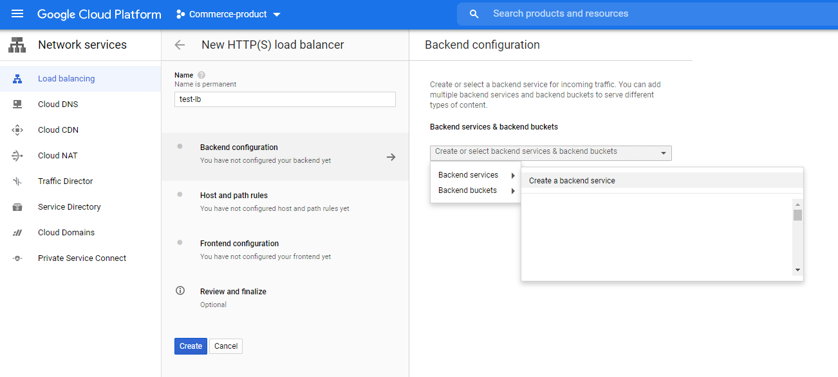

Enter a name and select backend Type as “Internet Network endpoint group”, change the protocol as required — this protocol will be used by Google Load balancer to connect to the origin server.

Select “Create Internet network endpoint group” from “Internet network endpoint group” dropdown.

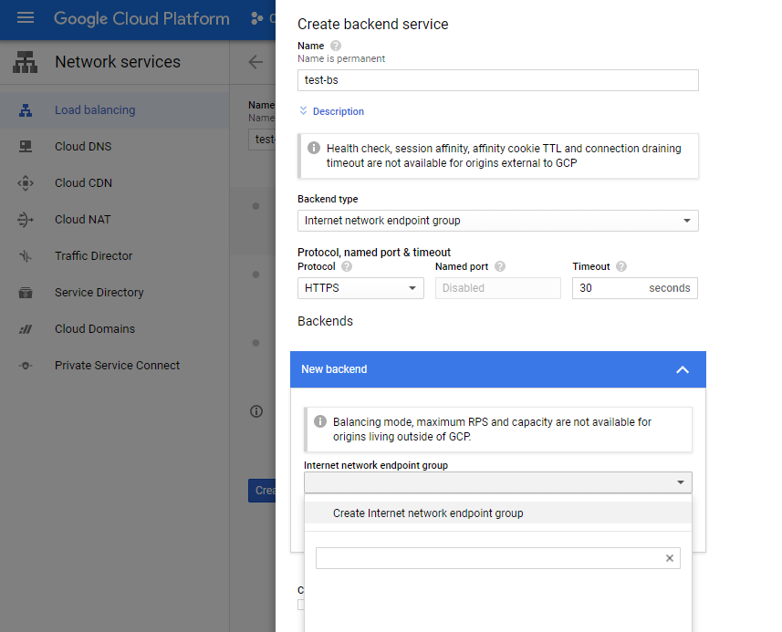

Enter a name for the Internet network endpoint group, select “Network endpoint group type” as Network endpoint group (Internet).

Add the default port to connect to origin server — my case the server is accessible through port 6443, enter the IP address or the Fully qualified name of the origin server.

Click on Create.

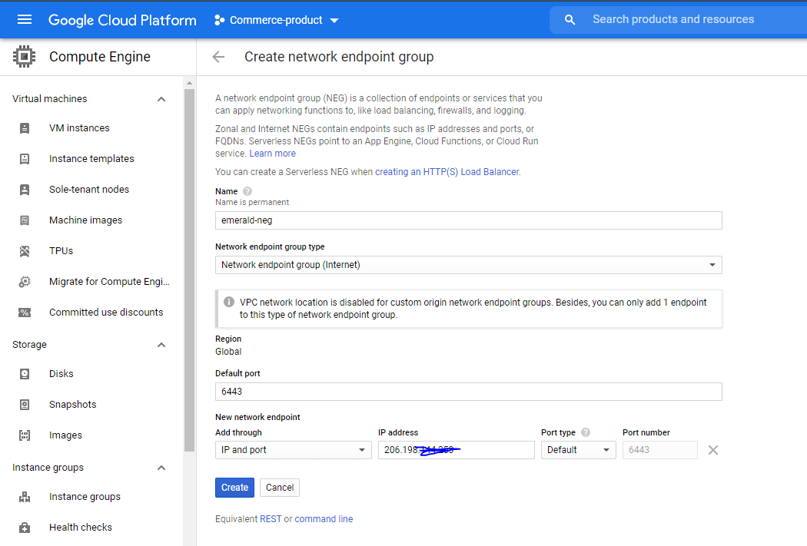

Select the created Internet network endpoint group in backend service configuration screen and click on Done.

Select “Enable Cloud CDN” and click on create.

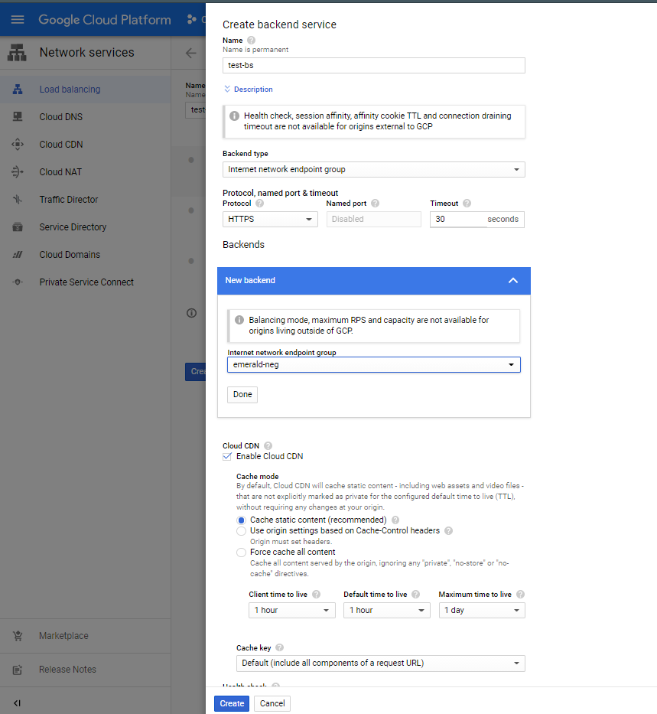

Select Host and Path Rules and enable the required rules. Currently going with default rule configurations.

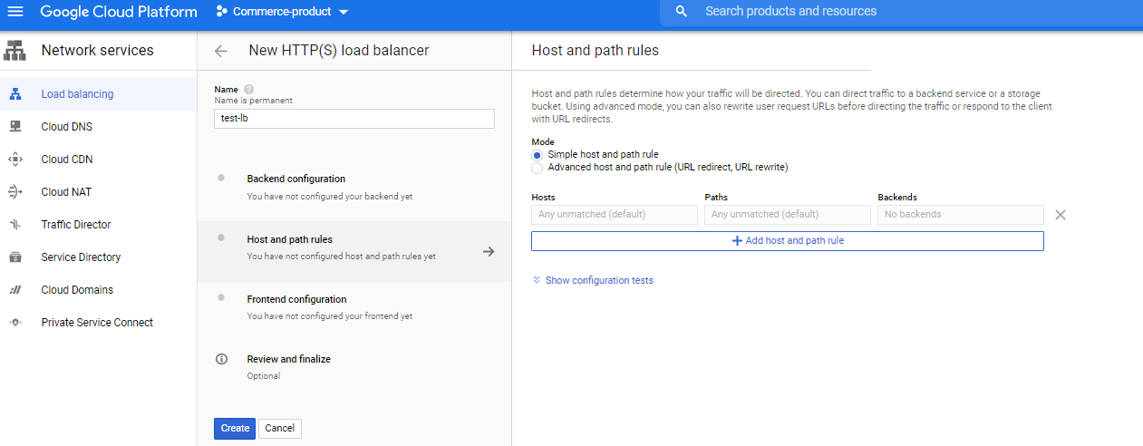

Now click on Frontend Configurations.

Enter a name.

Select the protocol users uses to connect to the website, the SSL certificate should be uploaded if the protocol is selected as HTTPS with supported Domains.

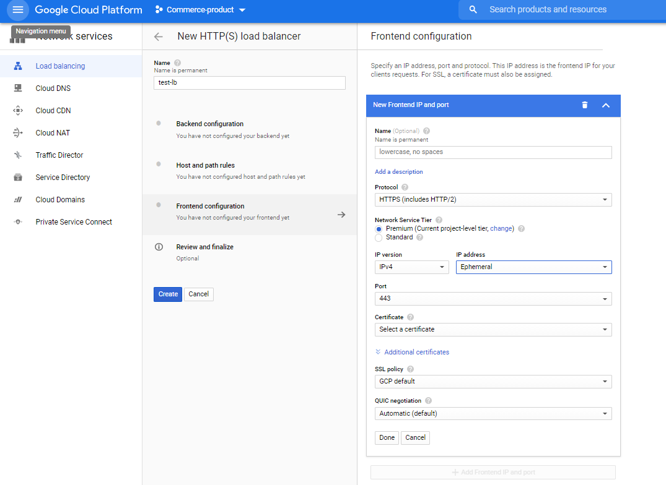

You can upload the existing certificate or create google managed SSL certificate.

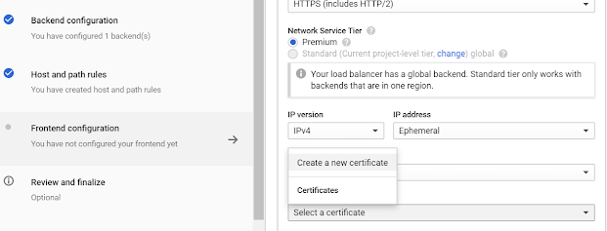

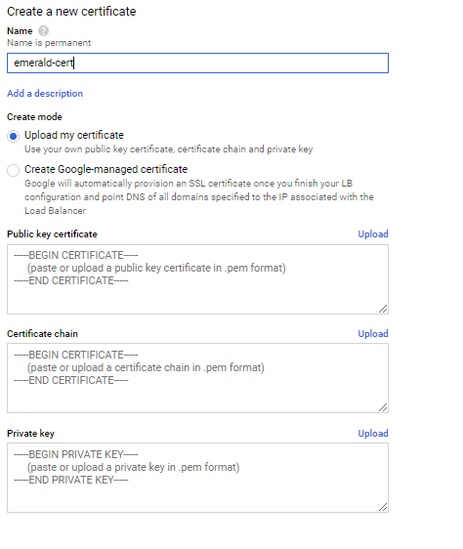

Enter a Name and choose Google Managed certificate and add the domain which you owns and then Click Create.

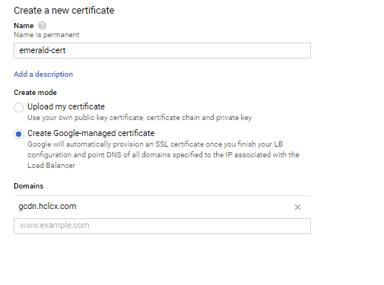

Create a new IP address — the default IP address lives for a short time, create a static IP address.

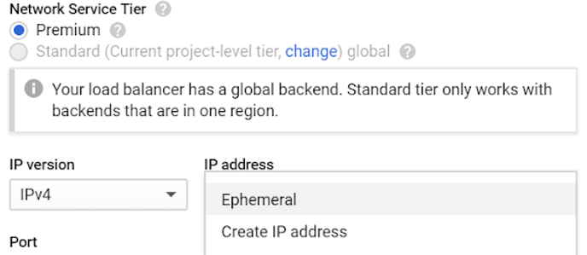

Enter the name and click on Reserve.

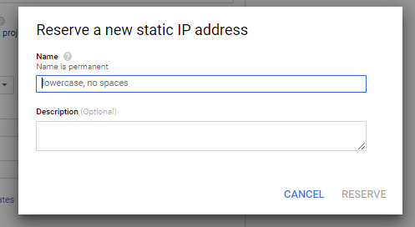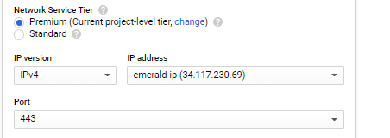

Review the configurations and click on Create.

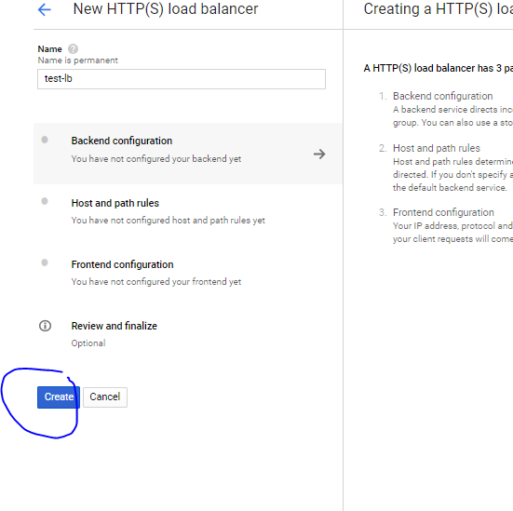

Now the HTTP(S) Load Configuration is ready and enabled with CDN.

Enable A-Record for DNS

Now your website is accessible through the Google CDN Front end IP, add a Record pointing to the Frond End Ip for the website DNS through the network provider (cloud DNS)

Example: gcdn.hclcx.com 34.117.xxx.xx

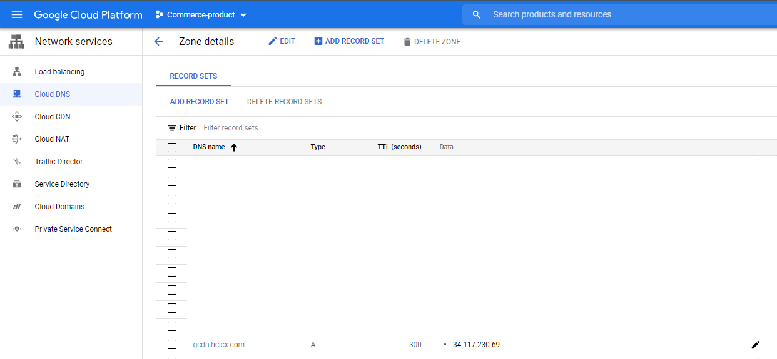

Now gcdn.hclcx.com should be accessible through Google CDN, you can monitor the traffics through the console.

