Looker On-Prem Installation Guide

For Looker On-Prem installation, we are referring the Customer Hosted Installation steps provided on the following link –

<https://docs.looker.com/setup-and-management/on-prem-install>

Steps to follow while installing Looker application for a customer-hosted deployment:

1. Installing Looker

* Add Looker to server
* Configure Looker startup options
* Configure SSL certificate for proper HTTPS
* Consider port forwarding for a cleaner URL
* Allow Looker support to access instance
* Set up Looker monitoring
* Set up Looker backups
* Ensure that Looker can access necessary services
* Install rendering software
* Determine if Looker instance can accommodate the Looker Action Hub

1. Enable secure Database Access
2. Configure Database for Looker
3. Connect Looker to Database
4. Test Database Connectivity
5. Configure Looker Sign-in options

As a pre-requisite, we have to install Linux (Ubuntu Linux LTS release) for internal Looker hosting. We can install Ubuntu on Windows 10 using following steps:

1. In Windows 10, enable Developer mode (type "develop" in the Windows search box on the taskbar and click Use developer features)

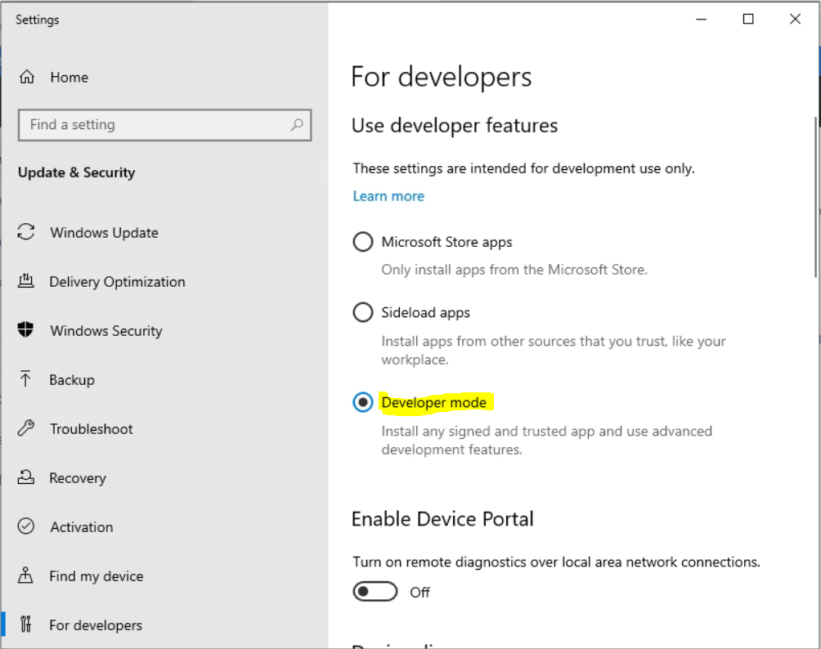

After you select **Developer mode**, Windows searches for and installs the Developer Mode packages.

2. Restart your computer.

3. Type "PowerShell" in the Windows search box and select Run as administrator from right-side options.

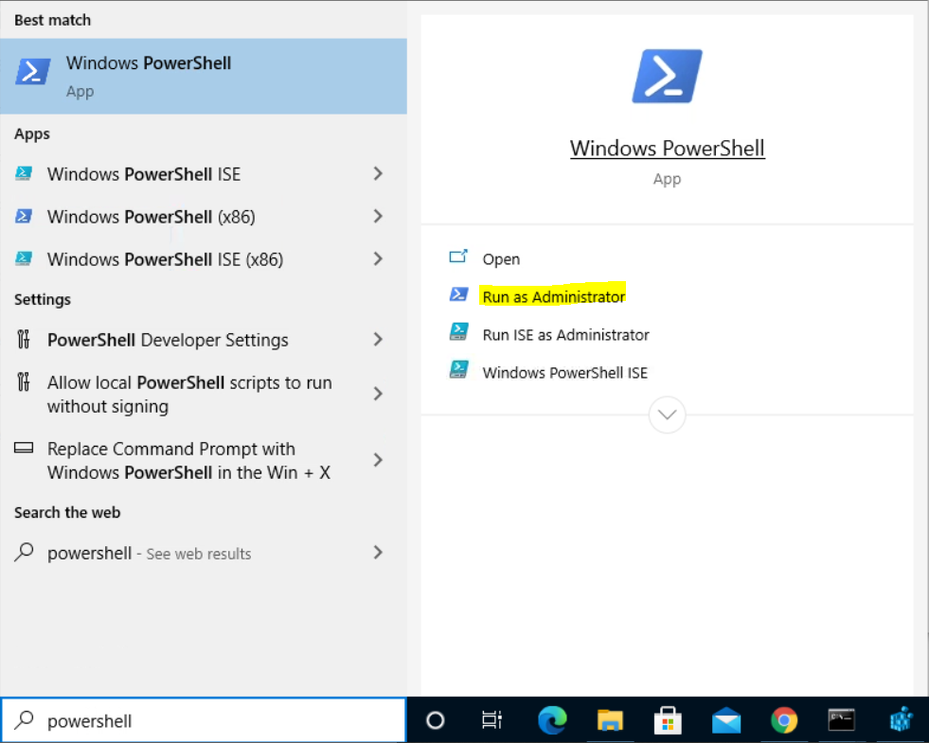

4. Run the following command in PowerShell to enable the Windows Linux Subsystem:

C:\> Enable-WindowsOptionalFeature -Online -FeatureName Microsoft-Windows-Subsystem-Linux

5. When prompted, select the option to restart the computer.

6. Visit the Microsoft Store and download Ubuntu.

7. After the download is complete, click the Launch button on the Ubuntu page in the store, or click the Ubuntu tile in the Windows Start menu.

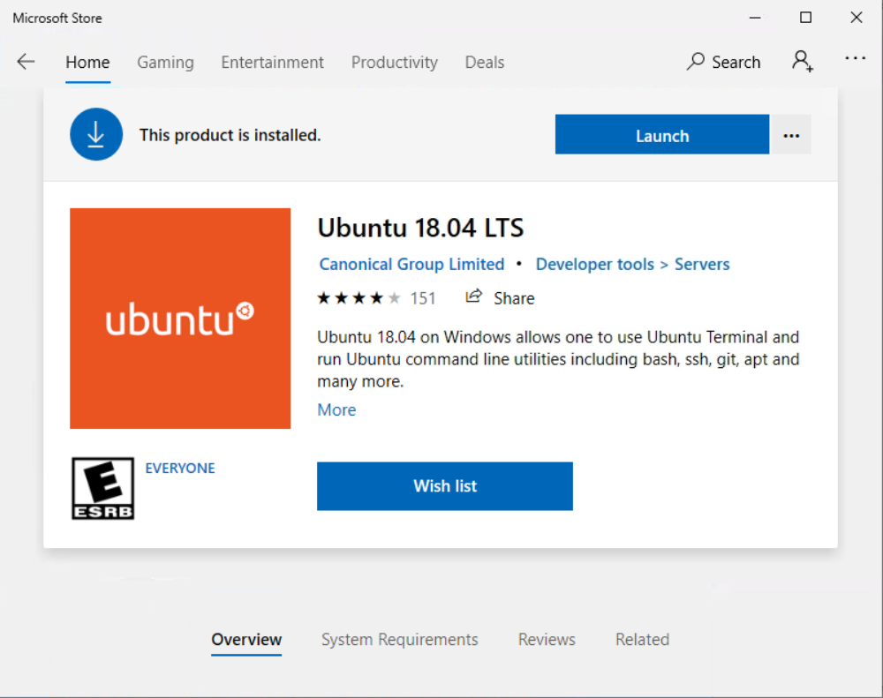

8. When prompted, enter a username and password for the Unix account (use a username and password you will remember).

9. You can now close the window and run linux directly at the command prompt. Go search and type "cmd", run the program and type the following command:

c:\> bash

10. Run the following housecleaning command (you will need to use the password you created):

$ sudo apt-get update  
  
11. Install JDK and JRE version 8 using commands:  
 sudo apt install openjdk-8-jre-headless  
 sudo apt install openjdk-8-jdk-headless

12. Install libssl-dev for libssl and libcrypt using command:  
 sudo apt-get install -y libssl-dev  
  
13. The /tmp folder must **NOT** be mounted with the noexec option  
 sudo mount -o remount,exec /tmp  
  
14. Install NTP for time synchronization using command:  
 sudo apt-get install ntp  
 sudo ntpq -p

(ntpq is a query tool for ntpd. The -p flag asks for information about the NTP servers (or peers) ntpd has connected to.)

For starting ntp servers, follow the steps:

1. Start a registry editor (e.g., regedit.exe).
2. Navigate to the HKEY_LOCAL_MACHINE\SYSTEM\CurrentControlSet\Services\W32Time\Parameters registry subkey.
3. From the Edit menu, select New, DWORD Value.
4. Enter the name LocalNTP, then press Enter.
5. Double-click the new value, set it to 1 to enable or 0 to disable, then click OK.
6. Restart the computer for the change to take effect.

After completing all these basic steps, we have to follow steps for installing Looker application from - <https://docs.looker.com/setup-and-management/on-prem-install/installation> under the heading “Install the Looker Application”.

**Note:** For step-7 under this, we have to enter the License key and registered email address to download the JAR file.

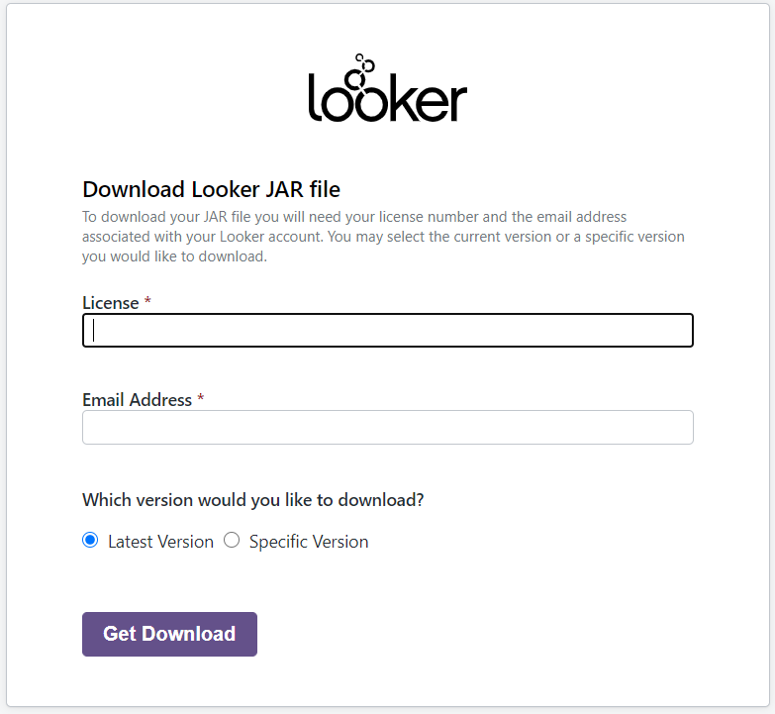

Download the startup scripts from the GitHub repo.  
<https://github.com/looker/customer-scripts/tree/master/startup_scripts>

After completing all the above steps, we can open the Looker on localhost using port 8080 (<http://localhost:8080/login>), and login using the registered email address and password set.

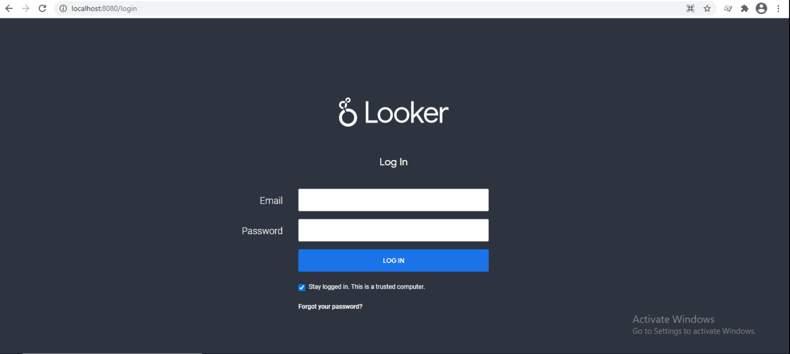

1. After Successful Login, the home screen will be displayed.

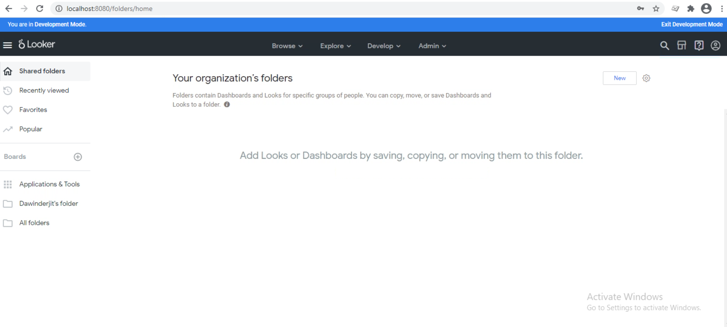

1. Create a database connection by selecting Connections option from Admin -> Connections

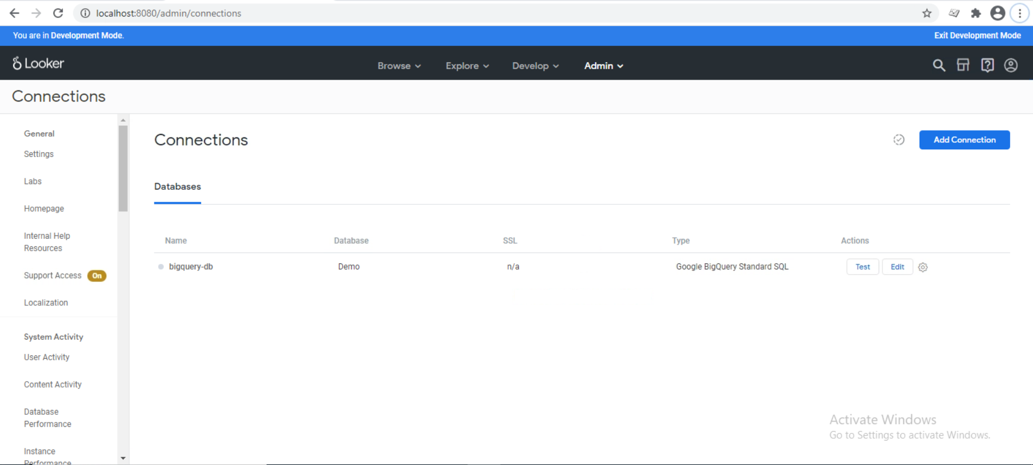

1. Here we can add a new connection or edit the existing connection.

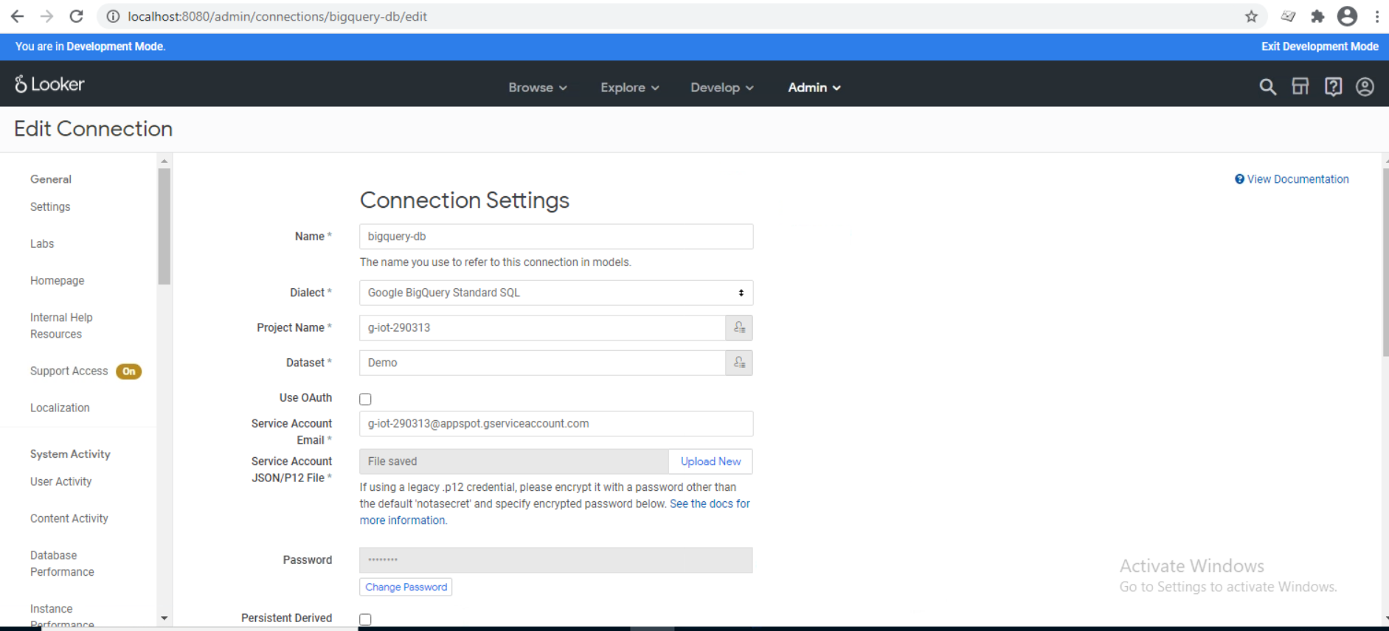

1. After adding connection, we can test the connection by clicking on the Test button.

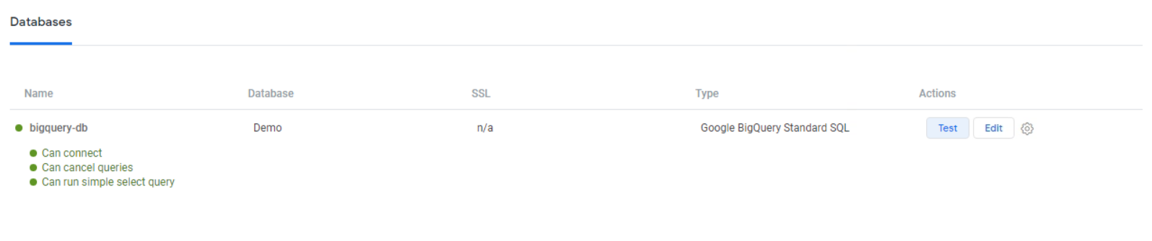

1. From Explore menu, select the table-name from the database added through connection. Select the fields from left panel which we wanted to get displayed on the report and on the right side we will get the visualization and data from table for the fields which we have selected.

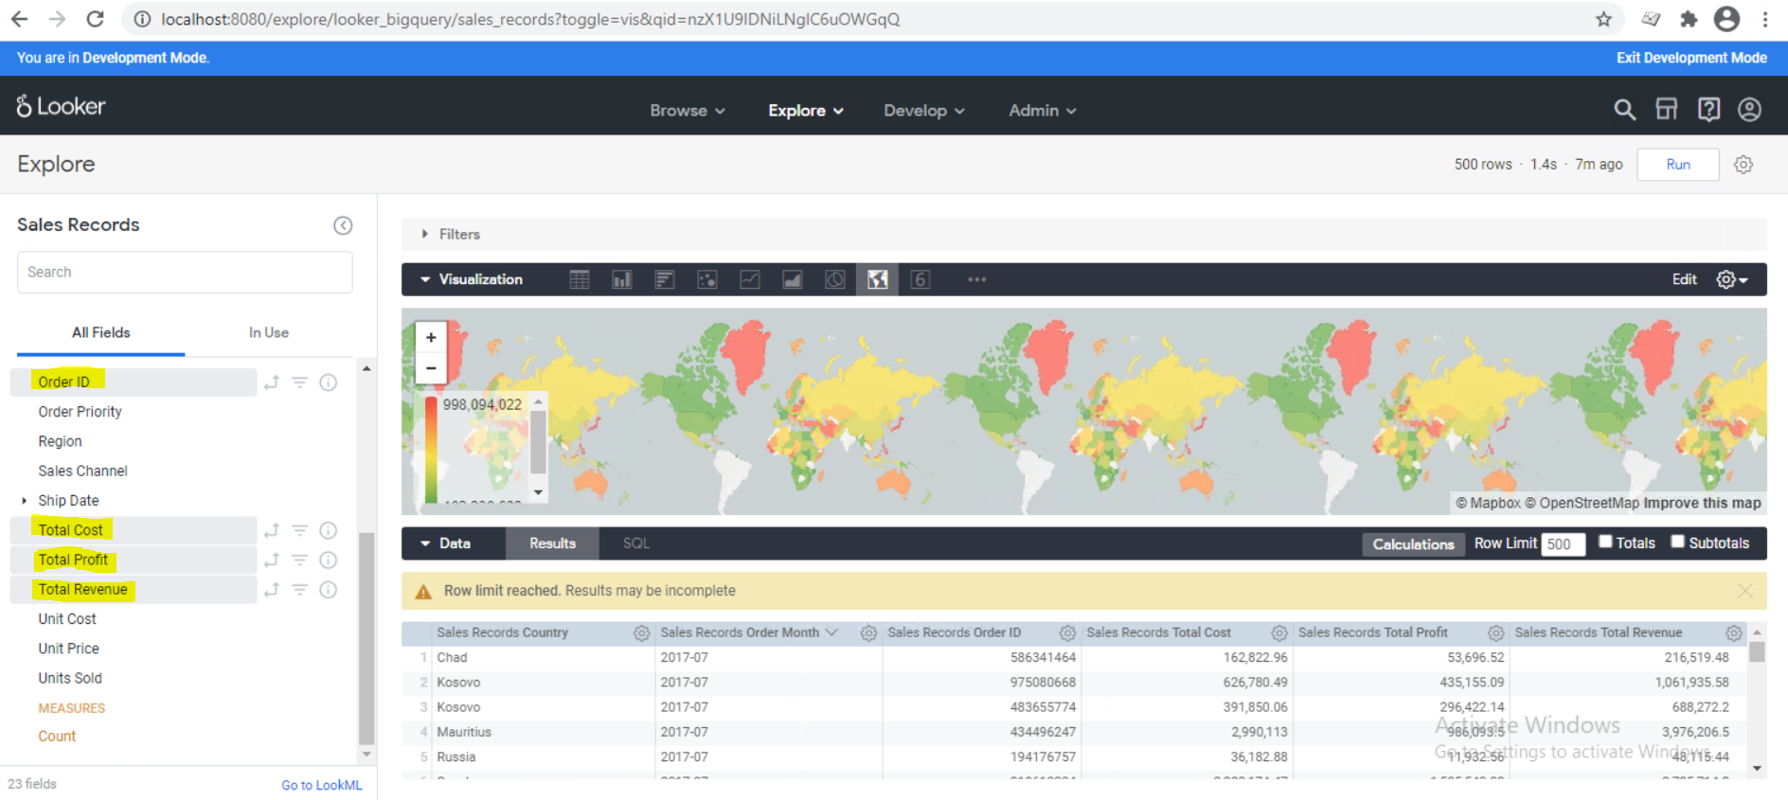

1. We can add this report to the dashboard, by selecting Save to Dashboard option from the settings icon. The below options are available on settings icon

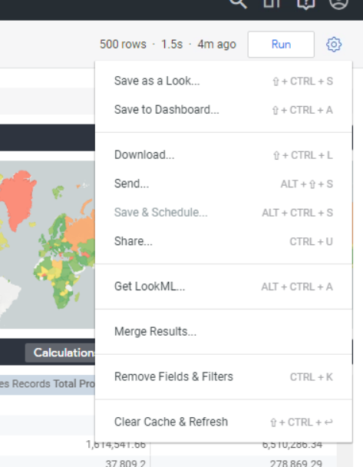

1. The popup will be displayed where we can add title to the report and the folder where we need to save that report.

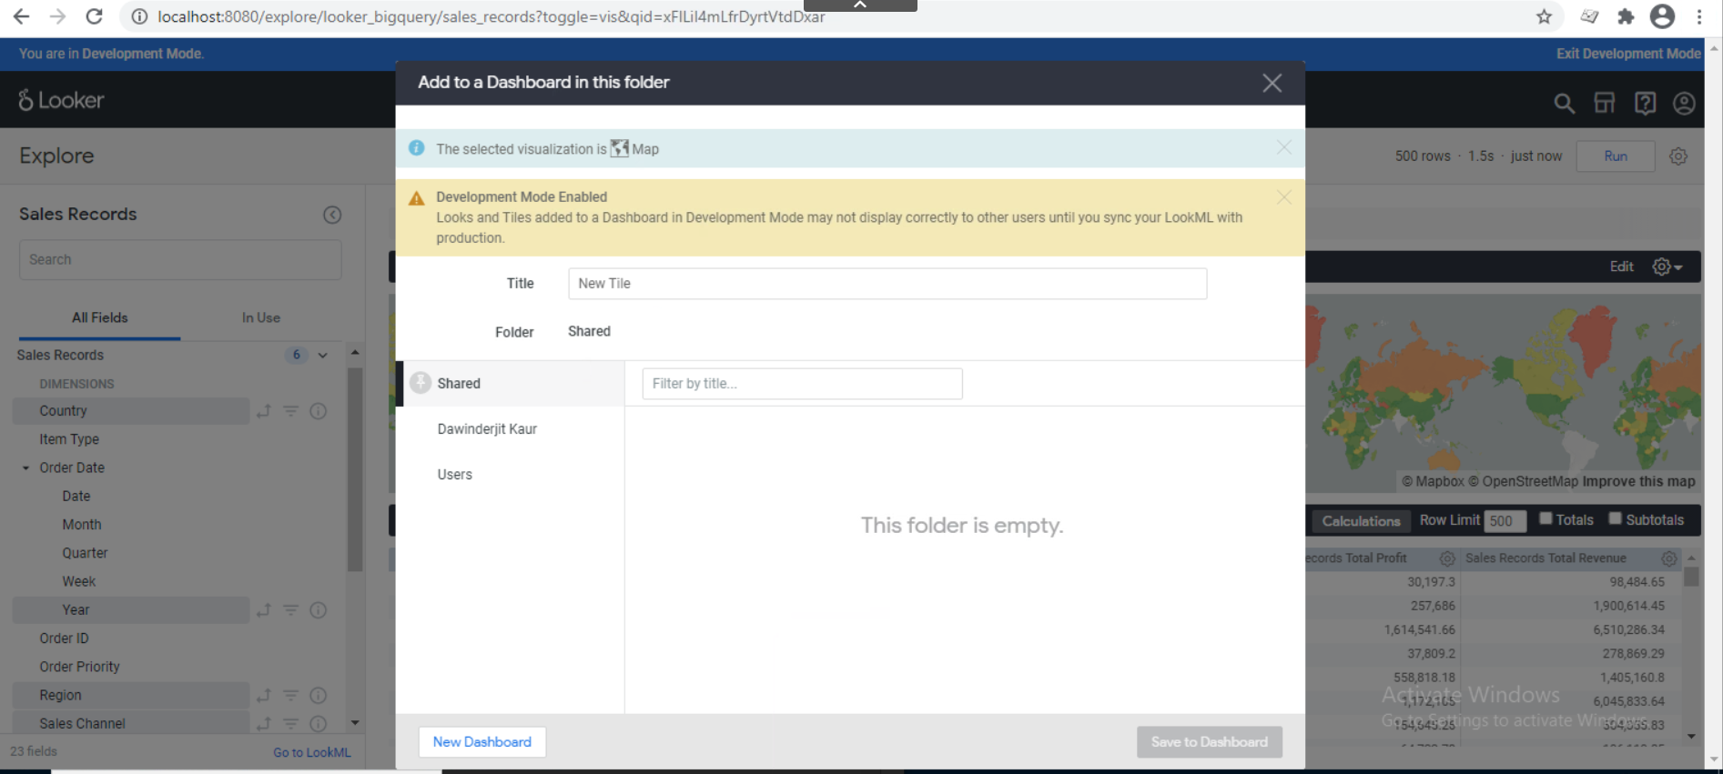

1. The report will be displayed on the dashboard.

