HCL Commerce Looker Integration

Requirements Outline

Create proof of concept to connect HCL Commerce with Looker to create the different reports and dashboard for data analysis.

Technology Outline Diagram

Looker is a great tool to create the different reports and dashboards that helps you explore, analyze and share real-time business analytics easily. Looker is an enterprise platform for BI, data applications, and embedded analytics that helps you explore and share insights in real time

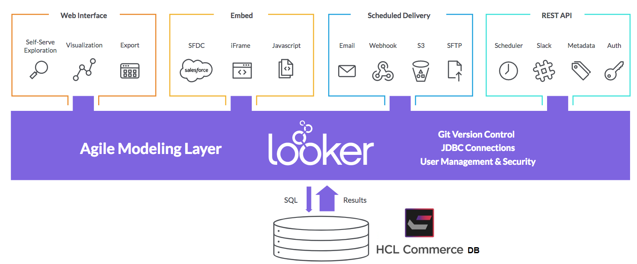

We will consider two Use cases for the POC.

* Connect Looker with Google analytics 360 with the help of BigQuery for the data which helps in analysing the user behaviour and product performance etc.

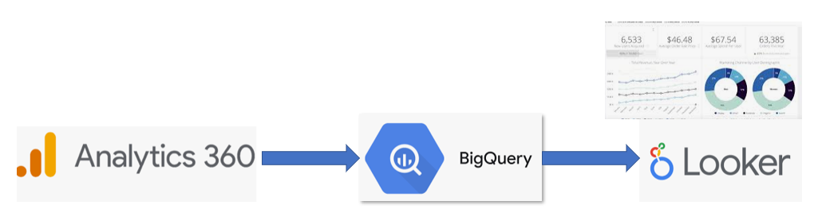

* Connect with HCL commerce DB to explore and analyse the data that helps to analyse the store performance.

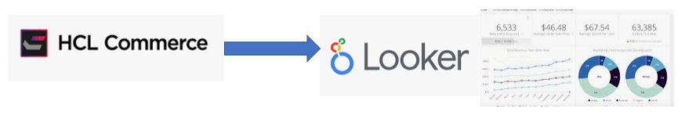

**Steps to work in Looker.**

* Connecting Your Data
* Modelling Your Data
* Collaborating on Your Model
* Visualising Your Data

1. Make a connection with DB and test it

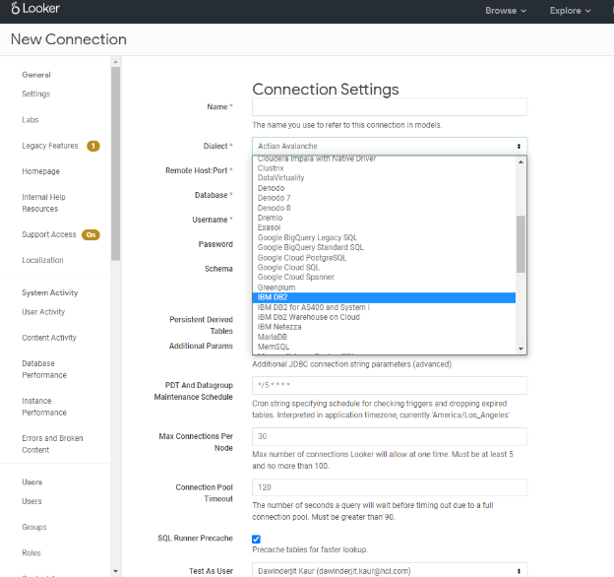

1. Create model, Explore and views in LookML based on the DB schema.

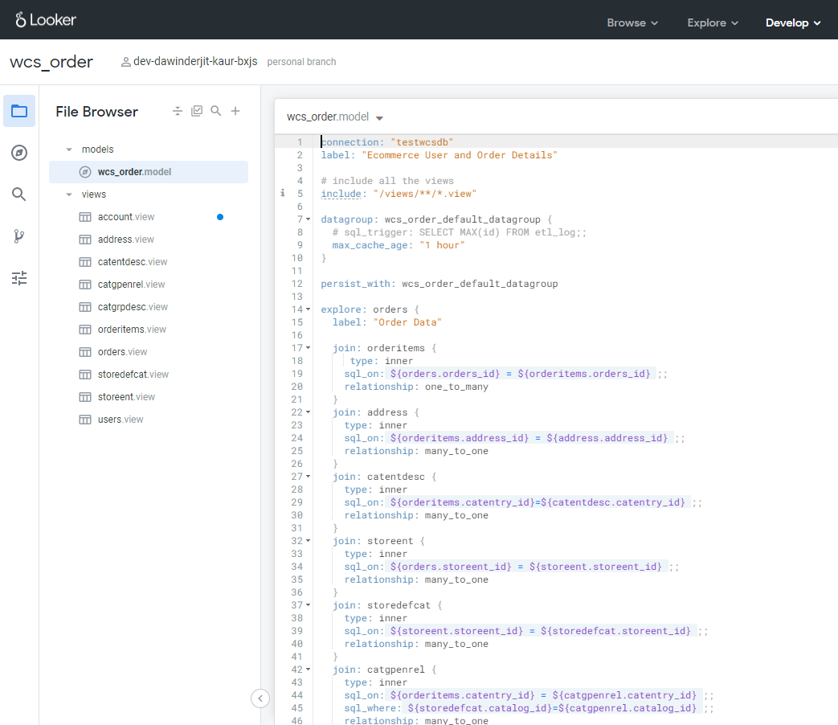

1. Create looks in the Explore section and save it to dashboard as a tile.

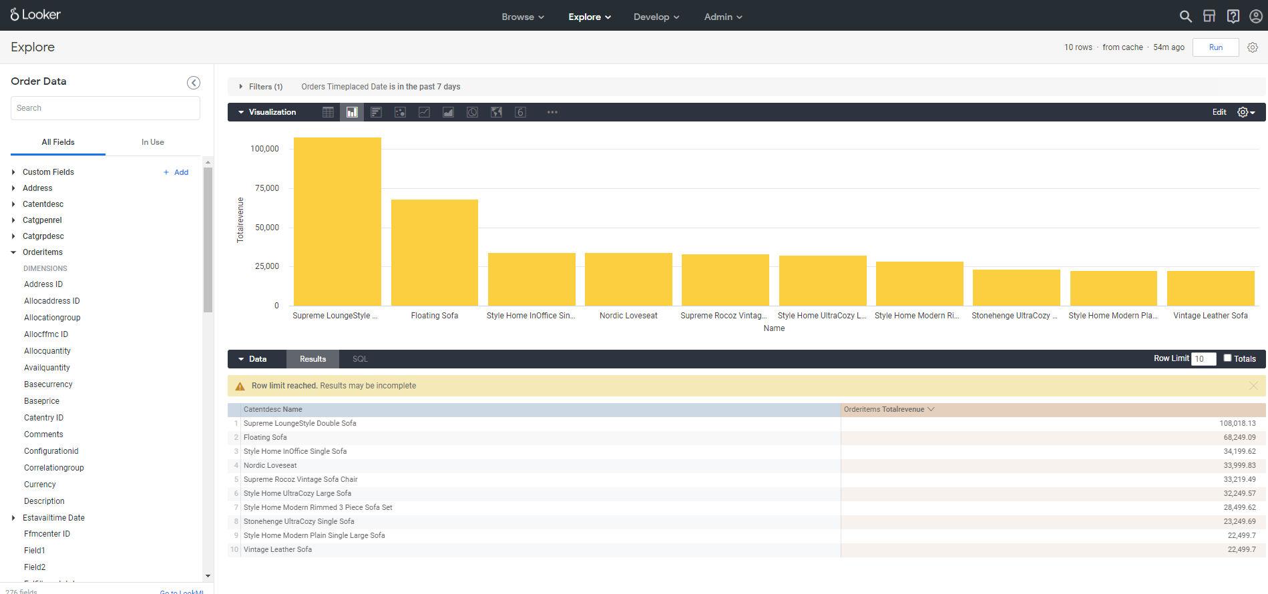

1. Check the Dashboard

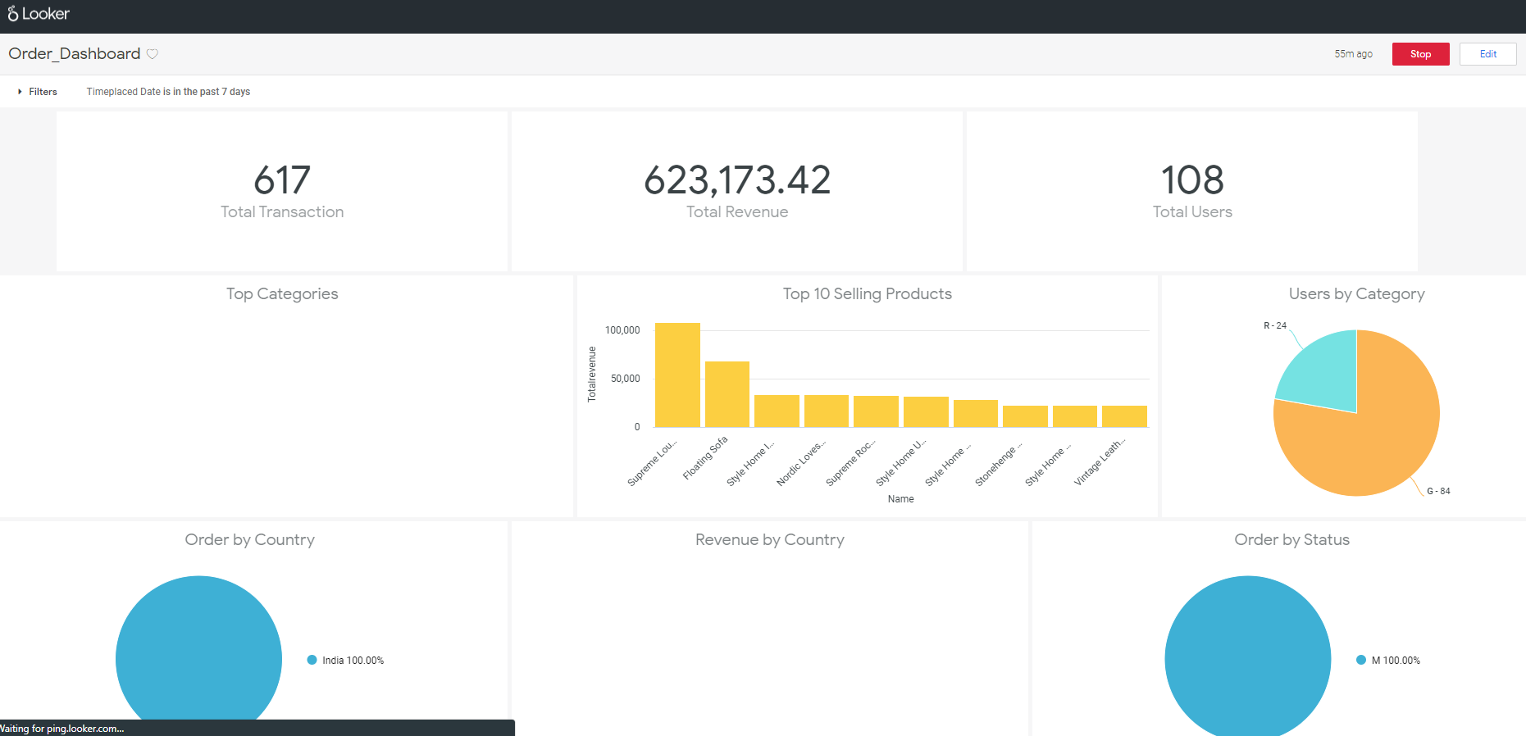

1. Commit your changes and push it to production.

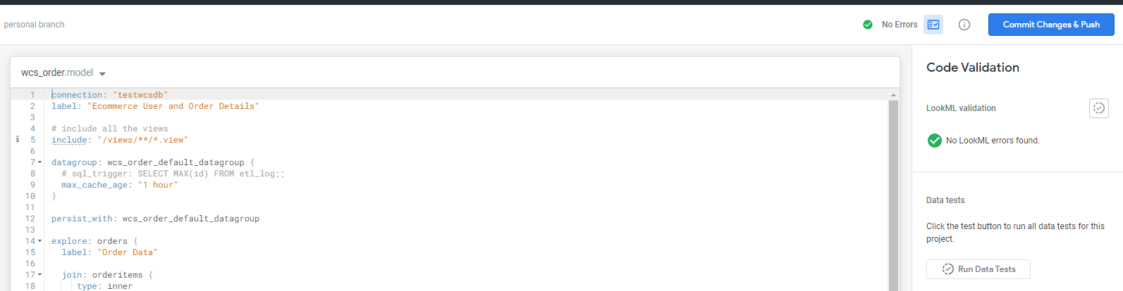

**Embed the Looker Dashboards in our store i.e., Management Centre**

Embedding the looker Dashboard requires the below things.

1. Generate the Looker Secret Key

* Go to the Embed page in the admin section of Looker.
* Select Enabled from the Embed Authentication drop-down and then press Update.
* Press the Set Secret button to generate you embed secret.

Note: Be sure to copy this secret to a secure location because you will not be able to retrieve it from Looker again without resetting it. Resetting the key will break any embeds using the old key.

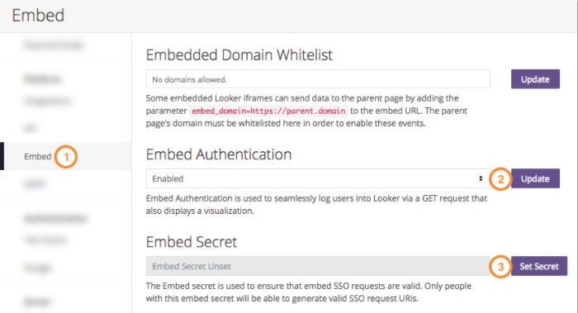

1. Building the Embed URL

An SSO embed URL has the following format:



**HOST** - The host is the location where your Looker instance is being hosted

**Embed URL:**

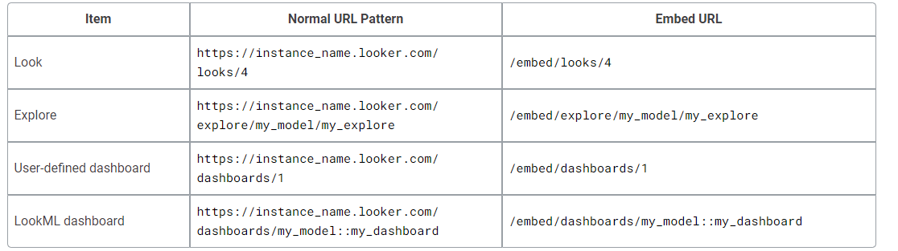

**Parameters**:

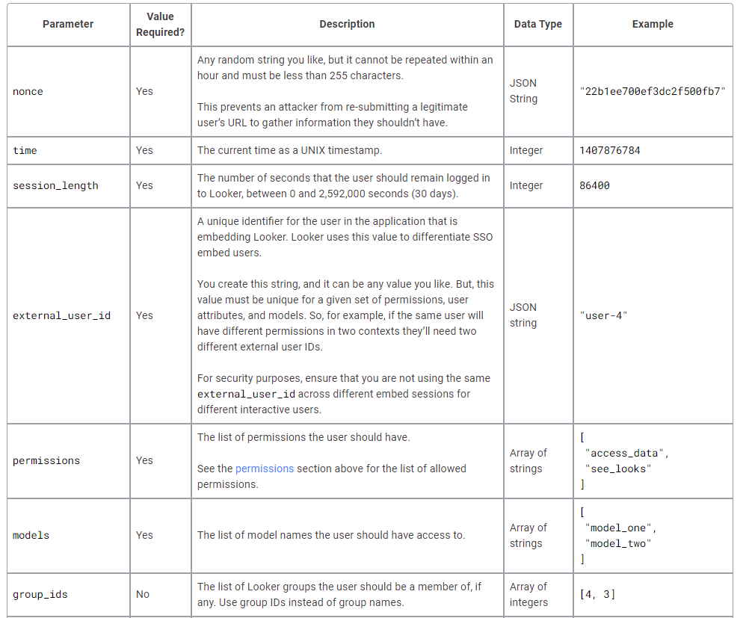

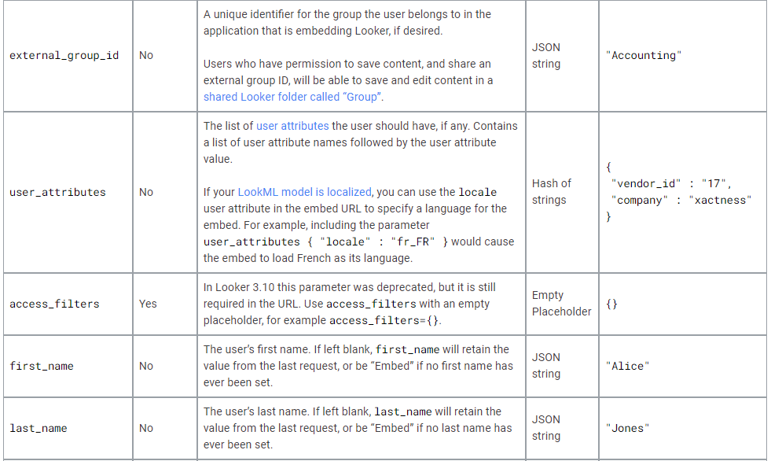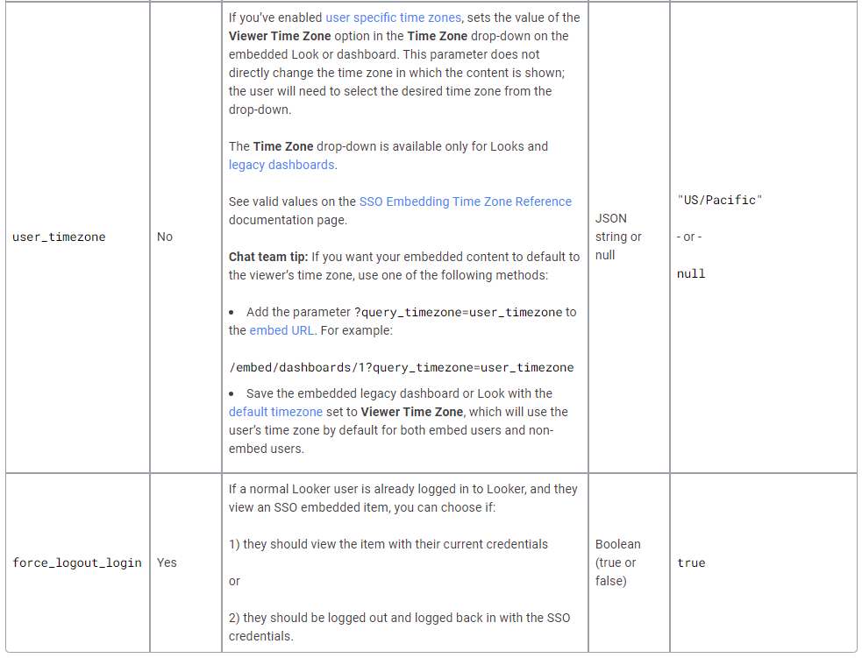

**Signature**

To generate the signature, you will need to follow these steps.

1. Gather the following parameter values in this order:

Host, followed by login/embed/ (for example, analytics.mycompany.com/login/embed/)

Embed URL

Nonce

Current Time

Session Length

External User ID

Permissions

Models

Group IDs

External Group ID

User Attributes

Access Filters (requires an empty placeholder)

1. Format all values other than Host and Embed URL as JSON
2. Concatenate the values with line breaks (\n)
3. HMAC sign the concatenated string with your Looker embed secret

**Encoding**

The final step is to URL encode your URL.

Before you encode the URL, a properly formatted embed URL that uses all possible parameters might look like this:

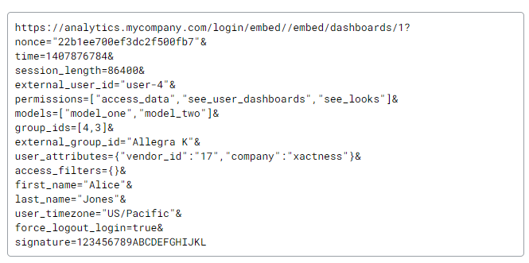

As noted above, it is correct for /embed//embed/ to appear in your URL.

After you encode the URL, it would look like this:

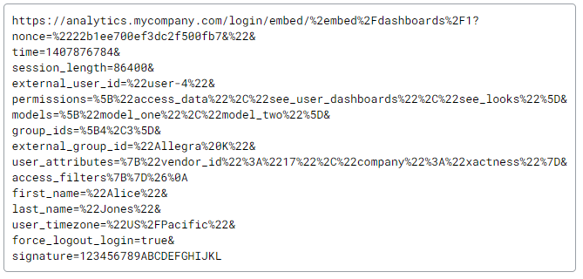

Once URL is created, it can be used inside Iframe.

<iframe src=” <embedURL>”></iframe>

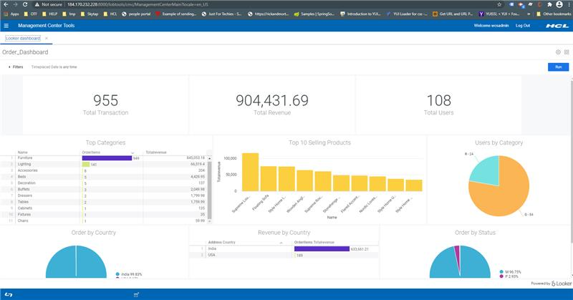

Permission detail that needs to be set while creating embed URL

