BARCODE SEARCH

**Requirements:**

Provide the capability to search HCL Commerce Catalog using barcode recognition on React Stores.

**User Flow:**

React Webcam Barcode Scanner is used to request access to the customer's camera to capture the barcode from the live image. It reads the barcode type of **code128, EAN and UPC-A**.

The barcode icon is displayed in the search Bar. When the user clicks on the barcode icon the first time, the computer will ask for permission to allow the webcam to start.

Once a user allows it, the webcam will start, the barcode library will be initialized and starts the video-stream and begins locating and decoding the barcode from the live image.

Once Barcode is detected, detected text will appear on the search box.

Below the screenshot of the Barcode scanner.

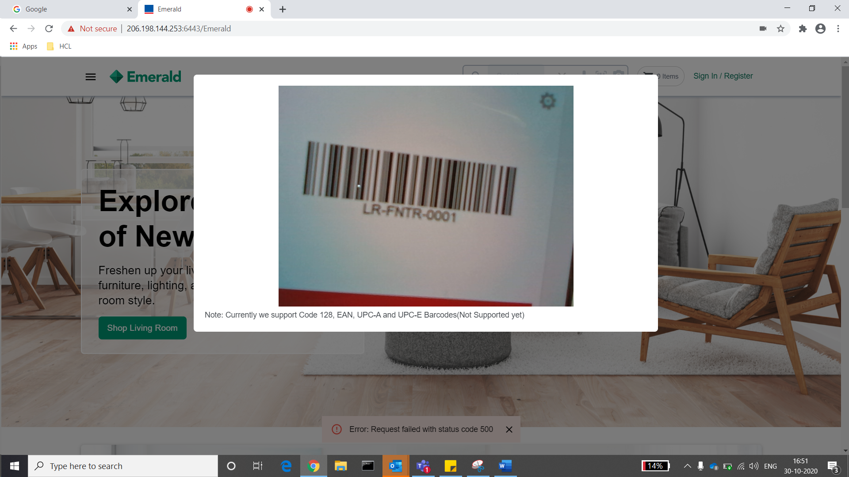



Once barcode is detected, search will happens and results will be displayed like below:

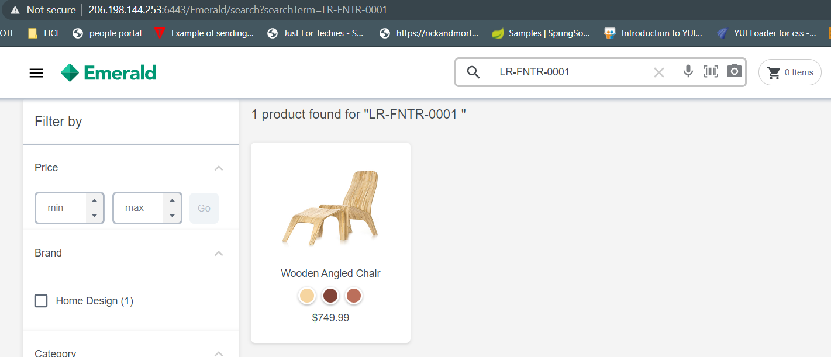

Note:

-The Barcode Scanner currently supports only Code128 barcode,EAN and UPC-A.

-The library “react-webcam-barcode-scanner “used for scanning barcode doesn't support in IOS chrome as this library uses HTML5 Media API “getUserMedia” which is not supported by chrome in IOS. Hence, we have hidden the barcode scan icon for the above scenario.

**Steps to include the Barcode scanner in your project:**

1. You need to install the ‘react-webcam-barcode-scanner’ in your project as a dependency.

react-webcam-barcode-scanner can be installed using npm.

> npm install react-webcam-barcode-scanner

Once installation is done, Verify the entry of react-webcam-barcode-scanner in your package.json file .

1. Include “search-types” folder in src/components/widgets folder.
2. The Folder search-type has following files required for barcode scanning.

**BarcodeScan**.tsx - It's a component and has barcode icon in it and on click of the icon, it will call BarcodeScanner.js file to initialize the react-webcam-barcode-scanner and show camera to scan the barcode so, once barcode is detected, text will get set in the search box with the help of props.

**SearchTypes**.scss - It has styling code used to prettify the component.

**Search-types**.tsx - It has the code to call the barcode component from search box.

1. Below changes need to add in the SearchBar.tsx file present in src/components/widgets/search-bar folder

We have created a Search Type component to specify the search type for the user.

User can configure this according to his choice

- Import this file in the SearchBar.tsx file.

import { SearchTypes } from "../Search-types/search-types";

This component can be used as below.

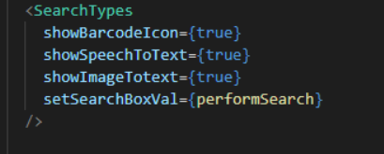

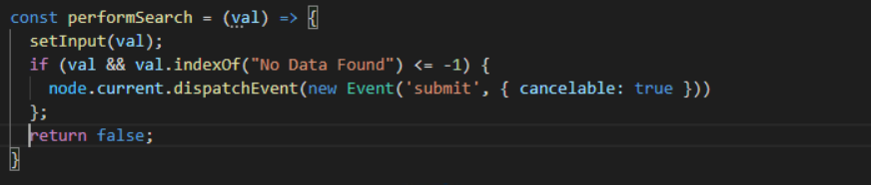

showBarcode Iconà used for barcode scanning.

showSpeechToText à used for Voice transcribe.

showImageToText à used for Image search.

setSearchBoxValà used to set the value of the search result.

Set true for showBarcode attribute and set false to other attributes.

1. The Search Types component looks like below.

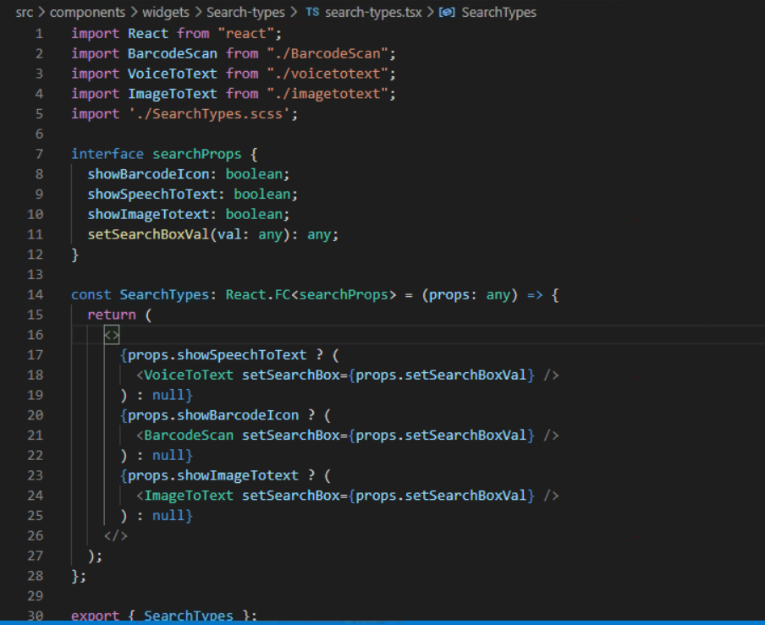

In this document we will see only the Barcode Scan Component.

1. The barcodeScan.tsx file look like below:

The partial snippet:

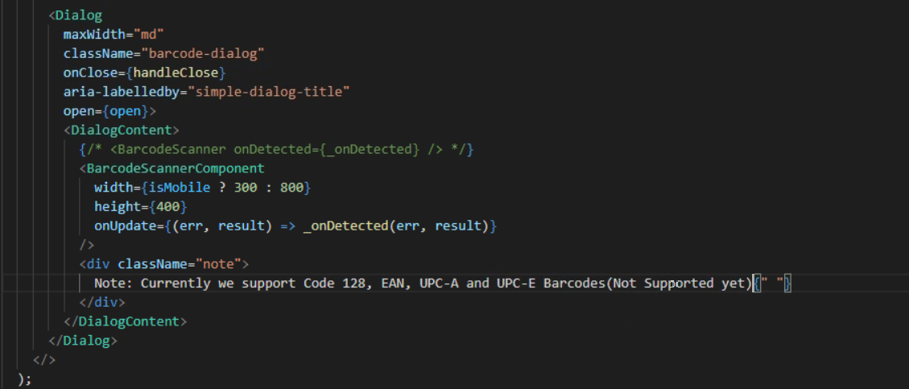

We have used the BarcodeScannerComponent for showing the barcode scanner. This component is imported from the react-webcam-barcode-scanner.

Whenever the scanner come across a barcode. It calls the onUpdate method and send the result. As we see the method called below. It uses the getText method to get the encoded text in the barcode. If the barcode is invalid, it gives an error as output.

Once we get the text. The search box is populated with it.

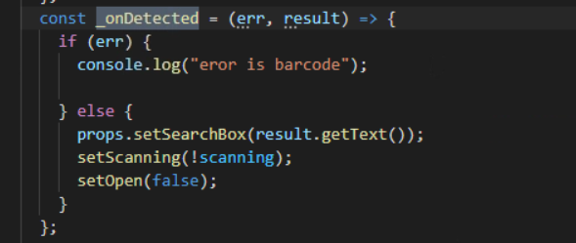

Iconify library is used for the barcode icon.Install iconify and icon-mdi using the script below.

>npm install @iconify/react @iconify/icons-mdi



8. SearchTypes.scss file - it has all styling code for all three assets (voice ,image and barcode scan search) .Below is the css for barcode scan

