ECOMMERCE WEB APPLICATION

Technical Story Card

Revision History
Version No. | Date | Prepared by / Modified by | Significant Changes
1 | 1 May 2022 | TEAM4 | Draft version

Glossary
Abbreviation | Description
BSC | Business Story Card
TSC | Technical Story Card

Table of Contents
1 Introduction 4
2 Scope of Change 4
3 List of impacted modules 4
4 Design and Detailed technical updates 5
4.1 Process Model
4.1.1 Use case Model 5
4.1.2 Class diagram 6
4.1.3 Sequence diagram……………………………………………………………………………………….7
4.1.4 State diagram………………………………………………………………………………………………8
4.1.5 Data Flow diagram…………………………………………………………………………………9-10
4.2 Description……………………………………………………………………………………………………….11-13
4.3 Architecture 14
5 Other Technical changes 15
6.1 CI / Build relates tasks / changes 15
6.2 Non-functional related changes 15
6 Additional details 16
7.1 Open Questions / clarifications / Assumptions 16
7.2 Additional notes to technical team 16
8 References 16

1 Introduction
The objective of this project is to develop a general-purpose e-commerce store where any product (such as books, CDs, computers, mobile phones, electronic items, and home appliances) can be bought from the comfort of home through the Internet. However, for implementation purposes, this paper will deal with an online book store.
An online store is a virtual store on the Internet where customers can browse the catalog and select products of interest. The selected items may be collected in a shopping cart. At checkout time, the items in the shopping cart will be presented as an order. At that time, more information will be needed to complete the transaction.
Usually, the customer will be asked to fill or select a billing address, a shipping address, a shipping option, and payment information such as credit card number or cash on delivery. An e- mail notification is sent to the customer as soon as the order is placed.

Scope of Change
Change will not be entertained and whatever specifications mentioned in this document is final.

3 List of impacted modules
All the functional modules will be created from scratch.

Design and Detailed technical updates

4.1 Process model

Use case Model

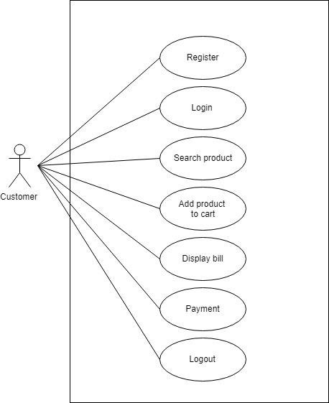
4.1.2 Class diagram

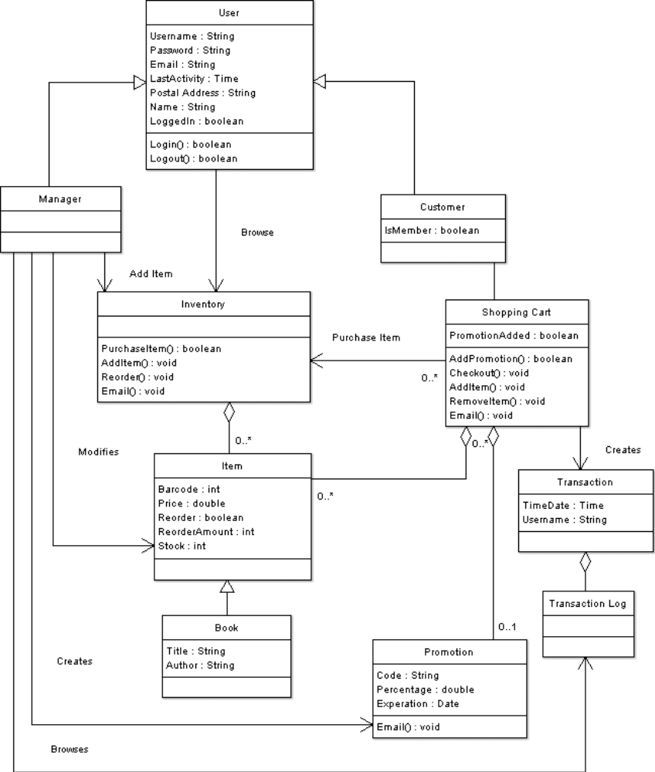

Sequence diagram

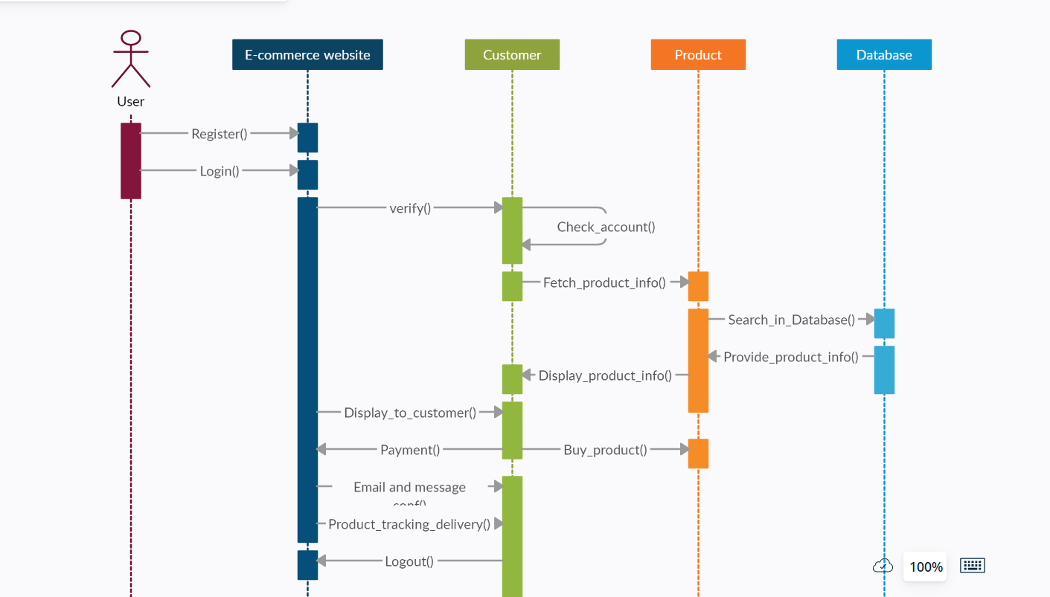

State diagram

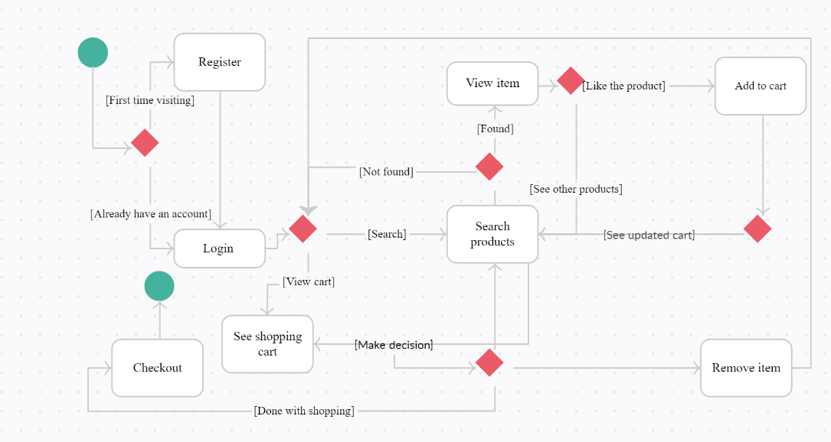

Data Flow diagram

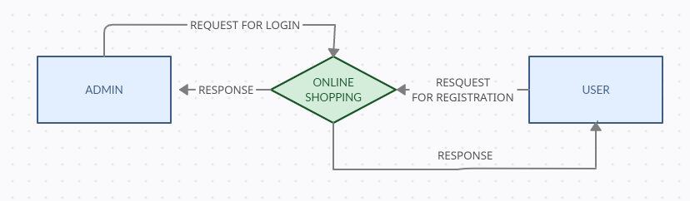

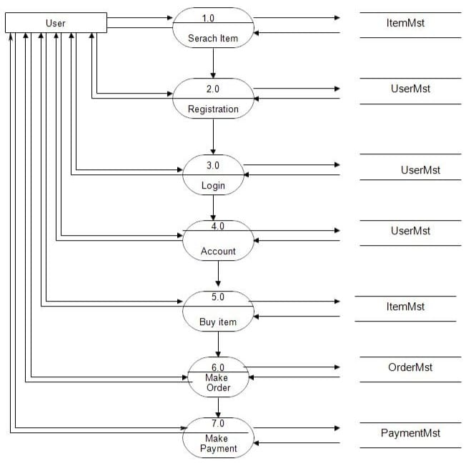

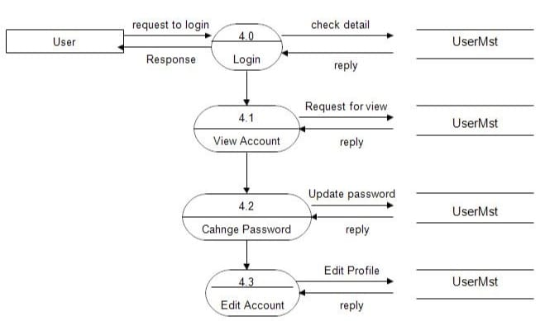

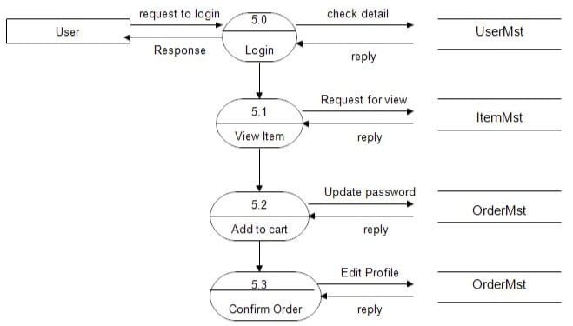

4.2 Description

i. Registration Page

Brief Description | Registration Page
Basic Flow | This page describes how a customer gets a profile created .  - The customer has to register himself into the system.  - The following information is required for Registration.  - First Name  - Last Name  - Email Id  - Phone Number  - Password  - Confirm Password  - Address
Alternate Flow | 1.The system will validate the credentials provided.
Validation | - Valid Username or Mail ID  - Password is similar as Confirm Password
Pre-Conditions | User should have network access and Browser with latest updates.
Post-Conditions | Landing page has to be displayed.

ii. Login Page

Brief Description | Login Page
Basic Flow | This page shows how an Customer gets into login page  1.The customer has to register himself into the system.  2.After the successful registration, user will be taken to the appropriate login page.  3.The following information is required to login.  - Username or Mail Id  - Password
Alternate Flow | 1.The system will validate the credentials provided. If credentials are invalid, login form will be redirected again with error message.
Validation | 1.Valid Username or Mail Id  2.Valid Password
Pre-Conditions | User should have an account which is registered.
Post-Conditions | Home page has to be displayed.

iii. Home Page

Brief Description | Home Page
Basic Flow | This page shows all the category of items that are available to the customer in the application to buy.
Alternate Flow | 1.The customer will select the items by browsing or searching in the search bar. If required item is not available it shows no item available.
Validation | 1.Checking whether user account is existing or not.
Pre-Conditions | User should have logged in to the website with existing account.
Post-Conditions | User should be able to add the items to the cart.

iv. Cart Page

Brief Description | Cart Page
Basic Flow | This page shows all the items that are selected by the customer to buy.
Alternate Flow | 1.This leads to the payment page if items are selected else it shows an error as “Please select at least one item”.
Validation | 1.User should add at least one item to the cart.
Pre-Conditions | User should have logged in to the website with existing account.
Post-Conditions | User should be able to make the payment .

v. Payment Page

Brief Description | Payment Page
Basic Flow | This page shows different modes of payment available for the customer. It has either options of cash on delivery or online UPI payment .
Alternate Flow | 1.This leads to the payment page if items are selected else it shows an error as “Please select at least one item”.
Validation | User details about the payment are verified .
Pre-Conditions | User should select items that he want to purchase.
Post-Conditions | User is taken to order confirmation page showing the order summary.

vi. Confirmation Page

Brief Description | Confirmation Page
Basic Flow | This page shows the items that customer made the payment for and the order summary i.e., delivery date and price of the order .
Alternate Flow | This leads to the payment failed page if the online transaction is not successful.
Validation | User online payment is authenticated.
Pre-Conditions | User online payment must be successful.
Post-Conditions | User can see order summary and should be able to go back to the home page.

4.3 Architecture Diagram

Layer
Logical View
Technology/ Framework

UI Components
Presentation Layer
HTML/ CSS/ JavaScript/ AJAX/ Angular
Export (pdf)
Validations
Resources

Report

Web-Server Classes
Java 1.8/ Spring MVC
Application/ Business Layer
Configuration
Controllers

Service
REST Controllers

Entity/ Model Classes

Data Access Layer
Repository classes
Hibernate ORM

Oracle 11g Database

Presentation Layer:
This layer consists of all UI components.
- Export component: The plug-in is used to export the reports in pdf format. It helps to reduce the workload on the web/ application server.
- Validation component: All basic level data validations should be done at UI level.
- Report component: All reports to be generated to the user, will be processed and generated at the browser end.
- Resources: All HTML/CSS/ images, which are required for the page design.
Application Layer:
This layer comprises of all server and business classes.
- Configuration settings (XML or Class based) will define the application and server configuration.
- Spring Controllers defines the server classes, which are required to process the incoming http requests.
- Service classes are required to perform the required business services.
- REST Controllers to process the HTTP AJAX requests.
- Model classes are used the define the functions of the entities present in the system.
Data Layer:
Data layer is implemented through Hibernate ORM. It will contain the repository classes, which provides interface to the table.

Other Technical changes

CI / Build relates tasks
<If the story requirements are about implementation of continuous integration or build, update the details to be done here>

Non-functional related changes
<Non-functional requirements related to response time, System load or Network load>

Additional details

Open Questions / clarifications / Assumptions
<Mention the details of any open technical questions/clarifications or assumptions made, pertaining to story >

Additional notes to technical team
<provide details if any>

References
https://angular.io/start
https://www.javatpoint.com/spring-tutorial
https://www.oracletutorial.com/oracle-basics/
https://www.restapitutorial.com/lessons/httpmethods.html

