**NATIONAL UNIVERSITY**

**INTERNATIONAL UNIVERSITY – HCMIU**



**- PROJECT REPORT -**

**Algorithms & Data Structures**

**2048 Game**

**CONTENTS**

1. Introduction
2. Project’s details
3. Group contribution
4. Implementation
5. References
6. **INTRODUCTION**

***2048*** is a single-player sliding block puzzle game designed by Italian web developer *Gabriele Cirulli* **[1]**. The game's objective is to slide numbered tiles on a grid to combine them to create a tile with the number 2048. However, you can continue to play the game after reaching the goal, creating tiles with larger numbers.

***2048*** is played on a gray 4×4 grid (or you can change the size of the game in whatever size you prefer), with numbered tiles that slide smoothly when a player moves them using the four arrow keys.Every turn, a new tile will randomly appear in an empty spot on the board with a value of either 2 or 4. Tiles slide as far as possible in the chosen direction until they are stopped by either another tile or the edge of the grid. If two tiles of the same number collide while moving, they will merge into a tile with the total value of the two tiles that collided. The resulting tile cannot merge with another tile again in the same move. Higher-scoring tiles emit a soft glow.

1. **PROJECT’S DETAIL**

Our game is fully coded in mostly *JavaScript*. There is also *HTML* in a part of our game.

At first, we did lots of coding in many languages but we agreed to choose *JavaScript* and *HTML* to develop 2048 game in the end.

This project has been implemented to 3 features: ***Resize***, ***Undo*** and ***Redo***

* ***Resize****:* You can change the tiles into whatever size you prefer; from 8x8, 16x16 or even ridiculous one like 12x5!!! But this feature can be done in console only!
* ***Undo:***Go back one step at a time and you can press anytime you want (we did thought about limiting how many time you can use this feature, but we faced with lots of bugs and removed it)
* ***Redo****:* If you think your undo-move is not quite good as you imagine, you can press Redo button in order to step forward to fix your mistake (we did thought about limiting how many time you can use this feature, but we faced with lots of bugs and removed it)

1. **GROUP CONTRIBUTION**

|  |  |  |  |  |  |
| --- | --- | --- | --- | --- | --- |
| **Group Contribution** | | | | | |
|  | | **Đỗ Thái Anh Huy** | **Tăng Minh Khôi** | **Lê Gia Vỹ** | **Nhữ Đình Nam** |
| **Frontend** | **Layout** | 5 | 30 | 40 | 25 |
| **Design** | 0 | 20 | 60 | 20 |
| **Backend** | **Base game logic** | 45 | 40 | 0 | 15 |
| **Game control** | 60 | 0 | 0 | 40 |
| **Undo / Redo** | 90 | 10 | 0 | 0 |
| **Average contribution** | | 40 | 20 | 20 | 20 |

GitHub link: <https://github.com/HCMIU-CSE-DSA2019/2048>

1. **IMPLEMENTATION**

Platform and Tools

* Microsoft Visual Code
* Visual Code extension: Live Server

**Installation guide**

1. Clone the GitHub project
2. Open **Game.html** to run the game

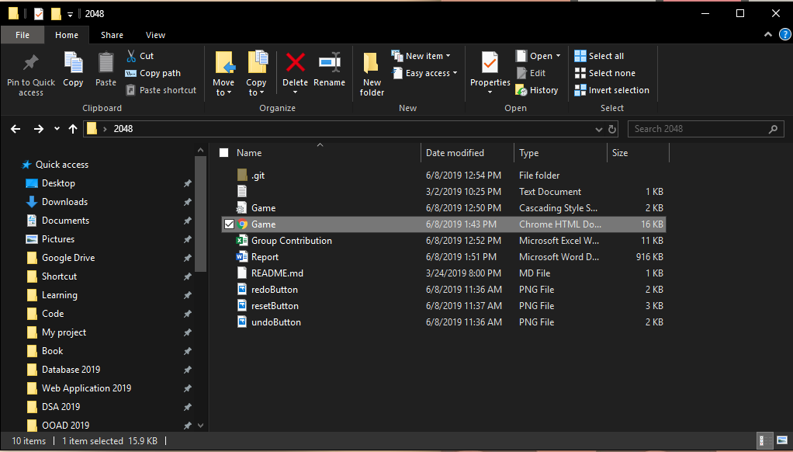

**Game Demo**

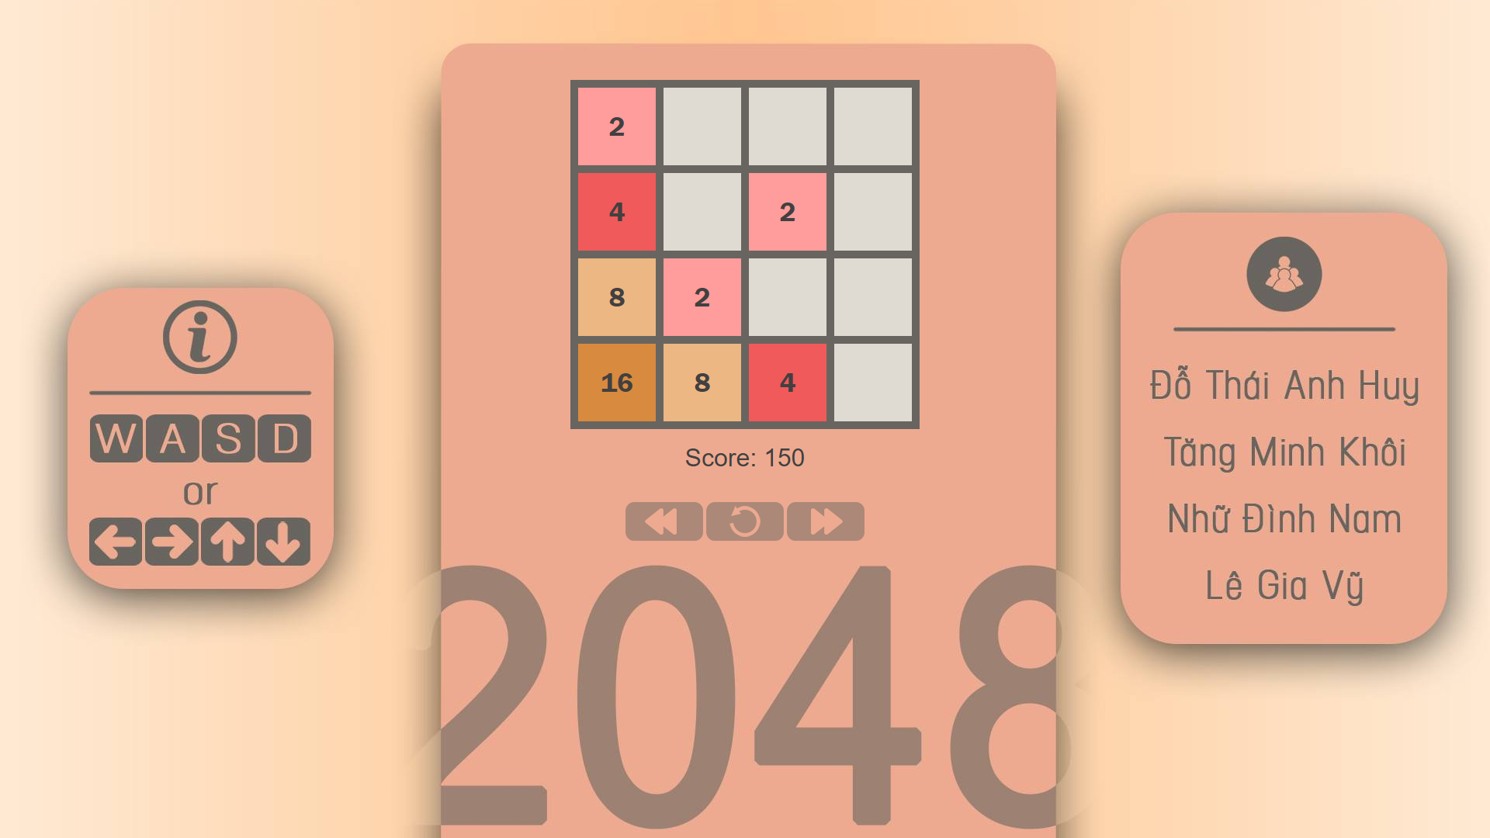

1. **CONCLUSION**

Developing this project will bring this team many experiences:

* Learn a new programming language: Javascript
* Understand the basic of the Array and Stack data structures
* Understand the 2048’s algorithm.

1. **REFERENCES**

**[1]** <https://en.wikipedia.org/wiki/2048_(video_game)>

<https://play2048.co/>