**PROJECT REPORT: MOBILE STORE**

Group member:

* Đỗ Thái Anh Huy ITITIU16095
* Hồ Thanh Hoài ITITIU16026
* **CHAPTER I : INTRODUCTION**
  + Motivation: Our team want to create a website that helps people buy mobile devices more easily, a website that is friendly to everyone.
  + Problems Statement:

- Whenever a new mobile device is needed, people will not need to go directly to the store. People who can go online to order and it will be delivered to the place.

* + Scope:

- This system will be an website for any people or any companies who want to use system. The system will be designed to help the user to:

+ Search for goods

+ Follow goods

+ Manage previous trades/ exchange history

+ Filter search

+ Buy goods

* **CHAPTER II: LITERATURE REVIEW**
  + Similar Applications/Systems

- Thegioididong, Tiki, Fptshop, …

* + Platform and Tools Review

- In general, the above applications and systems are also quite good but sometimes there are some inconveniences such as: unsuccessful order, long delivery, some common items are not available, high market prices…

* **CHAPTER III: SYSTEM DESIGN**
  + **System Requirement Specification**

System requirements are expressed in a website requirement document. The website requirement specification is the official of what is required of the system developers. This requirement document includes the requirements definition and the requirement specification. The website requirement document is not a design document. It should set out what the system should do without specifying how it should be done. The requirement set out in this document is complete and consistent.

The website specification document satisfies the following:

* It specifies the external system behaviors.
* It specifies constraints on the implementation.
* It is easy to change.
* It serves as reference tool for system maintainers.
* It record forethought about the life cycle of the system.
* It characterizes acceptable response to undesired events.
  + - **Functional Requirements**

- The system must provide following functionalities:

+ Keeping records of admission of customers.

+ Keeping the record of products.

+ Keeping the daily sell.

+ Storing the feedback given by the customer.

+ Keeping details about the product it is delivered or not.

* + - **Requirements Analysis**

-

* + - **Non-functional Requirements**

- Insurance on internet:

+ Secure access of confidential data

+ 24/7 availability

+ Better component design to get better performance.

+ Various other non-functional requirements are:

. Security

. Reliability

. Maintainability

. Portability

. Extensibility

. Reusability

* + System Design Specification

- Smartphone Product ERD:

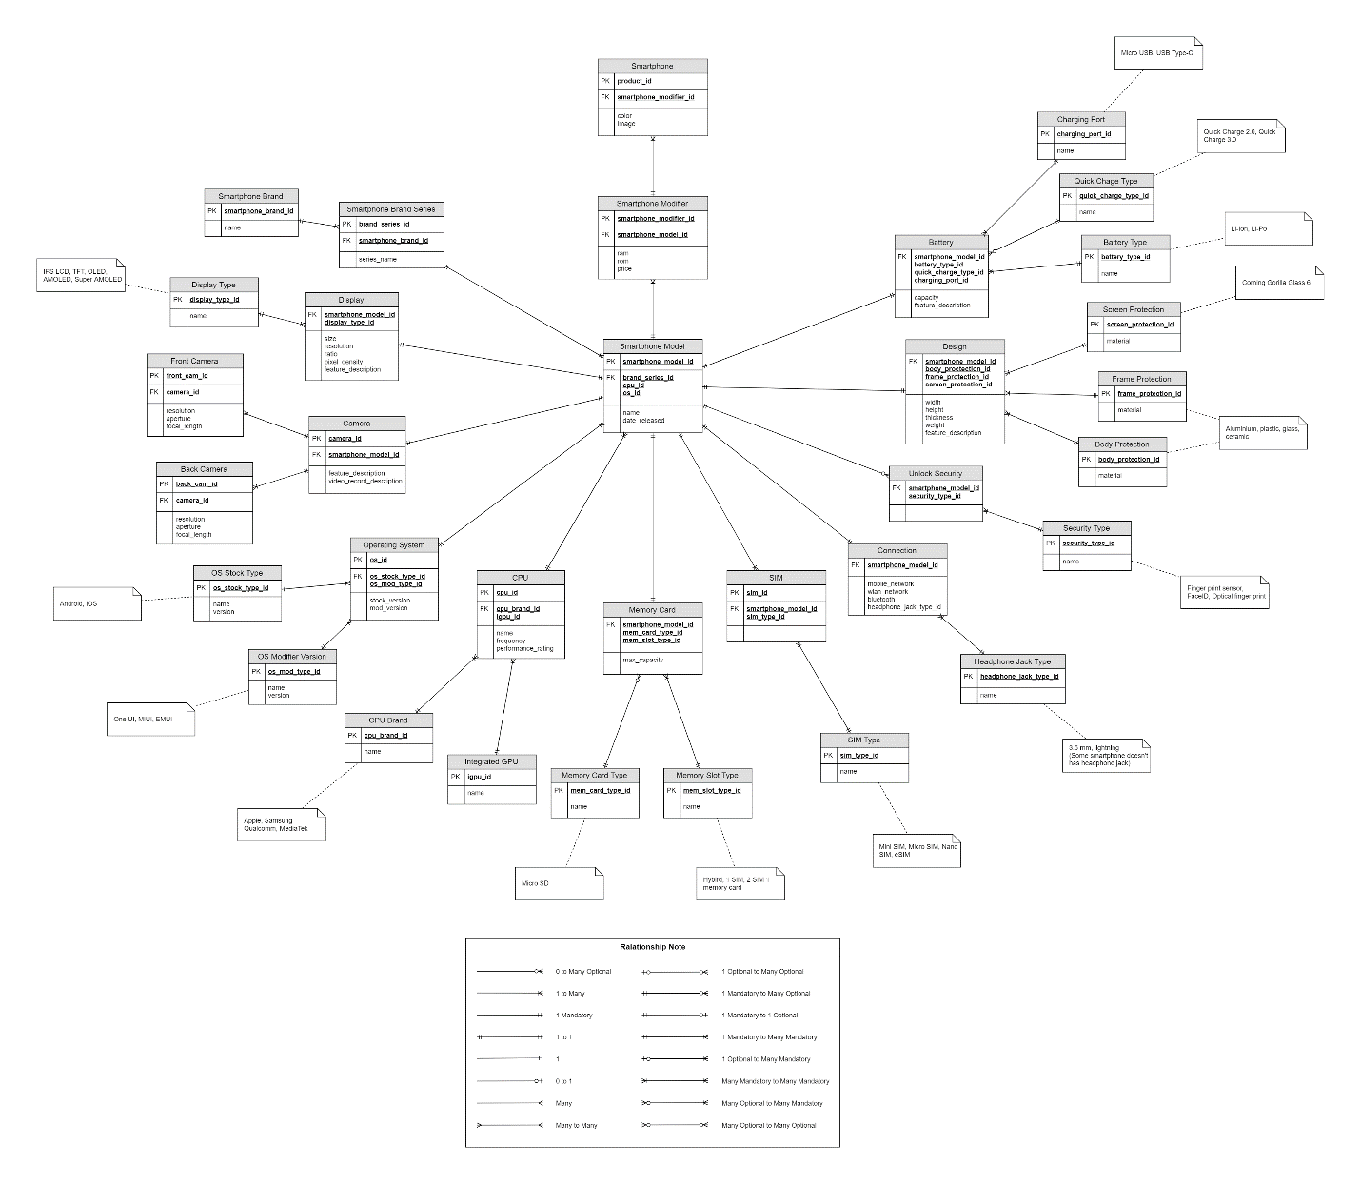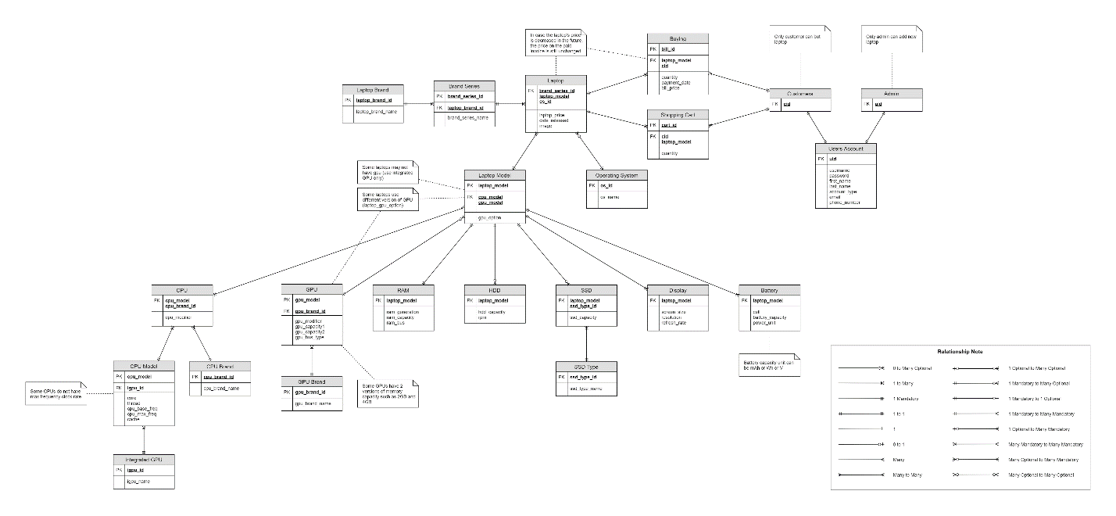

Laptop Product ERD

(You can zoom in or open this image at the Diagram forder to make it easier to see).

* + - Use-cases Diagram (summary goal use case and at least 3 main use cases)
    - Sequence Diagram (at least 3 main sequence)
    - Activity Diagram (at least 3 main activities) (optional)
    - Class Diagram
* **CHAPTER IV: SYSTEM IMPLEMENTATION**

-

* **CHAPTER V: CONCLUSION AND DISCUSSION**
  + List of accomplished work

- Homepage

- Page of smartphone, laptop

- Smartphone detail

* + Strength and Weakness
  + Future Work

- User account system

- Delivery

- Online payment

* References

Intel CPU specification (7th and 8th gen):

<https://en.wikipedia.org/wiki/Kaby_Lake>

<https://en.wikipedia.org/wiki/Coffee_Lake>

Intel integrated GPU specification:

<https://en.wikipedia.org/wiki/Intel_Graphics_Technology#Kaby_Lake_Refresh_/_Amber_Lake_/_Coffee_Lake_/_Whiskey_Lake>

AMD CPU specification (Ryzen 2nd gen):

<https://www.amd.com/en/products/specifications/processors>

<https://en.wikipedia.org/wiki/List_of_AMD_Ryzen_microprocessors>

Nvidia GPU specification (900, 10 and 20-series):

<https://en.wikipedia.org/wiki/GeForce_900_series>

<https://en.wikipedia.org/wiki/GeForce_10_series>

<https://www.nvidia.com/en-us/geforce/gaming-laptops/20-series/>

AMD GPU specification (Radeon Pro 500 Series):

<https://en.wikipedia.org/wiki/List_of_AMD_graphics_processing_units#Radeon_Pro_500_Series>

Apple Macbook specification:

<https://everymac.com/systems/apple/macbook/index-macbook.html>

<https://everymac.com/systems/apple/macbook-air/index-macbook-air.html>

<https://everymac.com/systems/apple/macbook_pro/index-macbookpro.html>

Laptop, mobile phone specification and image from e-commerce websites:

<https://phongvu.vn/macbook-phu-kien-715.cat?pv_medium=m-4>

<https://tanthanhdanh.vn/danh-muc/laptop/>

<https://www.thegioididong.com/>

<https://fptshop.com.vn/>

[https://tiki.vn/](https://tiki.vn/?utm_source=masoffer&utm_medium=5cf4d5102b951100413ea733&traffic_id=5cf4d5102b951100413ea733&utm_campaign=AFF_NBR_MAS_AFM_SNC_ALL_VN_ALL_UNK_UNK_N.FIB6i252EA9J2tz5f3uOHw)