**VIETNAM NATIONAL UNIVERSITY – HO CHI MINH CITY**

**INTERNATIONAL UNIVERSITY**

**SCHOOL OF COMPUTER SCIENCE AND ENGINEERING**



WEB APPLICATION COURSE PROJECT REPORT

PROJECT NAME: TOEIC ONLINE SYSTEM

Student:

Nhữ Đình Nam – ITITIU16114

Nguyễn Kim Kha – ITITIU16033

Ho Chi Minh City, Vietnam

Year 2019

Toeic Online System Report

**Chapter I: INTRODUCTION**

* **Motivation**

Nowadays, people who speak English well can earn high salary and grow further. Everyone wants to get an international English certification. TOEIC is the best choice lead to it is the most popular English testing system in Vietnam. In order to help TOEIC candidates check and prepare their English before the real test easily and conveniently, we build a web application to simulate the real test. Candidates can do it anywhere and anytime.

* **Problem statement**

People who attend a TOEIC English course need to go to class every day. Whenever they want to take exam, they download it on the Internet, finish the text and check themselves. It costs a lot of time. We build a TOEIC online testing system. It helps candidates do the test on web browser of desktop or cellphone with time counter. The system receives submission when the test done and shows the score of the test and the answer for each question.

Administrator of this website maybe don’t know anything about MySQL and Java because they are English teacher. They get difficulty when upload a new test. User want to do test on mobile phone couldn’t see all the information of the test because of the size of the cellphone screen. Many libraries used to build this web application, we will get trouble to manage it. Every time you tick on the choice of the test. It is reloaded to show the answer, this problem cost a lot of time.

* **Scope**

Focusing on simple application meet some requirements below:

- TOEIC candidates have a good environment to study English better.

- School and English center have a TOEIC test opensource to speed up the test preparation time

- Contributor with administrative ID can upload their test to the system easily to share with the others.

**Chapter II: LITERATURE REVIEW.**

* **Similar Application/System**
* Anh ngữ Ms Hoa <https://www.anhngumshoa.com/>
* Practice Toeic Test Online **Practice-the-toeic-test.com**
* **Platform and Tools Review.**
* **IDE: IntelliJ IDEA.**

**Every aspect of IntelliJ IDEA is specifically designed to maximize developer productivity. We use it as our IDE to build our project. IntelliJ IDEA is a good environment for developer. It is easy to be used and extended.**

* **Maven**

Apache Maven is a software project management and comprehension tool. Based on the concept of a project object model (POM), Maven can manage a project's build, reporting and documentation from a central piece of information.

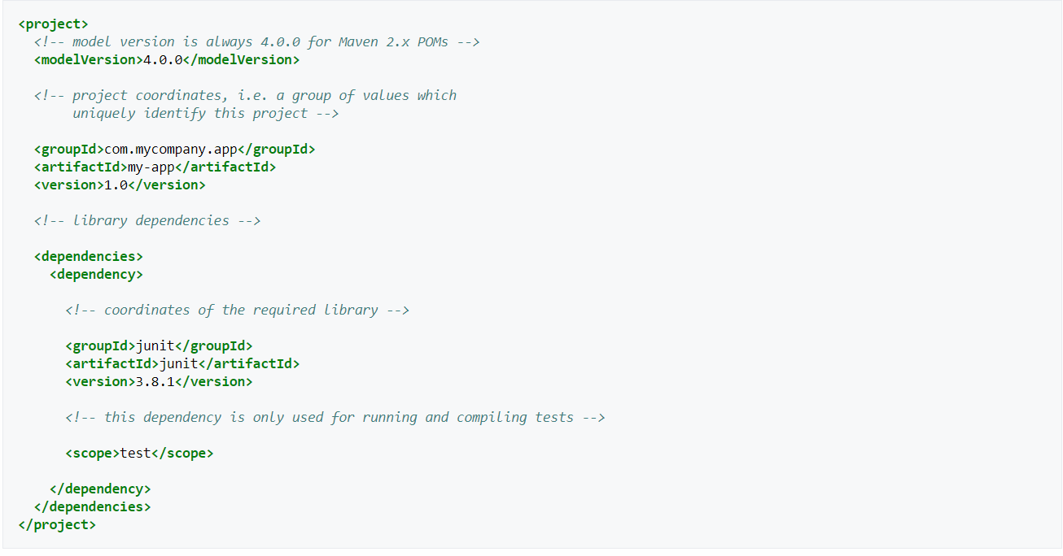

* **MySQL database**

**MySQL Enterprise Edition includes the most comprehensive set of advanced features, management tools and technical support to achieve the highest levels of MySQL scalability, security, reliability, and uptime. It reduces the risk, cost, and complexity in developing, deploying, and managing business-critical MySQL applications.**

* **Hibernate**

**Hibernate ORM (Hibernate in short) is an object-relational mapping tool**

**for the Java programming language. It provides a framework for mapping an object-oriented domain model to a relational database. Hibernate handles object-relational impedance mismatch problems by replacing direct, persistent database accesses with high-level object handling functions.**

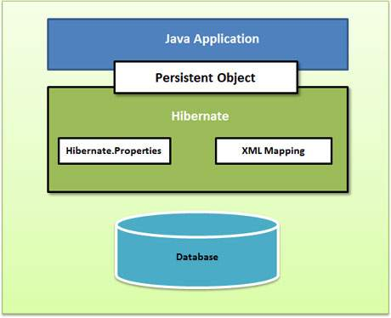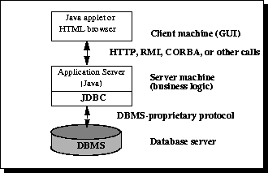

* **Bootstrap**

**Build responsive, mobile-first project on the web with the world’s most popular front-end component library. Bootstrap is an open source toolkit for developing with HTML, CSS, and JS. Quickly prototype your ideas or build your entire app with our Sass variables and mixing, responsive grid system, extensive prebuilt components, and powerful plugins built on jQuery. Bootstrap is one of the most popular.**



**Chapter III: SYSTEM DESIGN**

* **System Requirement Specification**
  + **Functional Requirements and Analysis**

1. ***Administrative functions***

Administrator of TOEIC online webpage will be a people who don’t know about IT, and using MySQL. It’s very hard for them to import or upload a new text. To solve this problem, we build Administrative page. It is a friendly webpage using graphical user interface. They can upload the new test easily with Excel file. We use Hibernate to do that. Hibernate is Object-Relational Mapping or ORM is the programming technique to map application domain model objects to the relational database tables. A Framework that provides option to map plain old Java objects to traditional database tables with the use of JPA annotations as well as XML based configuration

1. *External Interfaces*

User interface designed by using Bootstrap library. It helps us create responsive web page. Candidates can use cell phone with small screen to do the test easily without losing information.

1. *Transaction corrections, adjustments and cancellations*

This is the basic structure that Hibernate programs should have, concerning Transaction Handling

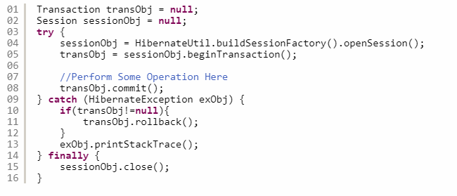

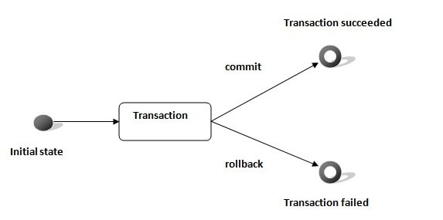

A transaction is associated with Session and instantiated by calling session. beginTransaction(). Whenever a HibernateException happens we call rollback() method that forces the rollback of the transaction. This means that every operation of that specific transaction that occurred before the exception, will be canceled and the database will return to its state before these operations took place.

Every Transaction follows some transaction properties and these are called as ACID properties. ACID stands for Atomicity, Consistency, Isolation, and Durability.

**Atomicity**: Is defined as either all operations can be done or all operation can be undone

**Consistency**: After a transaction is completed successfully, the data in the datastore should be a reliable data. This reliable data is also called as consistent data

**Isolation**: If two transactions are going on the same data then one transaction will not disturb the other transaction

**Durability**: After a transaction is completed, the data in the datastore will be permanent until another transaction is going to be performed on that data

* + **Non-functional Requirements and Analysis**

1. *Response time*

Every time you tick a choice in the test online, web page doesn’t reload anymore during the test time. Because our website use Ajax techniques on the client side to create asynchronous web applications. Ajax allows web pages and, by extension, web applications, to change content dynamically without the need to reload the entire page. Base on that, we obtain immediate response time.

1. *Scalability*

Using Hibernate instead of JDBC make our application have database independence, we can easily edit few lines of code to connect other database management systems such as SQL Server, MySQL, Oracle Database… It makes our web application scalable.

1. *Performance*

Hibernate provides a Hibernate Caching, which reduces the number of times access to the application's database as much as possible. This will have a significant performance boost for your application. Hibernate stores objects in the session when transaction is enabled. When a query is executed continuously, the value stored in the session is reused. When a new transaction starts, data is retrieved from the database and stored in the session.

* **System Design Specification**

***Class Diagram***

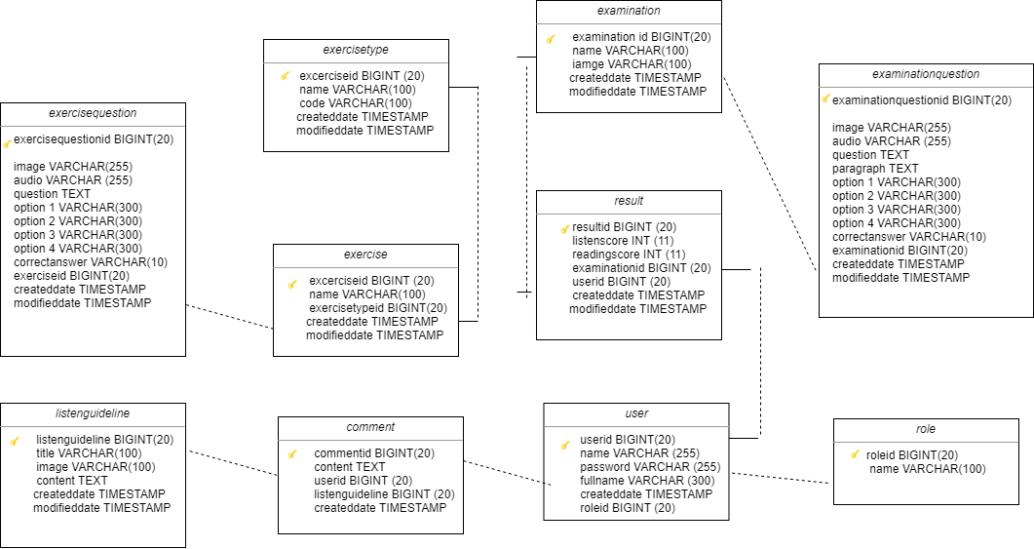

**Use cases diagram.**

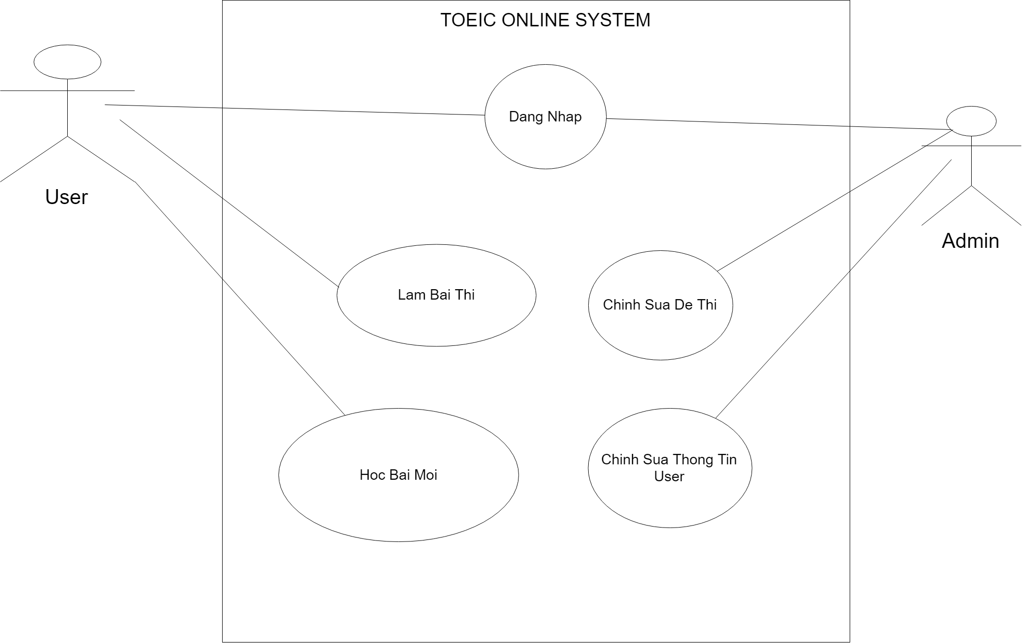

**Main use cases.**

**Use case: Lam Bai Thi**

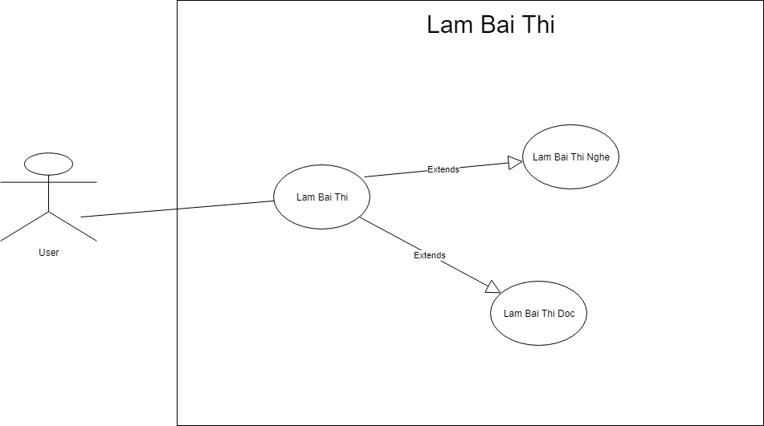

**Use case: Hoc Bai Moi**

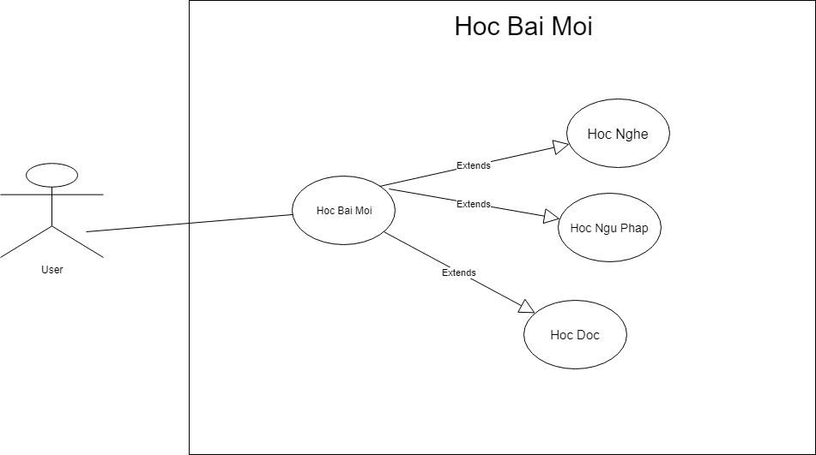

**Use case: Chinh Sua Thong Tin User**

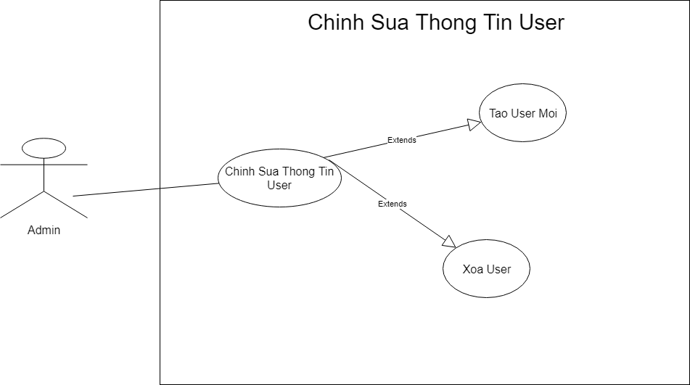

**Sequence Diagram 1**

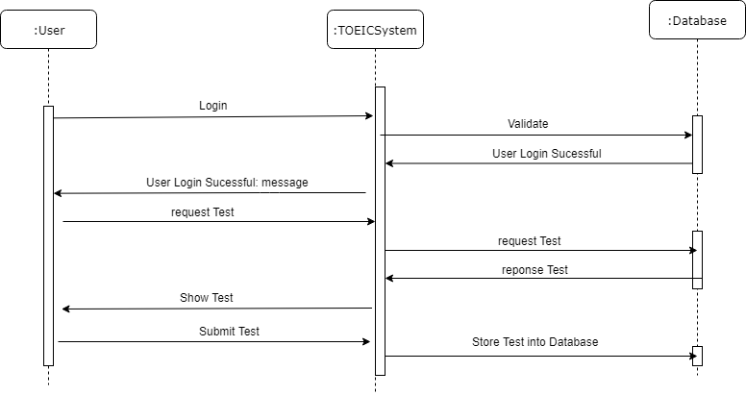

**Sequence Diagram 2**

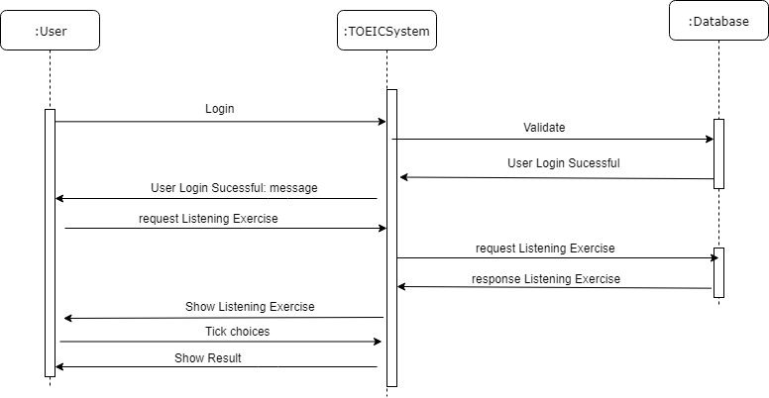

**Sequence Diagram 3**

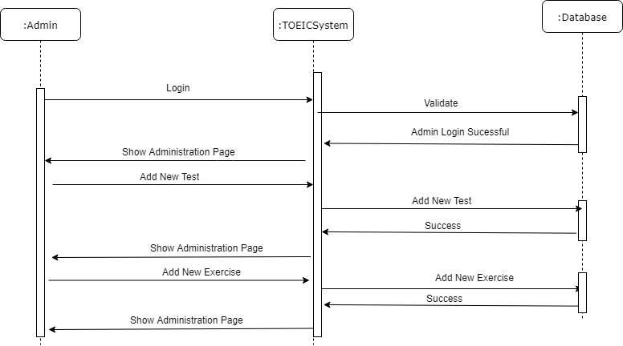

**CHAPTER IV: TECHNIQUES**

* **Servlets & Jsp**

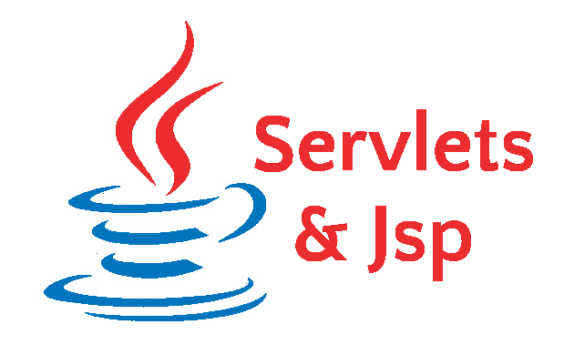

* **JSTL ( JSP Standard Tag Library):** a collection of useful JSP tags which encapsulates the core functionality common to many JSP applications.
* **MVC Model**

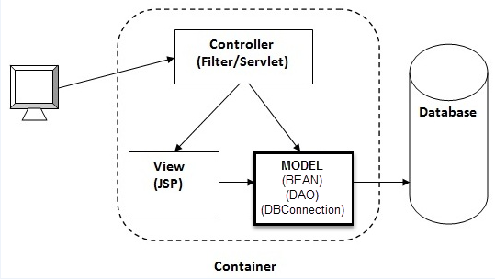

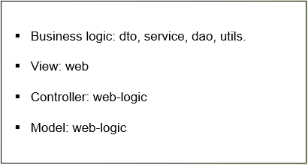

* **Jquery, Ajax, Javascript**
* **Hibernate:** a high-performance Object/Relational persistence and query service, which is licensed under the open source GNU Lesser General Public License (LGPL) and is free to download. Hibernate not only takes care of the mapping from Java classes to database tables (and from Java data types to SQL data types), but also provides data query and retrieval facilities.
* **Display Tag:** an open source suite of custom tags that provide high-level web presentation patterns which will work in an MVC model. The library provides a significant amount of functionality while still being easy to use.

<%@ **taglib prefix**="**display**" **uri**="**http://displaytag.sf.net**" %>

* **Decorator:** [SiteMesh](http://www.opensymphony.com/sitemesh/) is a web layout framework for Java.  It differs from frameworks such as Tiles in that it utilizes the decorator pattern.  For example, you create a number of pages and then you tell SiteMesh that you’d like to add the same header, footer, and menus to each of those pages.

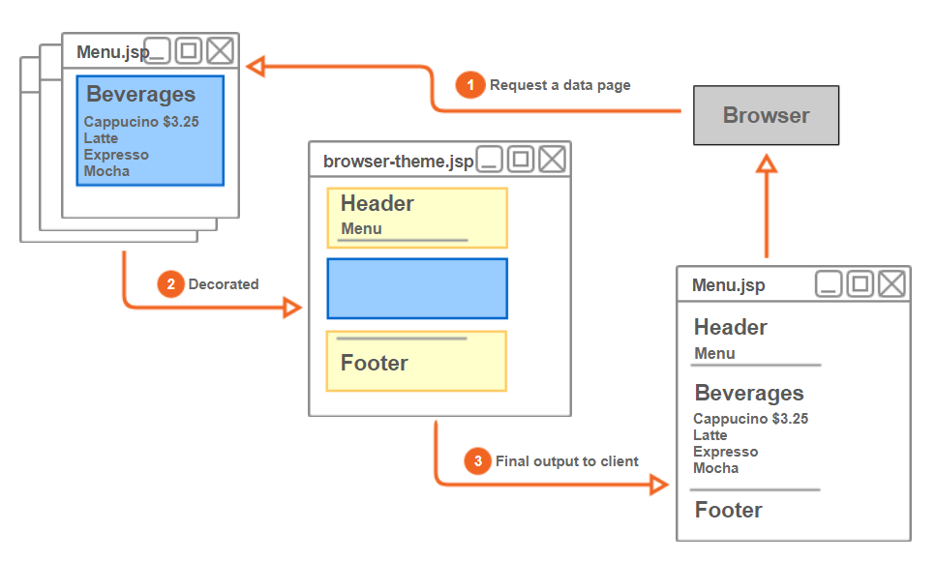

<%@ **taglib prefix**="**dec**" **uri**="**http://www.opensymphony.com/sitemesh/decorator**" %>

* **CKEditor:** a [WYSIWYG](https://en.wikipedia.org/wiki/WYSIWYG) [rich text editor](https://en.wikipedia.org/wiki/Online_rich-text_editor) which enables writing content directly inside of web pages or online applications. Its core code is written in [JavaScript](https://en.wikipedia.org/wiki/JavaScript) and it is developed by CKSource. CKEditor is available under open source and commercial licenses.

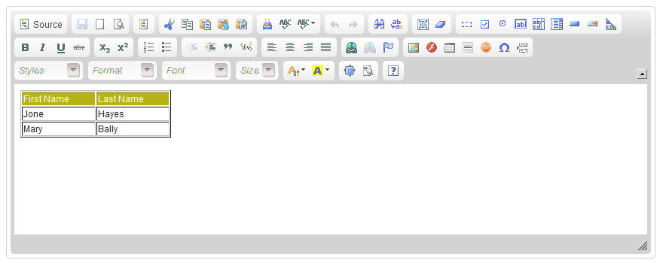

**CHAPTER V: CONCLUSION AND DISCUSSION**

* **List of accomplished work**

1. Design front-end neat, responsive, and nice.
2. Design database follow ORM (Object Relational Mapping) with Hibernate. It speeds up performance of database connection.

* **Strength and Weakness**

Strength

* Performance is good.
* System is easy to maintain for more purpose.
* TOEIC online can change the other database easily by editing a few lines of code. It is scalable.
* Using Bootstrap makes our website work responsive with mobile phone screen.
* Maven manage our source code base on dependencies. If someone add a new module for a new function. Maven helps them import the necessary libraries

Weakness

* Front-end is not attractive with user
* TOEIC online website offers few types of exercises
* TOEIC online website is poor in interactivity.
* Password is not security

* **Future Work**

- Install more and more non-functional requirements for this system.

- Design front-end to make it more attractive.

- Add more type of exercise.

- Add advertisement from Google Ads to advice user some good English center and earn money from promotion.

- Make the database more security.

- Add Facebook and Google Log in API, so new user can log in with Facebook, Google account or phone number.

**REFERENCES**

<https://maven.apache.org/guides/>

<https://getbootstrap.com/docs/4.3/getting-started/introduction/>

<https://hibernate.org/orm/documentation/4.3/>

<https://dev.mysql.com/doc/>

<https://www.jetbrains.com/idea/documentation/>