**HO CHI MINH UNIVERSITY OF SCIENCE**

**HO CHI MINH NATIONAL UNIVERSITY**

**FINAL SEMESTER PROJECT**

**Subject: Introduce to Machine learning**

**YOLO – ANIMAL DETECTION**

**COURSE CODE**

**CSC14005**

**Ho Chi Minh city – 2022**

**TABLE OF CONTENT**

**1.** **Overview** 3

**2.** **Detail** 3

2.1 Dataset 3

2.2 Web interface 3

2.3 Code 3

2.4 Evaluate the model 3

**3.** **Advantage and Disadvantage** 3

3.1 Advantages 3

3.2 Disadvantages 3

**4.** **Result** 4

**5.** **Necessary files** 4

**6.** **Instruction for running code:** 4

**7.** **Reference** 4

# **Overview**

|  |  |  |
| --- | --- | --- |
| **Student ID** | **Full name** | **Email** |
| 19127392 | Tô Gia Hảo | 19127392@student.hcmus.edu.vn |
| 19127525 | Nguyễn Thanh Quân | 19127525@student.hcmus.edu.vn |
| 19127625 | Lâm Chí Văn | 19127625@student.hcmus.edu.vn |

# **Detail**

## 2.1 Dataset

* We have done:
* Reference from source code

## 2.2 Web interface

* We have done:
* Reference from source code

## 2.3 Code

* We have done:
* Reference from source code

## 2.4 Evaluate the model

* F1-score or suitable score
* Data
  + Train: 60
  + Test: 20
  + Validation: 20
* score on these sets and the score by epoch

# **Advantage and Disadvantage**

## 3.1 Advantages



## 3.2 Disadvantages



# **Result**

# **Necessary files**

final_model.h5:

<https://studenthcmusedu-my.sharepoint.com/:u:/g/personal/19127525_student_hcmus_edu_vn/EUfrX0QDy7lErWMnXYSKNU8BrmgPLHXxLRQnztb4UJtJgg?e=VeU3mQ>

dogs-vs-cats.zip:

<https://www.kaggle.com/c/dogs-vs-cats/data>

hoặc

<https://studenthcmusedu-my.sharepoint.com/:u:/g/personal/19127525_student_hcmus_edu_vn/EYip60GjDlpOkjaReE33d88BK5TEoVWqem0UydHD3oehhA?e=5rnDCi>

# **Instruction for running code:**

**Cách 1:**

**Bước 1:** Truy cập đường link: <https://www.kaggle.com/tquntv/19127392-19127525-19127625>

(Sử dụng trực tiếp project của nhóm bọn em trên kaggle)

**Bước 2:** Chọn **Copy and Edit** ở góc bên phải

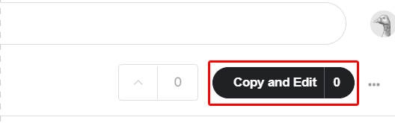

**Bước 3:** Chọn **Run All**

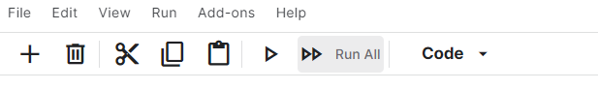

# **Reference**