**Project Initialization and Planning Phase**

| Date | 14 June 2025 |
| --- | --- |
| Team ID | SWTID1749820017 |
| Project Name | Dog Breed Identification using Transfer Learning |
| Maximum Marks | 3 Marks |

**Problem Statement:**

Understanding the needs of our users is crucial to building a solution that truly adds value. Many first-time or potential dog owners often struggle to identify the breed of their dog accurately. They try to search online or rely on guesses, but with hundreds of breeds and subtle differences between them, this becomes overwhelming and unreliable. This uncertainty prevents them from providing the best care, nutrition, or training suited for their pet. On the other hand, veterinary professionals and shelter workers are under pressure to identify breeds quickly and accurately, but the process is often manual and error-prone. These challenges highlight a clear need for a reliable, easy-to-use dog breed classification tool that empowers users with accurate information, reduces confusion, and enhances the care and experience for both pets and their humans..

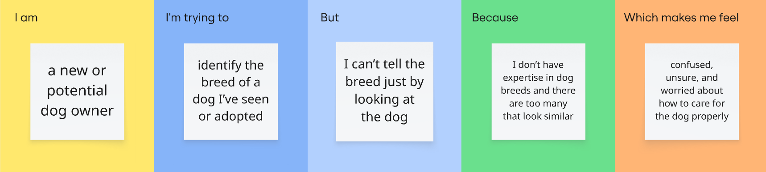

|  |  |  |  |  |  |
| --- | --- | --- | --- | --- | --- |
| **Problem**  **Statement (PS)** | **I am**  **(Customer)** | **I’m trying to** | **But** | **Because** | **Which makes me feel** |
| PS-1 | a new or potential dog owner | identify the breed of a dog I’ve seen or adopted | I can’t tell the breed just by looking at the dog | I don’t have expertise in dog breeds and there are too many that look similar | confused, unsure, and worried about how to care for the dog properly |
| PS-2 | a veterinarian or animal shelter worker | quickly classify a dog’s breed for medical, nutritional, or behavioral assessments | manual breed identification is time-consuming and prone to errors | visual characteristics aren’t always reliable or distinct | frustrated, inefficient, and concerned about providing incorrect treatment or guidance |