**Model Development Phase**

| Date | 17th June 2025 |
| --- | --- |
| Team ID | SWTID1749820017 |
| Project Name | Dog Breed Identification using Transfer Learning |
| Maximum Marks | 5 Marks |

**Model selection report**

Now comparing the two models we can clearly see that model 2 is half the size of model

1. Now on training both these models we found out that model 2 (the smaller model –

NASNetLarge with Flatten() layer) gave a higher validation accuracy than model 1 (the

larger model – NASNetLarge with GlobalAveragePooling2D() layer).

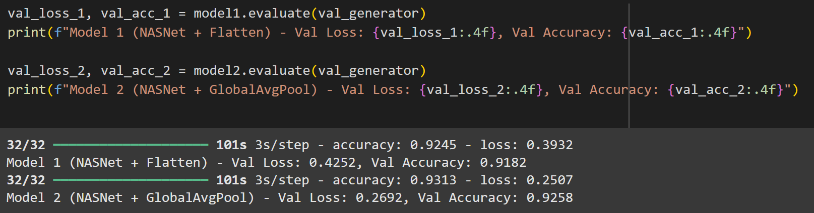

|  |  |  |  |
| --- | --- | --- | --- |
| **Model** | **Description** | **Hyperparameters used** | **Performance Metric** |
| NASNetLarge with the Flatten() Layer | NASNetLarge base  model with a Flatten  layer followed by a  Dense classification  head. High-capacity  architecture, effective for  deep feature extraction. | Learning rate = 10-4  Batch size=128  Epochs=40  Early stopping was used with a patience of 7.  Reduce Learning rate on plateau was also used with a factor of 0.1, patience of 3 and a minimum learning rate of 10-6 | Validation accuracy of 91.82% |
| NASNetLarge with GlobalAveragePooling2D() layer | NASNetLarge base with  GlobalAveragePooling2D  layer, providing a more  compact and efficient  feature summarization.  Helps reduce overfitting  and model size. | Learning rate = 10-4  Batch size=128  Epochs=40  Early stopping was used with a patience of 7.  Reduce Learning rate on plateau was also used with a factor of 0.1, patience of 3 and a minimum learning rate of 10-6 | Validation accuracy of 92.58% |