**Model Optimization and Tuning Phase**

| Date | 17th June 2025 |
| --- | --- |
| Team ID | SWTID1749820017 |
| Project Name | Dog Breed Identification using Transfer Learning |
| Maximum Marks | 10 Marks |

**Motivation for optimization**

When we first loaded the NASNetLarge model with the flatten() layer we realized that the model was extremely huge even before training had been done(547.26MB). Shown below:

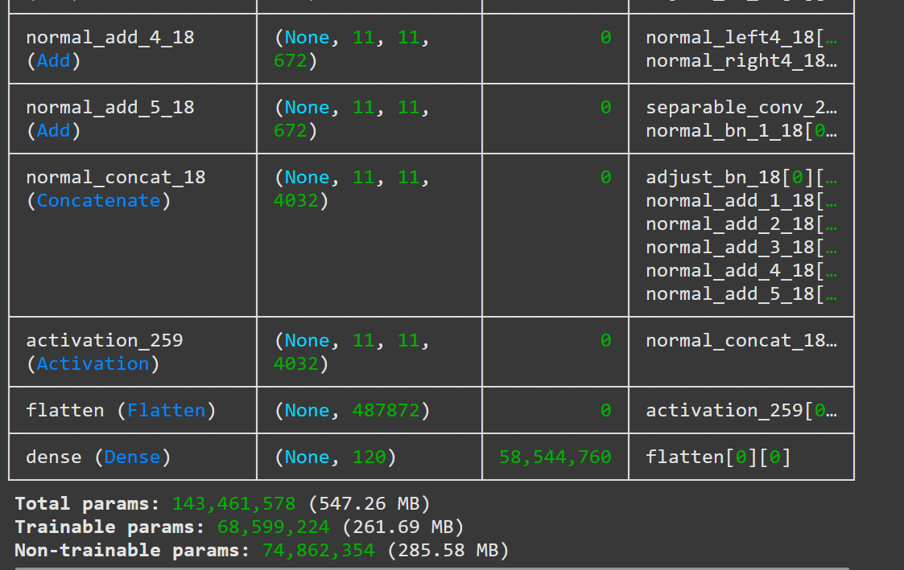

So we decided to replace the flatten() layer with a GlobalAveragePooling2D() layer which decreased the size of the model by 40% (325.78MB). Shown below

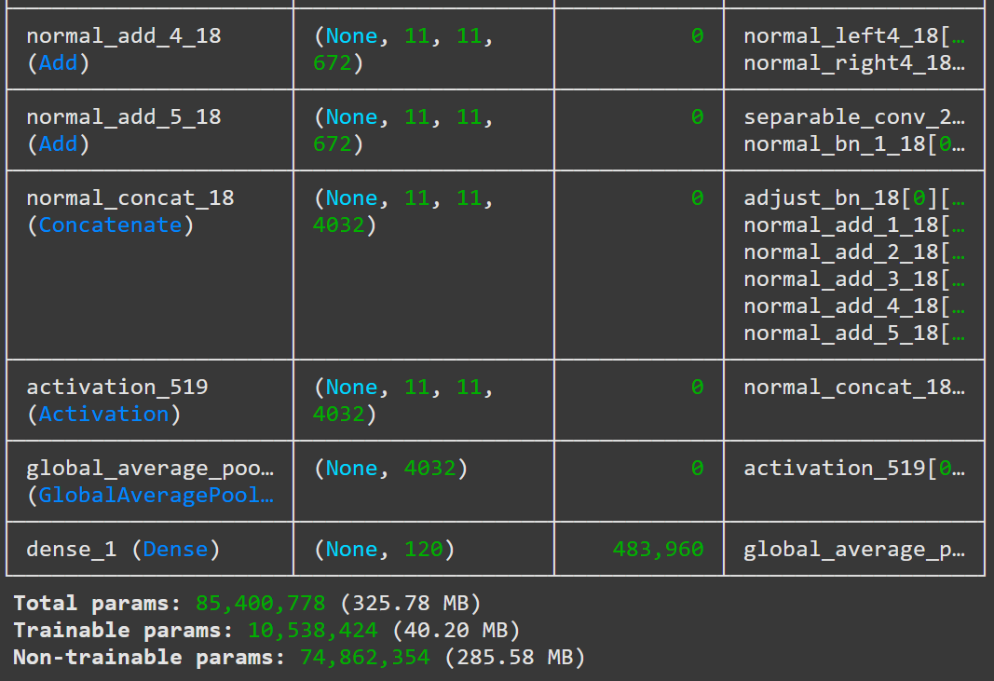

**Experimental Comparisons:**

1. Accuracy and Loss

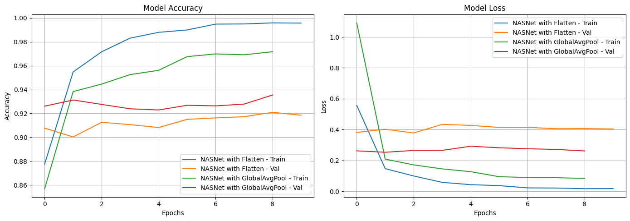

1. Confusion Matrix

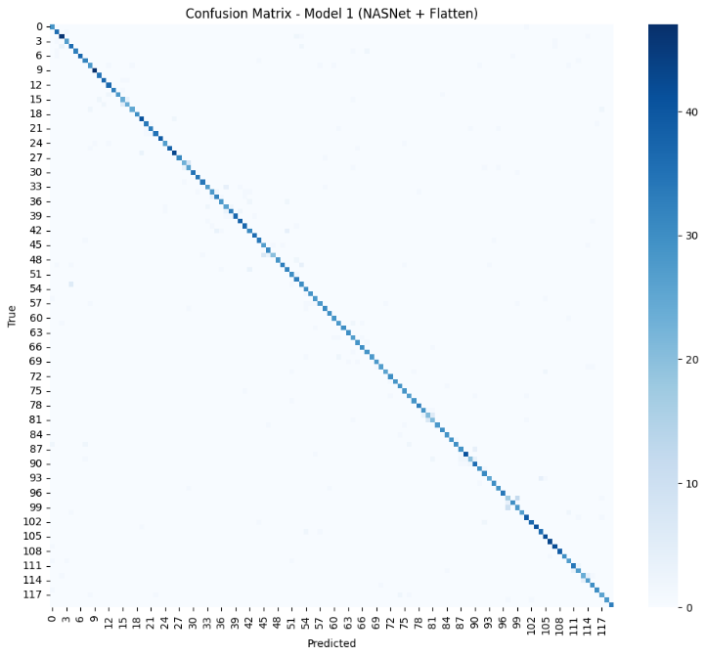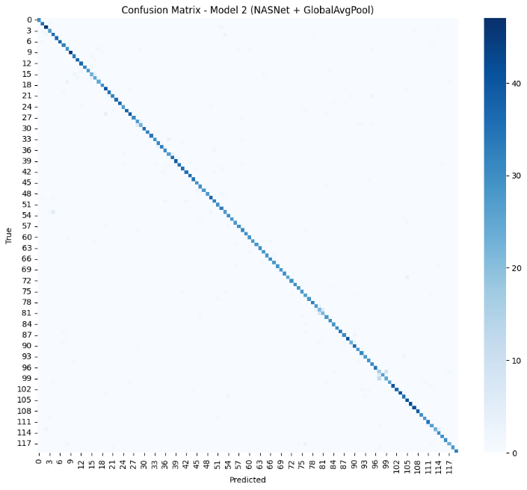

1. Validation accuracy

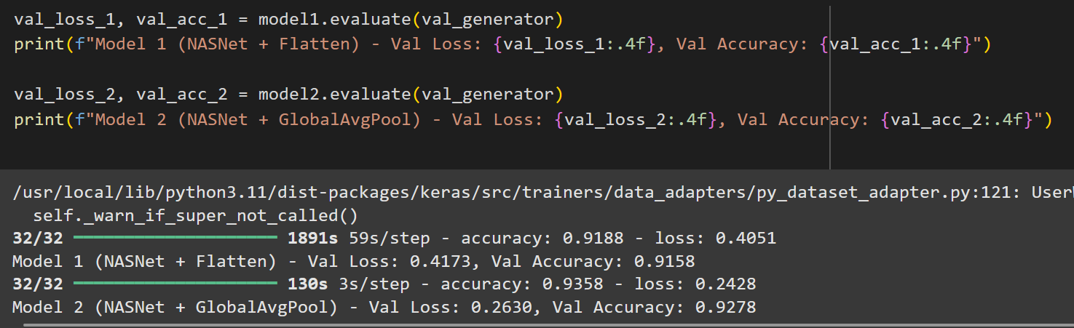

1. Precision, Recall and F1-Score

* Model 1: NASNetLarge with Flatten() layer

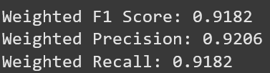

* Model 2: NASNetLarge with GlobalAveragePooling2D() layer

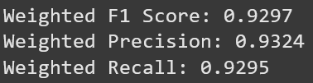

1. Model size:

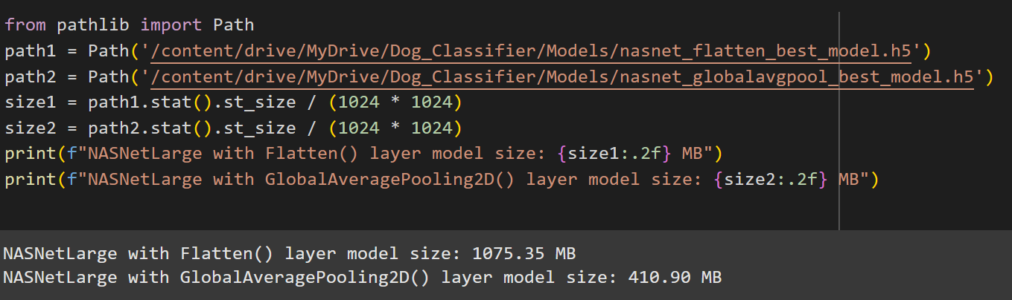

**Conclusion:**

From the above experimental results we can conclude that the NASNetLarge with GlobalAveragePooling2D() layer model is not only smaller but also provided high validation accuracy, recall score, precision score and F1-socre than the NASNetLarge with Flatten() layer model.