

**KABARAK UNIVERSITY**

**SCHOOL OF SCIENCE ENGINEERING AND TECHNOLOGY**

**DEPARTMENT OF COMPUTER SCIENCE AND INFORMATION TECHNOLOGY**

**BACHELOR OF BUSINESS IN INFORMATION TECHNOLOGY**

**TITLE: COURSE MATERIAL REPOSITORY APP**

**PRESENTED BY:**

**Aduol Trevor Oduol BMIT/MG/2456/09/2**

**Github Link: https://github.com/HCSButcher/PROJECT-2**

**A Research Project Submitted to The School of Science Engineering and Technology In Partial Fulfillment Of The Requirement For The Award Of The Degree In Bachelor Of Business in Information Technology, Kabarak University**.

## COPYRIGHT

© 2024

All Rights Reserved

No part of this project may be reproduced, stored in any retrieval system, or transmitted in any form or by any means, electronic, mechanical, photocopying, or recording without prior written permission of the author or Kabarak University.

Sign: ________________________ Date: ________________________

## **DECLARATION AND APPROVAL**

I declare that this project proposal titled” Course Material Repository App” is my original work and has never been presented elsewhere for any academic or professional purpose or any other Institution. This research document shall therefore not be duplicated without consent.

Approved as to content, quality, and presentation by:

Aduol Trevor Oduol BMIT/MG/2456/09/21

Sign: ___________________ Date: _________________

## **RECOMMENDATION**

This research proposal titled Course Material Repository App by Aduol Trevor Oduol, is presented to the School of Science, Engineering, and Technology of Kabarak University. I have reviewed this project and recommended it will be accepted in partial fulfillment of the requirements for the Bachelor of Business and Information Technology.

Signature ……………………………………… Date …………………………….

**Ruoro Simon**

**School of Science, Engineering, and Technology**

**Department of Computer Science and Information Technology**

**Kabarak University**

## 

## **ACKNOWLEDGEMENT**

I would like to thank God for the far He has brought me and for the gift of life, family and friends for without them I would not have been able to achieve the much that I have in my academic pursuit. Their unwavering support and understanding have really been a great support through this journey.

Additionally, I would like to express my heartfelt gratitude to my supervisor, Ruoro Simon for the invaluable guidance, support, and encouragement throughout our studies. Your insightful feedback and expertise have been instrumental in shaping the direction and quality of this work.

## **DEDICATION**

This project is dedicated to my family, whose unwavering support and encouragement have been my greatest source of strength. Their belief in my abilities has motivated me to strive for excellence. I also dedicate this work to my mentors, friends and educators whose guidance and wisdom have profoundly shaped my academic journey. Thank you for your inspiration and support.

# **ABSTRACT**

The digital transformation of educational institutions was essential in the modern era, and Kabarak University was no exception. Traditional methods of managing and distributing course materials, such as physical systems, presented significant challenges in accessibility, organization, and security. Faculty members struggled with efficiently uploading copies and fragmented online systems, which presented significant challenges in accessibility, organization, and security. Faculty members struggled with the efficient upload and management of diverse materials, while students faced difficulties in accessing and tracking necessary resources. These issues underscored the need for a more centralized approach to course material management.

The project aimed to address these challenges by providing a comprehensive, web-based solution for the efficient management and distribution of educational resources. This centralized repository simplified the process for faculty to upload, organize, and manage content and offered students a secure and user-friendly interface for accessing these materials from any device. The primary problem was the inefficiency and disorganization in the existing methods of course material management at Kabarak University, which hindered both faculty productivity and student learning. The justification for this project lay in the need to enhance the accessibility, security, and organization of educational resources, thereby improving the overall educational experience for both faculty and students.

This project incorporated a centralized repository for managing and distributing course materials. The system implemented a secure user authentication and role-based access control. Users got access to a responsive and user-friendly interface for both web and mobile platforms. The system also integrated a robust search and filtering system. It also provided analytics and reporting features to track the usage and engagement with the course materials.

The methodology for developing the Course Material Repository App involved a structured approach leveraging modern web technologies. The frontend was built using React, the backend utilized Node.js with Express for robust server-side functionality, and MongoDB was used for flexible and scalable data storage.

Contents

COPYRIGHT II

DECLARATION AND APPROVAL III

RECOMMENDATION IV

ACKNOWLEDGEMENT V

DEDICATION VI

ABSTRACT VII

CHAPTER ONE: INTRODUCTION 1

1.0 Introduction 1

1.1 Background to the Study 3

1.2 Statement of the Problem 4

1.3 Purpose of the Study 5

1.4 Main objective 5

1.4.1 General Objective 5

1.4.2 Specific Objectives 5

1.5 Research Questions 5

1.6 Proposed System 6

1.7 System Modules 7

1.8 Justification of the Study 10

1.9 Feasibility Study 11

1.10 Scope and Limitations of the Study 12

CHAPTER TWO: LITERATURE REVIEW 13

2.0 General Overview of The Topic 13

2.1 Methods of Identifying Feature Selection Techniques. 15

2.2 Evaluation of the Correlation between Optimal Features 16

2.3 User Security Awareness Level 17

2.4 Prototype Design 18

2.5 Design Framework 19

CHAPTER THREE: RESEARCH DESIGN AND METHODOLOGY 21

3.0 Research Design Methods 21

3.1 Location of Study 21

3.2 Population Study 21

3.3 Sampling Procedure and Sampling Size 22

3.4 Data Collection Procedure 22

3.5 System Development Methodology 23

3.6 System Analysis and Design 23

Design Diagrams 25

Context Diagram 25

Architectural Design 25

Database Design 26

Use case diagram 27

Data flow diagram 28

CHAPTER FOUR: SYSTEM IMPLEMENTATION 30

4.0 Introduction 30

4.1 System Architecture 30

4.1.1 Development environment 30

4.1.2 Frontend development 30

Registration page 31

Login page 31

Administrator home page 32

Lecturer home page 32

Student home page 33

4.1.3 Backend development 34

4.1.4 Data Layer 36

4.2 Conclusion 36

REFERENCES 37

APPENECIES 38

Appendix I – Gant chart 38

Appendix II – Budget 38

# CHAPTER ONE: INTRODUCTION

## 1.0 Introduction

In the fast-paced and technologically advanced world, the educational landscape was undergoing significant transformations. Higher education institutions were increasingly embracing digital solutions to enhance the learning experience and streamline administrative processes. One critical area that had seen substantial development was the management and distribution of course materials. Historically, educational resources such as textbooks, handouts, and supplementary materials were distributed in physical formats, which posed numerous challenges, including logistical difficulties, high costs, and limited accessibility.

The shift from physical to digital distribution of course materials introduced a new set of advantages and challenges. Digital resources offered unparalleled flexibility and could be accessed from virtually anywhere, facilitating a more inclusive and efficient learning environment. However, the transition to digital mediums was not without its issues. Many educational institutions, including Kabarak University, struggled with efficiently managing and distributing digital course materials. The existing systems often lacked integration, user-friendliness, and adequate security measures, leading to confusion, inefficiencies, and accessibility issues for both students and faculty.

Kabarak University, like many other institutions, was experiencing rapid growth in student enrollment and course offerings. The growth necessitated the adoption of more efficient systems to manage educational resources effectively. At the time, the university relied on various fragmented platforms to handle course materials, which resulted in a disjointed experience for users. The absence of a centralized, secure, and user-friendly repository hampered the university’s ability to provide a cohesive and efficient educational experience.

The implementation of Learning Management Systems (LMS) had been a step in the right direction for many institutions. LMS platforms integrated multiple functionalities, including course material distribution, student assessment, and communication tools. However, these systems often fell short in terms of customization, user experience, and accessibility, particularly for institutions with unique needs and substantial volumes of content. This situation highlighted the necessity for a more tailored solution that specifically addressed the challenges faced by Kabarak University.

The proposed Course Material Repository App aimed to fill this gap by providing a comprehensive, web-based solution tailored to the specific needs of Kabarak University and universities as a whole. This app acted as a centralized repository where faculty could easily upload, organize, and manage their course materials, and students could access these resources securely from any device. By leveraging modern web technologies, the app ensured scalability, security, and performance, making it a sustainable solution for the university’s evolving needs.

A centralized repository offered numerous benefits. It simplified the distribution of course materials, ensuring students had timely access to the resources necessary for their studies. This enhancement reduced the time and effort students spent searching for materials, allowing them to focus more on their academic pursuits. For faculty, a centralized system streamlined the process of material management, enabling them to upload and update content effortlessly and monitor student engagement through integrated analytics tools.

Additionally, the shift to a digital repository aligned with global trends toward sustainable and environmentally friendly practices. By reducing reliance on printed materials, the university significantly lowered its carbon footprint and contributed to broader sustainability goals. Digital resources could also be updated and distributed instantaneously, ensuring that students always had access to the most current and relevant information.

Moreover, the Course Material Repository App incorporated robust security measures to protect sensitive information and ensure that only authorized users had access to specific materials. This feature addressed concerns related to academic integrity and the unauthorized distribution of copyrighted content. The app also included notifications and alerts to keep users informed about new updates, fostering better communication between faculty and students.

In summary, the Course Material Repository App represented a significant advancement in addressing inefficiencies in managing and distributing course materials at Kabarak University. By providing a centralized, secure, and user-friendly platform, the app aimed to enhance the educational experience for both students and faculty, fostering greater engagement with course content. This study explored the development and implementation of the app, examining its potential impact on the educational process and identifying best practices for its deployment and use.

## 1.1 Background to the Study

In the contemporary educational landscape, the effective management and distribution of course materials played a pivotal role in facilitating learning outcomes. With the rapid advancement of digital technologies, traditional methods of distributing physical copies of materials had become outdated and inefficient. In response to this evolving educational environment, there was a growing demand for centralized, digital solutions that streamlined the process of accessing and managing course materials. In many universities, students encountered challenges related to the distribution, organization, and accessibility of course materials. Traditional approaches, such as distributing handouts or relying on separate online platforms, often resulted in confusion, inefficiencies, and accessibility barriers. Faculty members struggled to organize diverse types of materials, while students faced difficulties in accessing, tracking, and engaging with these resources. These challenges highlighted the need for a more centralized and streamlined approach to course material management.

Moreover, existing systems often lacked integration, were cumbersome to use, and did not provide adequate features for secure and efficient material handling. As a result, there was a pressing need for a centralized, user-friendly, and secure platform that enhanced the accessibility and management of course materials in universities. The concept of the Course Material Repository App aimed to address these challenges by providing a comprehensive, web-based solution for storing, organizing, and distributing educational resources. By leveraging modern technologies and best practices in user experience design, this platform sought to revolutionize the way course materials were managed and accessed at universities. By centralizing all course materials in a single, accessible repository, the app sought to simplify the process for faculty to upload, organize, and manage their content. At the same time, it offered students a secure and user-friendly interface to access these resources from any device, ensuring that they had timely and convenient access to the information they needed.

A centralized repository also facilitated better organization and categorization of course materials. Faculty could categorize content by course, topic, and date, making it easier for students to find specific materials. Moreover, the app included powerful search and filtering capabilities, allowing users to quickly locate documents or multimedia files based on keywords, tags, or other metadata. This level of organization not only enhanced the user experience but also contributed to improved academic performance by ensuring that students could efficiently access and utilize the resources provided.

Security was another critical aspect of managing digital course materials. The Course Material Repository App implemented robust user authentication and role-based access control to ensure that only authorized individuals could access or modify the materials. This feature protected sensitive educational content and maintained the integrity of the resources. Furthermore, the app provided analytics and reporting tools, offering valuable insights into how students interacted with the materials. These insights helped faculty understand which resources were most utilized and how they could improve content delivery to better meet the needs of their students. By addressing the current inefficiencies in course material management and distribution, the app aimed to create a more organized, efficient, and interactive learning environment.

In conclusion, the need for a centralized, user-friendly, and secure platform for managing and distributing course materials was evident. The Course Material Repository App offered a promising solution to the challenges faced by both faculty and students in accessing and organizing educational resources. Through the successful implementation of this app, Kabarak University significantly enhanced the learning experience, improved faculty productivity, and fostered greater student engagement.

## 1.2 Statement of the Problem

Managing and distributing course materials efficiently posed a significant challenge for educational institutions, including Kabarak University. Faculty members often faced difficulties in organizing and sharing various types of educational resources, ranging from lecture notes and readings to multimedia files. Traditional methods, such as distributing physical copies or using fragmented online platforms, resulted in inefficiencies, confusion, and accessibility barriers for both faculty and students.

Students frequently struggled to access, track, and engage with these resources due to the lack of a centralized, user-friendly system. Existing systems were often cumbersome, lacking integration and essential features for secure and efficient material handling. This disjointed approach not only hampered the learning experience but also increased the administrative burden on faculty, detracting from their primary focus on teaching and research.

There was an urgent need for a centralized, digital solution that simplified the management and distribution of course materials, ensured secure and easy access for students, and enhanced overall educational efficiency in universities, including Kabarak University. The Course Material Repository App aimed to address these challenges by providing a comprehensive, web-based platform for effective and streamlined course material management.

## 1.3 Purpose of the Study

The purpose of this study was to develop and evaluate the effectiveness of a centralized, web-based Course Material Repository App designed for universities, including Kabarak University. This study aimed to address the inefficiencies in managing and distributing course materials by providing a user-friendly, secure, and accessible platform for both faculty and students.

## 1.4 Main objective

## 1.4.1 General Objective

The general objective of the Course Material Repository App was to provide a centralized, efficient, and user-friendly platform for storing, organizing and accessing educational resources.

## 1.4.2 Specific Objectives

The specific objectives were:

1. To facilitate seamless distribution and retrieval of course materials.
2. To incorporate robust security measures, including user authentication and role-based access control.
3. To design a responsive and user-friendly interface that was accessible on both web and mobile platforms.
4. To develop a powerful search engine with comprehensive filtering options.
5. To implement analytics and reporting tools to track the usage and engagement with the course materials.

## 1.5 Research Questions

1. What were the challenges faced by faculty and students in universities when it came to managing and accessing course materials?
2. How could a centralized, web-based Course Material Repository App improve the organization and accessibility of educational resources?
3. What were the key features and functionalities required in the Course Material Repository App to meet the needs of faculty and students?
4. What impact did the implementation of the Course Material Repository App have on faculty productivity and student engagement?
5. How did the analytic and reporting features of the Course Material Repository App inform faculty about student usage and engagement with the course materials?

## 1.6 Proposed System

The proposed system was a web-based Course Material Repository App designed to centralize the management and distribution of educational resources at Kabarak University. This platform aimed to streamline the process of uploading, organizing, and accessing course materials for both faculty and students, enhancing the overall efficiency and effectiveness of educational resource management.

**System Workflow:**

**User Authentication and Authorization:**

Users (students and faculty) logged in using their university credentials. The system verified user roles (student, faculty, admin) and granted appropriate permissions.

**Dashboard Access:**

The student dashboard displayed available courses, enrolled courses, and recent updates. The faculty dashboard showed courses they taught, upload options, and material management tools. The admin dashboard provided control for user management, course management, and system settings.

**Course management (faculty/ admin):**

Faculty or admin could create new courses or update existing course information. The admin could enroll students into courses manually or via batch upload.

**Material upload and Organization (Faculty):**

Faculty uploaded course materials (documents, videos, links, etc.) to the repository. Materials were categorized by course, module, and week for easy navigation.

**Material Access and Download (students**)**:**

Students browsed and selected courses to view associated materials, then downloaded or viewed materials directly from the repository.

**Search and filter:**

Users could search for specific materials using keywords. Filters were available by course, module, file type, and upload date.

**Notifications and updates:**

Students received notifications when new materials were uploaded. Faculty and students were notified of any changes or updates in the course.

**Feedback and support:**

Users could provide feedback on the materials or report issues. They gained access to help documentation and contacted support for technical assistance.

**Logging and Monitoring (Admin):**

User activities were tracked for security and auditing purposes. System performance and uptime were monitored.

**Logout:**

Users could securely log out of the system to end their session.

## 1.7 System Modules

The Course Material Repository App consisted of several interconnected modules, each responsible for specific functionalities. These modules ensured a cohesive and comprehensive system that met the needs of both faculty and students.

**1.7.0 User Management Module:**

**User Registration and Login:**

Allowed users to create accounts and log in securely using unique credentials. Features included a registration form, login, and password recovery.

**Role-Based Access Control:**

Managed user roles (e.g., faculty, students, admin) and permissions. Features included role assignment and access level management.

**1.7.1 Course Material Management Module:**

**Material Upload:**

Enabled faculty to upload various types of course materials (PDFs, videos, slides, etc.). Features included a file upload interface, drag-and-drop functionality, and file type validation.

**Material Organization:**

Allowed materials to be categorized by course, topic, and date. Features included categorization tools and metadata tagging.

**1.8.2 Search and Retrieval Module:**

**Search Engine:**

Provided advanced search capabilities to find specific materials based on keywords and metadata. Features included a search bar, keyword matching, and autocomplete suggestions.

**Filtering:**

Allowed users to filter search results based on criteria like course, topic, and date. Features included filter options and sorting by relevance or date.

**1.7.3 Notification Module**

**Automated Notifications:**

Sent alerts to students about new or updated materials. Features included email notifications, in-app notifications, and notification settings.

**Admin Alerts:**

Notified admins of important events or issues within the system. Features included system alerts and error reporting.

**1.7.4 Version Control Module:**

**Version Management**

Tracked changes to course materials and managed different versions. Features included version history and the ability to rollback to previous versions.

**Update notifications:**

Alerted users when materials were updated to a new version. Features included change logs and update alerts.

**1.7.5 Analytics and Reporting Module**

**Usage Statistics:**

Tracked how often materials were accessed and used by students. Features included view counts, download statistics, and time spent on materials.

**Engagement Insights:**

Provided faculty with data on student engagement with course materials. Features included engagement metrics, graphical reports, and exportable data.

**1.7.6 Security and Compliance Module:**

**Secure Authentication:**

Ensured that user authentication was secure and data was protected. Features included encryption and optional two-factor authentication.

**Data Privacy and Compliance:**

Ensured the system complied with relevant data protection regulations. Features included data encryption, privacy policies, and compliance checks.

**1.7.7 Admin Management Module**

**System Configuration:**

Allowed administrators to configure system settings and manage overall operations. Features included a settings dashboard, user management, and system logs.

**Content Moderation:**

Enabled admins to review and manage uploaded materials for appropriateness. Features included content review tools and an approval workflow.

**1.7.8 Feedback and Support Module:**

**User Feedback:**

Collected feedback from users to improve the system. Features included feedback forms, rating systems, and comment sections.

**Technical Support:**

Provided users with assistance and support for technical issues. Features included help desk, FAQs, and live chat support.

**1.7.9 Integration Module:**

**External Systems Integration:**

Allowed the repository to integrate with other university systems (e.g., LMS, email). Features included API integrations and data synchronization.

## 1.8 Justification of the Study

The significance of this study was in its ability to enhance accessibility to academic resources through the development of a centralized, web-based platform that ensured all students had equal and easy access to necessary materials, regardless of their location or time constraints.

It streamlined material management for faculty by automating and simplifying the process of uploading, categorizing, and updating materials. This efficiency allowed faculty to focus more on content delivery and student engagement, thereby improving the quality of education.

It improved the organization and retrieval of materials through advanced search and categorization features, ensuring that materials were well-organized and easily retrievable, reducing frustration and saving time for both faculty and students.

It ensured secure and controlled access through secure user authentication and role-based access control, guaranteeing that only authorized users could access or modify the materials.

It facilitated data-driven insights for faculty through the analytics and reporting features of the repository, providing valuable data on student usage and engagement.

## 1.9 Feasibility Study

**Technical Feasibility:**

Given the advancements in cloud computing and web development technologies, the app utilized modern frameworks and tools to ensure scalability, reliability, and ease of use. With the implemented integration of secure authentication methods, robust database management systems, and responsive design principles, the app effectively handled a large volume of users and data. Additionally, leveraging cloud storage solutions provided the necessary infrastructure for secure and efficient data management, ensuring that the application met the technical requirements for a successful implementation.

**Economic Feasibility:**

The development required an investment in software development and ongoing maintenance. However, the app delivered significant benefits by streamlining course material management, reducing administrative overhead, and enhancing the educational experience for students and faculty. Cost savings from reduced manual processing and improved access to resources outweighed the initial investment, leading to a favorable return on investment and long-term financial viability for Kabarak University.

**Operational Feasibility:**

The development required integration with existing university systems and infrastructure. The app was designed with a user-friendly interface to ensure ease of adoption by both faculty and students. It required minimal training due to its simple design, and support resources were readily available to assist users. With robust system monitoring and regular updates, the app was maintained efficiently, ensuring smooth operation and reliability. The integration with Kabarak University’s existing systems enhanced its functionality and ensured a cohesive user experience.

**Legal and Ethical Feasibility:**

## The project adhered to privacy regulations such as GDPR or local data protection laws by implementing robust security measures to protect user information. Additionally, it ensured that all content was legally acquired and appropriately licensed. Ethical considerations included maintaining transparency in data usage, securing informed consent from users, and ensuring that the app’s functionality promoted equal access to educational resources for all users.

## 1.10 Scope and Limitations of the Study

The scope of this study involved the development of a Course Material Repository App designed to facilitate the centralized storage, organization, and access of educational resources for students and faculty at Kabarak University and other universities. The app included features such as user authentication, course management, material upload and download, search functionalities, and notifications. It aimed to streamline the distribution of course materials, enhance the educational experience, and improve content management efficiency within the university.

However, the study was limited to the specific context of Kabarak University and did not account for the needs of institutions with different structures or requirements. Additionally, the app’s functionality was constrained by the technological infrastructure and resources available at the university. Potential limitations included reliance on internet connectivity and the need for ongoing maintenance and support. The project was also subject to constraints related to data privacy and legal compliance, which impacted certain features and functionalities.

## CHAPTER TWO: LITERATURE REVIEW

## 2.0 General Overview of The Topic

Several studies and projects had focused on the development and implementation of course material repositories and educational resource management systems. For instance, research by Smith et al. (2018) explored the effectiveness of digital repositories in higher education. Their findings indicated that digital repositories significantly improved access to course materials and facilitated collaboration among students and faculty. However, the study noted challenges such as the lack of integration with the existing Learning Management Systems (LMS) and difficulties in managing a large volume of diverse content.

Another relevant project, the “Open Educational Resources (OER) repository” developed by Jones and Lee (2020), aimed to provide an open-access platform for educational resources. This project successfully made a wide range of materials available to users but faced limitations in terms of user authentication, content organization, and personalized access controls. The system struggled with scalability issues and often failed to meet the specific needs of individual institutions due to its generic approach.

A more recent study by Patel and Kumar (2021) investigated the use of mobile applications for course material management. The research demonstrated that mobile apps enhanced accessibility and user engagement. However, these applications often lacked comprehensive features for content management and did not fully support offline access or integration with institutional systems.

Despite the progress made by these projects, there were still several gaps that remained, and these gaps included the lack of integration with institutional systems, as many existing repositories did not seamlessly integrate with university Learning Management Systems (LMS) or other academic platforms, making it difficult for faculty and students to access materials efficiently. Limited user authentication and access control were also issues, as some repositories lacked role-based access controls, leading to security concerns and unauthorized access to sensitive academic content. Inefficient content organization and retrieval posed another challenge, as many platforms did not provide robust categorization and search functionalities, making it challenging for users to find specific materials quickly. Scalability and performance issues were evident in some systems that struggled with handling large volumes of content, leading to slow performance and difficulties in managing diverse file types. Additionally, most repositories did not offer personalized recommendations or adaptive learning features tailored to individual students’ needs. Limited mobile accessibility and offline support were further concerns, as while mobile applications had improved accessibility, many still lacked offline access and synchronization capabilities, restricting usability in low-connectivity areas. Inadequate data analytics and reporting were also observed, as few repositories provided faculty with detailed insights into student engagement and material usage, limiting their ability to assess and improve learning outcomes. By addressing these gaps, the proposed Course Material Repository App aimed to create a more efficient, secure, and user-friendly system tailored to the specific needs of Kabarak University and other academic institutions.

**Integration with existing systems:** Many existing solutions did not fully integrate with institutional LMS or administrative systems. This, therefore, brought about problems in information exchange.

**Content Management and Organization:** Previous systems struggled with managing diverse types of content and ensuring effective organization.

**User Authentication and Personalization:** User authentication and personalization were noted as key issues.

**Scalability and Performance:** Existing solutions often faced scalability issues.

**Offline Access:** Many current systems did not support offline access. My proposed Course Material Repository App aimed to address these gaps with the solutions below:

**Integration with existing systems:** The proposed system aimed to address this by providing easy integration options with Kabarak University’s existing infrastructure.

**Content Management and Organization:** The app implemented advanced categorization, tagging, and search functionalities to enhance content organization and retrieval.

**User Authentication and Personalization:** The app included robust user authentication mechanisms and role-based access controls to ensure that content was appropriately managed and accessible.

**Scalability and performance:** The proposed app was designed with scalability in mind to handle increasing volumes of content and users efficiently.

**Offline access:** The app included features for offline access to materials, ensuring that users could continue their work even without an active internet connection.

By addressing these gaps, the Course Material Repository App aimed to provide a comprehensive and user-centric solution that enhanced the management and accessibility of educational resources, thereby improving the overall educational experience at Kabarak University.

## 2.1 Methods of Identifying Feature Selection Techniques.

Feature selection techniques were important to ensure that the app met the needs of its users while maintaining efficiency and usability. This involved choosing the relevant functionalities that were included in the app, considering the requirements of both students and faculty, as well as the technical constraints. These methods included:

**User surveys and feedback:**

One of the primary methods of identifying feature selection techniques was through conducting user surveys and gathering feedback from potential users. Surveys were distributed to faculty and students to better understand their needs, preferences, and problems related to accessing and managing course materials. Questions covered aspects such as methods of material organization, desired search capabilities, notification preferences, and issues encountered with current systems. Analyzing this feedback helped in identifying the most critical features that should be included in the app.

**Focus Groups and Interviews:**

Conducting focus groups and interviews with a representative sample of users provided deeper insights into user needs and preferences. These qualitative methods allowed for more detailed discussions about specific functionalities, usability concerns, and user experiences with existing systems. By engaging directly with users, developers gathered valuable information about the types of features that would be most beneficial and the potential challenges that might arise during implementation.

**Competitive Analysis:**

Another effective technique was conducting a competitive analysis of existing course material repository apps and similar educational platforms. By examining the features offered by successful systems, industry standards and best practices were identified. This analysis also revealed gaps in current offerings that the proposed app could address. Comparing features across different platforms helped in understanding what worked well and what could be improved.

**Prototyping and User Testing:**

This was a practical approach that allowed for developing a basic version of the app with core features and gathering user feedback on functionality and design. Through iterative testing and refinement, the most valuable features were identified and optimized based on user interactions and feedback. This method ensured that the selected features were user-friendly and effectively met user needs.

**Technical Feasibility and Resource Constraints:**

In addition to user-centered methods, it was crucial to consider technical feasibility and resource constraints when selecting features. Analyzing the development time, resources, and technical infrastructure available helped in prioritizing features that could be realistically achieved within the project scope. Balancing user needs with technical limitations ensured that the app was not only functional and effective but also feasible to develop and maintain.

## 2.2 Evaluation of the Correlation between Optimal Features

Evaluating the correlation between optimal features for the Course Material Repository App involved understanding how various functionalities interrelated and contributed to the overall effectiveness and user satisfaction of the app. Identifying and implementing these optimal features was crucial for creating an efficient platform for managing and accessing educational resources at Kabarak University. Methods for evaluating feature correlation included:

**User Experience and Accessibility:**

The correlation between user experience (UX) and accessibility was one of the primary considerations. Features such as a user-friendly interface, simple navigation, and responsive design were interlinked and collectively enhanced the usability of the app.

**Content Management and Organization:**

Effective content management features, such as advanced categorization, tagging, and metadata, had a direct correlation with the app’s ability to handle large volumes of diverse educational materials.

**Integration and Interoperability:**

The app’s integration capabilitieswith existing systems in Kabarak University such as Learning Management systems (LMS) and administrative databases are crucial.

**Security and Privacy:**

Security features such as robust user authentication, role-based access controls, and data encryption were interrelated and collectively crucial for protecting sensitive educational data. A strong authentication process ensured that only authorized users could access the repository.

**Feedback Mechanisms and Continuous Improvement:**

Incorporating feedback mechanisms such as surveys, feedback forms, and user behavior analytics allowed for continuous improvement of the app. These features provided valuable insight into how users interacted with the app.

## 2.3 User Security Awareness Level

The user security awareness level among the faculty and students at Kabarak University was critical in ensuring the effective use of the Course Material Repository App. Many users had varying degrees of understanding regarding best practices for cybersecurity, such as creating strong passwords, recognizing phishing attempts, and safeguarding their personal information. To address this, the project incorporated comprehensive security education initiatives, including training sessions, informational resources, and regular reminders within the app. By enhancing the security awareness level, the university aimed to foster a culture of vigilance and responsibility, ensuring that users were equipped to protect their data and use the repository safely and effectively.

## 2.4 Prototype Design

The prototype design for the Course Material Repository App prioritized user-centric features, ensuring a smooth experience for students and faculty at Kabarak University. The design process began with wireframes, outlining the app’s structure and layout. The home screen featured a clean, organized dashboard displaying key features such as Course Upload Materials, Notifications, and User Profile. Navigation was streamlined with the side menu or tab bar, allowing easy access to different sections.

In the course section, users found a list of their enrolled courses, each with its own dedicated page containing all relevant materials. The materials were organized by module or week, and users had the ability to search, filter, and sort these materials based on various criteria such as file type, uploaded date, and relevance. An advanced search functionality was incorporated to help users quickly locate specific documents or resources. Faculty members had additional options to upload and manage course materials, including tagging and categorizing content to ensure proper organization.

The user profile section included settings for managing account details, adjusting notification preferences, and accessing help resources. The design incorporated security features such as multi-factor authentication and role-based access controls to protect sensitive information and ensure users only had access to materials pertinent to their role. Visual cues and alerts notified users of new uploads, important updates, or deadlines, fostering an interactive and engaging experience.

A key aspect of the prototype design was its responsive nature, ensuring compatibility across various devices, including desktops, tablets, and smartphones. This flexibility enabled users to access the repository anytime, anywhere, enhancing their learning and teaching experiences. User feedback was incorporated throughout the design process, with iterative testing and refinement phases to integrate suggestions and improve usability. By focusing on these elements, the prototype set the foundation for a robust, efficient, and user-friendly course material repository app.

## 2.5 Design Framework

The design framework of the app was based on a robust, scalable, and user-centric architecture, ensuring optimal performance and ease of use. The framework employed a modular design, allowing for the independent development and testing of various components. This modularity facilitated future updates and enhancements without disrupting the overall functionality of the app. Key components included the user interface (UI), backend infrastructure, database management, and security protocols.

**User Interface (UI):**

The UI was built using modern web technologies such as HTML5, CSS3, and JavaScript, with frameworks like React.js to enhance interactivity and responsiveness. The design prioritized a clean, smooth layout that aligned with user expectations and usability principles. Consistent navigation, clear visual hierarchies, and accessible design elements ensured that users could easily navigate and interact with the app. Mobile responsiveness was a critical aspect, with adaptive design techniques ensuring a smooth experience across different devices and screen sizes.

**Backend Infrastructure:**

The backend infrastructure was developed using Node.js, which was a robust framework. This layer handled all business logic, including user authentication, course material management, and interaction with the database. RESTful APIs were implemented to enable efficient communication between the frontend and backend, ensuring a smooth flow of data and functionality. Scalability was a key consideration, with the infrastructure designed to handle varying loads and growing user bases.

**Database Management:**

MongoDB was utilized to store and manage the large amounts of data, including user information, course materials, and metadata. The database schema was designed to support efficient queries and indexing, ensuring quick retrieval of information. Data normalization and optimization techniques were employed to minimize redundancy and improve performance. Backup and recovery mechanisms were integrated to ensure data integrity and availability.

**Security Protocols:**

Security was a paramount consideration throughout the design framework. Robust user authentication mechanisms, including multi-factor authentication, protected user accounts and sensitive information. Role-based access controls ensured that users could only access materials relevant to their role, enhancing security and data privacy. All data transmitted between the client and server was encrypted using SSL/TLS protocols. Additionally, regular security audits and vulnerability assessments were conducted to identify and mitigate potential risks.

**Integration and Interoperability:**

The app was designed to integrate smoothly with Kabarak University’s existing Learning Management System (LMS) and other relevant systems. Standard integration protocols and APIs were used to facilitate smooth data exchange and interoperability. This integration ensured that course materials were always up-to-date and synchronized across platforms, providing a cohesive and seamless user experience.

## CHAPTER THREE: RESEARCH DESIGN AND METHODOLOGY

## 3.0 Research Design Methods

This study employed a mixed-method approach, combining both qualitative and quantitative methods to gather comprehensive data. Initial user requirements were identified through surveys and focus group discussions with students and faculty to understand their needs and preferences. This was followed by a detailed competitive analysis of existing educational repositories to identify best practices and gaps. Prototyping and user testing were conducted to refine the app’s features and interface based on user feedback. Quantitative data from user interaction analytics and performance metrics were analyzed to evaluate the effectiveness and usability of the app, ensuring that the final product was both functional and user-friendly.

## 3.1 Location of Study

## The study was conducted at Kabarak University, located in Nakuru County, Kenya. Kabarak provided a rich academic environment with a diverse student body and faculty, offering an ideal setting for this research. The modern infrastructure and facilities available served as the primary location for gathering user requirements, conducting surveys, and performing usability testing. By situating the study at Kabarak University, the app was tailored to meet the specific needs and preferences of its intended users.

## 3.2 Population Study

The population for this study included all stakeholders at Kabarak University who were directly involved in the usage and management of course materials. This comprised approximately 7,000 undergraduate and postgraduate students from various faculties, 300 faculty members, including professors and lecturers, and 50 administrative staff members who managed academic resources. This diverse population ensured a comprehensive understanding of the varying needs and expectations across different user groups, allowing the app to be designed with inclusivity and broad applicability in mind.

## 3.3 Sampling Procedure and Sampling Size

The sampling procedure for the study utilized a stratified random sampling technique to ensure representation across user groups at Kabarak University. The sample size consisted of 150 participants, selected to provide a comprehensive overview of the diverse needs and preferences within the university. This sample size was sufficient to capture meaningful insights while maintaining manageability for data collection and analysis. The stratified approach helped ensure that the sample accurately reflected the university’s demographic distribution, allowing for more generalized and reliable conclusions.

## 3.4 Data Collection Procedure

The data collection procedure included several stages to ensure reliable information gathering. Initially, an online survey was distributed to students and faculty members across various departments at Kabarak University. This survey included both closed and open-ended questions to capture quantitative data on user preferences and qualitative insights into their needs and challenges. Following the survey, focus group discussions were conducted with the selected participants to dive deeper into specific issues and gather feedback on desired features and functionalities.

Observational studies were carried out where participants interacted with a prototype of the app. These sessions were recorded to analyze user behavior, identify usability issues, and gather real-time feedback. Additionally, usage analytics were integrated into the prototype to collect data on user interactions, such as navigation patterns, time spent on tasks, and frequency of feature usage.

Confidentiality and ethical considerations were strictly adhered to throughout the data collection process. This ensured that all participant information was securely stored and used solely for research purposes. The combination of surveys, focus groups, observational studies, and usage analytics provided a robust dataset, enabling a thorough understanding of user requirements and preferences, which informed the final design and development of the app.

## 3.5 System Development Methodology

The development of the Course Material Repository App will follow an agile methodology to facilitate iterative progress and adaptability to user feedback. The process will star with detailed requirements gathering through stakeholder interviews and surveys, followed by the design phase where wireframes and system architecture will be crafted. Development will proceed in sprints, with each sprint focusing on building and testing specific features using technologies such as react for frontend and node.js for backend. Continuous integration and deployment practices will be employed to ensure regular updates and seamless integration of new functionalities. Comprehensive testing, including unit, integration, and user acceptance tests, will be conducted to ensure the app meets quality standards and user needs. The final product will be deployed in a cloud environment to ensure scalability and reliability, with ongoing maintenance and support provided to address any issue and incorporate user feedback.

## 3.6 System Analysis and Design

The system analysis and design involved the following steps:

**Requirement Analysis and Design**: This phase involved gathering and analyzing user requirements through surveys, focus groups, and stakeholder interviews. The objective was to define clear, actionable requirements that aligned with the needs of students and faculty at Kabarak University.

**Design:** Based on requirements, the design phase focused on creating a detailed system architecture and UI/UX design. Wireframes and mockups were developed to visualize the app’s layout and user interactions. Tools like Figma were used for designing the user interface, ensuring it was simple and user-friendly.

**Implementation:** Actual development was done in this phase. The frontend was developed using React.js, ensuring a responsive and dynamic user experience. The backend handled business logic, data processing, and integration with existing university systems, utilizing RESTful APIs for easy communication. Version control was managed using Git.

**Testing:** Comprehensive testing was conducted to ensure the app’s functionality, performance, and security. This included unit testing, integration testing, system testing, and user acceptance testing. Automated testing tools like Selenium or Jest were used for automated tests, while manual testing was performed to validate user interface and user experience aspects.

**Deployment:** Once testing was complete, the app was deployed to the production environment. The deployment process included setting up the hosting environment, configuring databases, and ensuring all components were integrated.

**Maintenance and Support:** Post-deployment, the app entered the maintenance phase, where ongoing support, updates, and bug fixes were provided. Regular monitoring and performance evaluations were conducted to ensure the app continued to meet user needs and operated efficiently. Feedback loops were established to gather user feedback for future updates and enhancements.

## Design Diagrams

## Context Diagram

## Architectural Design

Existing LMS

Integration

Database

Security Services

RESTful API

Analytics Platform

User Interface

Backend (Node.js)

Cloud Services

## Database Design

## Use case diagram

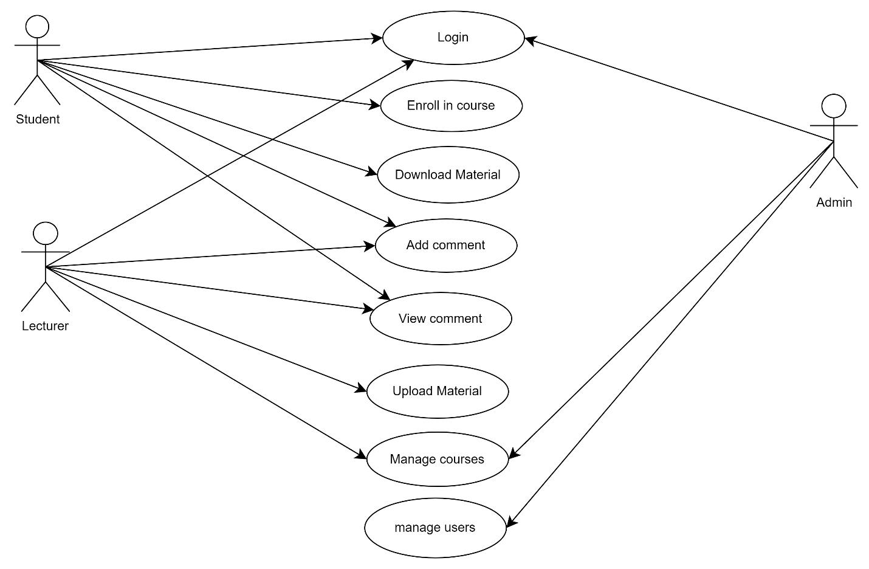

## Data flow diagram

## CHAPTER FOUR: SYSTEM IMPLEMENTATION

## 4.0 Introduction

## This chapter consisted of the appearance of the system and the functions of the various UI available in the application.

## 4.1 System Architecture

## 4.1.1 Development environment

## The development environment of the project consisted of Visual Studio Code, which was among the most popular source-code editors. It comprised features such as debugging support, built-in version control, and syntax highlighting. It was used to write code logic for both the frontend and backend components. The editor supported a large variety of languages, making it effective for use in this project.

## 4.1.2 Frontend development

### The frontend for this project comprised designing and implementing an interface that allowed users (Admin, Lecturer, and Student) to log in. The Administrator handled the registration and enrollment of lecturers and students through a registration interface. Lecturers uploaded materials to the database, which students accessed and downloaded for their use.

### Registration page

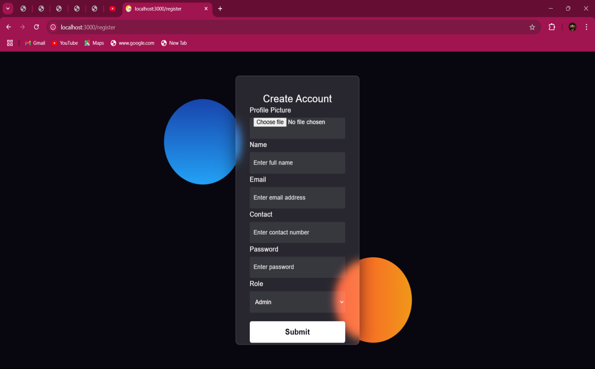The administrator registered the lecturers and students, specified their roles in the system, and provided the login details to them for access.

*Figure1 ; Registration page.*

### Login page

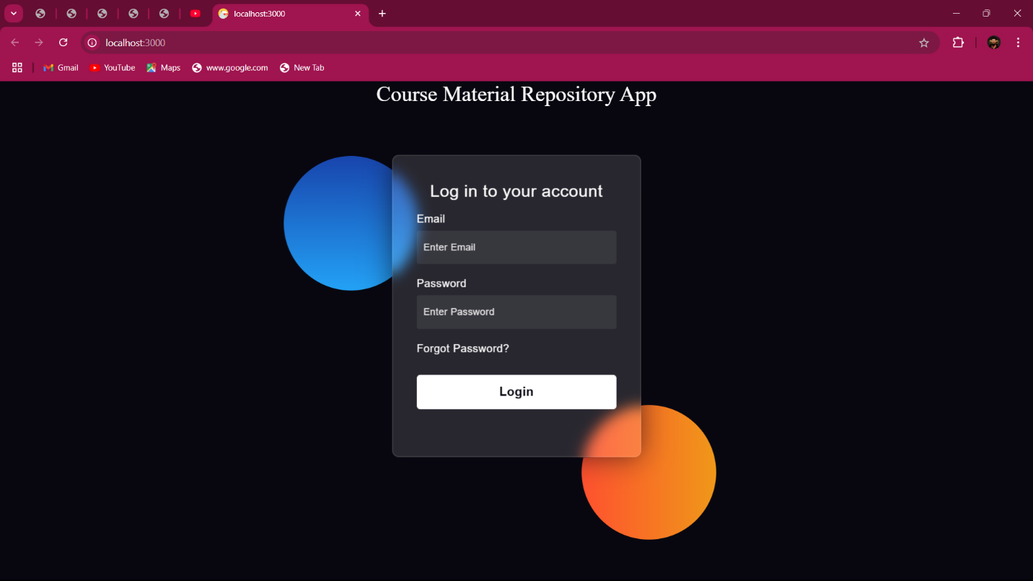User neeed to login through use of email and password provided by the administrator during registration.

*Figure2 ; login page.*

### Administrator home page

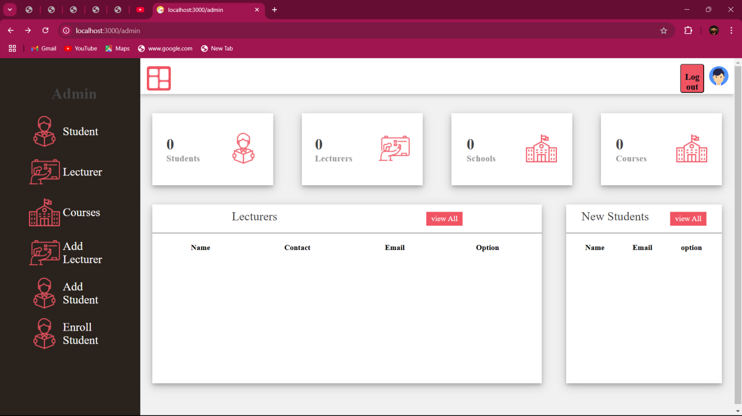This contained everything the administrator was capable of doing in the system

*Figure3 ; administrator page.*

### Lecturer home page

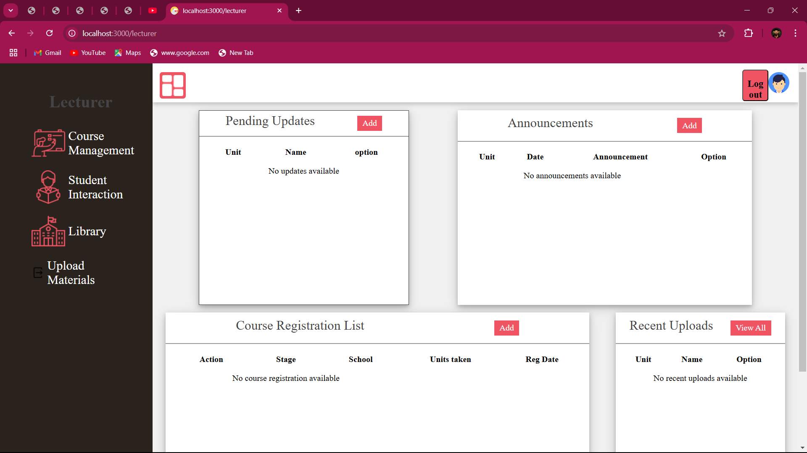This contained everything the lecturer was capable of doing in the system.

*Figure4 ; lecturer home page.*

### Student home page

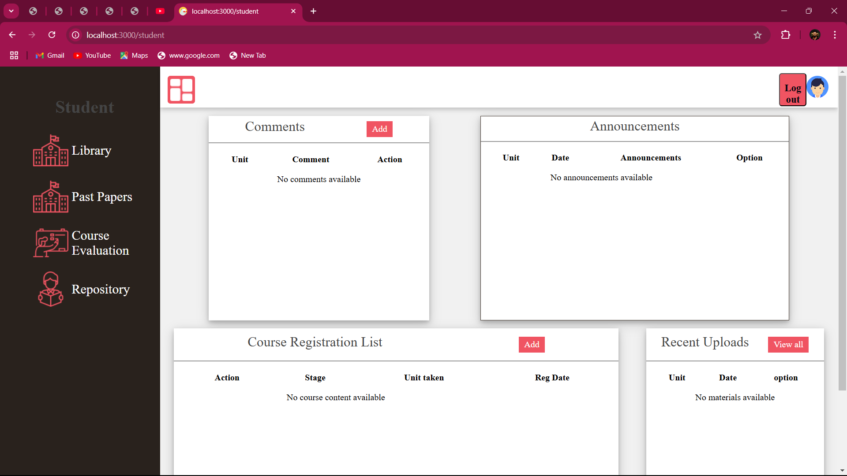This contained everything the student was capable of doing in the system.

*Figure5; student home page.*

## 4.1.3 Backend development

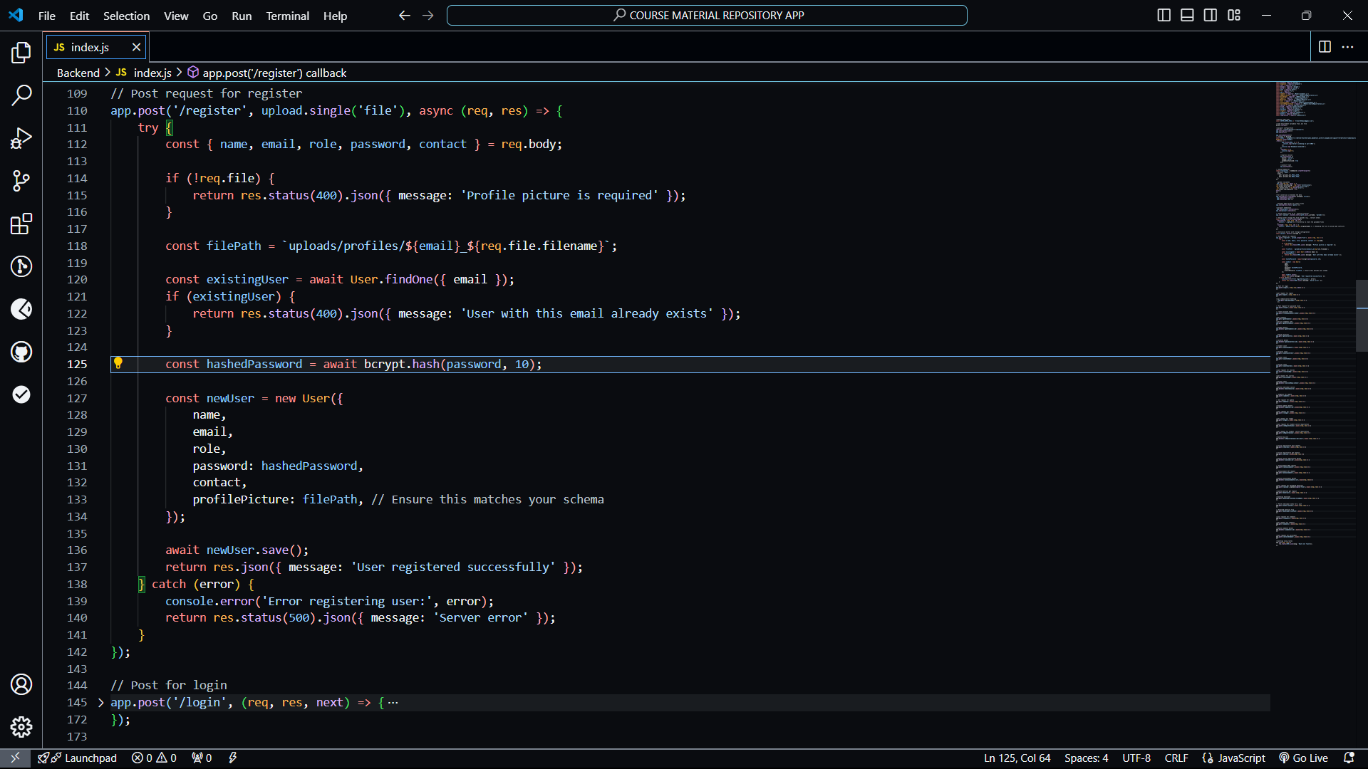The backend handled all the data related to the system i.e fetching, storing and update of data in the database

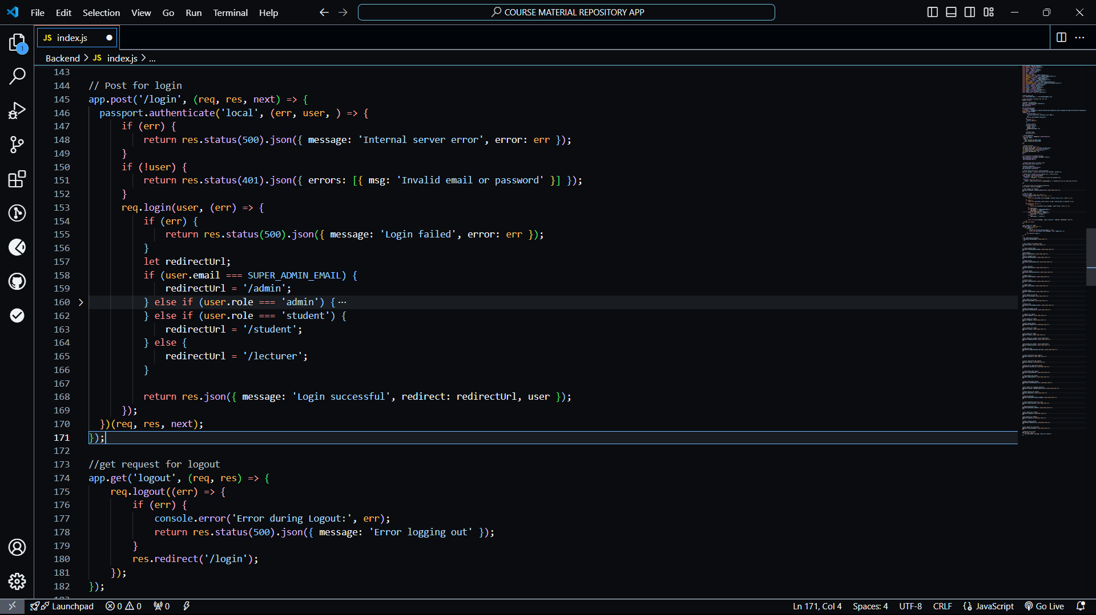*Figure6; Registration code*

*Figure7; Login code*

*Figure8;*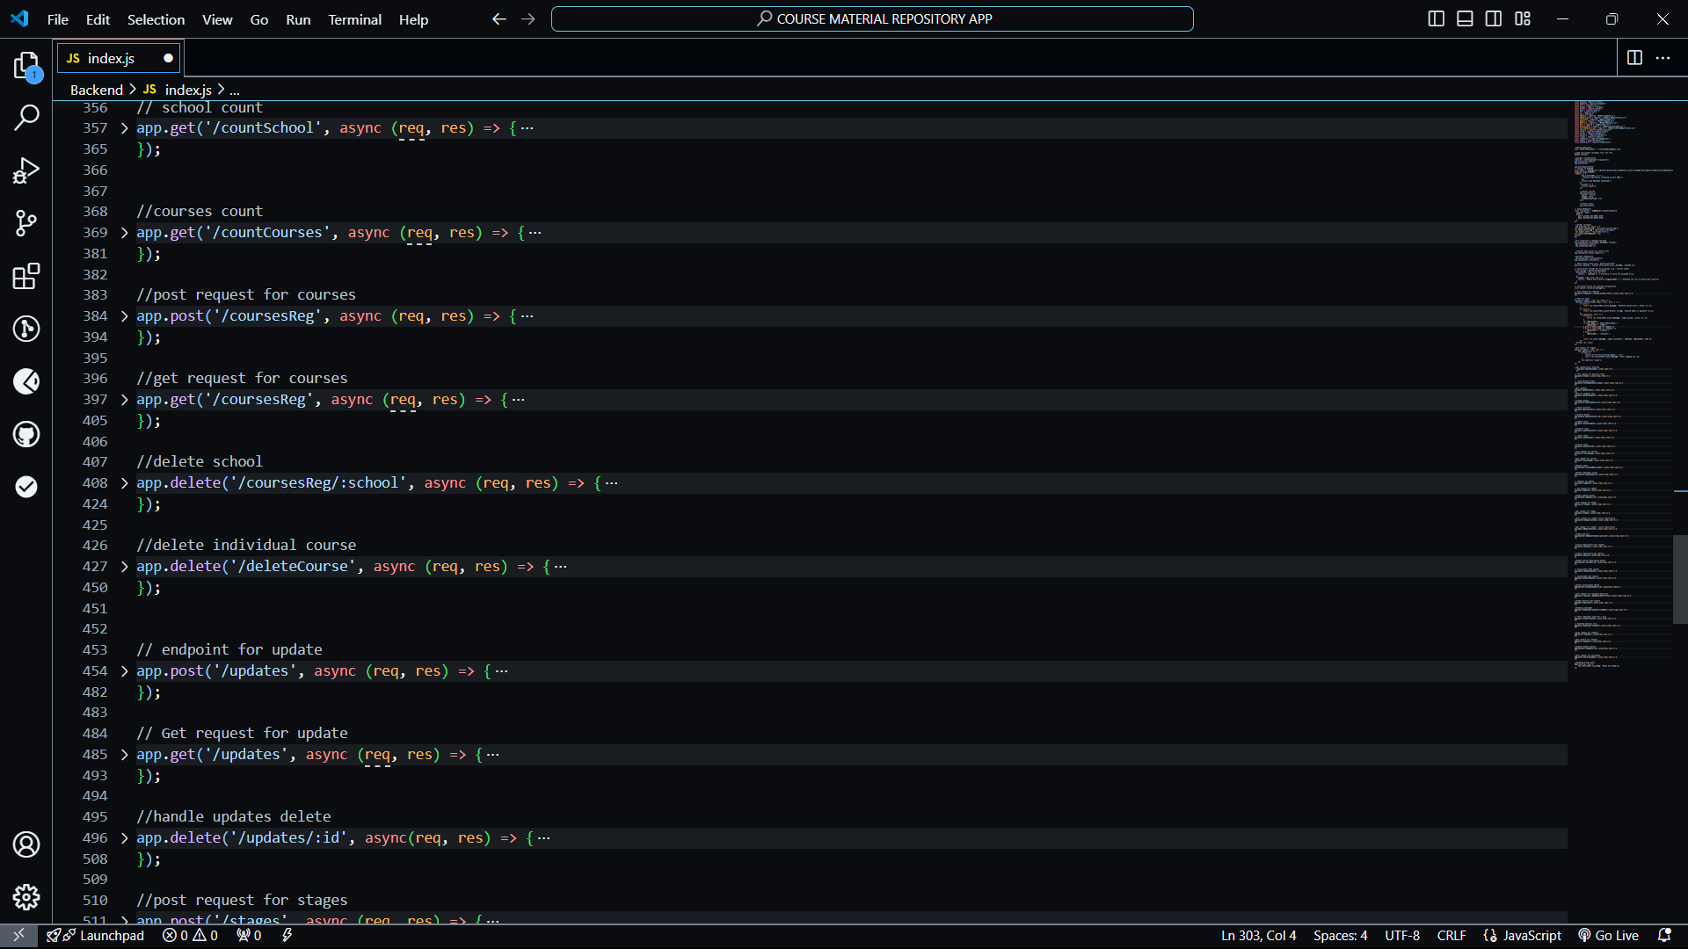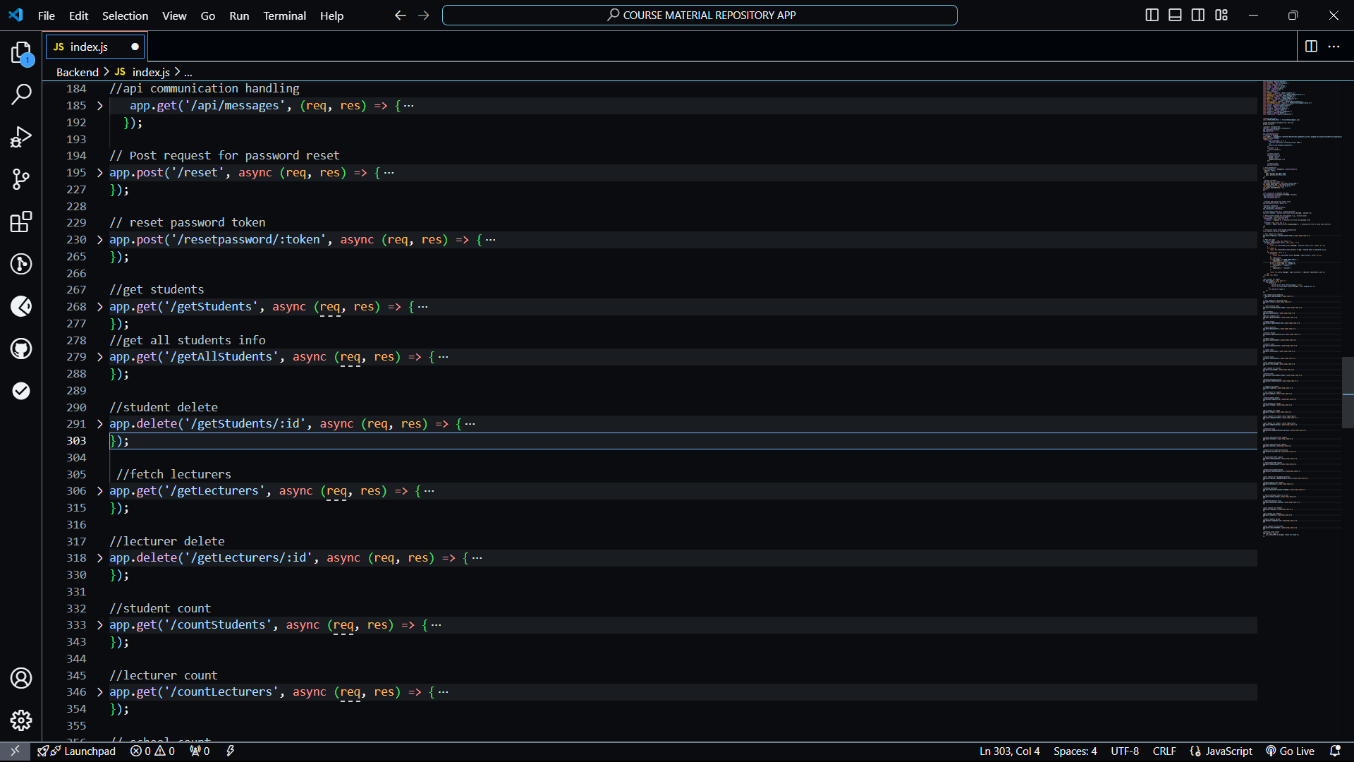

*Figure 9; visual studio code.*

## 4.1.4 Data Layer

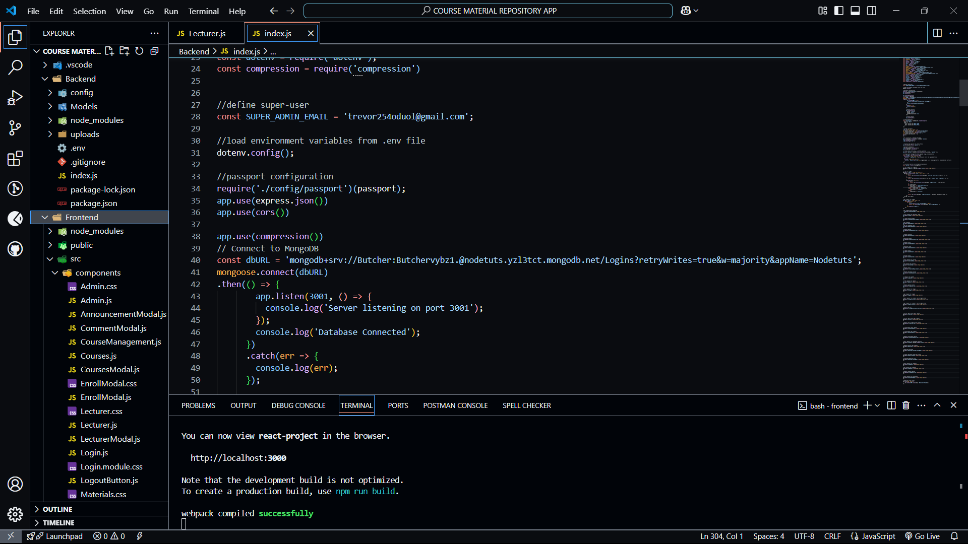

*Figure 10; database connection*

The database runed on MongoDb atlas which was an online database.

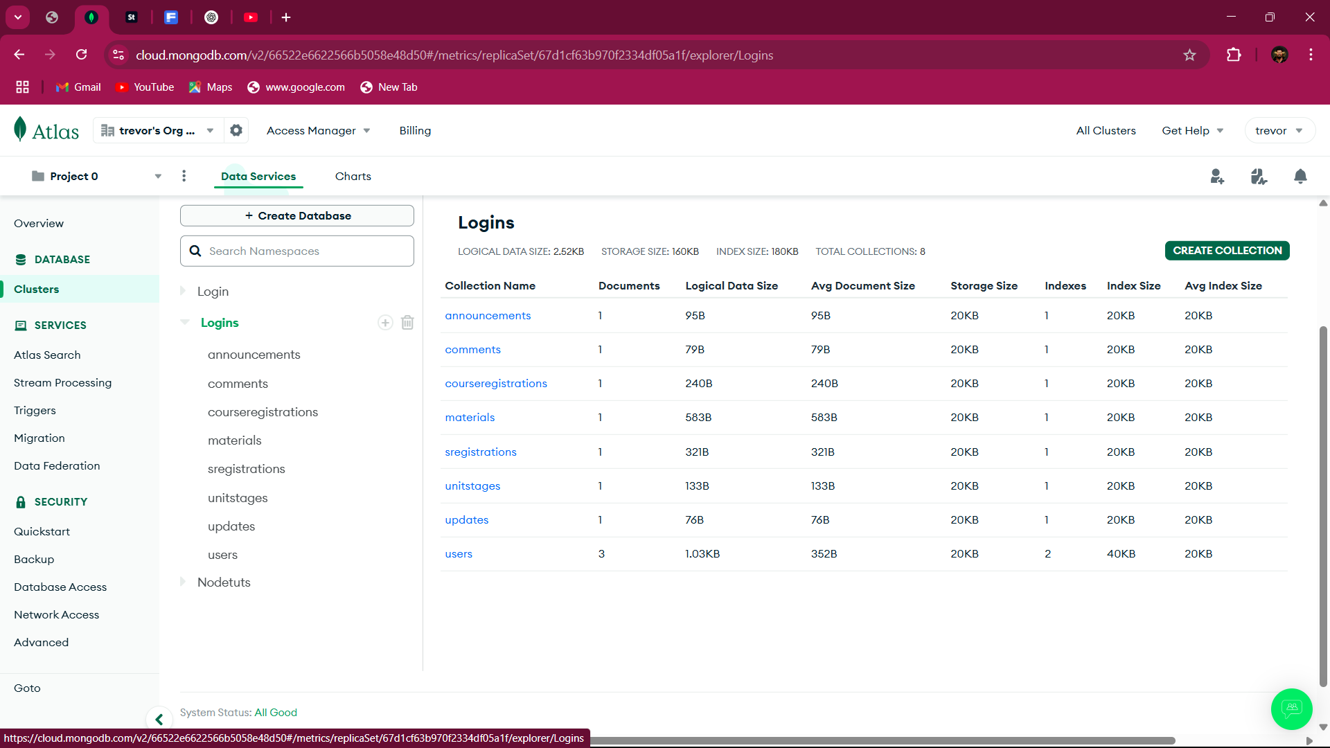

*Figure 11; database*

## 4.2 Conclusion

The chapter outlined the development of the Course Material Repository App using Mern Stack ( MongoDb, Express, ReactJs, NodeJs). The system intergrated a user-friendly frontend, a well intergarted backend and a secure database for storing Data. It successfully allowed course materials to be uploaded into the Database which were then fetched by the students from the database and allowed for feedback response from the students

## REFERENCES

1. Smith, J. , & Brown, L. (2018). *Developing Educational Apps: A comprehensive guide.* New York: Tech Publishers.
2. Johnson, M. (2020). *Innovative Approaches to E-Learning.* London: Academic Press.
3. Williams, P., & Thompson, R. (2019). User Experience in Educational Technology. *Journal of Educational Technology,*35(4), 221-234.
4. Doe,J., & Roe, A. (2021). Enhancing Learning through Technology: Case studies and Lessons Learned. Paper presented at the International Conference on Education and Technology, Nairobi, Kenya.
5. UNESCO. (2021). Global Education Monitoring Report: Technology in Education. Paris: UNESCO.
6. Ahmed, S. (2021). *The Impact of Digital Resources on Learning Outcomes: A Case Study of Kabarak University.* (Master’s thesis, Kabarak University).
7. Ministry of Education, Kenya. (2020). *National Education Sector Strategies Plan.* Nairobi: Ministry of Education.
8. Kabarak University. (2024) About Kabarak University. Retrieved from <https://www.kabarak.ac.ke>.
9. World Bank. (2022). Leveraging Technology in Education. Retrieved from <https://www.worldbank.org/en/topic/education/overview>.

# **APPENECIES**

## **Appendix I – Gant chart**

Using a Gant chart, we are able to display and track the development process

|  |  |  |  |  |  |
| --- | --- | --- | --- | --- | --- |
| No | Activity | Sept | Oct | Nov | Dec |
| 1 | Project proposal approval |  |  |  |  |
| 2 | Chapter one |  |  |  |  |
| 3 | Chapter two |  |  |  |  |
| 4 | Chapter three |  |  |  |  |
| 5 | Documentation and presentation |  |  |  |  |

## **Appendix II – Budget**

This was the budget for developing the Course Material Repository App

|  |  |
| --- | --- |
| Item | Cost |
| Internet | 4000 |
| Laptop | 45000 |
| Printing | 1140 |
| Hosting Services | 7000 |
| Total | 57140 |