Title

Population dynamics and screening for Hepatitis C in Thailand: the effect of population structure and screening strategies on achieving elimination by 2030

*Timelines of Hepatitis C Virus elimination in Thailand: comparing the effect of screening strategies and population structures on WHO targets*

Abstract

Introduction

Hepatitis C Virus (HCV) is a large health burden in Thailand and transmission is entangled in age structure, which is changing along with other population dynamics in the country. Screening is necessary to catch asymptomatic cases and prevent transmission, but screening coverage is low and generally only accessed once symptoms are present, many years – sometimes decades – after infection. Modelling population dynamics can provide a more detailed look at what’s happening with HCV transmission and allow for more informed decisions to be made with respect to screening and treatment policies in order to achieve national elimination goals.

Background

HCV is an infectious disease that primarily affects the liver, and the majority of global burden exists in Low- and Middle-Income Countries (LMICs) (Graham and Swan, 2015). Serious disease such as liver fibrosis, liver cirrhosis and hepatocellular carcinoma (primary liver cancer) can follow as a direct result of HCV infection (Wasitthankasem et al., 2016). These stages of liver failure can take many years to cause symptoms, and in fact only occur later in life, with the respective average ages of HCV patients with fibrosis and cirrhosis caused by HCV being 36 (Ryder and Group, 2004) and 52 (Sajja, Mohan and Rockey, 2014). Asymptomatic carriers may hence spend many years transmitting the disease while unaware of their status. For this reason, screening can be an effective tool for intercepting these asymptomatic cases and supplying treatment much earlier on, halting the transmission chain and reducing health and economic burden by preventing further cases. Prior to 2019, the first-line treatments for HCV were Pegylated Interferon therapies (PEGs). The current first line treatment in Thailand for HCV is oral administration of Direct-Acting Antivirals (DAAs), which are effective but generally only given to symptomatic patients, and there is no targeted screening programme in currently place, despite suggestions that screening is necessary to reach elimination goals (Posuwan *et al.*, 2020). Rearrange this section for flow?

Transmission in recent years has been relatively low and prevalence in south east Asia is declining, however the burden in Thailand is still relatively high, with approximately 790,000 cases in Thailand in 2019 (Posuwan *et al.*, 2019). More affordable treatment for HCV is leading researchers to believe that elimination is an attainable goal (Thaineua *et al.*, 2021), and the Ministry of Public Health Thailand have called for a push for elimination by 2030 (Drugs for Neglected Diseases Initiative, 2022), with elimination defined in the most recent Global Hepatitis Report as a 90% reduction in yearly incidence and a 65% reduction in yearly mortality as compared to the 2015 values (World Health Organization, 2017).

The population structure of Thailand, as with many other MICs, is changing as mortality amongst older age groups decreases rapidly (Sudharsanan and Bloom, 2018), and as such the proportions of older age groups are growing while younger groups decrease in proportion. HCV disproportionately affects older age groups (Wasitthankasem *et al.*, 2020) and hence it may be useful to consider these heterogeneities within a population when considering the disease’s impact and possible intervention and treatment options.

Previous HCV transmission models in Thailand have not considered age or population dynamics, rather modelling the population as a whole, with all individuals equally susceptible to infection and different disease stages (Poovorawan et al., 2016). The model in this report incorporates changing population structure, birth and death rates in to an HCV transmission model to inform potential screening policy decisions. Aspects of this model could be used in other transmission models in Thailand, and with data from other countries could be used globally for other countries with different population projections. Furthermore, with data on other population dynamics on specific groups relevant to disease transmission, this approach could be used to model targeting risk groups as well as age groups.

This report employs a novel, age-structured HCV transmission model to investigate the effect of changing population structure on the effectiveness of baseline and targeted screening programmes, and explore whether elimination goals outlined by the World Health Organisation are feasible in the timescale suggested.

Methods

All data used (in raw and modified formats) can be found in Supplementary File A and is publicly available via the links in the file. Further descriptions of all methods can be found in Supplementary File E.

*Population Data*

United Nations demographic data was used for the years 2004 to 2021 to visualise the population dynamics of Thailand and to calibrate the model. Population structure, birth and death rates (per person per year) were recorded and UN projections were considered(United Nations, 2019). Figure 1 shows the proportion of each age group in Thailand. Total population and birth rate data and projections can be found in Supplementary Figure S1 (United Nations, 2022).

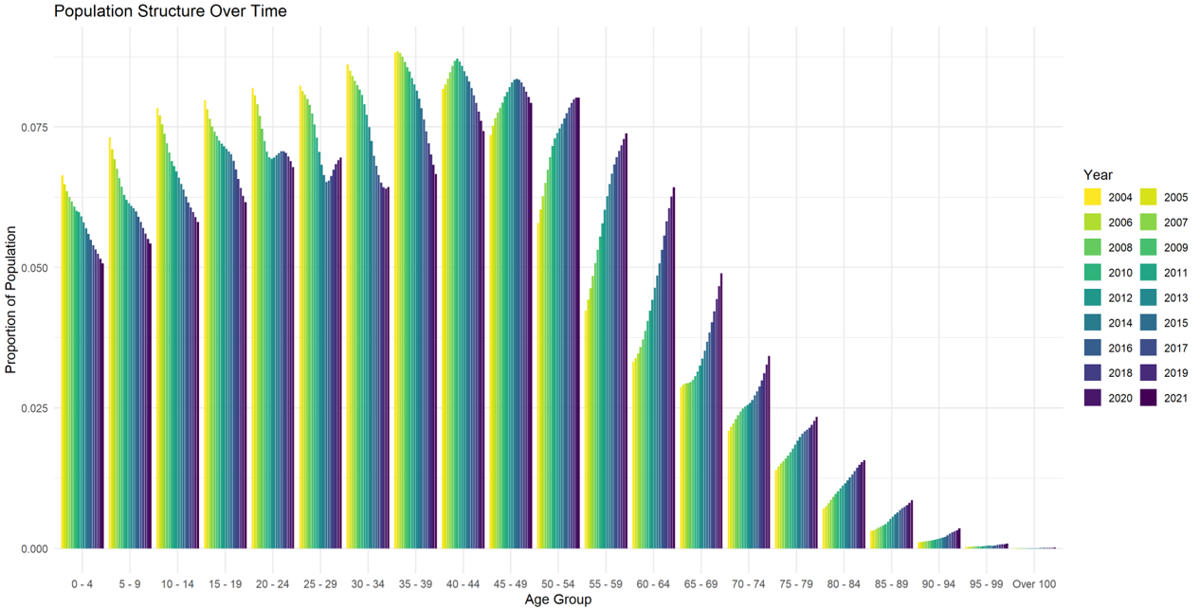

Figure 1: Population structure of Thailand by age group from 2004 to 2021. Note the clear aging of the population: age groups below 44 are shrinking while those above 50 are growing.

*Prevalence Data*

Data on HCV prevalence in Thailand are very scarce, especially by age. Other sources report both the presence of anti-HCV and HCV in the Thai population (Wasitthankasem *et al.*, 2018). Throughout this investigation, data on anti-HCV carriers was used for prevalence calculations, in line with previous HCV transmission modelling work (Poovorawan et al., 2016). The work of Wasitthankasem et al., 2016 was used to calibrate the model as the study includes relatively complete national prevalence data stratified by age groups. The 2004 values were used to inform the initial conditions of the model and the 2014 values for model calibration. These data and calculations can be found in Supplementary File A: *prevalence_data_by_age*, with more information in Supplementary File E.

*Sexual Contact Matrix*

The contact matrix was derived from data on sexual partners and sexual contact between age groups from a study on Human papillomavirus infection (HPV) in Laos (Chanthavilay *et al.*, 2016). Although more complete contact matrices exist describing other types of contact between age groups (Prem, Cook and Jit, 2017), very limited data is available on the particular type of contact that transmits HCV; namely sexual and blood-borne contact. Although not specific to HCV and Thailand, the contact matrix for a sexually transmitted disease in a South East Asian setting was deemed the most appropriate for the purposes of this model. A heat map of the transmission matrix *beta* can be found in Supplementary Figure S2.

*Transmission model*

An age-structured compartmental model was used to model progression through the transmission cycle that also accounted for population dynamics, with screening and treatment programmes represented in the model. The HCV transmission portion was adapted from (Poovorawan et al., 2016) and the age structure from an otherwise unrelated disease transmission model (Pan-Ngum *et al.*, 2017). Figure 2 shows the general structure of the transmission and age compartments of the model. A full list of equations, compartments and parameters can be found in Supplementary Files B, C and D, with the full model code available at *https://github.com/HCVinThailand/elimination_targets*. More details about the methods involved in the model setup can be found in Supplementary File E.

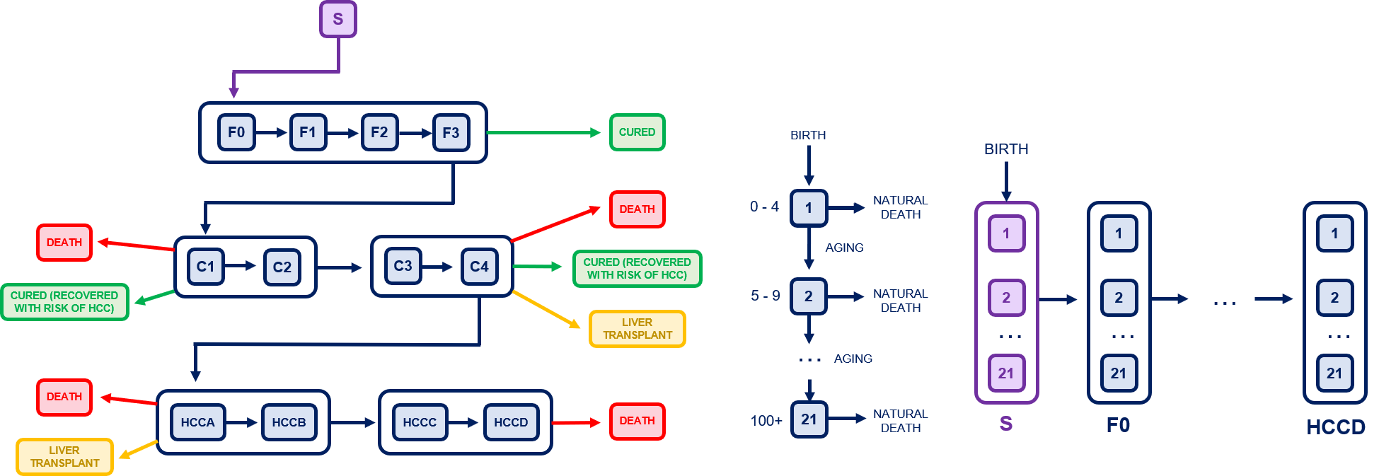

Figure 2: Compartment diagram showing the HCV transmission cycle modelled as well as the embedded age structure. Individuals travel through both simultaneously.

The target population for the treatment intervention was any individual in the liver fibrosis (F0-F3) and cirrhosis (C1-C4) compartments i.e. anyone with active HCV infection that had not yet progressed to HCC. The current first-line treatment of DAAs was modelled to begin in 2019, with the previous standard treatment being PEGs. All parameters relating to HCV transmission and treatment were taken from the work of Poovorawan et al., 2016. The screening intervention was modelled at different age group targets and coverages depending on the strategy explored. Prevalence (%) was defined as 100 times the total number of cases (F, C and HCC) over total individuals in that age group or population, while incidence was defined as the total number of new cases of HCV in the given year. The elimination targets outlined in the Global Hepatitis Report (World Health Organization, 2017) – a 90% reduction in new cases and a 65% reduction in HCV related death – refer only to global values, and no Thailand specific values were given for 2015 baseline values. The 2015 values of the model were hence used to calculated values for 2030 target incidence and deaths due to lack of data.

Four population scenarios were compared to explore potential patterns of population growth in order to investigate the effect of population structure on HCV transmission and elimination, in order to assess the impact of population structure on screening strategy success. The baseline mortality scenario was that the natural death rates (deaths per person per year) would continue to decrease at 2.5% per year compared to the average across the rates from 2012 to 2021, fitting the overall projected trend in the Thai population (United Nations, 2019). Three further scenarios of population decline, plateau and growth were then compared to this baseline. In the decreasing population scenario, mortality rates across all age groups were assumed to increase by 2% per year compared to the baseline. In the plateau scenario, mortality for age groups 0-49 was the same as the baseline, whereas 50-100+ mortality decreased by 2% per year compared to baseline, in order to reflect the aging population of Thailand demonstrated in Figure 1. Similarly, in the population growth scenario, mortality decreased by 2% per year for 0-49 and by 4% per year for 50-100 compared to the baseline. These scenarios and their effects on total population are visualised in Figure 3. The mortality rates for each age group over time for each population scenario can be seen in Supplementary Figure S3, and all scenarios can be found in Supplementary File A: *mortality_scenarios*.

Within these four population scenarios, six screening strategies including the current baseline were compared to investigate whether the national elimination goals appeared to be achievable in the desired time frame. The baseline was chosen as whole-population voluntary screening at a coverage estimated to be normally distributed with a mean of 6% and standard deviation of 7% to fit 2004 and 2014 data, as the true baseline coverage is not recorded. The six other screening strategies targeting three different age groups at medium (50%) and high (90%) coverage starting in 2023 at a duration of seven years, due to the 2030 elimination target year. A summary of the strategies can be found in Table 1.

|  |  |  |  |
| --- | --- | --- | --- |
| Screening Strategy | Age Group Screened | Yearly Coverage | Duration |
| Baseline | All | 7% | - |
| A | 30-39 | 50% | 7 years |
| B | 30-39 | 90% | 7 years |
| C | 40-49 | 50% | 7 years |
| D | 40-59 | 90% | 7 years |
| E | 50-59 | 50% | 7 years |
| F | 30-59 | 50% | 7 years |

Table 1: A summary of the screening strategies explored in this investigation

*Model calibration*

The population structure of the model was compared to total and age stratified population data (United Nations, 2019) to ensure correct distribution of individuals across age groups. A single multiplier was applied to the UN birth rate data (United Nations, 2022) to ensure an appropriate fit of the total population data. Figures 3 and 4 show the baseline output of the model with the United Nations data and projections. More details about the model calibration can be found in Supplementary File E.

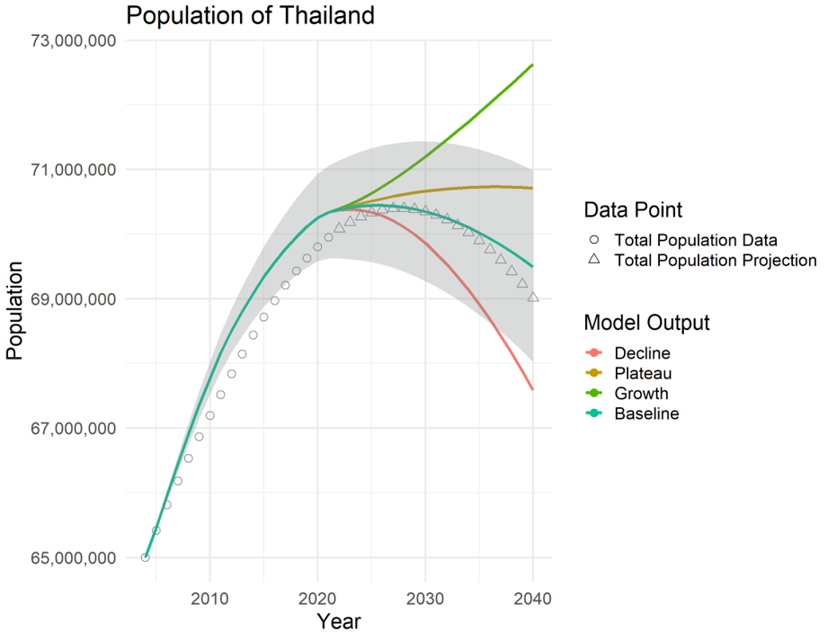

Figure 3: The model output of the total population of Thailand for each of the four population structure scenarios. The grey ribbon shows the 95% confidence interval based on the distribution estimate of birth rate. The points show the United Nations data and projection for Thailand’s population.

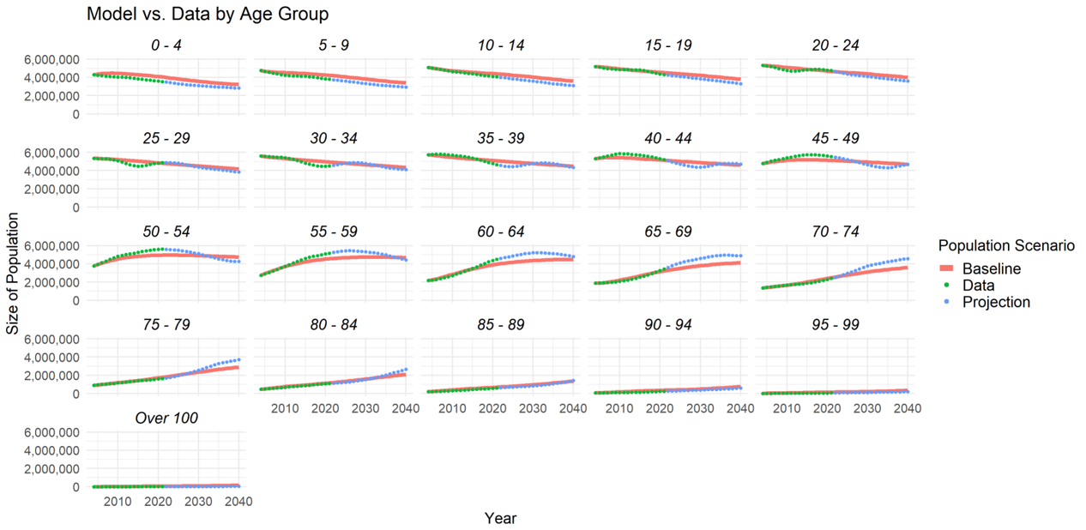

Figure 4: The model output of population by age group overlaid with United Nations data and projections

Thai HCV prevalence data from 2004 and 2014 was used to calculate initial conditions and to check the fit of the HCV transmission aspect of the model. Data on prevalence in Thailand is very limited (give reason?), especially prevalence by age, so the baseline coverage between 2004 and the start of proposed screening programmes was estimated in order to fit the data available. The baseline screening coverage was assumed to be uniform across age groups, and normally distributed with mean 7% and standard deviation 3%. Thus, the upper and lower 95% levels were calculated at population and screening baseline to give an upper and lower estimate of the deaths, prevalence and incidence. The model showed a sufficient representation of the data available, as shown in Figure 5. More details about model calibration can be found in Supplementary File E.

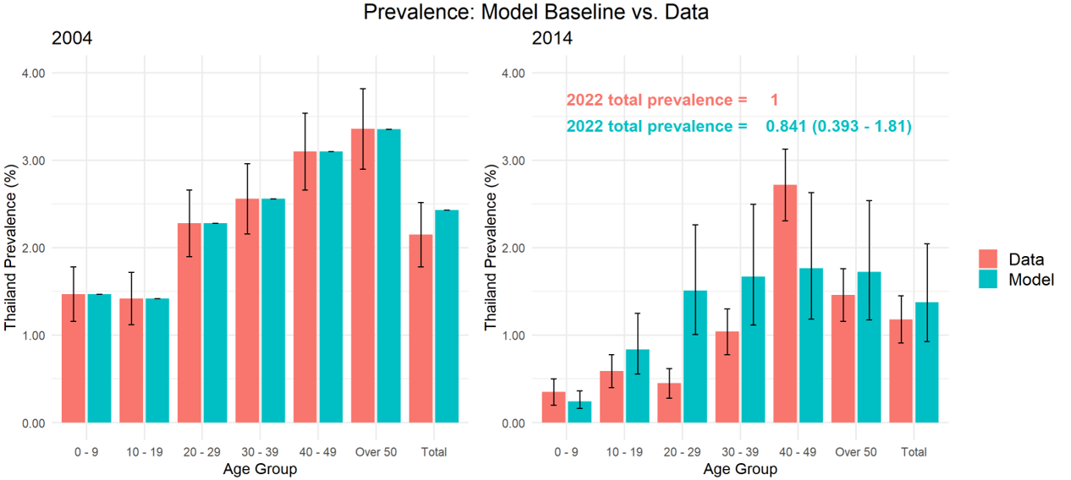

Figure 5: Model output compared with data on 2004 and 2014 prevalence by age group. Note the total prevalence in 2004 is slightly higher due to differences in total population value between the data source used for prevalence and population.

*Model Assumptions*

Inherent in the use of a compartmental transmission model is the assumption that all individuals in a single compartment are identical. By stratifying the previous model into age groups this assumption has been mitigated somewhat, but there are still limitations to the conclusions that can be drawn from such a model.

The limited data available was used to initialise the model in the year 2004, and assumptions were made about younger age groups being constrained to the earlier stages of disease (see Supplementary File E). Little to no reliable data could be found on distribution of age groups throughout the stages of fibrosis, cirrhosis and HCC, so an early initialisation (2004) compared to present day (2022), along with calibration to 2014 data was imposed to mitigate this assumption: transition rates between liver stages over a period of 18 years was assumed to stabilise results enough to make the necessary conclusions about 2023 onwards.

The model assumed that an individual in a disease compartment will be treated if they are targeted by the screening programme, and that all individuals requiring treatment will receive it. Due to Thailand’s universal healthcare system this assumption is mostly reasonably, however it is noted that, in reality, not all those who need treatment receive it.

*Technology*

R Studio® version 2021.09.0 Build 351 was used to run the model. Microsoft® Excel® 2019 MSO (16.0.10387.20023) 64-bit was used to store and manipulate data, initial conditions, results and scenarios. R packages used were: pacman, tictoc, Hmisc, viridis, deSolve, tidyverse, doParallel, manipulate, readxl, gridExtra, grid, scales.

Results

The success of each screening strategy with respect to elimination target years did not vary significantly between population growth scenarios, in both HCV incidence and HCV related death. In all four population scenarios, the current baseline screening strategy of 7% coverage per year across all age groups did not reach incidence elimination until 2039. The mortality elimination goal was not reached until after the end of the simulation (2040) with any of the screening strategies or the population scenarios. At the baseline screening strategy, the total number of deaths increased in the plateau and growth population scenarios compared, with 536 and 203 fewer deaths averted than baseline population. With all other screening strategies, the deaths averted increased with population decline, and decreased with population growth and plateau.

Increasing coverage from 50% to 90% for 30-39-year olds only brought the year of incidence elimination forward by 1, from 2036 to 2035, while with 40 – 49-year olds incidence elimination was reached in 2037 at both coverages. The difference in incidence elimination years between baseline and the most radical screening strategy (30 – 59 at 90%) was 6 years (2039 to 2033). The 10-year age group with the earliest incidence elimination year at 50% coverage was 30 – 39 at 2036, with 50 – 59 being the latest at 2038.

The strategy with the most cases and deaths averted was screening 30 – 59-year olds at 90% coverage per year for 7 years in all four population scenarios, with 8,924 cases and 5,148 deaths averted at baseline population. However, this naturally involved the highest level of excess screening, at 193,814 individuals over the 7-year period. This strategy also reached incidence elimination the earliest, in 2033.

Yearly incidence (total new cases per year) and mortality (HCV related deaths per year) for each population scenario and screening strategy are shown in Figure 6. Results of the baseline population scenario only are shown in Table 2. Full results of all scenarios can be found in Supplementary File A: *Results*.

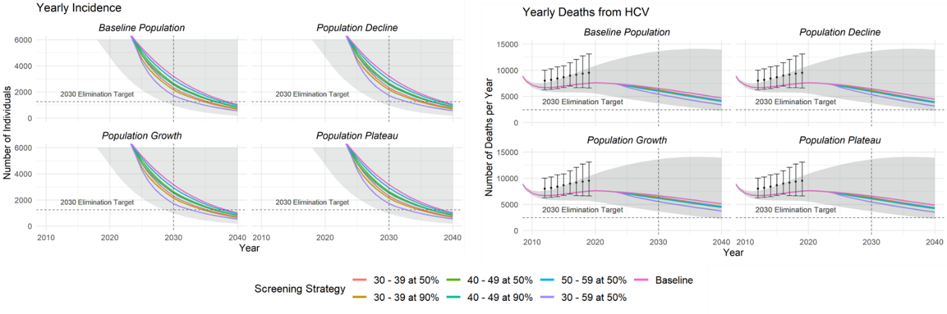

Figure 6: Model output for incidence and deaths compared with the WHO elimination goals and HCV deaths data (Coalition for Global Hepatitis Elimination and World Health Organisation, 2019). The grey ribbon shows the 95% interval of the baseline scenario as given by the uncertainty in the baseline screening coverage.

|  |  |  |  |  |  |  |  |
| --- | --- | --- | --- | --- | --- | --- | --- |
| **Screening Strategy** | **Incidence Difference to 2030 Target** | **Deaths Difference to 2030 Target** | **Cases Averted** | **Deaths Averted** | **Extra Screened** | **Year Incidence Elimination Target Reached** | **Year Mortality Elimination Target Reached** |
| Baseline | 1,937 | 4,092 | 0 | 0 | 0 | **2039** | Beyond simulation |
| 30-39 at 50% | 1,066 | 3,800 | 4,973 | 1,151 | 70,130 | **2036** | Beyond simulation |
| 30-39 at 90% | 905 | 3,731 | 6,524 | 1,514 | 82,462 | **2035** | Beyond simulation |
| 40-49 at 50% | 1,395 | 3,668 | 3,112 | 1,851 | 78,391 | **2037** | Beyond simulation |
| 40-49 at 90% | 1,289 | 3,573 | 4,107 | 2,434 | 93,110 | **2037** | Beyond simulation |
| 50-59 at 50% | 1,689 | 3,565 | 1,427 | 2,480 | 78,824 | **2038** | Beyond simulation |
| 30-59 at 90% | 472 | 2,979 | 8,924 | 5,148 | 193,814 | **2033** | Beyond simulation |

Table 2: Results of all screening strategies at baseline population scenario

Discussion

The results showed that the four population structure projections modelled do not significantly affect the elimination year of any of the screening strategies modelled: a screening strategy reaches incidence elimination incidence target values at roughly the same time regardless of changing population demographics. This is likely because the strategies were based on a percentage coverage, so as the number of older individuals increased, so did the amount of excess screening. However, the aging population scenarios (growth and plateau) lead to a higher number of deaths and cases overall, due to HCV disproportionately affecting older individuals. If the population projection of Thailand changes due to fertility campaigns or further decreasing mortality, or indeed in other counties where population structure is volatile and changing rapidly, consideration of population dynamics and structure may not be necessary when proposing screening programmes and policies. However, more HCV-related deaths and cases could be expected in an aging population.

The model showed that yearly screening coverage may impact elimination results less than the age group targeted, and in fact even radical screening strategies may only bring incidence elimination forward by a few years. The most effective group to target appeared to be 30 – 39-year olds, but even at very high coverage this strategy did not achieve the WHO 2030 target in the model.

The programmes modelled would undoubtedly require a great deal of resources to achieve such coverages of a large population due to the high cost of screening, which may not be feasible within government budgets and resource allocation. The screening strategies with the highest success (cases and deaths averted, year of incidence elimination) require a large amount of excess screening. Further in-depth economic would be required to investigate the economic impact of such screening strategies compared to the current baseline.

There is a significant lack of data surrounding age stratification of HCV cases and deaths in Thailand, leading to a large amount of uncertainty in the results, and this limitation is recognised. Mortality decreases around 2020 both in data and in the model, likely due to the new treatment programme implemented in 2019. However, the model underestimated the number of deaths caused by HCV compared to data, and mortality elimination targets were still not met in the timescale simulated. Few robust conclusions can be drawn about efficacy of screening programmes on mortality based on the results of this report, however it appears that the WHO mortality goal will not be reached by 2030 in Thailand.

The work in this report could be built upon by applying the age stratified transmission structure and changing population demographics to other populations. Better fitting of the model could be performed if more data becomes available. The model could be modified to focus on risk groups that are disproportionately affected by HCV as well as older age groups, such as MSM (Men who have Sex with Men), prisoners and IDU (Injecting Drug Users).

Conclusion

This model implied that with the current HCV screening programme in Thailand, the elimination targets set out by WHO (90% reduction in new cases and 65% reduction in HCV related death from 2015 baseline) may not be achieved by 2030 even with the introduction of intensive targeted screening programmes. Screening coverage appears to have less effect on incidence than the age group targeted, and significant changes in the structure of a population do not appear to affect the success or failure of an age-targeted screening strategy. Without intervention, incidence elimination might be achieved by 2039, and with a very high coverage targeted screening programme could be reached as early as 2033, however mortality targets may not be reached until at least 2040 even with the implementation of such programmes.

make sure this aligns with title and research question and title. Does the whole thing tell a nice story, and answer the question it set out to?

Data Availability Statement

All data used was publicly available and can be found using the following links (also provided in Supplementary File A:

Birth rate data:

*https://www.macrotrends.net/countries/THA/thailand/birth-rate*

Mortality rate data:

*https://population.un.org/wpp/Download/Standard/Mortality/*

Population structure data (UN):

*https://www.populationpyramid.net/thailand/2004/*

Sexual contact data (HPV in Laos):

*https://bmchealthservres.biomedcentral.com/articles/10.1186/s12913-016-1662-5#Sec15*

Prevalence data (National HCV Prevalence Survey):

*https://bmcinfectdis.biomedcentral.com/articles/10.1186/s12879-022-07074-2*

*https://journals.plos.org/plosone/article?id=10.1371/journal.pone.0149362*

HCV deaths data (WHO data):

*https://www.globalhep.org/country-progress/thailand*

All code and data can be found at:

*https://github.com/HCVinThailand/elimination_targets*

Code Availability Statement

All code for data cleaning and analysis associated with the current submission is available at *https://github.com/HCVinThailand/elimination_targets*. Any updates will also be published on Github.

Declarations of interest: None

References

Chanthavilay, P. *et al.* (2016) “The economic evaluation of human papillomavirus vaccination strategies against cervical cancer in women in Lao PDR: A mathematical modelling approach,” *BMC Health Services Research*, 16(1), pp. 1–10. Available at: https://doi.org/10.1186/S12913-016-1662-5/TABLES/4.

Coalition for Global Hepatitis Elimination and World Health Organisation (2019) *HCV-related deaths*, *Hepatitis C in Thailand Dashboard*. Available at: https://www.globalhep.org/country-progress/thailand (Accessed: August 6, 2022).

Drugs for Neglected Diseases Initiative (2022) *Thai partners unite with DNDi to improve access to treatments and diagnostics for people with hepatitis C in Thailand | DNDi*. Available at: https://dndi.org/press-releases/2022/thai-partners-unite-with-dndi-improve-access-treatments-diagnostics-for-people-with-hepatitisc-in-thailand/ (Accessed: August 3, 2022).

Graham, C.S. and Swan, T. (2015) “A path to eradication of hepatitis C in low- and middle-income countries,” *Antiviral research*, 119, pp. 89–96. Available at: https://doi.org/10.1016/J.ANTIVIRAL.2015.01.004.

Pan-Ngum, W. *et al.* (2017) “Predicting the relative impacts of maternal and neonatal respiratory syncytial virus (RSV) vaccine target product profiles: A consensus modelling approach,” *Vaccine*, 35(2), pp. 403–409. Available at: https://doi.org/10.1016/J.VACCINE.2016.10.073.

Poovorawan, K. *et al.* (2016) “Estimating the Impact of Expanding Treatment Coverage and Allocation Strategies for Chronic Hepatitis C in a Direct Antiviral Agent Era,” *PloS one*, 11(9). Available at: https://doi.org/10.1371/JOURNAL.PONE.0163095.

Posuwan, N. *et al.* (2019) “Serological evidence of hepatitis A, B, and C virus infection in older adults in Khon Kaen, Thailand and the estimated rates of chronic hepatitis B and C virus infection in Thais, 2017,” *PeerJ*, 7(8). Available at: https://doi.org/10.7717/PEERJ.7492.

Posuwan, N. *et al.* (2020) “Towards the elimination of viral hepatitis in Thailand by the year 2030,” *Journal of Virus Eradication*, 6(3), p. 100003. Available at: https://doi.org/10.1016/J.JVE.2020.100003.

Prem, K., Cook, A.R. and Jit, M. (2017) “Projecting social contact matrices in 152 countries using contact surveys and demographic data,” *PLOS Computational Biology*, 13(9), p. e1005697. Available at: https://doi.org/10.1371/JOURNAL.PCBI.1005697.

Ryder, S.D. and Group, on behalf of the T.H.C.S. (2004) “Progression of hepatic fibrosis in patients with hepatitis C: a prospective repeat liver biopsy study,” *Gut*, 53(3), p. 451. Available at: https://doi.org/10.1136/GUT.2003.021691.

Sajja, K.C., Mohan, D.P. and Rockey, D.C. (2014) “Age and Ethnicity in Cirrhosis,” *Journal of investigative medicine : the official publication of the American Federation for Clinical Research*, 62(7), p. 920. Available at: https://doi.org/10.1097/JIM.0000000000000106.

Sudharsanan, N. and Bloom, D.E. (2018) *The Demography of Aging in Low- and Middle-Income Countries: Chronological versus Functional Perspectives.* , *Future Directions for the Demography of Aging: Proceedings of a Workshop. Washington (DC): National Academies Press (US)*. Edited by Majmundar MK and Hayward MD. Available at: https://www.ncbi.nlm.nih.gov/books/NBK513069/ (Accessed: August 4, 2022).

Thaineua, V. *et al.* (2021) “A Proactive Policy to Eliminate Viral Hepatitis Infection: Five-Year Results for the Subdistrict Model in Thailand,” *Journal of community health*, 46(5), pp. 927–931. Available at: https://doi.org/10.1007/S10900-021-00977-2.

United Nations (2019) *Population Pyramid of Thailand from 1950 to 2100*. Available at: https://www.populationpyramid.net/thailand/ (Accessed: August 4, 2022).

United Nations (2022) *Thailand Birth Rate 1950 to 2100*. Available at: https://www.macrotrends.net/countries/THA/thailand/birth-rate (Accessed: August 4, 2022).

Wasitthankasem, R. *et al.* (2016) “Decreasing Hepatitis C Virus Infection in Thailand in the Past Decade: Evidence from the 2014 National Survey,” *PLOS ONE*, 11(2), p. e0149362. Available at: https://doi.org/10.1371/JOURNAL.PONE.0149362.

Wasitthankasem, R. *et al.* (2018) “Birth-cohort HCV screening target in Thailand to expand and optimize the national HCV screening for public health policy,” *PloS one*, 13(8). Available at: https://doi.org/10.1371/JOURNAL.PONE.0202991.

Wasitthankasem, R. *et al.* (2020) “Prevalence of Hepatitis C Virus in an Endemic Area of Thailand: Burden Assessment toward HCV Elimination,” *The American Journal of Tropical Medicine and Hygiene*, 103(1), pp. 175–182. Available at: https://doi.org/10.4269/AJTMH.19-0817.

World Health Organization (2017) “Global Hepatitis Report.” Available at: https://scholar.google.co.uk/scholar_url?url=https://apps.who.int/iris/bitstream/handle/10665/255016/9789%3Fsequence%3D1&hl=en&sa=X&ei=AzvqYomUAYeymgHbw4vIDg&scisig=AAGBfm0Yaji3BVzBq3Xi2WK_RIcSkbGHiA&oi=scholarr (Accessed: August 3, 2022).

Supplementary Figures

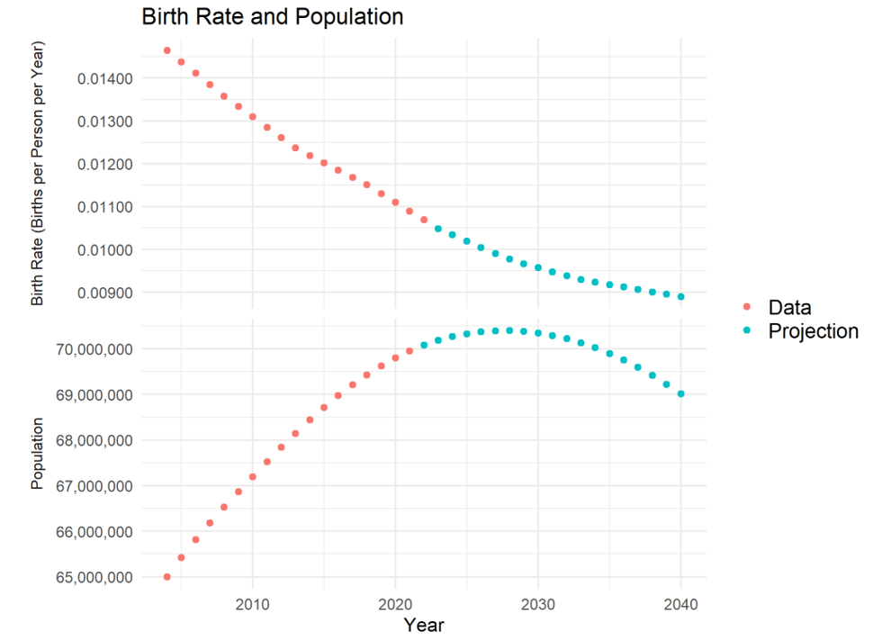

Supplementary Figure S1: Birth rate and population data and projection from UN data

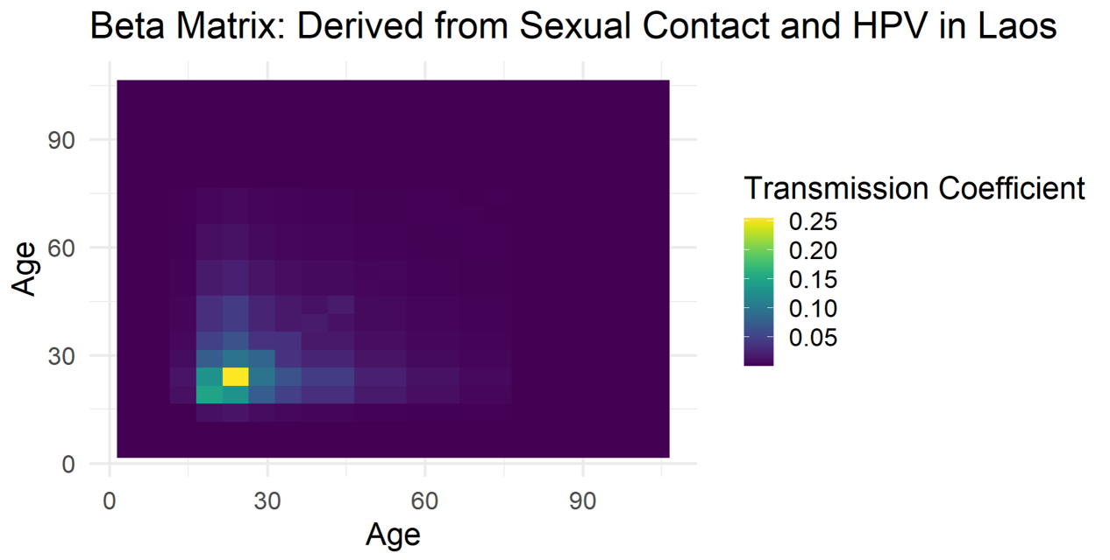

Supplementary Figure S2: Beta transmission parameter matrix

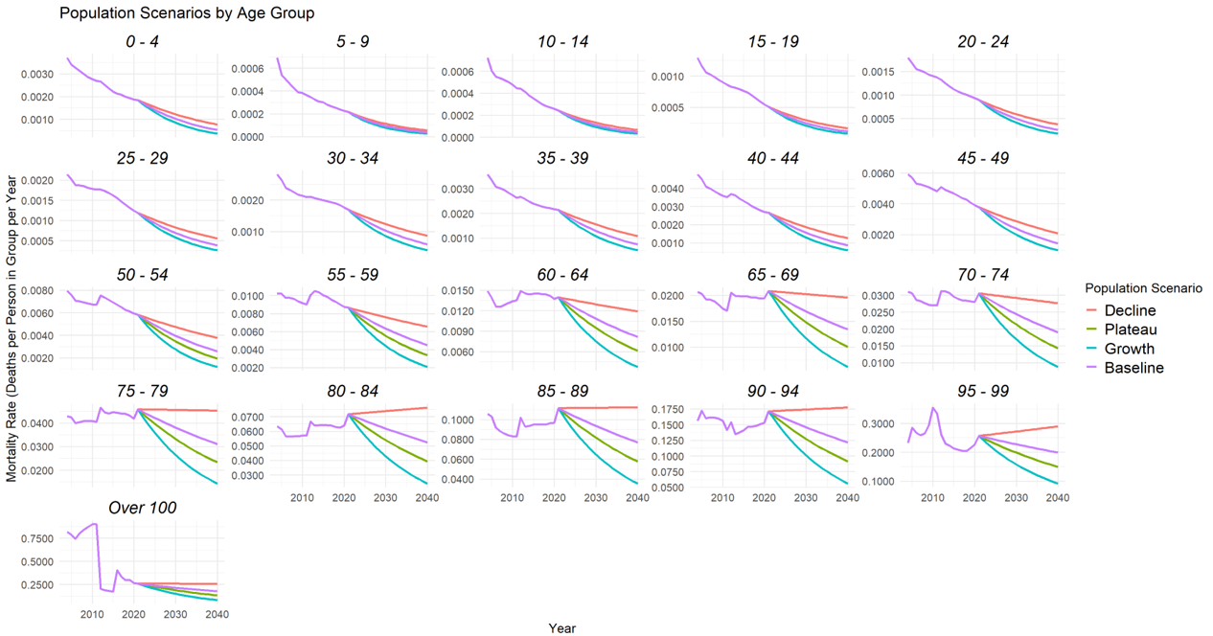

Supplementary Figure S3: Population structure scenarios by age group