### ****AUTOMATED E-MAIL SENDER****

### ****Application Part****

#### ****Technical Details****

For this project, I developed a Python-based application to automate email reminders for important days of the year using the crontab scheduler. The project is divided into three main components:

1. **Data Collection**:
   * The data for the project includes a JSON file (data.json) containing event names and their respective dates. This file was created by scraping an online source of important days using Python’s selenium library.
2. **Email Sending**:
   * The smtplib library was used to handle email sending via the SMTP protocol. The program connects to Gmail’s SMTP server to send emails to a specified recipient. The email content is dynamically generated based on the event name and date.
3. **Crontab Scheduling**:
   * The Python script is executed daily at 5:10 PM using a crontab entry:

10 17 * * * /usr/bin/python3 /home/ck/Desktop/Projects/369/email_sender.py >> /home/ck/Desktop/Projects/369/email_log.txt 2>&1

* + Crontab ensures that the script runs automatically without manual intervention.

#### ****Code Overview****

The core functionality is implemented in Python. Below is a simplified outline of the code(Full code is available at the end of the report):

1. **Date Validation**:
   * The script compares today’s date with the dates in data.json to identify matching events.
2. **Email Sending**:
   * A function send_email(event_name) formats the email content and sends it via the SMTP server.
3. **Automation**:
   * The datetime library is used to fetch the current date, ensuring the program works dynamically year-round.

#### ****Input and Output****

* **Input**: A JSON file containing event names and dates.
* **Output**: An email reminder sent to the specified recipient’s inbox.

### ****Report Part****

#### ****Summary of Work****

This project automates the process of sending email reminders for significant dates. The primary motivation was to explore the intersection of web scraping, automation, and email handling, all while demonstrating the capabilities of crontab as a scheduling tool in Unix/Linux systems.

#### ****Problems Encountered****

1. **Gmail Authentication Errors**:
   * Initially, Gmail blocked the script due to security settings. This was resolved by enabling less secure app access.
2. **Duplicate Entries**:
   * While scraping data, duplicate entries were included in the JSON file. This issue was addressed by using a Python set to track unique events.
3. **Manipulating Date:**
   * **While scraping data, entries were Turkish while datetime library gave the date in English. This issue solved by coding a simple script to convert months to English.**
4. **Scheduling Debugging**:
   * Testing crontab required careful handling of file paths and permissions.

#### ****Solutions****

* Implemented a solution to convert Turkish month names to their English equivalents using a dictionary, ensuring proper date formatting for crontab scheduling.
* Handled file paths and permissions for crontab scheduling by ensuring proper directory structure and making the script executable with appropriate permissions.
* Added error handling for Gmail authentication to gracefully handle failures in email sending and alert the user with specific error messages.
* Regularly tested the entire process end-to-end to ensure no edge cases were missed, including verifying the email sending functionality and ensuring correct execution of scheduled tasks.

#### ****Personal Interest****

My interest in this topic stems from a fascination with automation and its potential to simplify daily tasks. Scheduling and reminders are essential in various domains, and this project provided an opportunity to explore how they can be implemented effectively.

### ****Creativity Part****

#### ****Proposed Assignment****

**Title**: "Automating Social Media Post Scheduling with Crontab and Python"

**Assignment Description**: Develop an application that automates posting to social media platforms at scheduled times. Students should:

1. Use crontab to schedule posts.
2. Use Python libraries like selenium to scrap data.
3. Use Python library smtplib to automate e-mail sending process.
4. Log all successful and failed posts for debugging purposes.

**Reason for Selecting This Topic**: Social media automation is a highly relevant problem in today’s digital age. This assignment introduces students to:

* Web scrapping with selenium.
* E-mail automation with smtplib.
* Scheduling and logging mechanisms using crontab featues.
* Real-world applications of Python in marketing and content management.

By tackling this project, students gain hands-on experience in automation while developing a practical tool applicable to real-life scenarios.

**Full Code of the Program**

**scrap.py:**

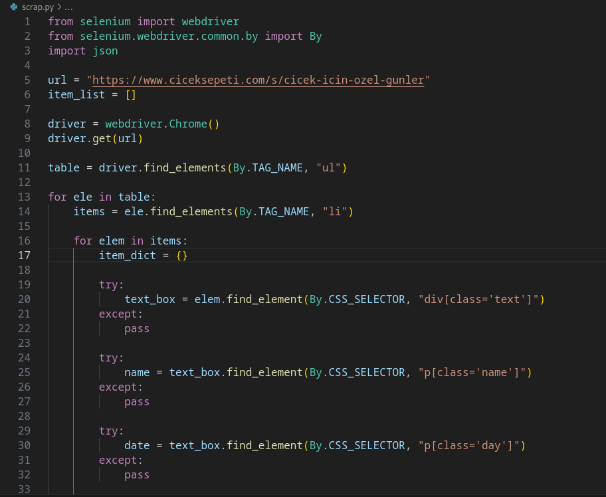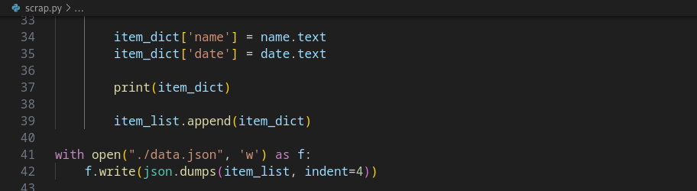

**month_converter.py:**

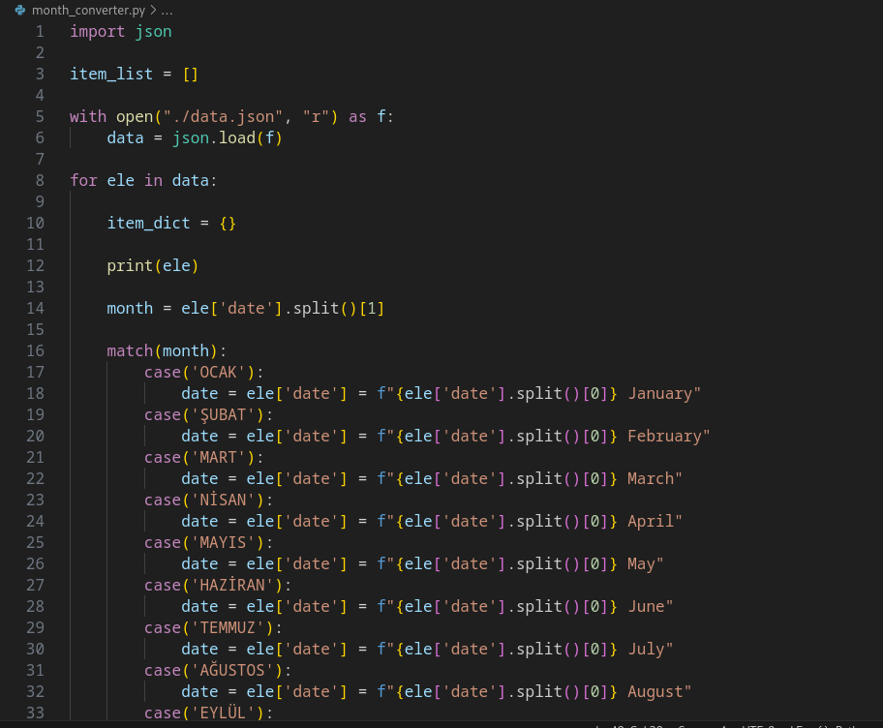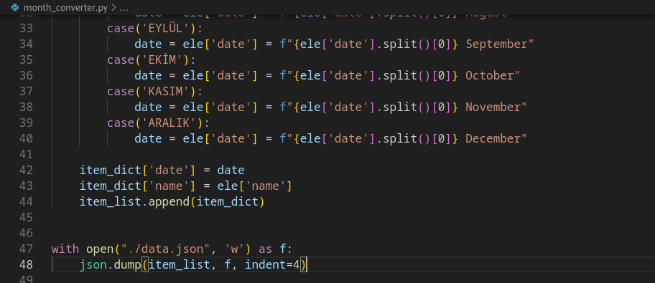

**email_sender.py:**

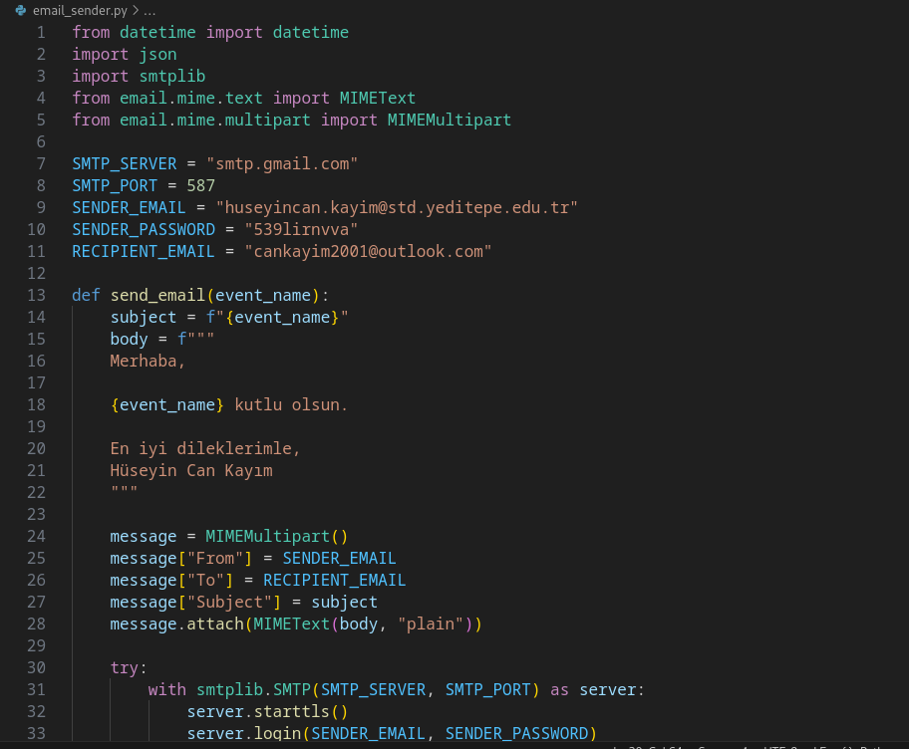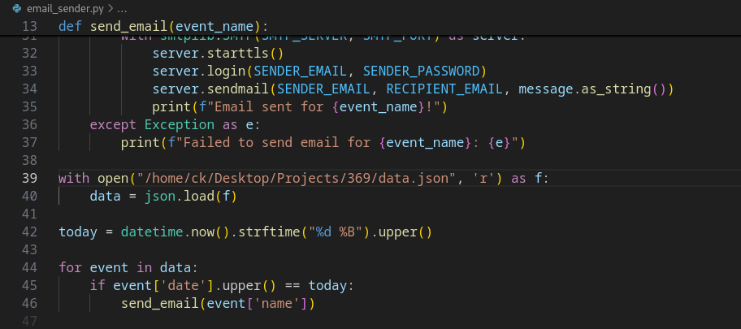

**duplicate_finder.py:**

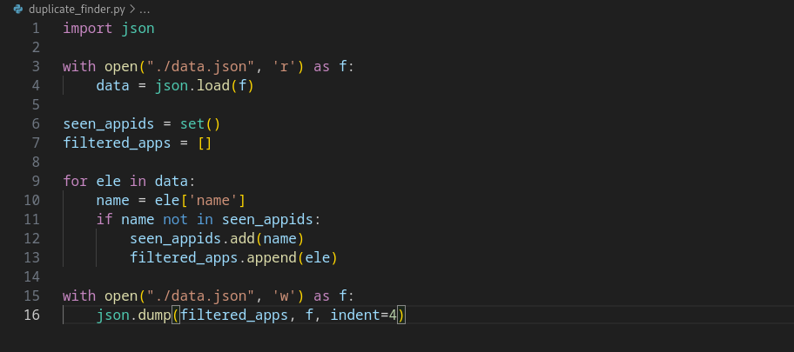 **email_log.txt:**

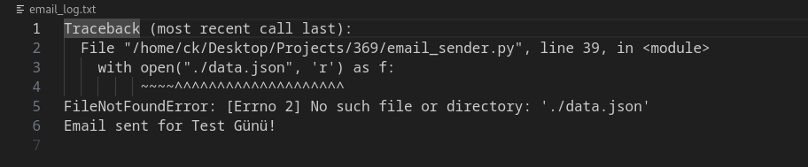 **crontab part:**

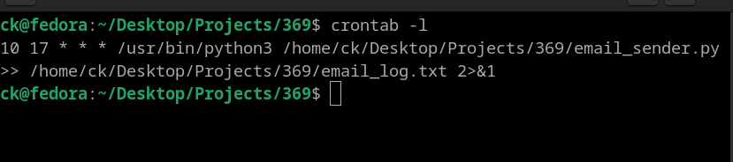 **email proof:**

