SMART TRAFFIC SIGNAL OPTIMIZATION

NAME : D.L.H.C.
DHARMAWARDANA
REGISTRATION NO : EN 113602
INDEX NO : 23/ENG/030

Problem
Traffic lights in Sri Lanka generally operate on a Fixed-Time system. This means the red, yellow, and green lights have pre-set times that are programmed into the system. Most intersections in Sri Lanka use this method, where a full cycle usually lasts between 90 to 180 seconds. Because this system is not flexible, it creates major inefficiencies.
These fixed timers cannot tell if a lane is full of vehicles or completely empty. You have probably been stuck at a red light with many other cars, while watching a green light shine for an empty cross street with no cars at all. During peak hours at major intersections in Sri Lanka, this problem gets so bad that the automatic traffic lights become completely useless. Because of this, the traffic lights are often turned off. Instead, traffic police officers have to step in and control the traffic manually by looking at the length of the vehicle queues. These fixed systems cannot handle unexpected situations, such as a car accident or a sudden surge in traffic. Because they cannot adapt to changing conditions, intersections often become completely blocked.
When major city intersections use these inefficient fixed timers, small delays quickly turn into a massive crisis for the whole country. Research shows that this inefficiency costs the Sri Lankan economy over 1 billion rupees every day. Vehicles waiting idly at unnecessary red lights waste a huge amount of fuel. This drains personal money as well as the country’s foreign exchange reserves. Instead of spending their time working or studying, people spend millions of hours a week stuck in traffic. This lowers the country's overall economic productivity. Additionally, engines idling in one place cause severe air pollution and release greenhouse gases in crowded city areas.
Solution
To avoid this problem, low-cost cameras are placed on the traffic light poles to watch the lanes. This makes it possible to instantly count the exact number of cars, three-wheelers, buses, and motorcycles waiting in each lane in real time. After that, the lanes can be ranked to give priority to the ones that need it. Every cycle, the system uses a smart ranking tool called a "Max-Heap". This tool instantly figures out which lane has the longest line of waiting vehicles and needs help the most.
Instead of dividing the time equally, the "Greedy Allocation" algorithm can share the green light time based on real vehicle demand. To make sure no one is stuck in one place forever, a small, mandatory minimum green time (like 10 seconds) is guaranteed for every lane.
2

The system gives all the remaining green time to the busiest roads. For example, if a main road has 70% of the total traffic, it gets exactly 70% of the extra green time. Empty side roads only get the minimum safety time mentioned before. This brings great benefits, such as reducing traffic jams and saving both time and money.

Existing system : Fixed timer control
Fixed-Timer Control is the basic method currently used at most intersections. It is a very rigid system where the total cycle time is divided equally among all four lanes of the intersection. This means every lane gets the exact same green light time (such as 30 seconds), without considering the actual number of vehicles in that lane. Since it does not use any data structures or comparisons, it cannot adapt to real traffic needs.
The algorithm behind this system follows simple rules. The total cycle time is divided directly by the number of lanes $(n)$. Then, each lane receives an identical share of time. No matter how long or short the vehicle queues are on the road, this time never changes from cycle to cycle. However, traffic volume is rarely equal across all roads.
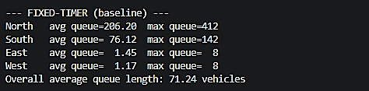

Figure 1: Average & Maximum Queue Length per Lane (Fixed-Timer Baseline Simulation Output)
The above values are empirical values generated by a stochastic (randomized) simulation. They are neither completely random nor purely theoretical. They are the result of running a controlled mathematical model. This simulates a Poisson Process, which is the standard mathematical model used by traffic engineers to represent real-world vehicle arrivals.
Because the East and West lanes have very little traffic, their small vehicle queues clear very quickly. As a result, the traffic light stays green for a completely empty road. According to the test data, the number of vehicles constantly waiting in the North lane averages 206, and it rises up to 412 vehicles during peak times. Similarly, the maximum queue in the South lane reaches 142 vehicles. The overall average queue length for the entire intersection climbs up to 71.24 vehicles.
3

The decision rule of this system is very simple and only needs to be calculated once per cycle.
- Calculating the time split has a complexity of$Ο(1)$. This is because it is a single, simple mathematical division that stays the same no matter how many lanes there are.
- Implementing the full decision has a complexity of $Ο(n)$. This is because it simply assigns the exact same value to all $\left(n\right)$ lanes.
Proposed solution
Instead of using a rigid, equal time split that ignores real-world conditions, the developed algorithm dynamically changes green light times every cycle. The system uses a Greedy strategy combined with a Max-Heap data structure to quickly rank the lanes from busiest to quietest.
For an intersection with $n=4$ lanes (North, South, East, West) and a total cycle time of 90 seconds, the algorithm executes several steps,
Dedicate the Safety Minimum Time
To ensure no lane is left waiting forever, the algorithm first reserves a mandatory minimum green time of 10 seconds for every single lane.
$$Total time reserved=4 lanes ×10 seconds=40 seconds$$
$$Remaning time =90 seconds-40 seconds=50 seconds$$
Build and Process the Max-Heap
The system takes the real-time vehicle counts and organizes them into a binary tree structure called a Max-Heap.
Heapify $(Ο(n))$ : The computer arranges the lanes so that the lane with the absolute maximum number of vehicles is automatically pushed to the very top.
Extract-Max $(Ο(n.\log{n}))$: The system pops the busiest lane from the top of the heap to calculate its extra time. Every time a lane is removed, the tree instantly reshuffles itself to find the next busiest lane.
4

Proportional Greedy Allocation
The system takes the remaining pool of 50 seconds and distributes it using a greedy approach. Extra time is given as a direct percentage based on a lane's share of total traffic demand. If the North lane holds 60% of all waiting vehicles at the intersection, the greedy algorithm instantly hands 60% of the remaining 50 seconds to the North lane on top of its 10-second minimum safety time.
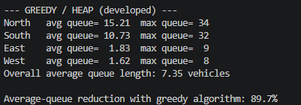

Figure 2:Average & Maximum Queue Length per Lane (developed Simulation Output)
The simulation results clearly show how this solution completely eliminates the heavy congestion caused by the old fixed-timer system:
- Massive Queue Reductions: The overall average queue length across the entire intersection drops drastically from 71.24 vehicles down to just 7.35 vehicles. This is an immediate 89.7% reduction in traffic jams.
- Clearing the Main Roads: On the busiest main road (North), the average line of waiting cars falls from 206.20 vehicles down to 15.21 vehicles an improvement of over 13 times.
- Fairness to Small Lanes: The minor lanes (East and West) remain low and perfectly stable. This proves that the greedy approach fixes the main highways without hurting or sacrificing the smaller side streets.
When evaluating computer algorithms, engineers look at time complexity.
- The Brute-Force Alternative $(Ο(n!))$: Checking every single math combination to find a perfect order scales factorially. For a 10-lane junction, a computer would have to run over 3.6 million calculations per cycle, which is completely impractical.
- The Greedy Max-Heap Approach $(Ο(n.\log{n}))$: Because it uses a heap structure, it only scales slightly faster than a fixed-timer. For our 4-lane setup, it only takes 8 comparison-scale operations per cycle to make smart, adaptive decision.

5

Complexity comparison
The three approaches to allocating green-light time trade off decision cost against real-world outcome. The table below summarizes the per-cycle decision complexity, the simulated average queue length under each approach, and whether each system can adapt to real-time demand.
System | Decision Complexity | Simulated Avg Queue | Adapts to Real-Time Demand
Fixed-Timer (existing) | O(n) | 71.24 vehicles | No
Greedy with Max-Heap (proposed) | O(n log n) | 7.35 vehicles | Yes
Brute-Force Optimal Order (theoretical) | O(n!) | Not simulated | Yes, but impractical

The Fixed Timer system is computationally the cheapest but it has no awareness of queue state at all, which is exactly why it produces the worst outcome (71.24 vehicles average queue). The theoretically optimal Brute-Force search, grows factorially and becomes infeasible for any realistic number of lanes. The Greedy with Max-Heap approach sits in between, only marginally more expensive than the Fixed Timer, yet it captures almost all of the benefit that the impractical Brute Force method would offer.

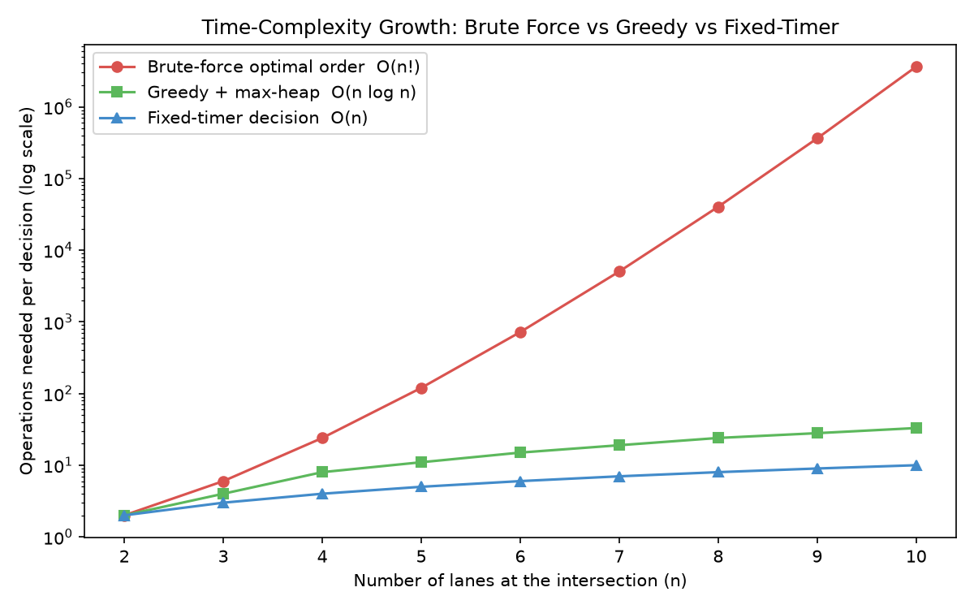
Figure 3: Time complexity growth of Brute force, greedy with max heap and the fixed timer as the number of lanes increases.

6
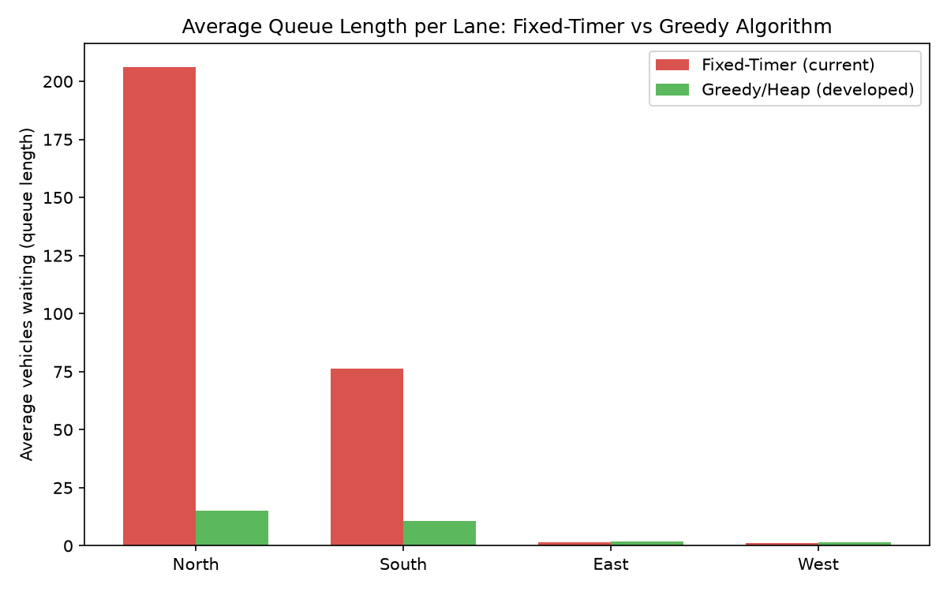

Figure 4: Average vehicles waiting per lanes, fixed timer Vs Greedy with heap
According to the above figure, the overall average queue length dropped from 71.24 vehicles to 7.35 vehicles, a reduction of approximately 89.7%. The busiest lane, North, improved more than 13 fold (from 206.20 to 15.21 vehicles), while the already light East and West lanes remained low and stable in both systems, confirming the greedy method does not sacrifice minor lanes to fix major ones.

Conclusion
In conclusion, the current fixed-time traffic signal system in Sri Lanka causes major delays, blocks intersections, and costs the economy over 1 billion rupees every day due to wasted fuel and lost time. Because it gives equal green light time to all lanes regardless of actual traffic, empty roads get green lights while busy roads face massive traffic jams.
The proposed Greedy with Max-Heap system offers a smart, low-cost solution by using cameras to count waiting vehicles in real time. It instantly gives more green light time to the busiest lanes while still guaranteeing a safe minimum waiting time for smaller side streets. The simulation results show that this new system achieves excellent results. The overall average number of waiting vehicles drops by 89.7% (from 71.24 down to just 7.35 vehicles). Traffic on the busiest road (North lane) drops over 13 times, from 206.20 vehicles to just 15.21 vehicles.
By adapting to real world conditions, this smart system can successfully eliminate heavy city traffic jams, save the country money, and reduce environmental air pollution.
7

