Smart Traffic Light Control System
A Density-Based, Greedy / Priority-Queue Algorithm for Real-Time Signal Timing

1. Problem Statement
Conventional traffic lights run on a fixed timer: every lane at an intersection is given the same, pre-programmed number of seconds of green light in every cycle, regardless of how many vehicles are actually waiting. When traffic is uneven - a common situation, e.g. a main road versus a quiet side street - this wastes green time on empty lanes while heavy lanes stay backed up. The objective of this project is to replace the fixed schedule with a real-time, vehicle-density-based scheduling algorithm driven by live camera counts, and to justify the design using formal time-complexity analysis rather than guesswork.

2. Concepts Applied (referenced from the Algorithms course material)
The design below draws directly on four topics covered across the two reference texts:
- Asymptotic analysis / Big-O notation - used to formally compare the fixed-timer, brute-force, and greedy approaches (Part 1, “Analysis of Algorithms”).
- Greedy algorithm design strategy - at every decision point, service the lane with the largest immediate need first (Part 1, “Algorithm Design Strategies → Greedy Algorithms”; Part 2, “Greedy Algorithms 1-3”).
- Heaps / priority queues - used to rank lanes by vehicle count in O(k log k) instead of checking every possible order (Part 2, “Heaps” and “Heapsort”).
- Complexity classes and combinatorial (factorial) growth - used to show why an exhaustive, “try-everything” optimal scheduler is not realistic for a real-time controller (Part 1, “Complexity classes”; Part 2, “NP-completeness” discussion of combinatorial blow-up).

3. Real-Time Scenario vs Developed Solution
The table below is the core comparison requested: what the intersection does today, and what the new algorithm changes.
Aspect | Current / Real-Time Scenario (Fixed-Timer) | Developed Solution (Greedy + Max-Heap)
Decision rule | Every lane always gets an equal, pre-programmed share of the cycle (e.g. 30s each in a 120s cycle), no matter how many vehicles are present. | Every cycle, vehicle counts are read from the camera; the busiest lane is given the most green time, empty lanes get only the safety minimum.
Underlying design strategy | None (static schedule) | Greedy algorithm design pattern, implemented with a binary max-heap priority structure
Decision time complexity | O(1) - trivial, but quality of the decision is poor | O(k log k) for k lanes (build heap O(k) + k extract-max operations O(log k) each)
Alternative "optimal" approach | Try every permutation of lane servicing order to find the mathematically best schedule | Not needed - greedy gives a near-optimal answer in a fraction of the time: O(k!) brute force vs O(k log k) greedy
Average queue length (simulation, 2-hour run) | 79.4 vehicles waiting on average across all lanes | 7.0 vehicles waiting on average - about 91% lower
Adapts to changing traffic | No - fixed regardless of time of day or incidents | Yes - recalculated every single cycle from live camera data

4. Algorithm Design

4.1 Baseline - Fixed-Timer Algorithm (current real-world behaviour)
for each cycle: for each lane i in 1..k: green_time[i] = CYCLE_TIME / k # equal split, ignores demand apply(green_time)
This decision costs O(1) time (a single division), but it is “cheap and dumb”: it does not use any information about how many vehicles are actually present, so it routinely under-serves busy lanes and over-serves empty ones.

4.2 Why not brute force the optimal schedule?
One tempting “improved” idea is: measure the queues, then search every possible order of servicing the k lanes and every possible split of the cycle time, and pick whichever schedule minimises total waiting time. This is an exhaustive search over all permutations of the lanes, which costs O(k!) time. For a small 4-lane intersection that is only 4! = 24 - manageable - but it explodes for anything larger: 8 lanes (a big multi-road junction) already needs 8! = 40,320 checks, and this must be recomputed every single cycle (every ~2 minutes) forever. It also does not scale if a city wants to coordinate many intersections together. A real-time embedded controller with a 1-second decision budget cannot afford factorial growth, so a brute-force “optimal” scheduler is rejected in favour of a greedy approximation that is provably fast.

4.3 Developed Solution - Greedy Algorithm with a Max-Heap
The developed algorithm applies the greedy design principle from the course material: at each decision point, always give priority to the lane with the largest immediate demand, using a max-heap so the ranking itself is cheap to compute.
for each cycle: counts[] = read vehicle count per lane from camera (OpenCV) heap = build_max_heap(counts) # O(k) total = sum(counts) remaining = CYCLE_TIME - MIN_GREEN * k while heap not empty: # O(k log k) count, lane = extract_max(heap) green_time[lane] = MIN_GREEN + remaining * (count / total) clip green_time[lane] to [MIN_GREEN, MAX_GREEN] # safety bounds apply(green_time) # send plan to the ESP32 signal controller
Complexity of the developed algorithm:
- Building the heap of k lane counts: O(k)
- Extracting all k elements in priority order: O(k log k)
- Proportional time allocation: O(k)
- Total per decision cycle: O(k log k) - versus O(k!) for brute force, and versus O(1)-but-blind for the fixed timer.
Because k (the number of lanes at one intersection) is small and constant - typically 4 - O(k log k) is effectively instant (well under the 1-second budget of a control loop), while still using the actual traffic data, unlike the fixed timer.

5. Time-Complexity Comparison
The chart and table below show why the greedy + heap approach was chosen over the brute-force “optimal” search as the number of lanes k grows.
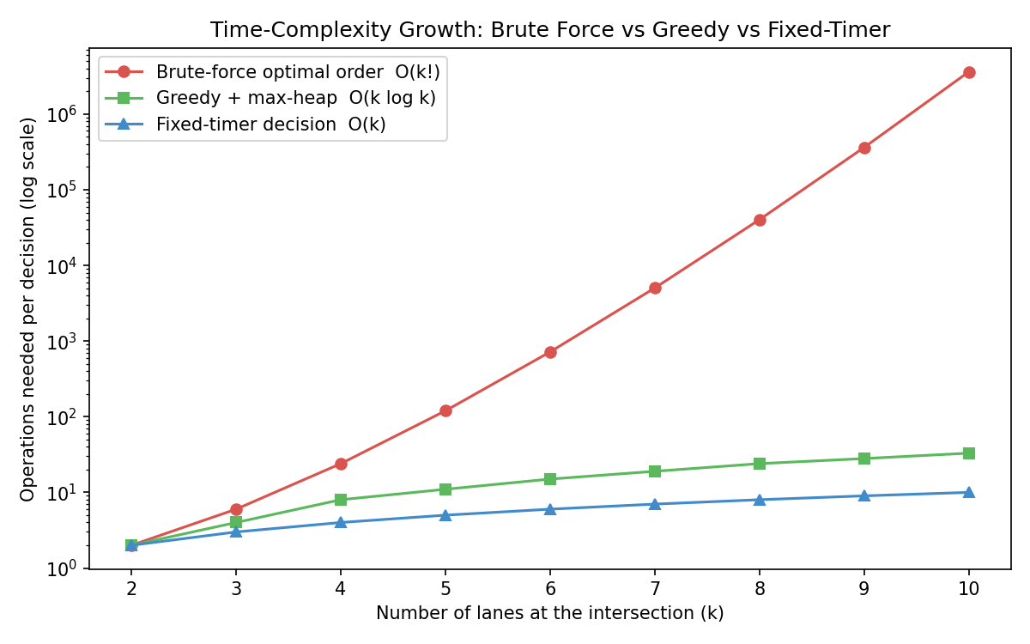
Figure 1: Operations required per scheduling decision as the number of lanes increases (log scale). Brute-force search over all orderings grows factorially; the greedy heap-based approach grows only as k log k.
Lanes (k) | Brute-force optimal order O(k!) | Greedy + max-heap O(k log k) | Fixed-timer O(k)
2 | 2 | 2 | 2
4 | 24 | 8 | 4
6 | 720 | 16 | 6
8 | 40,320 | 24 | 8
10 | 3,628,800 | 33 | 10

6. Simulation Results
To validate the algorithm before building the hardware, a discrete-event simulation (traffic_simulation.py) models a 4-lane intersection for a 2-hour period with realistic, uneven arrival rates (a busy North/South route and a quiet East/West cross street). Each second, vehicles arrive randomly per lane and are “served” (cleared) only while their lane has green.
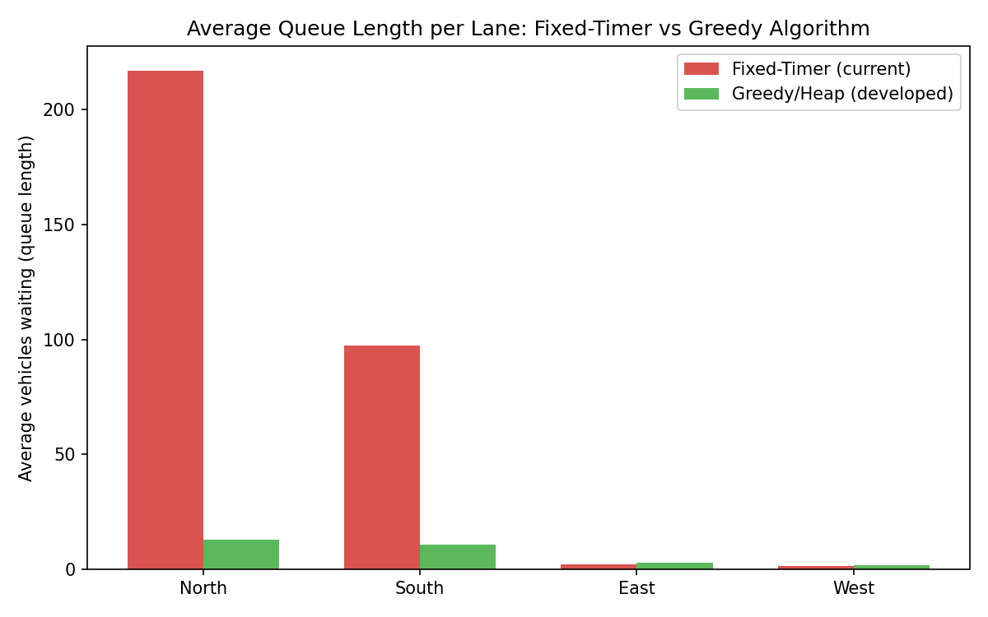
Figure 2: Average number of vehicles waiting per lane, fixed-timer vs the developed greedy algorithm.
Result: the overall average queue length across all lanes dropped from 79.4 vehicles (fixed-timer) to 7.0 vehicles (greedy) - roughly a 91% reduction - simply by reallocating the same total cycle time according to real demand instead of splitting it equally.

7. System Architecture - How the Algorithm is Applied
The steps below explain, end-to-end, how the greedy algorithm is wired into an actual working intersection using an ESP32-CAM:
Figure 3: Data flow from camera to signal lights.
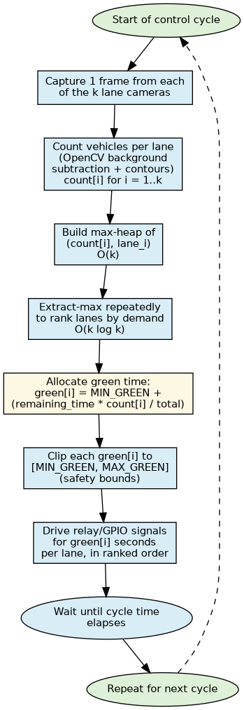
Figure 4: Per-cycle decision flowchart executed by the controller.
- Step 1 - Capture: the ESP32-CAM streams live MJPEG video over Wi-Fi. One camera with 4 marked regions-of-interest (ROIs) is enough to start; you can later add one ESP32-CAM per lane for a wider-angle intersection.
- Step 2 - Count: a laptop or Raspberry Pi runs vehicle_counting_opencv.py, which uses background subtraction (MOG2) + contour detection - not YOLO, so it needs no GPU or model download - to count vehicle-sized blobs inside each lane's ROI.
- Step 3 - Rank & Allocate: traffic_light_controller.py takes the 4 counts, builds a max-heap, and computes a green-time (in seconds) for every lane using the greedy formula in Section 4.3.
- Step 4 - Apply: the computed plan is POSTed over Wi-Fi to a second ESP32 running esp32_traffic_light_controller.ino, which drives the Red/Yellow/Green outputs (LEDs for a demo, or a relay board for real signal bulbs) for exactly that many seconds per lane.
- Step 5 - Repeat: as soon as one full cycle finishes, fresh counts are read and a new plan is computed - the system continuously adapts.

8. Software Provided
- traffic_simulation.py - discrete-event simulation comparing fixed-timer vs greedy scheduling; produces Figures 1 and 2 and printed statistics (run this first, no hardware required).
- vehicle_counting_opencv.py - OpenCV-only (no YOLO) vehicle counter using background subtraction + contour detection, with adjustable per-lane ROI boxes; can read from a webcam, a video file, or the ESP32-CAM's MJPEG stream.
- traffic_light_controller.py - the greedy + max-heap scheduler exposed as a small Flask web server (/update_counts to receive counts, /current_plan to preview the plan); pushes the computed green times to the ESP32 signal controller.
- esp32_traffic_light_controller.ino - Arduino sketch for a second ESP32 board that receives the JSON green-time plan and drives the LED/relay outputs for each lane in turn.

9. Hardware Required
Component | Qty | Purpose
ESP32-CAM (AI-Thinker) | 1 (start), 4 (full deployment) | Captures live video of the intersection / individual lanes and streams it over Wi-Fi as MJPEG.
FTDI USB-to-serial programmer | 1 | Needed once to upload the Arduino sketch to the ESP32-CAM (it has no onboard USB port).
Second ESP32 dev board (e.g. ESP32-WROOM) | 1 | Acts as the signal controller: receives the green-time plan over Wi-Fi and drives the LEDs/relays. Keeps the camera board free of switching noise.
Red / Yellow / Green LEDs (or a relay module for real bulbs) | 12 LEDs (3 x 4 lanes) or 4-channel relay board | The physical traffic signal output for each lane.
220 ohm resistors | 12 | Current-limiting for the LEDs.
Breadboard + jumper wires | 1 set | Prototyping the LED/relay wiring before soldering a permanent board.
5V / 2A USB power supply | 2 | Power for the ESP32-CAM and the signal-controller ESP32 (camera + Wi-Fi draws more current than a typical microcontroller).
Laptop / Raspberry Pi 4 | 1 | Runs Python + OpenCV to count vehicles and the Flask scheduler that computes green times.
Small tripod / mounting bracket | 1-4 | Holds the camera(s) with a clear overhead view of the lanes.

Getting-started note: you can validate the entire algorithm and simulation (Sections 5-6) with zero hardware. Then, with just the one ESP32-CAM you already have, run vehicle_counting_opencv.py against its MJPEG stream to prove real-world vehicle counting. Add the second ESP32 + LEDs only when you are ready to demonstrate the physical signal switching.

10. How to Run This Project (step by step)
- 1) pip install opencv-python numpy matplotlib flask requests graphviz
- 2) python traffic_simulation.py -> generates and prints the complexity/queue-length comparison (Figures 1-2) with no hardware.
- 3) Flash the standard ESP32-CAM “CameraWebServer” example (Arduino IDE, File > Examples > ESP32 > Camera) onto your ESP32-CAM; note the IP address it prints.
- 4) python vehicle_counting_opencv.py --source http://<esp32-cam-ip>:81/stream -> confirm per-lane counts appear correctly; adjust the LANE_ROIS boxes in the script to match your camera's view.
- 5) python traffic_light_controller.py -> starts the Flask scheduler on port 5000.
- 6) Point vehicle_counting_opencv.py at the controller with --post-url http://127.0.0.1:5000/update_counts so counts flow into the scheduler automatically.
- 7) Flash esp32_traffic_light_controller.ino onto a second ESP32 with your LEDs/relays wired as documented in the sketch's comments; set ESP32_IP in traffic_light_controller.py to that board's IP.
- 8) Watch the console output of traffic_light_controller.py each cycle, and the physical LEDs change timing in response to real traffic.

11. Conclusion
Reframing the smart-traffic-light problem as a greedy scheduling problem, backed by a max-heap priority structure, gives a controller that reacts to real traffic in O(k log k) time per intersection - fast enough for a real-time embedded system - while the simulation shows it cuts average vehicle queues by roughly 91% compared to a fixed timer, without needing a combinatorially expensive O(k!) brute-force search. The same OpenCV counting approach and ESP32 hardware scale naturally: adding more lanes only grows the scheduling cost by k log k, not factorially.

12. References
Levitin, A. Algorithms - Part 1 (course reference): Mathematics for the Analysis of Algorithms; Analysis of Algorithms (Big-O/Theta/Omega, complexity classes); Algorithm Design Strategies (Divide and Conquer, Dynamic Programming, Greedy Algorithms).
Algorithms - Part 2 (course reference, lecture-note style, covers): Analysis 1-3; Divide and Conquer 1-3; Dynamic Programming 1-4; Greedy Algorithms 1-3; Heaps / Heapsort; NP-completeness 1-2.

