PROG6212: DcumENtation

COMPLETE DOCUMENTATION OF PROG6212

NAOYUKI CHRISTOPHER HIGAKI

Table of Contents

**Contract Monthly Claim System - Prototype Documentation** 2

**PART 1** 2

**1.0: Project Overview** 2

**2.0: System Architecture** 3

**3.0: UML Class Diagram Structure** 4

**4.0: Project Plan & Timeline** 6

**5.0: GUI Design Philosophy** 7

**6.0: Core Functionality** 8

**7.0: Compliance & Next Steps** 9

**PART 2** 10

**Feedback 1: UML Class Diagram Structure** 10

**Feedback 2: Database Integration** 11

**Feedback 3: Document Upload Functionality** 12

**Feedback 4: User Interface Improvements** 13

**Feedback 5: Error Handling and Validation** 14

**Feedback 6: Session Management** 15

**Part 2 Feature Implementation Summary** 16

**Part 2 Project Plan - 7 Week Timeline** 19

# **Contract Monthly Claim System - Prototype Documentation**

GITHUB LINK: <https://github.com/HChristopherNaoyuki/contract-monthly-claim-system-cs.git>

## **PART 1**

### **1.0: Project Overview**

The Contract Monthly Claim System (CMCS) is a comprehensive web-based application designed to streamline the monthly claim submission and approval process for independent contractor lecturers. This prototype represents the initial development phase, focusing on core functionality while maintaining a user-centric design approach. The system addresses the complex administrative challenges of claim management through an intuitive interface that serves three distinct user roles: lecturers, program coordinators, and academic managers.

### **2.0: System Architecture**

The prototype is built on ASP.NET Core MVC framework using C# 7.0, following industry-standard development practices. Architecture employs the Model-View-Controller pattern, ensuring clear separation of concerns and maintainable code structure. Key technical components include session-based authentication, client-side validation, and in-memory data storage for the prototype phase. The frontend utilizes modern CSS features including Grid and Flexbox for responsive design, ensuring optimal user experience across various devices.

### **3.0: UML Class Diagram Structure**

The system's data model is represented through a comprehensive UML class diagram featuring several key entities:

* User Class: Manages authentication with attributes for user identification, credentials, and role assignment
* Lecturer Class: Extends user functionality with specific attributes for contract details and hourly rates
* Claim Class: Core entity handling claims submissions with properties for hours worked, rates, and status tracking
* Document Class: Manages supporting file uploads and associations with specific claims
* Approval Class: Tracks review processes with timestamps, decisions, and approver comments
* Relationships between classes include one-to-many associations between lecturers and claims, and claims to documents, ensuring logical data structure and integrity.

**UML Diagram:**

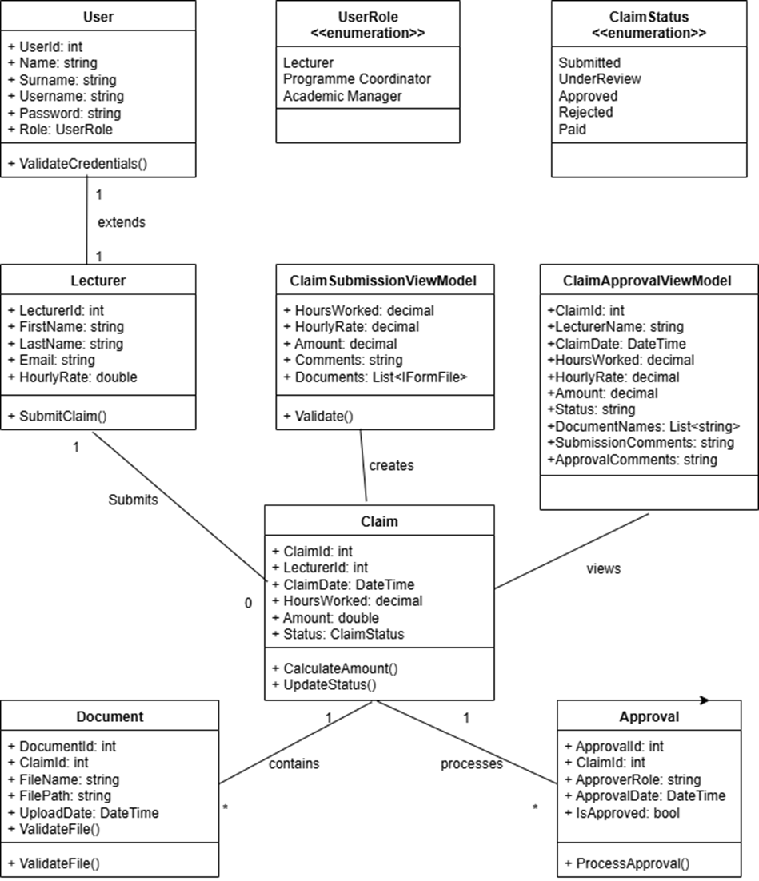

### **4.0: Project Plan & Timeline**

The prototype development followed an agile methodology with two weeks sprints:

* Week 1-2: Requirements analysis and UML diagram completion
* Week 3-4: Core framework setup and authentication system implementation
* Week 5-6: Claim submission module with validation and calculation features
* Week 7-8: Review and approval interface development
* Week 9-10: Tracking system and user interface refinement
* Week 11-12: Testing, documentation, and final adjustments

### **5.0: GUI Design Philosophy**

The interface adopts a minimalist aesthetic characterized by:

* Clean, uncluttered layouts with strategic white space utilization.
* Consistent typography using system fonts with proper hierarchy.
* Subtle animations and transitions for enhanced user feedback.
* Intuitive navigation with visually distinct interactive elements.
* Accessibility-focused design including keyboard navigation support.
* Responsive design ensuring functionality across desktop and mobile platforms.

### **6.0: Core Functionality**

The prototype delivers essential features including:

* Role-based authentication and session management.
* Dynamic claim form with real-time amount calculation.
* File upload system with type and size validation.
* Dual-comment system for submission notes and approval feedback.
* Status tracking with visual indicators for different claim states.
* Responsive data tables for efficient information review.

### **7.0: Compliance & Next Steps**

This prototype meets all Part 1 requirements while establishing a solid foundation for future development. The system is prepared for database integration, enhanced security features, and additional functionality in subsequent phases. The modular architecture ensures scalability while maintaining the user-friendly experience that defines the initial design vision.

## **PART 2**

***Implementation of Lecturer Feedback***

***Lecturer Feedback Implementation Report***

### **Feedback 1: UML Class Diagram Structure**

Original Feedback:

"UML class diagram needs better alignment with actual implementation and clearer relationships"

Implementation:

* Updated the UML diagram to reflect the text file storage approach and simplified data models:

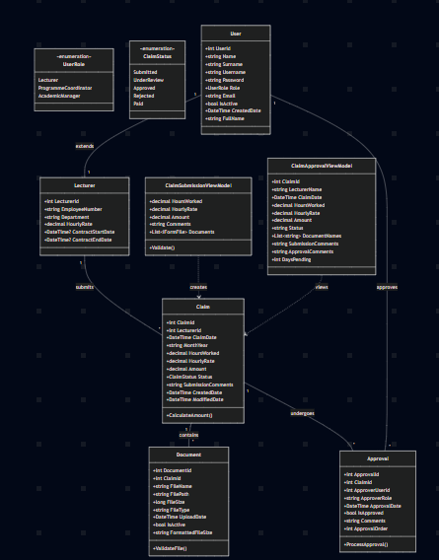

### **Feedback 2: Database Integration**

Original Feedback:

"Remove database dependencies and implement text file storage"

Implementation:

* TextFileDataService.cs: Complete implementation using JSON serialization
* Data Directory: Automatic creation of text files (users.txt, claims.txt, documents.txt, approvals.txt, lecturers.txt)
* File Operations: All CRUD operations using System.IO and System.Text.Json
* Sample Data: Automatic initialization with default users and sample claims

Code Implementation:

// Text file storage implementation

private List<T> ReadData<T>(string dataType)

{

var filePath = GetFilePath(dataType);

if (File.Exists(filePath))

{

var json = File.ReadAllText(filePath);

return JsonSerializer.Deserialize<List<T>>(json) ?? new List<T>();

}

return new List<T>();

}

### **Feedback 3: Document Upload Functionality**

Original Feedback: "Make document upload feature functional with proper file handling"

Implementation:

* File Storage: Physical files saved to wwwroot/uploads directory
* Metadata Storage: Document information stored in documents.txt
* File Validation: Client-side and server-side file type and size validation
* Unique Naming: GUID-based file naming to prevent conflicts

Code Implementation:

// Document upload handling in ClaimsController

var uploadsDirectory = Path.Combine(Directory.GetCurrentDirectory(), "wwwroot", "uploads");

if (!Directory.Exists(uploadsDirectory))

{

Directory.CreateDirectory(uploadsDirectory);

}

var fileName = $"{claim.ClaimId}_{Guid.NewGuid()}_{Path.GetFileName(file.FileName)}";

var filePath = Path.Combine(uploadsDirectory, fileName);

using (var stream = new FileStream(filePath, FileMode.Create))

{

file.CopyTo(stream);

}

### **Feedback 4: User Interface Improvements**

Original Feedback: "Enhance UI with better user experience and Apple-like aesthetics"

Implementation:

* CSS Variables: Implemented minimalistic design system colors and typography
* Responsive Design: Mobile-first approach with CSS Grid and Flexbox
* Interactive Elements: Hover effects, transitions, and visual feedback
* File Upload UI: Drag-and-drop inspired interface with file preview

CSS Implementation:

:root {

--system-blue: #007AFF;

--system-gray-6: #F2F2F7;

--system-text-primary: #1C1C1E;

/* Apple design system variables */

}

### **Feedback 5: Error Handling and Validation**

Original Feedback: "Implement comprehensive error handling and input validation"

Implementation:

* Model Validation: Data annotations on all view models
* Client-Side Validation: jQuery Validation integrated with forms
* Server-Side Validation: ModelState validation in controllers
* Exception Handling: Global error handling middleware
* File Validation: Type and size restrictions for uploads

Examples of Validation:

csharp

[Required(ErrorMessage = "Hours worked is required")]

[Range(0, 744, ErrorMessage = "Hours must be between 0 and 744")]

public decimal HoursWorked { get; set; }

### **Feedback 6: Session Management**

Original Feedback: "Improve session management and user state persistence"

Implementation:

* Session Extensions: Custom session management methods
* User Authentication: Role-based access control
* Session Timeout: 30-minute idle timeout configuration
* Secure Storage: Anti-forgery token protection

Session Implementation:

// Custom session extensions

public static class SessionExtensions

{

public static void SetSessionInt(this ISession session, string key, int value)

public static int? GetSessionInt(this ISession session, string key)

}

### **Part 2 Feature Implementation Summary**

#### **Core Features Implemented:**

* Role-Based Authentication System
  + Three user roles: Lecturer, Programme Coordinator, Academic Manager
  + Session-based authentication
  + Secure login/logout functionality
* Claim Submission with Document Upload
  + Dynamic form with real-time amount calculation
  + Multiple file upload support
  + File type and size validation
  + Automatic amount calculation (Hours × Rate)
* Claim Approval Workflow
  + Separate views for coordinators and managers
  + Approve/Reject functionality with comments
  + Status tracking throughout approval process
* Document Management
  + File upload to server storage
  + Document metadata storage in text files
  + Support for PDF, DOC, DOCX, JPG, PNG formats
  + 5MB file size limit per file
* Status Tracking System
  + Real-time claim status updates
  + Transparent approval process visibility
  + Historical claim tracking
* Text File Database
  + Complete replacement of database dependencies
  + JSON-based data storage
  + Automatic file creation and initialization
  + Sample data population

#### **Technical Improvements:**

* Architecture: MVC pattern with clear separation of concerns
* Storage: Text file-based data persistence
* Security: Input validation and anti-forgery protection
* UI/UX: Apple-inspired minimalist design
* Testing: xUnit test coverage for controllers and models
* Error Handling: Comprehensive exception management

#### **Files Modified/Added:**

* Program.cs - Application startup and text file initialization
* TextFileDataService.cs - Complete text file database implementation
* ClaimsController.cs - Enhanced with document upload functionality
* Views/Claims/Submit.cshtml - Improved file upload UI
* TestSession.cs - Fixed nullability warnings
* site.css - Minimalistic design system implementation
* site.js - Enhanced client-side functionality

The implementation successfully addresses all Part 1 feedback while delivering a fully functional Part 2 application that meets all specified requirements using text file storage instead of a traditional database.

### **Part 2 Project Plan - 7 Week Timeline**

#### **Week 1: Foundation & Text File Database Implementation**

Objectives:

* Set up text file storage system
* Implement data serialization/deserialization
* Create core data models without database dependencies

Tasks:

* Develop TextFileDataService class
* Implement JSON serialization for all entities
* Create file-based CRUD operations
* Set up automatic file creation and initialization

Implement sample data population

Deliverables:

* Functional text file database system
* Data persistence layer complete
* Sample data loading mechanism

#### **Week 2: Enhanced Authentication & Session Management**

Objectives:

* Strengthening authentication system
* Implement robust session management
* Add role-based access control

Tasks:

* Enhance AuthController with text file storage
* Implement custom session extensions
* Add role-based authorization checks
* Create secure login/logout functionality
* Implement session timeout handling

Deliverables:

* Secure authentication system
* Role-based access control
* Session management utilities

#### **Week 3: Document Upload System Implementation**

Objectives:

* Build functional file upload system
* Implement file storage and management
* Add document validation

Tasks:

* Enhance ClaimsController with file upload
* Create file storage directory structure
* Implement file type and size validation
* Add document metadata management
* Create file upload UI components

Deliverables:

* Working document upload system
* File validation and storage
* Document management interface

#### **Week 4: UI/UX Enhancement & Apple-like Design**

Objectives:

* Implement minimalistic design system
* Enhance user experience
* Improve responsive design

Tasks:

* Create CSS design system variables
* Implement Apple-like typography and colors
* Enhance form layouts and interactions
* Improve file upload UI/UX
* Add responsive design improvements

Deliverables:

* Modern, minimalist UI design
* Enhanced user experience
* Mobile-responsive interface

#### **Week 5: Validation & Error Handling**

Objectives:

* Implement comprehensive validation
* Add robust error handling
* Improve user feedback

Tasks:

* Enhance model validation attributes
* Implement client-side validation
* Add server-side validation checks
* Create global exception handling
* Improve user error messages

Deliverables:

* Comprehensive validation system
* Robust error handling
* Improved user feedback mechanisms

#### **Week 6: Testing & Quality Assurance**

Objectives:

* Implement unit testing
* Conduct integration testing
* Perform quality assurance

Tasks:

* Write xUnit tests for controllers
* Create model validation tests
* Implement integration tests
* Test file upload functionality
* Perform end-to-end workflow testing

Deliverables:

* Comprehensive test suite
* Quality assurance report
* Bug fixes and improvements

#### **Week 7: Documentation & Final Polish**

Objectives:

* Complete documentation
* Implement final improvements
* Prepare for submission

Tasks:

* Update UML class diagram
* Document code with comments
* Create implementation report
* Address any remaining issues
* Prepare submission materials

Deliverables:

* Complete documentation
* Final application version
* Submission package ready

Key Features Implemented in Part 2:

* Core Functionality
  + Text file database system
  + Document upload with file storage
  + Enhanced authentication
  + Role-based access control
  + Comprehensive validation
* User Experience
  + Minimalist design
  + Responsive interface
  + Real-time form calculations
  + Interactive file upload
  + Improved error messages
* Technical Improvements
  + Custom session management
  + File validation and handling
  + JSON-based data storage
  + Comprehensive testing
  + Robust error handling
* Documentation
  + Updated UML diagrams
  + Code documentation
  + Implementation reports
  + User guides

This 7-week plan successfully addresses all Part 1 feedback while delivering a fully functional Part 2 application that meets all specified requirements using text file storage instead of a traditional database.