**Analyzing the Dutch-Asiatic Trade in the 17th and 18th centuries by using a spatial and quantitative approach**

Robert-Jan Korteschiel, bachelor student art history (UvA)

Erik van Zummeren, bachelor student history (UvA)

In recent years the Dutch Huygens Institute has released several datasets on Dutch shipping in Asia. Examples include the digitisation of the Dutch-Asiatic Shipping dataset (DAS) and the Bookkeeper-General Batavia database (BGB). These databases contain an impressive amount of information. It does not only contain basic information such as a place and date of departure of every single voyage that went from the Dutch Republic to Asia and vice versa. But it also contains, in the case of the BGB database, a detailed list of on-board commodities. However, in it’s present day usage these sets are mostly used as a work of reference. By visiting the DAS or BGB-website you can get a good understanding of a single voyage, but it’s quite difficult to see the bigger picture.

By creating a geographical visualisation we hope to tackle this problem. … … This geographical visualisation is aided by filters and supporting graphs, with the timeline as main example.

By creating an open source web based GIS system we hope to tackle this problem. Our approach consists of plotting 18 000 voyages on a world map. Each of these voyages is linked with it’s date of departure and arrival. The canvas of our application only shows the voyages from a user specified time period. For instance if a user selects March 1643 only those voyages who were sailing in March 1643 show up. Further insights can be gained by colour-coding voyages that contain certain commodities such as tin, opium or Chinese paper. The sum of their financial value is distributed in years and are plotted in a graph underneath the map. Events are also added to the map. They show how the voyages relate to certain events, and they provide a narrative.

A very early concept drawing that shows the main concept behind our tool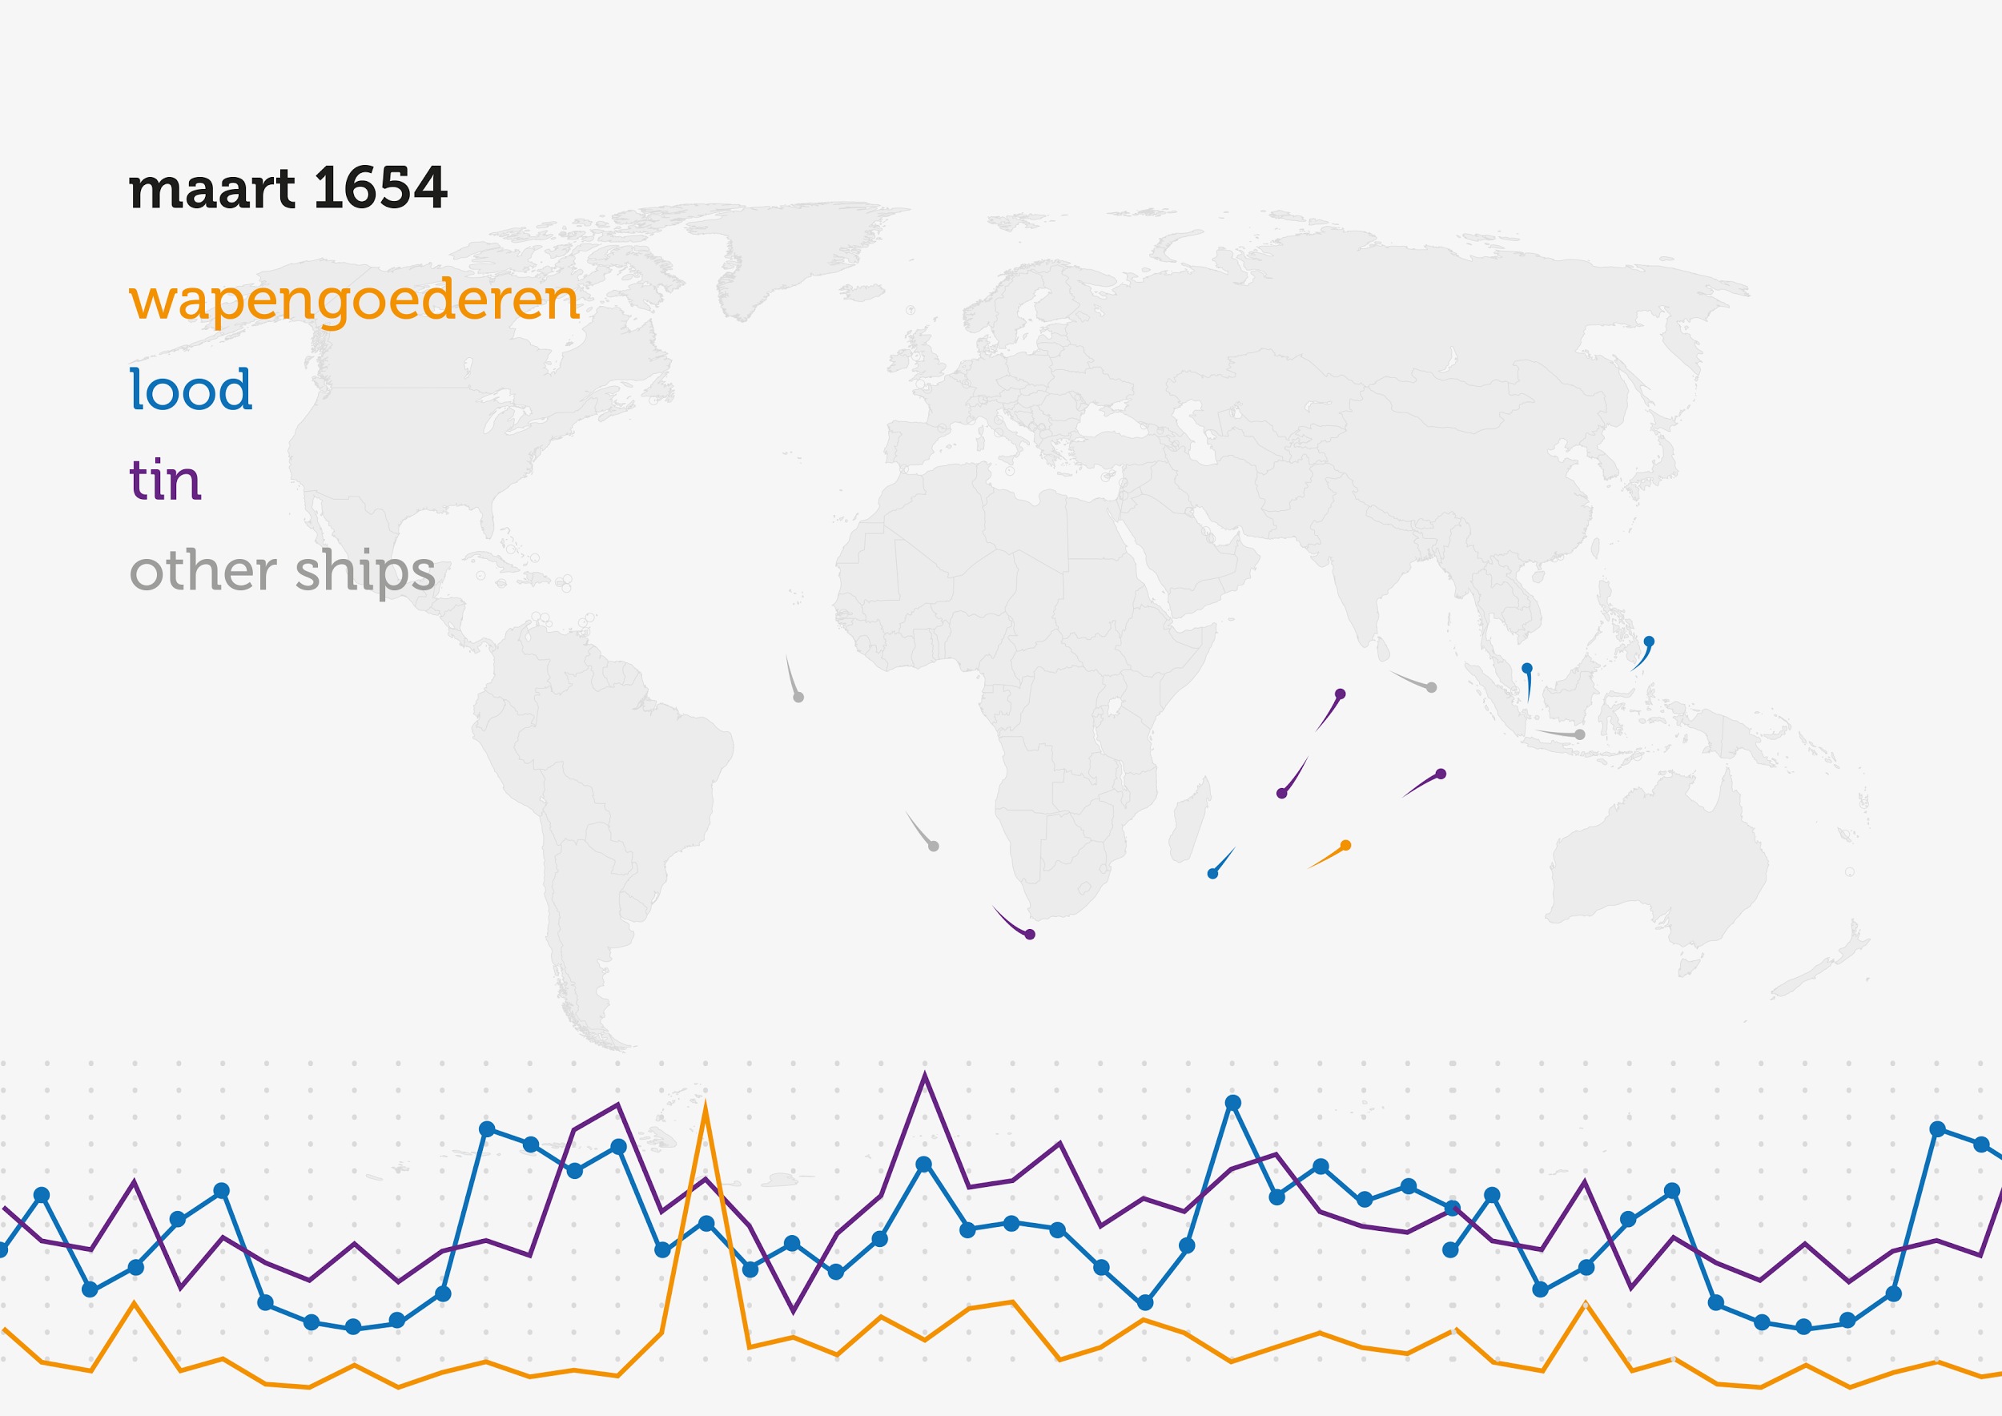

A play button and an interactive timeline enable the user to literally scroll through time. By doing so the user can not only see how trade evolves in time, but they also get a sense of the grand scale of the entire Dutch-Asian trading network. The tool also gives the possibility to dig deeper. For example how are certain commodities related to each other? Does an increase in the trade of weapons, for example, also increase the number of medical goods? Do certain products influence the distribution of other products, and what was their influence on the Dutch economy? (Misschien nog wat betere voorbeelden bedenken)

This project evolved from a course we did during the Digital Humanities minor (UvA/VU). Therefor this presentation/demo might not only be interesting for those who are into (H)GIS, maritime history or data visualisation, but also for those who want to get an idea how an average digital humanities student project looks like.

1. I like most of the start except for the problematic use of vocabulary, or absence thereof. We’re creating a geographical visualisation, by the use of open source GIS. I also thing its better to drop the term filtering near to the color-coding. And perhaps drop the term supporting graphs with the timeline as main example.
2. I’m missing methodological references, since we’re very much a new methodology.
3. I think we can do a better job defending the value of specific data by clarifying the relation data to event. Events are already something that is cared about I believe. The relation of commodities amongst themselves is perhaps not the strongest one to convince people with.
4. Open source could carry much more meaning in another context.
5. Our motivations and the value to others is quite meagre.

Time is an important element in the visualisation as well. The interactive timeline enables the user to literally scroll trough time, but it can also play automatically. This allows the user to passively consume the visualisation and intuitively interact with it when an interesting pattern presents itself. From there the user can dig deeper into the full detail of the dataset. To relate the data to actual event a look at the commodities being transported might be valuable. An example could be an expected build-up in weapons and medical goods before conflict, or replenishment after. Could we deduct the volatility of a situation or colony? This is also where events come into play. The gain and loss of colonies, important conflicts, major diplomatic achievements like treaties will be visualised on top of the data. We want the tool to assist the user in finding out where the data and the event intersect.

There are many other examples to be thought of, more that we could possibly phantom. That is why we will release our tool as open source. We hope to build something others can manipulate for their own interpretations. The tool is in the end only a means to achieve new interpretations. We’re not the same as Quantitative History. We don’t care about the numbers, for they are very much biased. We care about the story that numbers tell. We hope to tell the story of the Dutch colonies trough a new perspective, and show it to you trough this explorative tool.

The motivation behind this project is our struggle with the question that Digital Humanities pose in contrast to the methodologies that we learn. Taking command of the power that your own computer offers you is off course central to this. But there are also many other dimensions, like how to approach research in general. We are not going in with a predefined question; we’re working collaboratively and there is an interdisciplinary aspect. This interplay between the use of new methodologies at the same time as we’re learning the established methodologies is great opportunity for us to learn. Perhaps also for you: we hope that our project gives you insight in how a student research project in the Digital Humanities takes shape, we’re it aligns with traditional methods, or where it differs!