## 生成Service代理

使用SvcUtiil生成wcf服务的代理文件和配置文件

SvcUtil 服务地址?wsdl /out:代理文件名 /config:配置文件名

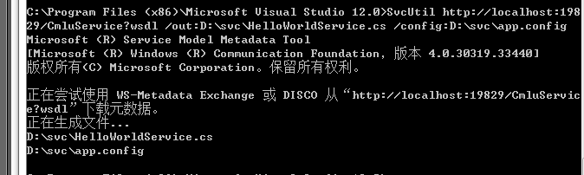

将config文件中的<system.serviceModel>拷贝到你的程序配置文件中

将代理类添加到你的程序中，添加程序集引用System.ServiceModel和System.Runtime.Serialization。

适当修改生成的类名以适合你的需要。然后就可以使用生成的ServiceClient调用你的服务了。

/// Tips:

/// 1:Always create the service with interface->Implementation format, mention the contract in interface.

/// 2:Define the service in class library and refer the class library in host project. Don't use service class in host project.

3:when we throw exception from service,it can't reach the client side.You must use throw new FaultException();

# WCF

### Host

IIS Host仅支持HTTP协议。Self host、Window Service、WAS支持所有的协议。

### Binding Type

* BasicHttpBinding

Suit for communicating with asp.net web services based services

This binding uses http

Security is disabled by default

Weak in interoperability

* WSHttpBinding

Defines a secure, reliable, interoperable binding suitable for non-duplex service contracts

offers lot more functionality in the area of interoperability

reliable and secure sessions using SOAP security

* WSDualHttpBinding

This binding is same as that of WSHttpBinding, except it supports duplex service

* NetTcpBinding

This binding provides secure and reliable binding environment for .Net to .Net cross machine communication.

It uses TCP protocol and provides support for security, transaction and reliability.

* NetNamedPipeBinding

provides secure and reliable binding environment for on-machine cross process communication.

* NetMsmqBinding

provides secure and reliable queued communication for cross-machine environment

Queuing is provided by using MSMQ as transport

enables for disconnected operations, failure isolation and load leveling

* NetPeerTcpBinding

provides secure binding for peer-to-peer environment and network applications

uses TCP protocol for communication