**PID Controller**

PID Controller is one of the frequently used control algorithms for controllers. Here basically we set the steering angle proportional to cross track error (CTE). CTE is the lateral distance between vehicle and reference trajectory. Here larger the error more we will try to steer towards the target trajectory.

PID has 3 components :

1. P - Proportional cross track error
2. I - Integrated cross track error
3. D - Differential cross track error

The effect of these components are controlled by PID coefficients - Kp,Ki & Kd

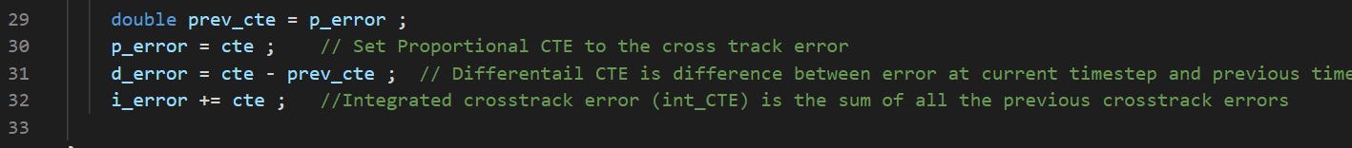

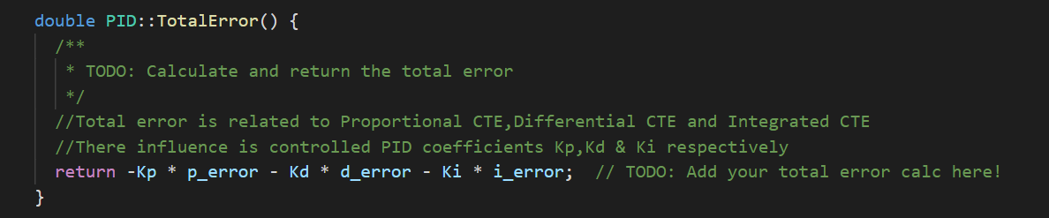

**P-Controller :**

Here the car steers is proportional to the cross track error and the magnitude of the proportion is controlled by a parameter Kp. We experiment with various values of Kp, before finalizing the value. One of the drawbacks of only using P controller is that the car will slightly overshoot the target trajectory.Eventhough the overshooting is very small, it'll never really converge and it reaches a state called “Marginally Stable”.

After trying out different values, finalized on 0.15 for the parameter Kp.

Also tried to see the effect on the steering, if we make Kp as zero. It turns out that this is an important component as the car was going towards the side of the road many times and then after sometime it goes off track. A video “Kp_zero.mp4” has been uploaded in videos folder to show the behaviour.

**D-Controller :**

Here the steering is related to temporal derivative of cross track error. This differential helps the car to gracefully approach the target trajectory and helps reduce the overshoot issue. Parameter Ki will be used to control the effect of D-controller. In practise the differential value is calculated by subtracting the CTE at current time step by the CTE of previous timestep.

After trying out different values, finalized on 2.5 for the parameter Kd.

Also tried to see the effect on the steering, if we make Kd as zero. This is the most important component as the car goes off track immediately. A video “Kd_zero.mp4” has been uploaded in videos folder to show the behaviour.

**I-Controller :**

If there is a “Systemic Bias” in our system, then it leads to large amount of error and this can be controlled using I-Controller. Steering drift is an example for Systemic Bias. I-Controller is nothing but a sum of cross track errors and its effect in the overall total error is controlled by a parameter Ki. When there is a systematic error in a system, overtime the error increases and this can be identified by integral of cross track error.

After trying out different values, finalized on 0.003 for the parameter Ki.

Also tried to see the effect on the steering, if we make Ki as zero. Because we have reduced speed and throttle for higher absolute steering angles (explained later), we don’t see Ki influencing as much as Kd.But we do see that during corners the correction of the steering angles happens little late as we don’t track the error integrals any more . A video “Ki_zero.mp4” has been uploaded in videos folder to show the behaviour.

**Parameter Settings and value finalization :**

I realized that adjusting the throttle and speed based on the absolute value of steer_value help to reduce jerks and makes the car driving more smooth.It also helps in reducing the addition of CTE errors in short period of time.

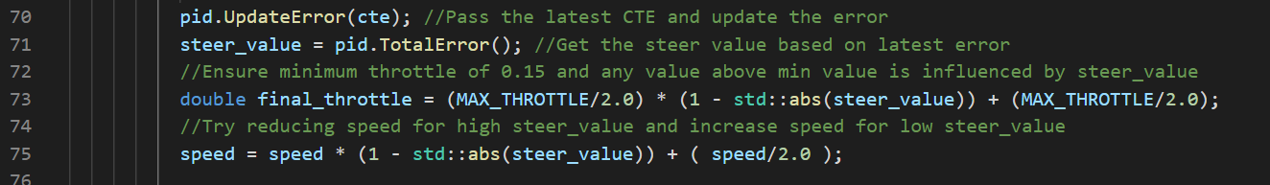

The following PID coefficients which were suggested in the course were good enough to complete the lap without any incidents.I tried various other values before this, but found the following values good enough to complete the lap.

Kp = 0.2 , Ki = 0.004 & Kd = 3.0

I could have used twiddle algorithm to find the better values, but did a manual search instead and also because I control the speed and throttle based on the total error, there was no need to use twiddle to make the car drive properly.

After some further manual search of the best parameters, finalized the following values:

Kp = 0.15, Ki = 0.003 & Kd = 2.5



All the components of PID Controller impacts the final steering angle. Here, as discussed earlier, P & D has large impact and I helps to make the drive smooth around corners. You can find the final video in the videos folder - “final_video.mp4”.