- Scientific Data Sets:The SD Model

- Chapter Overview
This chapter provides functional descriptions of the SD User’s Model, the SD Developer’s Model, and the HDF file structures used to represent these models.
- Standard UML notation is used extensively in the formal data model descriptions. Section 7.2, "UML Notation and Object Symbols in HDF Data Model Descriptions," describes the relevant UML elements.
- Section 7.3, "Introduction to the SD Model," introduces the HDF SD model.
- Section 7.4, "The SD User’s Model," and Section 7.5, "The SD Developer’s Model," provide more details, introducing the SD User’s Model as an intermediate step, and presenting the formal data model required to implement the SD Developer’s Model.
- Section 7.6, "Mapping between SD Developer's Model and HDF File Structures," and Section 7.7, "SDS Memory Structures and Storage Layout," map the elements of the SD Developer’s Model to HDF file structures and provide a detailed description of those memory structures and the storage layout in the file.
- Section 7.8, "Library Implementation Details with Example File and SDS," illustrates the HDF library implementation of the SD model.
- UML Notation and Object Symbols in HDF Data Model Descriptions
Many of the figures in this chapter and in Chapter 8, General Raster Images: The GR Model, employ UML notation (Unified Modeling Language notation) to show object relationships. The symbols and the relationships they describe are illustrated in Figure 7a. Note that UML can represent other objects and relationships as well; this discussion, Figure 7a, and Figure 7c present only what is required for this chapter.
- UML symbols and interpretations as used in formal HDF data model descriptions
An HDF object is represented as a rectangle.
Associations or relationships among object instances are indicated by arrows.
A diamond indicates the aggregation association, i.e., the a part of relationship. | 
Object D is part of object B. 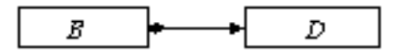
Object B is composed of object D.
The numbers at either end of the arrow indicate the multiplicity of associations. 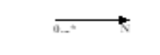
N exactly N
0...N zero up to N
0...* zero or more
Object A includes exactly one of objects B or C.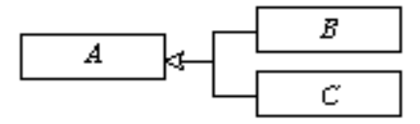
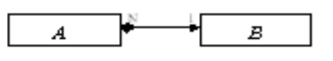For example, the following statements describe the diagram at the right:
- Object A is composed of exactly one object B.
- Object B is associated with exactly N objects of type A.
The figures that make up the formal definition of the data model, such as Figure 7g, "SD User’s Model -- The SD Model from the User’s Point of View," or Figure 7i, "SD Developer’s Model -- The SD Model from the Developer’s Point of View," use the above UML notation rigorously.
Figures that are intended to informally illustrate points of discussion, such as Figure 7f, "A sample user’s view of the SD model," or that illustrate the file layout, such as Figure 7p, "SDS View of the HDF File Structure," often use only a subset of the UML notation and treat the relationships less rigorously.

The formal data model discussions also include formal object descriptions clearly delineating the types of HDF objects and their attributes. The layout of these object descriptions is illustrated in Figure 7c.
- Formal object descriptions
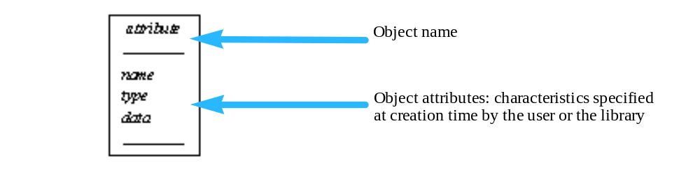In object description figures, e.g.Figure 7j, "SD Developer’s Model Objects," the top line specifies the name of the object. The entries immediately below the first horizontal bar list object attributes that are specified by either the user or the library when the object is created.
- Introduction to the SD Model
An HDF file may contain many elements, including scientific data sets (SDSs, the subject of this chapter), general raster images (GRs), groups of HDF objects, images, palettes, annotations, etc. Figure 7d provides a high-level illustration of one potential HDF file.
- An HDF file may contain several objects and object collections
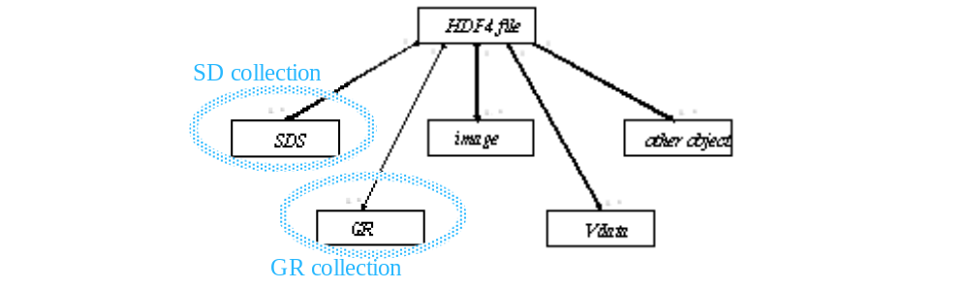A scientific data set, or SDS, is an HDF data structure used to store a multidimensional array of scientific data and the supporting metadata. An SDS is stored in a group of HDF objects collectively known as an SD collection. A file may contain only one SD collection; an SD collection may contain several SDSs. Chapter 3, “Scientific Data Sets (SD API),” in the HDF User's Guide describes the SD model, in terms of required and optional components that comprise a scientific data set, and the SD interface routines provided by the HDF library to create and access SDSs in the file.
When a file is opened with the SD interface, also called the SD API, only the SD collection is available A file opened with the SD interface should therefore be thought of in terms of Figure 7e. Other objects in the file are unavailable through the SD interface; they can, however, be accessed through other interfaces, e.g., the H, V, and SD interfaces.
- An HDF file opened with the SD interface
- 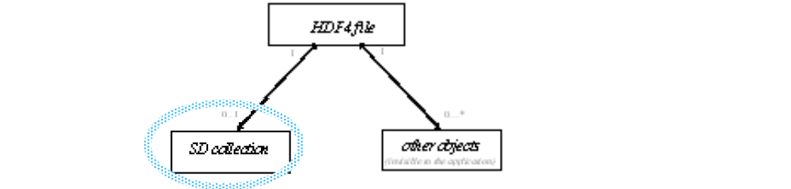When a file is opened with the SD interface, only the SD collection is available (circled above in blue; grey if medium is black-and-white). Other objects in the file are unavailable to the application.
- An SD collection may contain zero or more SDSs.
This chapter introduces two formal data models. The first version of the model, called the SD User's Model and illustrated in Figure 7g, formally describes the concepts introduced in Chapter 3 of the HDF User's Guide. The second model, called the SD Developer's Model or the Internal SD Model and illustrated in Figure 7i, is a generalization of the SD User's Model that reflects the technical implementation and the integration of the NetCDF data model into HDF. These models are described in Section 7.4, "The SD User’s Model," and Section 7.5, "The SD Developer’s Model."
Following the discussion of the data models, the mapping of the SD Developer's Model to HDF file structures is presented in Section 7.6, "Mapping between SD Developer's Model and HDF File Structures." Memory structures and storage layout are discussed in Section 7.7, "SDS Memory Structures and Storage Layout."
The last section, Section 7.8, "Library Implementation Details with Example File and SDS," offers an example of an HDF file containing an SD collection and describes the evolution of the file as different components of the SD collection and the SDS it contains are written to the file.
- The SD User’s Model
This section provides a logical description of an HDF file containing an SD collection. An example of a user’s view of the data model is presented in Figure 7f; a formal graphical representation is presented in Figure 7g, "SD User’s Model -- The SD Model from the User’s Point of View."
From a user’s point of view, an HDF file containing SDSs is structured as follows and as illustrated in Figure 7f:
- The file contains SDSs and possibly global attributes, which apply to all SDSs in the file.
- Each SDS may have associated attribute(s), dimension scale(s), and data.
An SDS is a multidimensional array of elements designed to store scientific data. Elements of the array may have one of the HDF predefined datatypes (see Section 5.5, "Scientific Data Sets," in this HDF Specification and Developer’s Guide). Spatial information (rank=N and dimension sizes) describes the shape and the size of the array and is specified by the user. Each SDS is identified by a user-defined name. (If the user does not define a name, the HDF library will assign a default name at creation time.) An SDS always has a storage layout associated with it which is defined at creation time and describes how the SDS raw data is stored. Raw data storage options are contiguous (the default), external, chunked, compressed, chunked and compressed, and extendible. Name, spatial information, datatype, and storage layout are required components of an SDS. An SDS may optionally include raw data, denoted as data in the UML diagram (Figure 7g).
- A sample user’s view of the SD model
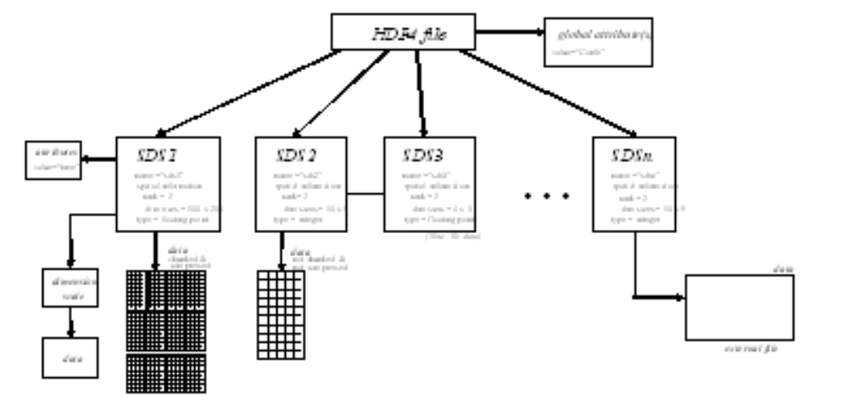The Formal SD User’s Model
The formal SD User’s Model includes one type of object the user does not actually see, the SD collection. An HDF file may contain zero or one SD collection which may, in turn, contain zero or more SDSs. The global attributes, of which there may be zero or more, are actually associated with the SD collection. Global attributes are optional, are defined by the user, and usually describe the intended usage of the SDSs in the file. The SDSs and the associated objects (see Figure 7g) are generally intended to be accessed only through the SD interface. When possible, however, the data sets are created to be readable via the older DFSD APIs.
An SDS may have zero or more associated attributes. These attributes are distinct from global attributes, which apply to all SDSs in the file.
The HDF library creates N dimensions associated with an SDS where N is the rank of the SDS. The library will assign a name to each dimension; if desired, these may be overwritten with user-defined names. Each dimension can be associated with more than one SDS. The size of the dimension is set up by the library, based on the SDS’s spatial information. When a dimension is associated with more than with one SDS, it is called a shared dimension. Shared dimensions are created by the user.
Each dimension may have zero or more dimension attributes. Each dimension may also have data associated with it, in which case the data is called a dimension scale or dimension variable, as in netCDF.
- SD User’s Model -- The SD Model from the User’s Point of View
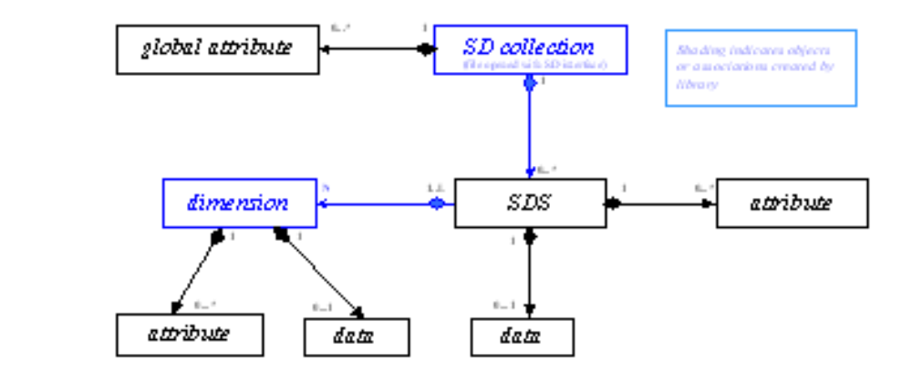The formal model is based on relationships among user-specified objects of the SD User’s Model and the associated object attributes, as described in Figure 7h.
- SD User’s Model Objects
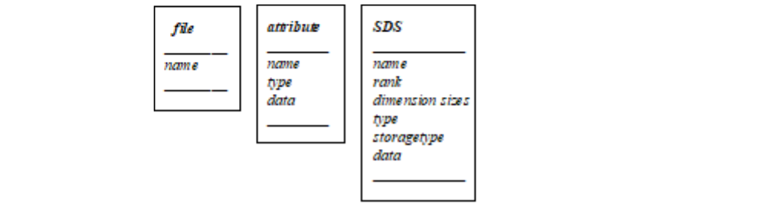The SD interface provides routines to access the objects depicted in Figure 7f, "A sample user’s view of the SD model." If an object is part of another object, it cannot be accessed by the SD interface without first accessing the enclosing object. E.g., dimension information can be accessed only after accessing the associated SDS.
- The SD Developer’s Model
SD User’s Model focuses on aspects of data and relationships among objects that facilitate the user’s scientific work. Since the library must translate that data into something that can be stored to and retrieved from the file in an efficient, universally-accessible manner, the SD Developer’s Model presents a slightly modified set of objects and relationships.
While the SD collection is a virtual object in the user’s model and the user never sees it or has any practical means of perceiving it, the SD collection is a very real object in the developer’s model. Different kinds of objects from the user’s model are generalized as a simple type of object in the developer’s model and some object relationships become more generalized.
As one can see in the UML diagram in Figure 7g, the dimension-data-attribute association is very similar to the SDS-data-attribute association. This leads to the generalized UML diagram in Figure 7i, called the SD Developer's Model or the Internal SD Model. In this diagram, SDS and dimension scales are replaced by a variable. The dimension object associated with the variable describes the spatial information of the corresponding variable (i.e., the corresponding SDS or dimension scale) and is independently a part of the SD collection.
Less formally expressed, when an attribute is assigned to the dimension, or data is associated with the dimension, the HDF library creates internal structures in which to store this information. These structures are the same as for an SDS. See Section 7.6, "Mapping between SD Developer's Model and HDF File Structures," for further discussion. The HDF library uses the terminology “a dimension is promoted to an SDS” and that promotion is transparent to the user. The user still accesses a dimension's data and dimension attributes via the SD interface routines and the SDS to which that dimension belongs.
Since a dimension scale is stored in the same type of HDF object as an SDS, there is no difference between them from the HDF library’s (and hence the developer’s) point of view. A dimension is simply a special case of the more general SDS and both objects are viewed by the library and the developer as variables. In the user’s view, an SDS can have associated attribute(s), data, and dimension(s) and a dimension can have associated attribute(s) and data. Therefore, in the developer’s view, a variable can have associated attribute(s), data, and dimension(s)
- SD Developer’s Model -- The SD Model from the Developer’s Point of View
- 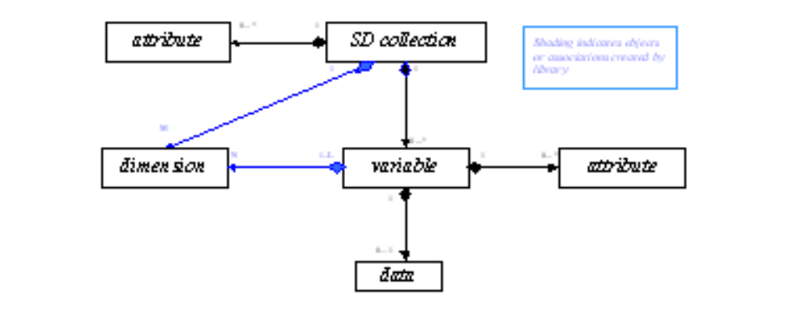variable can be either an SDS or a dimension scale.
- N is a rank of the variable.
- L is 1 if variable is a dimension scale.
- Neither the link from SD_collection to dimension nor the link from variable to dimension is available through the SD interface, though they are available via other HDF interfaces.
Each object in Figure 7i is represented by a set of HDF objects in the file as defined in Section 7.6, "Mapping between SD Developer's Model and HDF File Structures."
The SD collection is created automatically by the HDF library. The attributes, variables, and data are created by the user via the SD interface.
Figure 7j summarizes the data and metadata associated with each SD model object.
- SD Developer’s Model Objects
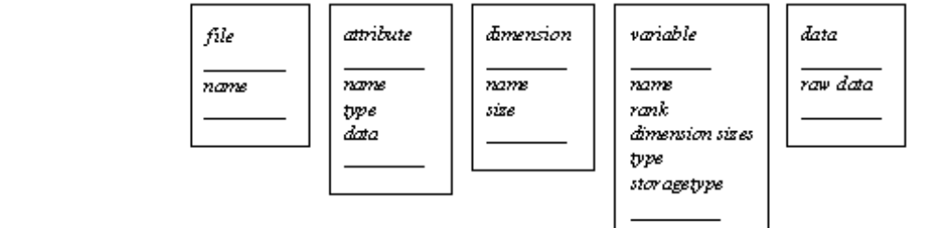A variable is an array structure that has a name, spatial information (rank and dimension sizes), datatype, and storage layout type and represents either an SDS or a dimension variable. The difference between two objects is in their rank and storage layout. The rank of a dimensional variable is always 1 and its storage layout type can be contiguous or extendible (unlimited). See Table 7a for a list of storage layout options.
A variable always has N associated dimensions with it. If variable is a dimension variable, then the multiplicity factor N is 1. A variable may have zero or more attribute objects associated with it.
- SDS Storage layouts
variable
SDS |  |  |  |  | dimension variable
contiguous | special storage |  |  |  | default | extendible
contiguous | chunked | compressed | chunked and compressed | external | default | extendible
- Contiguous storage is the default layout and requires no special storage tag.
- Mapping between SD Developer's Model and HDF File Structures
This section describes the mapping between the objects represented in the UML diagram in Figure 7i, "SD Developer’s Model -- The SD Model from the Developer’s Point of View," and the HDF objects in the file.
The illustrations in this section employ the symbols in Figure 7k to identify the indicated file structures.
- File structure symbols
Vgroup | 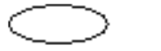 |  | HDF element identified with tag/ref pair | 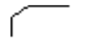
Vdata | 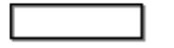 |  | Abstract SD model object | 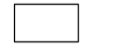
- SD Collection
SD_collection, which is the view of the file as revealed by the SD interface, is mapped to an HDF Vgroup with name=file_name and class=CDF0.0. For purposes of this discussion only and to distinguish this Vgroup from other Vgroups in the discussion, this is referred to as the top Vgroup in the file. All objects shown in Figure 7i, "SD Developer’s Model -- The SD Model from the Developer’s Point of View," are mapped to the HDF objects which are members of this top Vgroup, as illustrated in Figure 7l through Figure 7q.
- Model-to-File Mapping -- SD_collection 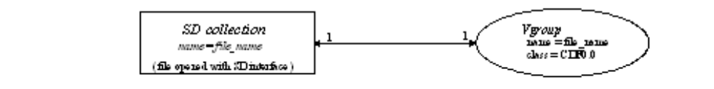
Note that at the user level, the SD collection is a virtual entity; it has no real existence for the user. At the developer level and in the file, however, the SD collection is a real object corresponding to the top Vgroup. All of the HDF file structures that make up the SD collection are gathered together into this Vgroup.
- Attribute
An attribute is mapped to the Vdata as follows:
- The Vdata has the name=attribute_name and the class=Attr0.0.
- The Vdata has only one field with the name [Values].
- For numerical attributes:
- The order of the field is 1 for a numerical attribute
- The data type of the field is the same as that of attribute.
- The Vdata has N records, where N is the number of attribute values.
- For character attributes:
- The order of the field is N, where N is the number of characters.
- The data type of the field is the same as that of attribute.
- The Vdata has exactly one record.
- If attribute is attached to the file, then the corresponding Vdata will be a member of the top Vgroup. If attribute is attached to the variable (an SDS or a dimensional scale), then the Vdata is a member of the variable Vgroup. (See Section 7.6.3, "Variable.")
- Model-to-File Mapping -- attribute 
- Variable
A variable is mapped to a variable Vgroup with name=variable_name and class=Var0.0. All variable Vgroups are members of the top Vgroup. A Vgroup that represents a variable has as members N Vgroups which represent dimensions, and where N is the rank of variable.
- Model-to-File Mapping -- variable, data, and attribute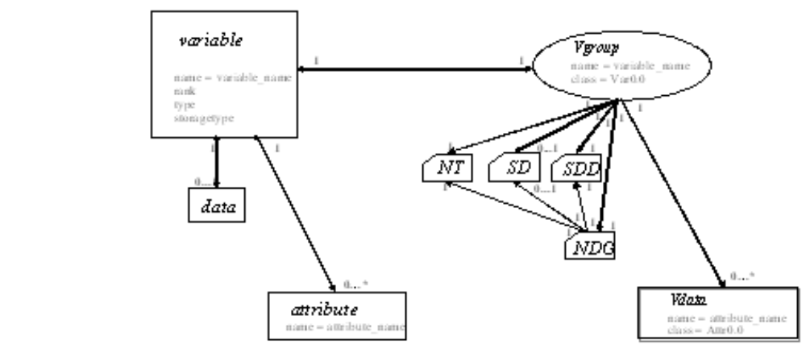
In Figure 7n, note that NT, SD, SDD, and NDG are discrete and identifiable objects in an HDF file and are accessible via the H interface. In this figure, the variable’s rank is stored in SDD, the storage type in NT, the data in SD, and the attribute in the Vdata. NDG exists to enable backward compatibility with the DFSD interface.
For a more complete discussion of the SDD, NT, SD and NDG structures, see Chapter , Tag Specifications. DFTAG_SDD, DFTAG_SD, and DFTAG_NDG are discussed in Section 9.3.7, "Scientific Data Set Tags." DFTAG_NT is discussed in Section 9.3.1, "Utility Tags."
- Dimension
A dimension is mapped to the following group of HDF objects:
- The Vgroup with the name of dimension_name and class of (U)Dim0.0. The U indicates that this is an unlimited dimension; otherwise the order of the dimension would be fixed.
- A Vdata within this Vgroup with the name dimension_name and class DimVal0.0 or DimVal0.1. (See Figure 7o).
- Note the two possible classes. This is a versioning mechanism sometimes used within the HDF library to identify internal technical changes. In this case, DimVal0.0 identifies a dimension created under the original approach while DimVal0.1 identifies a dimension created under a subsequent revision.
- If the class is DimVal0.1, the default behavior is that the Vdata has one integer field (int32) of order 1 and contains only one record with the size of the dimension. If the user has explicitly created/stored dimension information, then the Vdata will be of size k, as described in the following DimVal0.0 bullet.
- If the class is DimVal0.0, the Vdata will have k records, where k is the size of the dimension and the default value of each record equals the record’s position in the Vdata.
- The dimension Vgroup representing dimension is a member of the variable Vgroup representing variable (see Figure 7p).
- If dimension is shared, then the dimension Vgroup can be a member of more than one variable Vgroup.
- 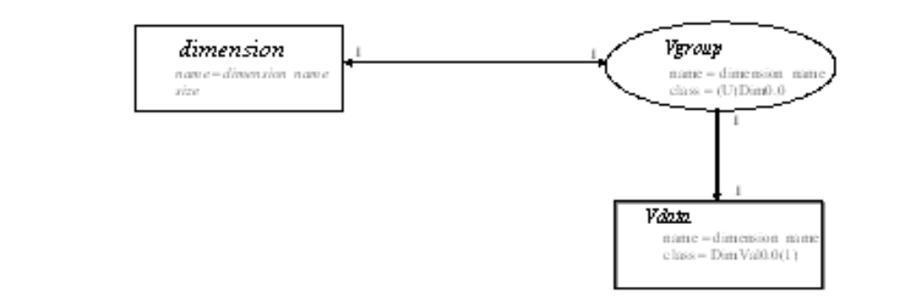Model-to-File mapping - dimension
As illustrated in Figure 7o, the dimension value is stored in the Vdata with name=dimension_name, which is itself a member of the Vgroup with name=dimension_name.
- Overall Correspondence of SDS Elements and the HDF File Structure
The aggregation of the preceding elements and relationships, at the HDF file structure level, is summarized in Figure 7p.
- SDS View of the HDF File Structure
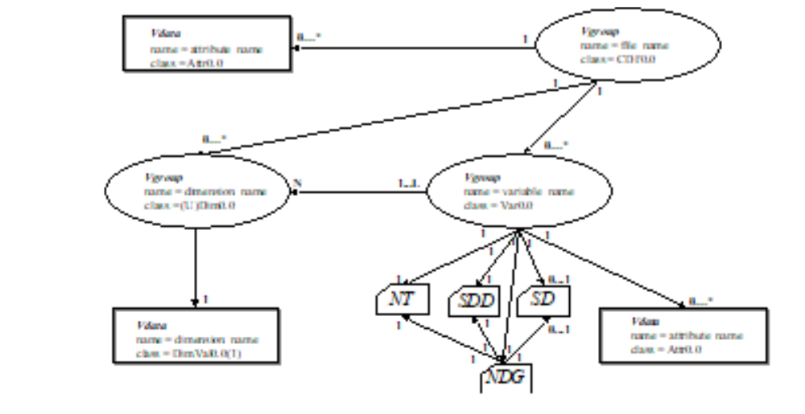Note the correspondence between the elements of the SDS view of the HDF file structure, as illustrated in Figure 7p, and the SD Developer’s Model, as illustrated in Figure 7i. This correspondence is illustrated in Figure 7q.
- The SD collection is represented by a Vgroup, the top Vgroup.
- Each variable, which can be either an SDS or a dimension scale, is represented by a variable Vgroup which is a member of the top Vgroup.
- Dimensions and attributes are represented by Vgroups and Vdatas, respectively, which are members of the SDS’s variable Vgroup.
- The raw data, data types, storage layout, and specialized information used by the library are represented by low-level tag/ref elements which are members of the variable Vgroup.
- A dimension attribute is represented by a Vdata which is a member of a dimension scale’s variable Vgroup.
The HDF SDS file structures are illustrated by the background elements (black) of Figure 7q. The foreground elements (blue or gray, depending on whether this is viewed in color or black-and-white) show the relationship between the SD Developer’s Model and the HDF SDS file structures. Note that Vgroups and Vdatas play several different roles in this scheme; the roles of individual Vgroups and Vdatas are indicated by their class.
- Developer’s view of the SD model (Figure 7i) and
the corresponding elements of the HDF file structure (Figure 7p)
- 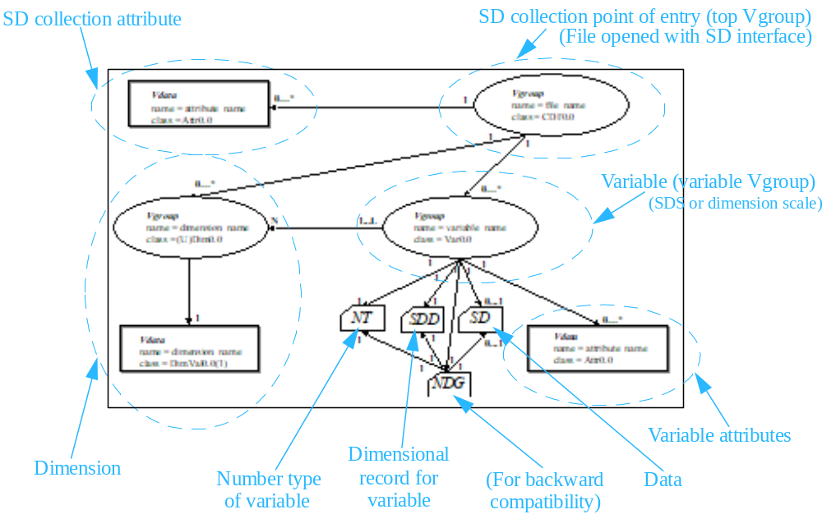Accessing SD Objects via non-SD Interfaces
The SD interface is the only HDF interface that carefully maintains objects, file structures, and the relationships among them to ensure the integrity of scientific data sets. While all elements of an SD collection are individually accessible and manipulatable via the more general HDF interfaces, such as the H interface, to do so introduces a significant risk of corrupting relationships and/or data within the SD collection and is not recommended.
- SDS Memory Structures and Storage Layout
The preceding sections of this chapter have focused on SD model objects and HDF file structures. With this section and the next, the focus shifts to the HDF library implementation of the SD models, including an extensive discussion of the memory structures employed.
The file data structures in which the objects of the SD models are stored are mapped by the library to data structures in memory either when an HDF file is opened with the SD interface or as the objects are created during execution. The UML diagram in Figure 7r illustrates this mapping.
- File Structures to Memory Structures Mapping
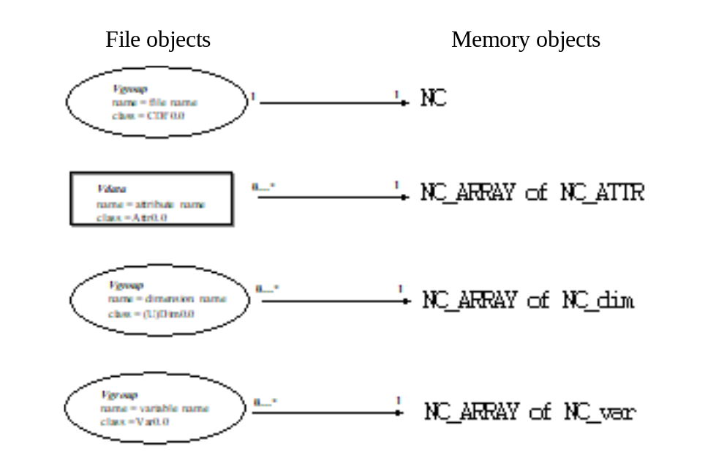These memory structures, NC, NC_ATTR, NC_ARRAY, NC_var and NC_dim, are described in detail in Section 7.8, "Library Implementation Details with Example File and SDS." The HDF file structures are mapped to the memory structures as follows:
- The top Vgroup, the Vgroup containing all elements of the SD collection, is mapped to the NC memory structure.
- Vdatas, containing data array attributes or dimension attributes, are mapped to the NC_ARRAY of NC_ATTR memory structure.
- Dimension Vgroups, each containing the elements of a dimension, are mapped to the NC_ARRAY of NC_dim memory structure.
- Variable Vgroups, each containing the elements of an SDS, are mapped to the NC_ARRAY of NC_var memory structure.
- Data structures for HDF file contents
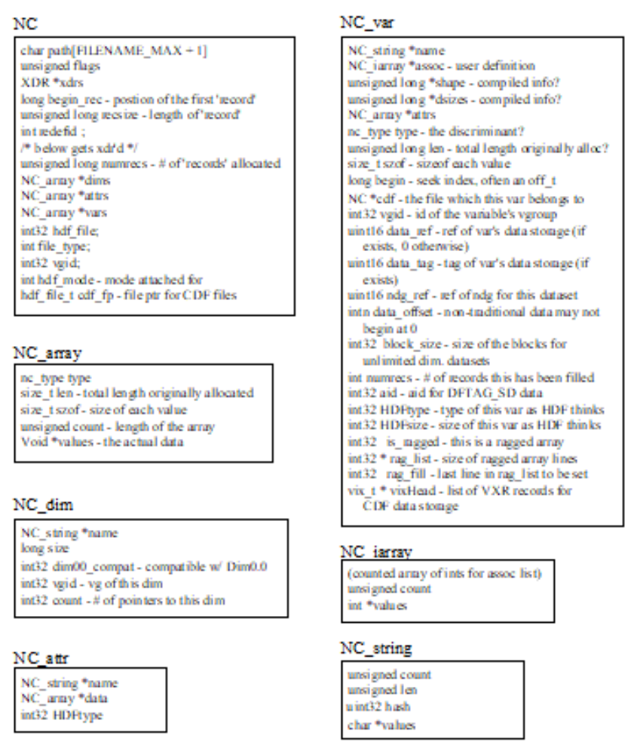
- Library Implementation Details with Example File and SDS
This section describes the interface routines that are used to create, open, and modify an SDS and its components in the file. In particular, the following evolutionary stages of accessing and manipulating the SDS are discussed:
- The file is created or open.
- An SDS is created.
- Data is written to the SDS.
- Global attributes are set for the file.
- Local attributes are set for the SDS (data string and attribute name) and the dimension (dimension scale and dimension string).
- Access to the file is terminated.
At each stage, the correspondence between storing the contents in memory and representing the data in the file is discussed.
Illustrations in this section adhere to the conventions used previously in this chapter, with the following additional elements:
- New items introduced for the next step are lightly shaded.
- Items being removed are heavily shaded and/or labeled in white text.
- Creating or opening an HDF file
The routine SDstart creates a new HDF file or opens an existing one.
- When SDstart creates a file, a structure NC is created with the pointers dims, attrs, and vars set to NULL.
- When SDstart opens a file, a structure NC is created and the structures NC_array, NC_var, NC_dim, and NC_attr are created and attached to the pointers vars, dims, and attrs corresponding to the contents of the file.
The objects are stored in these internal data structures (except for writing values) until the completion of SDend, which writes the contents in these data structures to the file in the form of Vgroups, Vdatas, and other objects, as described below in each stage of the file evolution.
- Creating an empty SDS
The routine SDcreate creates an SDS by the following steps:
- Creates an NC_dim for each dimension then inserts it into NC_array pointed to by dims. If dims is NULL, a structure of NC_array is created for it.
- For each NC_dim, creates a structure of NC_string to hold the name of the dimension.
- Creates an NC_var then inserts it into NC_array pointed to by vars. If vars is NULL, a structure of NC_array is created for it.
- Creates a structure of NC_string to hold the name of the SDS.
- Creates a structure of NC_iarray to hold the indices of the SDS dimensions.
Figure 7t illustrates the contents of the SD collection in the HDF file in memory at this point, when the collection contains an empty two-dimensional SDS.
- SD collection contents in memory after a 2-dimensional SDS is created
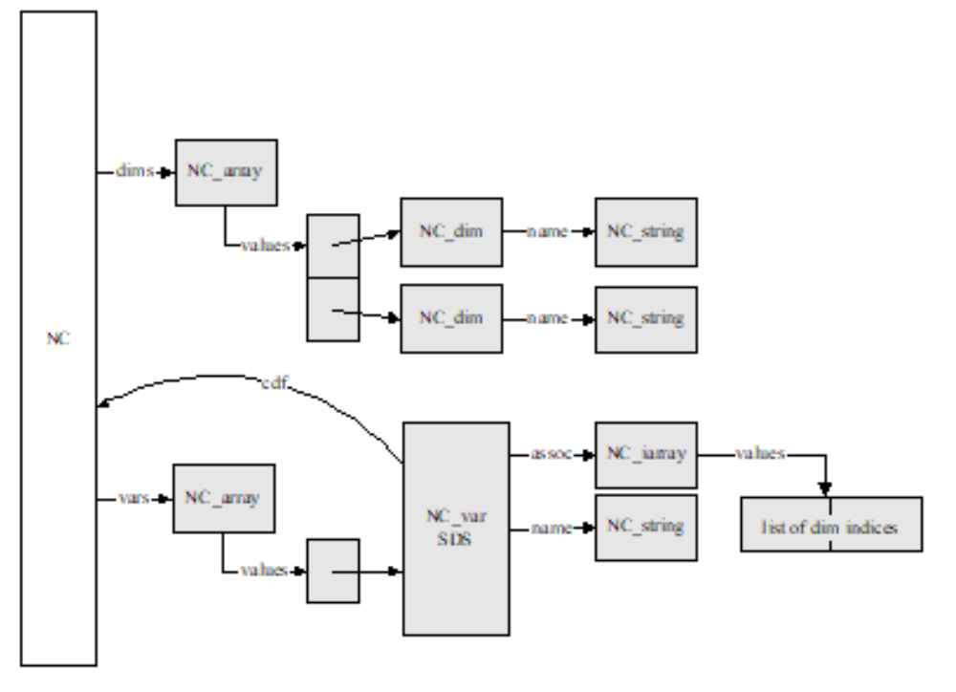Figure 7u illustrates the corresponding representation in the file of the contents of the SD collection after the access to the file is terminated, i.e., SDend is called. Refer to Section 7.8.9, "Terminating access to the SD collection and file," for the description of the termination process carried out by this routine. In Figure 7u, a Vgroup at the top level represents the SD collection and contain three other Vgroups. The first two second-level Vgroups represent the two dimensions of the SDS. Each of these dimension Vgroups includes a one-field Vdata that has one record storing the size of the dimension. The third second-level Vgroup represents the SDS. This Vgroup includes several low-level objects, which have been described earlier in the chapter (see Section 7.6.3, "Variable"):
- NT, SDD, NDG, and SD (introduced in Figure 7v) are tag/ref objects.
- NT, the number type of the SDS, is identified by the tag DFTAG_NT.
- SDD, the scientific data dimension, is identified by the tag DFTAG_SDD.
- NDG, the numeric data group, is identified by the tag DFTAG_NDG.
- SD, the scientific data, is identified by the tag DFTAG_SD. SD is present only after data has been written to the SDS.
- NT contains a number type definition which can be used by different data objects.
- NDG contains two pointers, one to the NT and one to the SDD. The NDG is included solely to enable backward compatibility with earlier versions of HDF.
- SD collection contents in the file with a 2-dimensional empty SDS 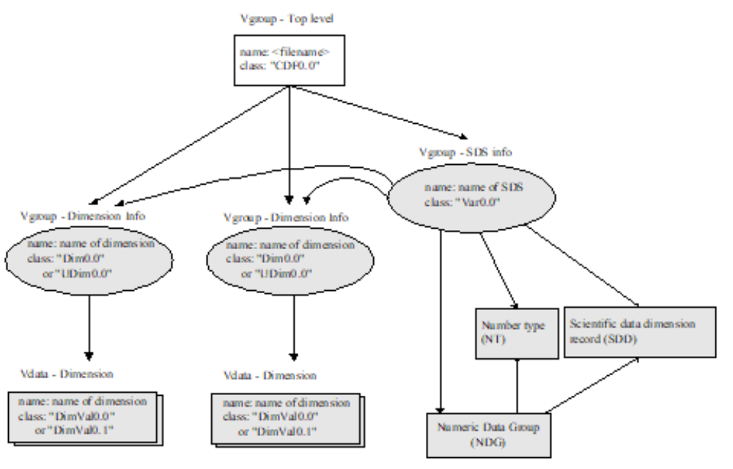

- Writing data to an SDS
The routine SDwritedata writes data to an SDS. Since the writes are directly to the file, no new internal data structures are introduced. The writing process includes searching the Vgroup that holds the SDS information for the SD object (tag DFTAG_SD.). If this object is not found among the elements of the SDS information Vgroup, i.e., data has never been written to this SDS, a new reference number is assigned for the SD object. This new object is then added to the SDS. The reference number of this new object is stored in (NC_var)->data_ref.
Figure 7v shows the change in the contents of the SD collection in the file after the SDS is written with data. A new object is added to the SDS Vgroup.
- SD collection contents in the file after a 2-dimensional SDS is written 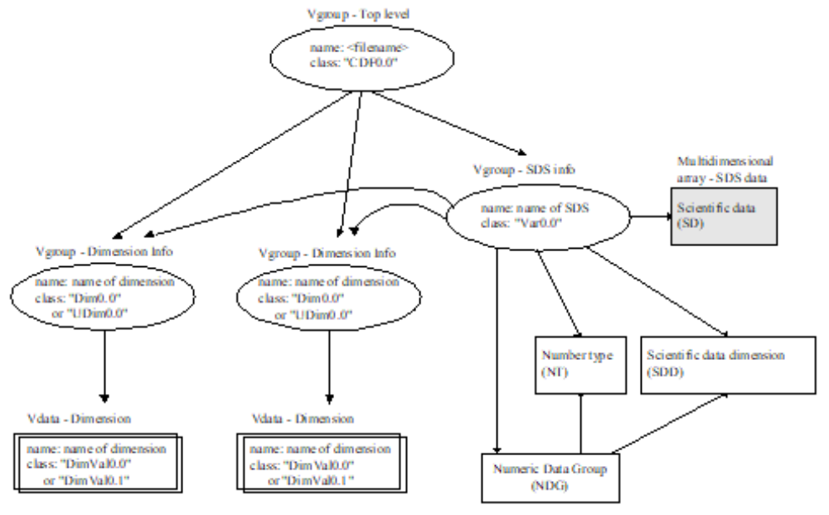
When more than one SDS is created, the process of writing to the file is the same as when only one SDS is created. The dimensions, variable record, and attributes of the succeeding SDSs are added to the pointer (NC)->dims, (NC)->vars, and (NC)->attrs and are written to the file in the same manner as for the first SDS.
If a storage layout is specified for the SDS (e.g., compression, chunking, or external storage), then the SD tag is promoted to a special tag, as described in Chapter 10, Extended Tags and Special Elements.
- Adding global and local attributes
The routine SDsetattr adds an attribute to
- the SD collection by the following steps:
Creates an NC_attr for the attribute.
Attaches the new attribute record to the pointer values of NC_array pointed to by attrs. If attrs is NULL, a structure of NC_array is created for it first.
- an SDS by the following steps:
Creates an NC_attr for the attribute.
If this object has not yet had any attribute created, i.e., attrs is NULL, starts the attribute list by creating a structure of NC_array, then attaches the new attribute record to the pointer values of NC_array.
If this object already has an attribute list, searches the attribute list for an attribute with the same name as the one to be added.
- If one is found, replaces the found attribute structure with the new one.
- If none is found, adds the new attribute structure to the attribute list. Note: the number of attributes must not exceed the maximum number of attributes allowed (MAX_NC_ATTRS.)
- a dimension by the following steps:
- Creates an NC_attr for the attribute
- If the SD collection contains no variable record (from the list (NC)->vars) that represents this dimension, promotes the dimension to a variable record, i.e. creates an NC_var for this dimension and attaches it to the variable list of the SD collection, (NC)->vars. At this point, the dimension has a variable record and, therefore, the rest of the attribute-setting process is identical to the process for an SDS.
Figure 7w, below, Figure 7x on page 77, and Figure 7y on page 78 illustrate the changes in the data structures as a global SDS attribute, an SDS attribute, and a dimension attribute are added, respectively.
- SD collection contents in memory after adding a global attribute
- 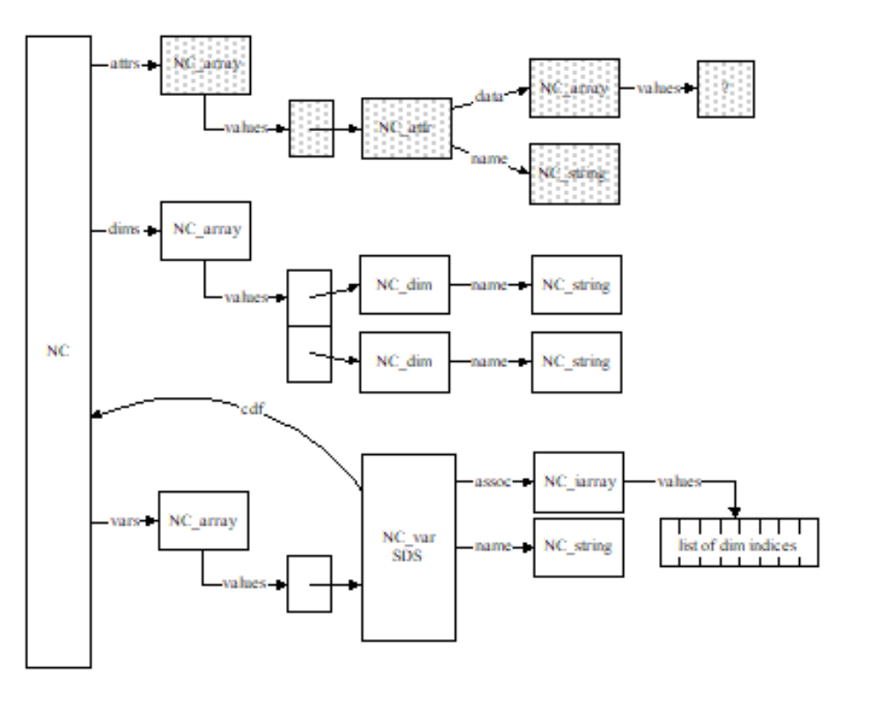SD collection contents in memory after adding an SDS attribute
- 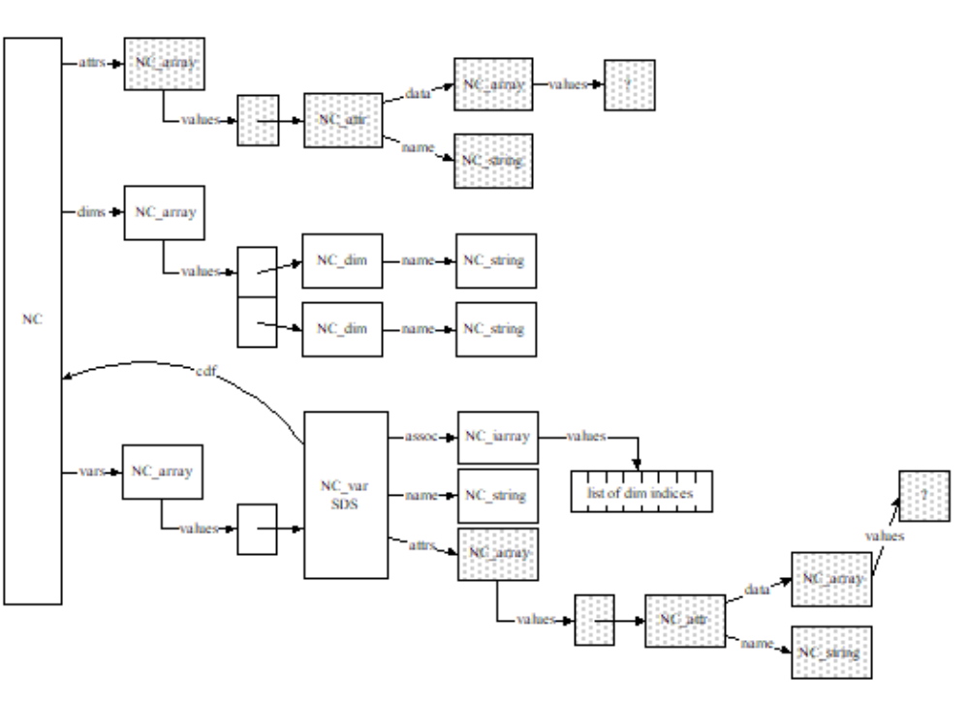SD collection contents in memory after adding a dimension attribute
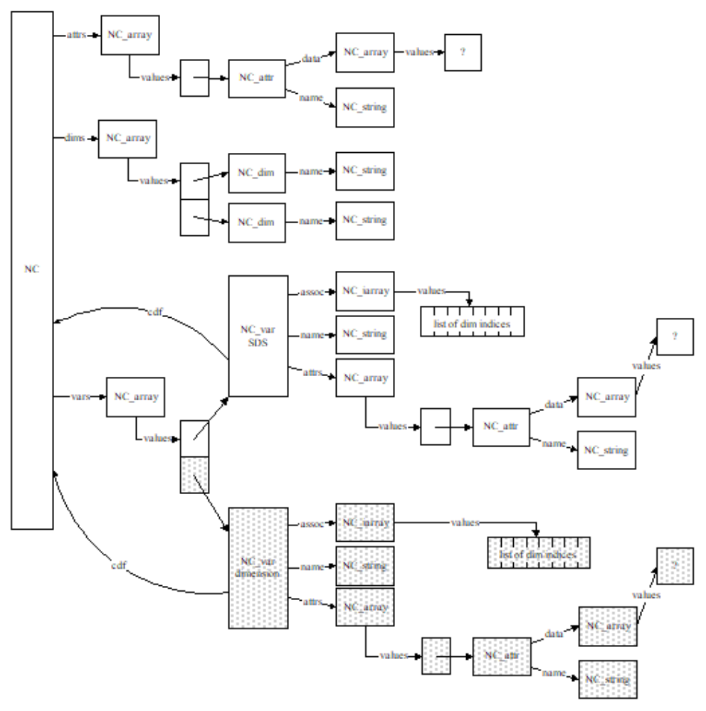It is worthwhile to pause at this point and review Figure 7z which highlights the relationship of the memory structures that have been built up by the library to the elements of the SD model discussed earlier in this chapter.
- Example of HDF memory structures describing an SD collection
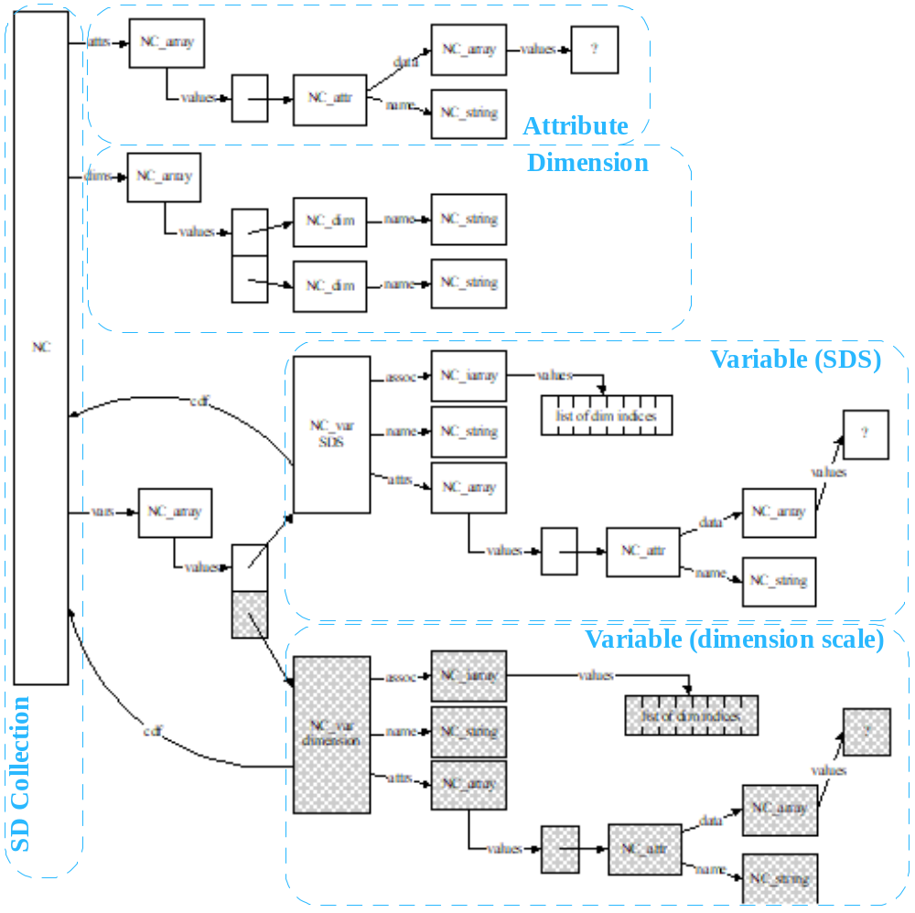If SDend is called after adding the preceding elements, Figure 7aa illustrates the representation of the SD collection in the closed and written file. The top level Vgroup, the SDS Vgroup, and one of the dimension Vgroups now each has another element, a Vdata, that holds its newly added attribute. Each attribute is stored in a one-field Vdata that has one record containing the attribute values. The Vdata's order is the number of values in the attribute.
- SD collection contents in the file after adding a global attribute, an SDS attribute, and a dimension attribute 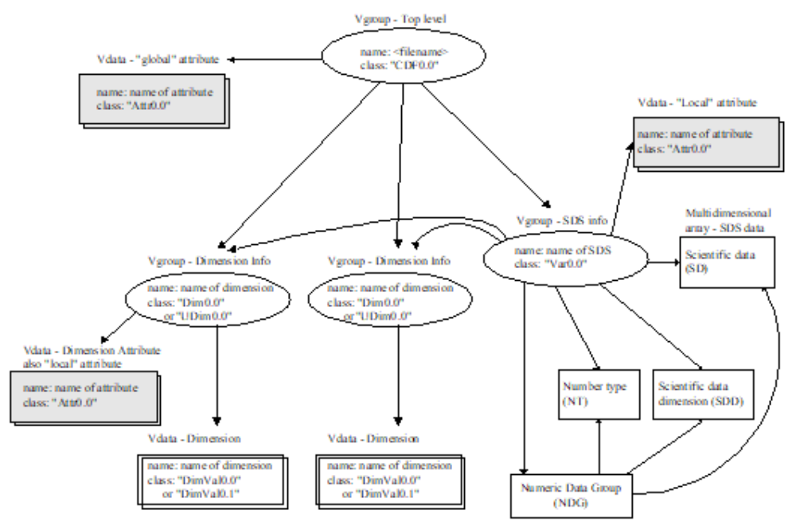
- Setting a data string
The routine SDsetdatastrs sets values for the pre-defined attributes label, unit, format, and coordinate system. The process of setting each of these attributes is similar to that of setting a user-defined attribute, as described in Section 7.8.4, "Adding global and local attributes," except that the names of these attributes are pre-defined rather than being set by the user.
- Setting a dimension name
Figure 7ab shows the dimension list attached to the SD collection structure in a simplified diagram so that the following illustrations will be easy to describe and understand. In this figure, there are four dimensions named as fakeDimn by default, where n is the index of the dimensions as they are created.
- Structures of the dimension list (example)
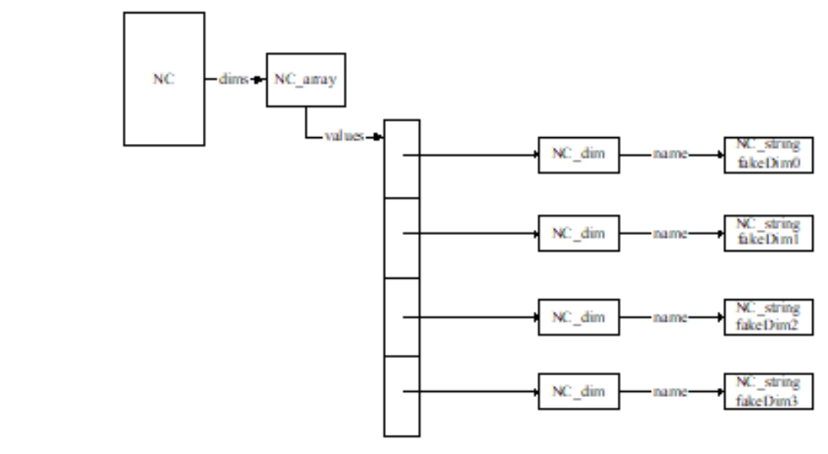The routine SDsetdimname sets the name for a given dimension according to the following criteria:
- If a dimension already exists having the same name as the name being set but having a size different from that of the given dimension, SDsetdimname fails.
- If no dimension with the given name exists, a new name structure is created and the dimension is set to the new name. The structure holding the dimension's old name, which can be a default name or one that was previously set, will be removed. Figure 7ac on page 82 shows the dimension fakeDim2 renamed to dimname.
- If a dimension already exists having the same name as the name being set and having the same size as the dimension being set, the found dimension structure (NC_dim) will be used for the dimension being set as well. Figure 7ad on page 82 illustrates this event. Let's say that we are setting name for the dimension fakeDim3 to a name, dim_name, that is the same as that of the third dimension. When the matched dimension is found, all pointers to the dimension being named are reset to point to the dimension dim_name. The old structure and its elements are then removed.
At this point, the SD collection illustrated in Figure 7t on page 72 and Figure 7u is considered completely evolved. The dimension settings are described in detail in Figure 7ab, Figure 7ac, and Figure 7ad.
- Setting a dimension name to a new name
- 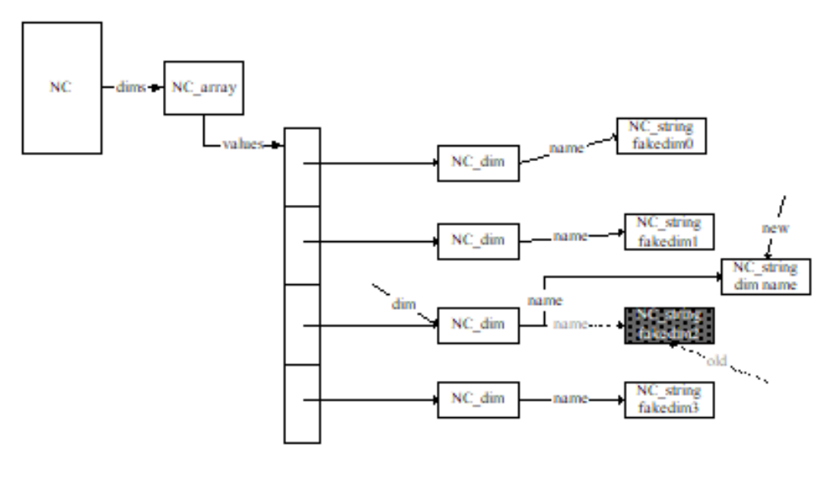Setting a dimension name to an existing name
- 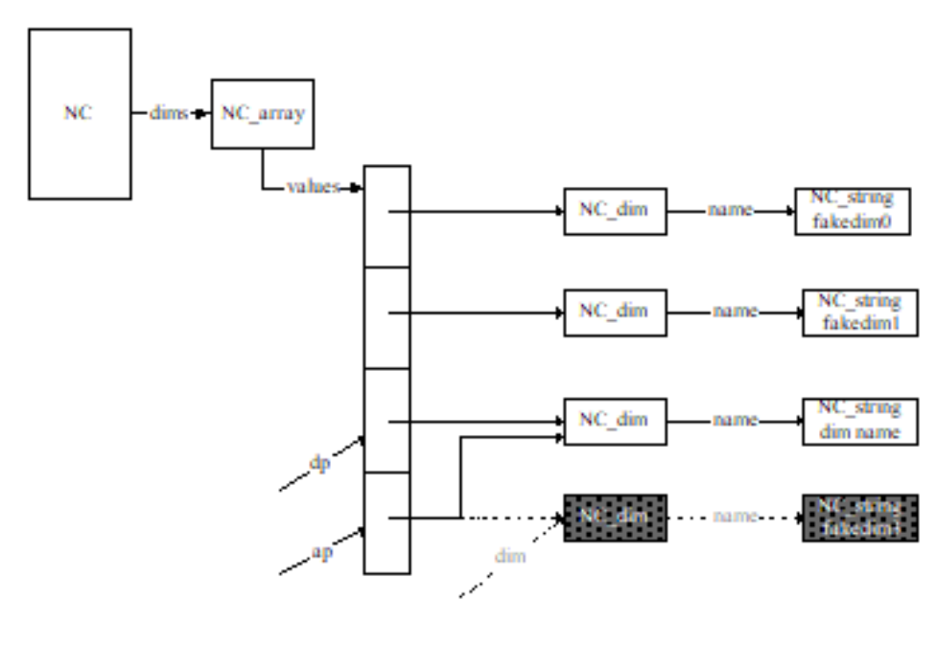Setting a dimension scale
The routine SDsetdimscale sets values to a given dimension as follows.
- If the SD collection contains no variable record (from the list (NC)->vars) that represents this dimension, promote the dimension to a variable record as described in the case of setting dimension attribute in Section 7.6.4, "Dimension." and illustrated in Figure 7y, "SD collection contents in memory after adding a dimension attribute." At this point, the dimension has a variable record and the scale values are written to the variable record.
- If this dimension already has a variable record, the record is updated with the scale values.
In both cases, the number type of the dimension is set via a call to SDsetdimscale.
- Setting a dimension string
The routine SDsetdimstrs sets values to the pre-defined attributes label, unit, and format for a dimension. The process of setting each of these attributes is similar to that of setting a user-defined attribute described in Section 7.6.4, "Dimension," except that the names of these attributes are pre-defined rather than being set by the user. Before setting values for any of these attributes, a variable record is created for this dimension if the record does not already exist. The creation of the variable record for a dimension is illustrated in Figure 7.6.4, "Dimension."
If SDsetdimstrs is called before SDsetdimscale, then the number type of this dimension will be set to DFNT_FLOAT32 (5).
- Terminating access to the SD collection and file
The routine SDend terminates access to the SD collection and the HDF file and, if the contents of the structures have changed, writes all the structures to the file. The following steps will be carried out:
- For each dimension
- a Vdata is created containing the size of the corresponding dimension.
- a Vgroup for this dimension is created. Its reference number is stored in (NC_dim)->vgid, a Vgroup containing the above Vdata.
- For each SDS
- the record SD that stores the SDS data is written if data has been written to this SDS.
- the record NT that stores the number type is written.
- the record SDD that stores the dimension values is written.
- the NDG record that is formed by the records SD, NT, and SDD is written.
- a Vgroup for this variable is created. Its reference number is stored in
(NC_var)->vgid, a Vgroup containing all of the dimensions' Vgroups, the attributes' Vgroups if there are any, and the SD, NT, SDD and NDG records.
- For the SD collection and the HDF file
- global attributes are written.
- a Vgroup for the top level is created. Its reference number is stored in (NC)->vgid, a Vgroup containing all of the global attributes' Vgroups, the dimensions' Vgroups, and the SDS Vgroups.

For a condensed description of UML, see UML Distilled: Applying the Standard Object Modeling Language, Martin Fowler with Kendall Scott, Addison-Wesley, 1997.

