RFC: Supporting GeoTiff in HDFView

06/01/2013

Peter Cao

The HDF Group

# Introduction

GeoTIFF is a data and metadata standard for earth science applications. It is based on binary Tagged Image File Format (TIFF). GeoTiff is one of the major file formats used by the earth science community. In the recent years, users, especially NASA users, have repeatedly requested supporting GeoTiff in HDFView. This document is to address the issues regarding GeoTiff support in HDFView.

The HDF-EOS to GeoTIFF Conversion Tool (HEG)[1] is a tool developed to allow a user to reformat, re-project and perform stitching/mosaicing and subsetting operations on HDF-EOS objects. Only certain HDFEOS products can be converted to GeoTiff. HEG does not work on general HDF files.

Kent Yang recently wrote a white on “GeoTIFF support for NASA HDF products”[2]. The white paper addresses three types of products to be converted to GeoTiff:

* HDF-EOS2/HDF-EOS5 to GeoTIFF
* HDF4 to GeoTIFF
* HDF5 to GeoTIFF

The HotdoG project [3], led by H. Joe Lee, is an effort and suite of tools to convert HDF/HDF-EOS format into GeoTIFF format. Some of the work from HotdoG can be re-used in HDFView.

# The Scope of the work

Supporting GeoTiff means many things. Some of the work can be very complicated, e.g. converting data to GeoTiff. The proposed work will be limited to the following cases:

* Import GeoTiff to HDF5
* Show GeoTiff information (data and metadata) in HDFView

Converting data (HDF4, HDF5, and HDFEOS) to GeoTiff is not covered by this work. It is better to do it after the work proposed by Joe Lee is done. By then, functions can be directly re-used in HDFView.

# The feature set

## Import GeoTiff to HDF5 in HDFView

GeoTiff contains geo-referencing information to be embedded within a TIFF. The information includes map projection, coordinate systems, ellipsoids, and datums. To convert GeoTiff to HDF5, both image data and metadata need to be converted to HDF5 datasets and attributes respectively.

We will use the following two Java packages to get the data and metadata of GeoTiff file and write it into HDF5 file.

* com.sun.media.imageio.plugins.tiff
* com.sun.media.imageioimpl.plugins.tiff

We have successfully implemented a prototype tool (tiff2hdf5) for the ERDC project. The tool takes a Tiff image file and converts it to an HDF5 file. In the same way, we can convert a GeoTiff file to an HDF5 file. The java package, com.sun.media.imageio.plugins.tiff.GeoTIFFTagSet, can be used to retrieve the geo-referencing information and write it to an HDF5 file.

The GeoTiff image conversion tool will be added to the list of HDFView image tools.

## Showing GeoTiff data in HDFView

We will only show the basic information of GeoTiff:

* Geotiff data in image
* Geo locations in grid, see markup example below.
* Geo location values as mouse moves

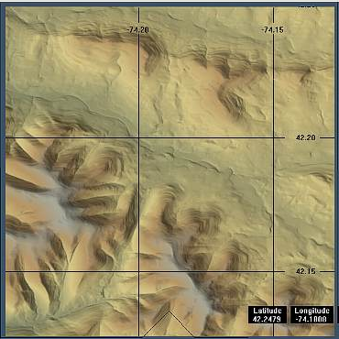

Other GeoTiff features, such as global mapping, may be added in the future.

# The task break-down and work estimation

The total work is 90 hours based on our first estimation.

## (50 hours) Import GeoTiff to HDF5 in HDFView

* (16 hours) Implement functions to retrieve tiff information (attribute and data)
* (16 hours) Implement functions to retrieve geotiff information
* (10 hours) Implement functions to add tiff/geotiff information to HDF5
* (8 hours) Add GUI components for convert geotiff to HDF5

## (32 hours) Showing GeoTiff data in HDFView

* (8 hours) Show tiff data in image
* (16 hours) Show geolocation information in grid
* (8 hours) Show Geo location values as mouse moves

## (8 hours) Updating user’s guide

# References

[1] HDF-EOS to GeoTIFF Conversion Tool (HEG)

<http://newsroom.gsfc.nasa.gov/sdptoolkit/HEG/HEGHome.html>

[2] GeoTIFF support for NASA HDF products

[http://confluence.hdfgroup.uiuc.edu/display/indproj/GeoTIFF+investigation](http://confluence.hdfgroup.uiuc.edu/display/indproj/GeoTIFF+investigation%20)

[3] HotdoG Proposal

<http://wiki.apache.org/incubator/HotdoGProposal>