Investigation on Java implementation of HDF Browser Plug-in

Below is a brief report on Java implementation of HDF Browser Plug-in. After a few days of research on this subject, it comes to the following options. None of the options seems to be a good choice.

1. Standard JDK package
There is no plugin package in the JDK because browser plugins are browser and platform dependent. In order to support plugin package, Java has to implement the native APIs to bridge the browser and Java Virtual Machine. Such APIs do not exist in the Java package and Sun has no intention to do so. I cannot see any Java Plugin examples.

2. Mozilla Pluglet
A Pluglet is a Plug-in that is written in the JavaTM programming language. At eh mozilla web site, it says “Writing a Plug-in in Java instantly makes it available on all platforms on which a Java Virtual Machine is available.” For more information about Pluglet, visit,
http://www.mozilla.org/projects/blackwood/java-plugins/

The following diagram shows how pluglets work.

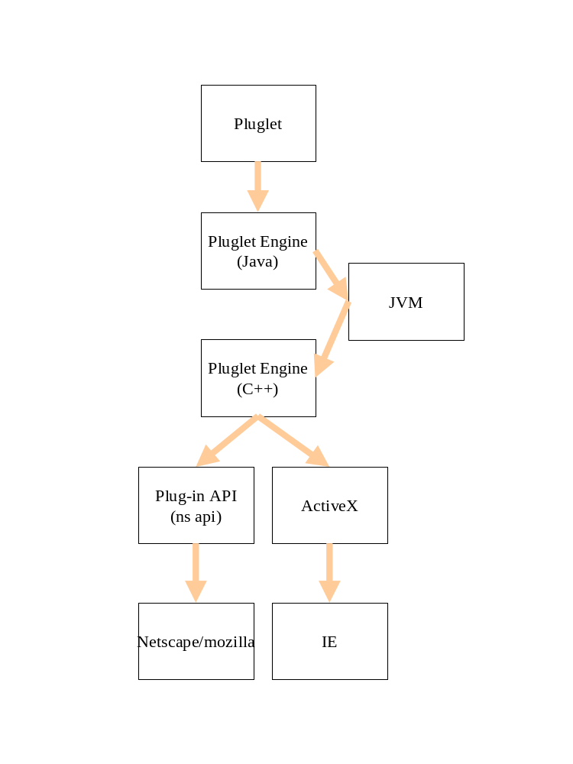

At first, I though this would what I need. I downloaded the source, and installed cgywin and tried to compile it on Windows 2000. I have no luck to successfully compile it. The package is so complex and configuration is very confusing.

The I downloaded and installed the precompiled binaries. The package comes with examples to run pluglet within mozilla. None of the example works. I tried on mozilla and IE.

Even if I can make the example work in the future, there are still two problems:

a) I still don’t know if dynamic link to hdf libraries will work on pluglet framework.
b) I still have to write the activex
c) I feel like I am repeating the HDFView work.
d) Signing and registering a pluglet is very complicated

3. Java Applet
An applet is a program written in the JavaTM programming language that can be included in an HTML page, much in the same way an image is included. When you use a Java technology-enabled browser to view a page that contains an applet, the applet's code is transferred to your system and executed by the browser's Java Virtual Machine (JVM).
1) Pluglets vs Applets: A frequently asked question is how are Pluglets different from Applets. Basically there are two differences. A Pluglet is launched when a certain Content Type is encountered, whereas an Applet is launched when an <applet> tag is encountered. The other difference is that Pluglets are installed onto disk and unlike Applets, are not downloaded at each invocation.
It is not reasonable to download the HDF plugin everytime users hit a page. With such a large size plugin, it takes too long to dowload.
2) A signed applet doe not need to be downloaded everytime. We can re-implement the HDFView to make it both as a standalone application and applet. So we do not have to support two products doing the same thing.
3) The problem with signed applet is that there is no way to launch the applet by file extension or MIME types. Have to ask the web server to register the file extension / MIME types. How about a local file ? Drag a hdf file into a browser to launch the applet will need activeX to register the applet.

4. What to do next
1) make the pluglet example work.
2) try if pluglet can load hdf libraries
3) try to figure out how to launch a signed applet by MIME type or file extension with involving server work.
4) I am still thinking of the native C++ implementation (MFC) (sleek and simple)

