Mapping HDF4 Objects to HDF5 Objects

Mike Folk, Robert E. McGrath, Kent Yang
National Center for Supercomputing Applications, University of Illinois

February, 2000

Revised: October, 2000, July 2001
Note to reader: We present here some guidelines on how to represent HDF4 objects in HDF5 and how to interpret HDF5 objects as HDF4 objects. It is meant to help in implementing software that has to deal with both formats in some consistent way, such as converting HDF4 files to HDF5, or adapting HDF4 tools to HDF5. Please send comments and corrections to hdfhelp@ncsa.uiuc.edu.

Introduction
All versions of NCSA HDF from HDF1 through HDF4 are essentially the same. The HDF4 format and library are backward compatible with all earlier versions of HDF. HDF5 is different. Although it shares many features with earlier versions of HDF and is intended for essentially the same uses, HDF5 is a completely new file format, and the NCSA HDF5 API and library are also new and entirely different.
Many applications have been written for accessing, visualizing, and otherwise dealing with HDF4 objects and files. Few have as yet been written for HDF5. A great deal of development time and expense could be saved if some HDF4 applications could be adapted for dealing with HDF5 objects. The purpose of this paper is to facilitate such adaptations by establishing standard ways to (a) represent HDF4 objects in HDF5, and (b) interpret HDF5 objects as HDF4 objects.
Case (a) assumes that an application writes an HDF5 object intending for the object to be understood as a particular HDF4 object. It may add extra attributes to the object to make it conform as fully as possible to the corresponding HDF4 data model. Case (b) assumes that the HDF5 object was not created with HDF4 in mind, but nevertheless conforms to one or more HDF4 objects. (In the context of this paper, the term "conform" means that the characteristics of the HDF5 object are such that it would be meaningful and useful to an HDF4 application. It does not mean that the HDF5 object is exactly the same as a corresponding HDF4 object would be.)
It is not our intention to map all possible HDF4 objects into HDF5, and vice versa. In section 2 we identify those HDF4 and HDF5 objects that will be mapped.
It is also not our intention to cover all possible cases for mapping HDF4 to HDF5. This is a specification of recommended default mappings only. If a different mapping is more appropriate for a particular application, then it should be used.
Section 2 describes the types of HDF4 and HDF5 objects that can be mapped, and identifies those for which mappings are not recommended.
Sections 3-5 cover case (a), how to convert HDF4 files to HDF5. Section 3 recommends ways to explicitly represent HDF4 objects in HDF5. It describes the basic mappings that are recommended, and presents a set of rules to instantiate the mappings, including metadata attributes that make an object conform as fully as possible to the corresponding HDF4 data model.
Section 4 covers issues related to overall file organization, including how to map the organization and name structure of an HDF4 file into HDF5.
Section 5 covers other considerations, such as how to deal the HDF4 reference numbers and file-level information.
Section 6 deals with case (b), how to interpret HDF5 objects as if they were HDF4 objects when there is no explicit metadata.

This document relies on a number of documents, which the reader may need to refer to for background concerning HDF4 and HDF5 datatypes. This includes the HDF4 User’s Guide, the HDF4 Specification and the HDF5 documentation cited in the reference section at the end of this document [2][3]. Also cited in the Reference section is the “HDF Configuration Record” specification [1], which provides a rigorous definition of all HDF4 objects.

HDF4 objects and HDF5 objects
The HDF4 format and library support the following eight basic objects:
- Scientific dataset (SDS), a multidimensional array with dimension scales
- 8-bit raster image (RIS8), a 2-dimensional array of 8-bit pixels
- 24-bit raster image (RIS24), a 2-dimensional array of 24-bit pixels
- General raster image (GR), a 2-dimensional array of multi-component pixels
- 8-bit color lookup table (palette), a 256 by 3 array of 8-bit integers
- Table (Vdata), a sequence of records
- Annotation, a stream of text that can be attached to any object
- Group, a structure for grouping objects
The HDF4 format also includes "primitive" objects that are used to construct these basic objects within an HDF4 file. These primitive objects are identified by "tags" within an HDF4 file. Since most HDF4 primitive objects have no counterpart in HDF5, nor are they accessed directly by most HDF4 users or applications, they will not be considered here. Exceptions to this are the HDF4 palette and annotation, which will be considered.
HDF5 includes two primary objects:
- Dataset, a multidimensional array of records
- Group, a structure for grouping objects
HDF5 objects can have “attributes", which are (usually) small, named datasets that are associated with groups or datasets. HDF5 includes other objects, such as named datatypes, but these have no counterparts in HDF4 and hence will not be considered here.

Representing HDF4 objects in HDF5
In this section we provide detailed rules for representing HDF4 objects in HDF5. All eight basic HDF4 objects can be represented in HDF5. Usually such representations require restrictions or extra metadata. In Table 1, a mapping is shown from HDF4 objects to their HDF5 counterparts.
Table 1. Representing HDF4 objects in HDF5.
HDF4 object | Corres-ponding HDF5 object | Restrictions
SDS | Dataset | HDF4 DIMENSIONLIST becomes an HDF5 attribute, if it exists. HDF4 dimension scales become HDF5 datasets. Only the first dimension can be unlimited. Not all HDF4 storage properties are supported.
Image | Dataset | The HDF5 dataset must conform to the HDF5 Image and palette Specification, Version 1.2 [4]. If the number of pixel components is 1, the dataset is a 2-dimesional with an HDF5 scalar (numeric) datatype. If the number of components is more than one, the dataset is 3-dimensional. Pixel or plane interlace may be used, indicated by an attribute. If a palette is present, HDF5 attributes are used to indicate this. Not all HDF4 storage properties are supported.
Palette | Dataset | The HDF5 dataset must be a 256 by 3 array of 8-bit integers. HDF5 attributes describe this dataset as a standard 8-bit palette.
Vdata (table) | Dataset | The HDF5 dataset must be 1-dimensonal, with a compound datatype equivalent to corresponding HDF4 field and record structure. Non-interleaved fields are not permitted in HDF5. (This last restriction could be lifted if a structure is created to store fields as separate datasets.)
Annotation | Attribute | HDF4 file annotations are attributes of the HDF5 root group. HDF4 object annotations are attributes of the corresponding HDF5 object. Only annotations on the HDF4 objects listed here are supported.
Vgroup | Group

As indicated in Table 1, in all cases except Vgroups and annotations HDF4 objects are mapped to HDF5 datasets with simple dataspaces. Vgroups are mapped to HDF5 groups, and annotations are mapped to HDF5 attributes. In the tables that follow we identify all components of an HDF4 object that an application is likely to use, and map it to a corresponding HDF5 component. This mapping includes only persistent objects and components. Items that are available only when accessing HDF4 files (e.g. file id and object index) are omitted.
All of the HDF5 objects except annotations have the following two optional attributes: HDF4_OBJECT_TYPE and HDF4_REF_NUM. HDF4_OBJECT_TYPE can be used to tell applications that the object is compatible with an HDF4 object. HDF4_REF_NUM is available for those applications that use reference numbers as identifiers for HDF4 objects.
The mapping tables. In the following sub-sections, each of the six mappings from table 1 is described in detail with a table containing five columns:
- Column 1: a flag indicating whether the object is required ("R”) in HDF5 in order for the object to conform to the corresponding HDF4 object. "O" (optional) means that it is not required.
- Column 2: components from HDF4 that are to be mapped to HDF5. Items with HDF4 names are in bold caps. Items in parentheses refer to information that is needed in the HDF5 version but do not have an HDF4 counterpart.
- Column 3: the HDF5 object that is mapped to.
- Column 4: information about the datatype, value, etc. of the HDF5 object.
- Column 5: additional information on how to perform the mapping.
The HCR definition of HDF4 was used to identify the HDF4 items that are to be mapped [1]. In the tables, we have tried to used the HCR terminology whenever possible. For instance, in column 2, DATATYPE refers to an HDF4 datatype. Non-terminals are shown in angle brackets (e.g. <name>). Most non-terminals are defined in the HCR documentation. Others that are used are:
- <string>: any legal quoted string
- <name>: any valid name
- <value>: any valid scalar value
- <HDF4 datatype>: any valid HDF4 datatype.
- <uint16>: a value of type DFNT_UINT16

SDS
The SDS mapping requires two types of HDF5 dataset, one for the SDS array and one for dimension scales. For each dimension, the creator of the HDF5 "SDS" must create a corresponding dimension dataset with a unique name. In the HDF5 "SDS" an attribute "DIMENSIONLIST" is created consisting of pointers to each of the respective dimension datasets and an attribute “DIMENSION_NAMELIST” with the full paths of the HDF5 dimension datasets.
Table 2. SDS mapping
 | HDF4 object | HDF5  object or component | Datatype, value, etc. | Notes
R | <SDSArray> | Dataset |  | Objects with unlimited dimensions are stored using chunked storage.
O | <SDS Dimension with Name> | Dataset |  | (See note 1)
O | (HDF4 object type) | Attr | HDF4_OBJECT_TYPE = "SDS"

 | <SDSArray>
R | NAME | Attr | HDF4_OBJECT_NAME = <SDSArrayName> | See Section 4 for details on how NAME is used as a link in HDF5.
R | DATATYPE | Datatype | <HDF4 datatype>
R | DIMENSIONRANK & DIMENSIONSIZE | Dataspace |  | Dimension sizes are also part of dimension information. See also section 5.4.
R | DIMENSIONLIST | Attr | DIMENSIONLIST = {object__ref1, object__ref2, … object__refn} | An array of object references that refer to the corresponding dimension datasets. See note 1.
R | DIMENSION_NAMELIST | Attr | DIMENSION_NAMELIST = {<DimName1, <DimName2>, …,<DimNameN>} | The absolute paths of dimensions are stored. Dimension names are defined in the HCR specification. See note 1.
R | (Data) | Data |  | See section 5.4 for details on how to handle datatypes.
O | <User-defined attribute > | Attr |  | rank = 1; size is fixed. Global attributes: see note 2.
O | <SDS pre-defined attribute > | Attr
O | (Reference number) | Attr | HDF4_REF_NUM = <uint16>
O | (Storage properties)
O | Compression property | Storage prop |  | Use if supported in HDF5.
O | Chunk property | Storage prop |  | Use if supported in HDF5.
O | External storage | Storage prop |  | Use if supported in HDF5.

O | <User-defined attribute > | Attr | <name> = <value>* | rank = 1; size is fixed. Global attributes are convered below .
R | NAME | Attr name | <AttributeName>
R | DATATYPE | Datatype | <Attributetype>
R | N_VALUES | Num-values | <AttributeCount>
R | DATA | Data | <AttributeData>

O | <SDS pre-defined attribute > |  |  | Same names, datatypes, etc., as the hdf4 counterpart
O | LONGNAME | Attr | .
O | UNIT | Attr
O | FORMAT | Attr
O | COORDINATE_SYSTEM | Attr
O | RANGE | Attr
O | FILL_VALUE | Attr | Set the fill value property to <FillValue> | See note 3.
O | SCALE_FACTOR | Attr
O | SCALE_FACTOR_ERROR | Attr
O | ADD_OFFSET | Attr
O | ADD_OFFSET_ERROR | Attr
O | CALIBRATED_NT | Attr

 | <SDS Dimension with Name> | Dataset
R | NAME | Name | <name> | See note 2.
R | SIZE | Dataspace |  | rank=1. Only the first dimension can be unlimited.
R | DATATYPE | Datatype | <HDF4 datatype>
R | DATA | Data | <value>*
O | <Dimension pre-defined attribute> |  |  | These are dimensions of an <SDS dimension with Name> dataset, not an SDS dataset
O | LONGNAME | Attr
O | UNIT | Attr
O | FORMAT | Attr
O | <User-defined attribute> | Attr |  | Defined above.

Note 1. Dimension scales are to be stored in HDF5 as separate datasets. Hence, all of the information in this category is stored as part of the corresponding HDF5 dimension scale dataset. See section 3.1.1. for a detailed explanation.
Note 2. Global SDS attributes should be stored as attributes to the HDF5 root group.
Note 3. It is “semantically correct” to write out all the values of a HDF5 dataset, even if they were fill-values not stored in the HDF4 file. This will make the stored file much larger than the HDF4 file. For efficiency, it is recommended that fill values be used in HDF5 whenever they are used in HDF4. See section 3.1.1 for a detailed explanation.

SDS global attributes
A special case is the SDS global attribute, which is an attribute that applies to all of the SDS in a file. An SDS global attribute is to be stored in HDF5 as an attribute on the root group with the suffix “GLO_SDS.” Other than these differences, an SDS global attribute is treated the same as a normal SDS attribute.
Table 3. SDS global attribute mapping
 | <SDS global attribute> |  |  | Attribute assigned to the root group.
R | NAME | Attr name | <AttributeName>_GLO_SDS
R | DATATYPE | Datatype | <Attributetype>
R | N_VALUES | Num-values | <AttributeCount>
R | DATA | Data | <AttributeData>

3.1.1. Storage of SDS as an HDF5 Dataset
SDS Dimensions and the HDF5 Dataspace
The dataspace for the HDF5 dataset should be constructed with dimensions that correspond to the dimensions of the SDS in HDF4, as reported by Sdgetinfo(). The last dimension is the fastest changing dimension in both cases. Figure 1 shows an exaple of C code to read the dimensions of an HDF4 SDS and create the correct HDF5 dataspace. It is important to note that the correct mapping for images is not simply a copy of the dimensions. See section 3.4 below.
Figure 1. Example code to create an HDF5 dataspace for and HDF5 SDS.
int data[X][Y]; /* Y is the fastest changing dimension /
SDgetinfo(..., dims[], ...); /* dims[0] == X; dims[1] == Y; */

/* To create the correct HDF5 data set, declare the data space as follows,
using the values of ‘dims’ returned above */
H5Screate_simple(...,dims[], ..);

Dimension Scales
Dimension scales are unique to the HDF4 file—no two dimension scales can have the same name in HDF4. In HDF5, all of the dimension scales are stored in the group called “/HDF4_DIMGROUP”. Dimension names are <DimName1>, <DimName2>, …,<DimNameN> as defined in HCR. Dimension scale datasets are identified in the HDF5 SDS dataset in two ways: by the attribute DIMENSIONLIST, and by the attribute DIMENSION_NAMELIST. The attribute DIMENSIONLIST is an array of object references to the dimension scale datasets DIMENSION_NAMELIST is an array containing the names of the dimension scale datasets. Figure 2 illustrates this structure. In the figure there are two two-dimensional datasets, sd1 and sd2, each of which has two dimension scales. The datasets share the dimension scale dimB.
Important note: a formal specification of HDF5 Dimension Scales is under consideration. This specification may change in the future to align with HDF5 Dimension Scales.

Figure 2. How HDF4 dimension Scales should be stored in HDF5.
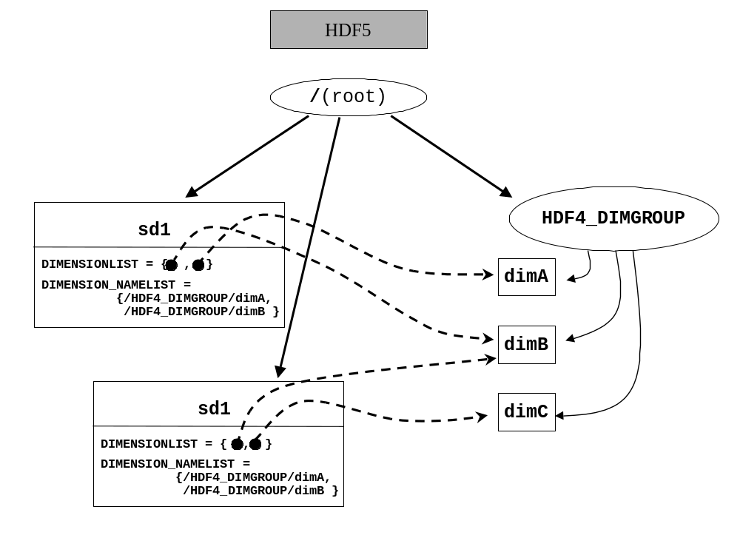
Unintialized Data
In general, all data from an SDS should be written to the HDF5 dataset. If an SDS has no data in it, or only part of the data has been written, then the HDF5 dataset may optionally contain only the data actually written to the SDS. Data from the SDS that was never written will be read as fill values. In all cases, it is correct to write all the data values to the HDF5 file including the fill values. This can result in the HDF5 dataset using much more storage than the HDF4 SDS, because fill values are unneccesarily written to the file. For this reason, it is recommended that data that was not written to the SDS (i.e., fill values) should not be written to the HDF5 dataset if it can be avoided.
If the HDF4 SDS was created but has never had any data written, the HDF5 dataset may be created with no data.
If the HDF4 SDS is chunked and some of the chunks have never been written, only the chunks that have been written need to be written to the HDF5 dataset. Chunks that have never been written (and would be entirely filled with fill values) may be written to the HDF5 dataset, or may be left empty.
However, in all cases it is correct to write all the data values to the HDF5 file including fill values.
SDS Storage Properties
In general, the HDF5 dataset is correct if it contains all the correct data values from the HDF4 SDS. However, if chunking and compression are used in HDF4 and not in HDF5, the HDF5 dataset may use much more storage and perform much poorer than the HDF4 SDS. For these reasons, the HDF5 dataset should use storage properties analogous to the HDF4 SDS, when possible.
The follow rules are recommended:
- If the HDF4 SDS is chunked, the HDF5 dataset should be chunked with the same chunk sizes
- If the HDF4 SDS is compressed, the HDF5 dataset should be compressed with the same compression method, if available.
- If the HDF4 SDS is compressed by any method not available with HDF5, the HDF5 dataset should be compressed with GZIP.
If the HDF4 SDS is compressed but not chunked, the HDF5 dataset should be “chunked” with the chunksize equal to the entire datase, and the HDF5 dataset should be compressed.
Table 4. Recommended conversion of chunking and compression
HDF4 | HDF5
No chunking, No compression | No chunking, No compression
Chunking, No compression | Same chunking, no compression
Chunking, compression  - GZIP compression  - Other compression | Same chunking, same compression if available.  - GZIP  - GZIP
No chunking, compression  - GZIP  - Other compression | Chunk with chunk size = whole dataset, same compression if available.  - GZIP  - GZIP

Vdata
Vdatas are mapped to one dimensional extendable HDF5 datasets of compound datatype.
Table 5. Vdata mapping
 | Vdata | HDF5 object or component | Datatype, value, etc. | Notes
R | NAME | Attr | HDF4_OBJECT_NAME = <string> | <string> is the same as the corresponding Vdata name
R | CLASS | Attr | HDF4_VDATA_CLASS = <string>
O | INTERLACEMODE | NA |  | Full interlace always used in HDF5 version.
R | (Number of records) | Dataspace |  | Rank=1, curr_size = the number of records, maximum size=unlimited.
R | (Record) | Compound datatype
R | (Field) | Member |  | Compound datatype member
R | NAME | Field name | <name>
R | DATATYPE | Field datatype | <HDF4 datatype>
R | ORDER | Num-values
O | <User-defined attribute> | Attr | <FieldName>:<name> = <value> | <FieldName> is value of NAME for the field.
R | (Data) | Data
O | <User-defined attribute > | Attr | <name> = <value> | rank = 1; size is fixed;
O | (HDF4 object type) | Attr | HDF4_OBJECT_TYPE = "Vdata"
O | (Reference number) | Attr | HDF4_REF_NUM = <uint16>
O | (External storage) | Storage prop

Vgroup
Vgroups are mapped individually to HDF5 groups. See section 4 for details on how to deal with the graph structures defined by the collection of Vgroups within an HDF4 file.
Table 6. Vgroup mapping.
 | Vgroup | HDF5 object or component | Datatype, value, etc. | Notes
R | NAME | Attr | HDF4_OBJECT_NAME = <string> | <string> is the same as a normal Vgroup name
O | CLASS | Attr | HDF4_VGROUP_CLASS = <string>
R | <Vgroup member> | Group member |  | HDF5 hard link
O | (HDF4 object type) | Attr | HDF4_OBJECT_TYPE="Vgroup"
O | <User-defined attribute> | Attr | <name> = <value> | rank = 1; size is fixed;
O | (Reference number) | Attr | REF_NUM = <uint16>

Note: HCR defines three additional items: MEMBERTYPE, MEMBERNAME, and PALETTEINDEX. MEMBERTYPE and MEMBERNAME correspond to the HDF4_OBJECT_TYPE and HDF4_OBJECT_NAME of the member object. The PALETTEINDEX would be awkward to represent these in HDF5 groups, and hence they have been omitted. If it is found that they are needed, they will be added later.

Raster images
Raster images (8-bit, 24-bit, and general raster (GR)) are mapped to HDF5 datasets that conform to the HDF5 Image and Palette Specification [4]. For 8-bit and GR images with one component, the HDF5 dataset is two-dimensional, and the elements are scalar (numeric) data types.
For 24-bit and GR images with more than one component, the HDF5 dataset is three-dimensional, with one of the dimensions for the components. The components are either the fastest changing dimension (pixel interlace) or the slowest changing dimension (plane interlace). The layout of the data is specified by the INTERLACE_MODE attribute. It is recommened that an HDF4 image that is stored as pixel interlace should be stored PIXEL_INTERLACE in HDF5, and HDF4 plane interlace should be stored as PLANE_INTERFACE in HDF5. However, implementations may choose whichever arrangement, so long as the data is stored correctly in HDF5. An HDF4 image stored as line interlace must be stored as either pixel or plane interlace.
All attributes required by the HDF5 Image and Palette Specification [4] should be included, even if not specified here. Notice that the HDF5 image conventions support additional information that is not supported in HDF4, such as image transparency.

Table 7. Raster image mapping.
 | Image | HDF5 object or component | Datatype, value, etc. | Notes
R | NAME | Attr | HDF4_OBJECT_NAME = <string> | <name> is the same as a GR name
R | (Pixel type) | Datatype |  | Atomic (numeric)
R | N_COMPS | Num values |  | order of the third dimension, if N_COMPS > 1
R | COMP_TYPE | Atomic type | <HDF4 datatype>
R | DIMENSIONSIZE | Dataspace |  | If N_COMPS = 1, rank=2. If N_COMPS > 1, rank = 3. Two dimensions are the height and width, the third dimesion is the pixel components. See also note 1.
R | (image array) | data
R¹ | INTERLACE_MODE | Attr | INTERLACE_MODE=  “PIXEL_INTERLACE” or “PLANE_INTERLACE” | Required if N_COMPS > 1. PIXEL_INTERLACE indicates the pixel components are the fastest changing dimension, PLANE_INTERLACE indicates the pixels are the slowest changing dimension.
O | <User-defined attribute> | Attr | <name> = <value> | rank = 1; size is fixed;
R | (Class) | Attr | CLASS = "IMAGE" | Required by HDF5 image spec.
O | (HDF4 object type) | Attr | HDF4_OBJECT_TYPE = "raster8", "raster24" or "GR"
O | (Reference number) | Attr | HDF4_REF_NUM = <uint16>
R² | <Image palette> |  | PALETTE =  {object__ref1, object__ref2, … object__refn} | PALETTE is an array of object references that refers to the corresponding palettes. See notes 2 and 3.
R² | (palette namelist) | Attr | PALETTE_NAMELIST = {palette_name1, palette_name2, …} | A list of the full path names of the HDF5 Palette datasets.
R² | (Image subclass) | Attr | IMAGE_SUBCLASS = "IMAGE_INDEXED" | See note 3.
O | (Storage properties)
O | Compression | Storage prop |  | If supported in HDF5. JPEG and RLE are not supported in HDF5.
O | Chunking | Storage prop
O | External storage | Storage prop

Note 1. Required if N_COMP > 1. Optional if N_COMP == 1.
Note 2. These are required if there is a palette associated with the image.
Note 3. In HDF5 there can be more than one palette in PALETTELIST, but in a translation from HDF4 to HDF5 there will be only one palette. In HDF5, palettes are stored in a special group called “/HDF4_PALGROUP”. Figure 2 illustrates this structure. In the figure there are two images, image1 and image2, each of which has an attached palette.
Figure 3. How HDF4 palettes should be stored in HDF5 and referenced by images.

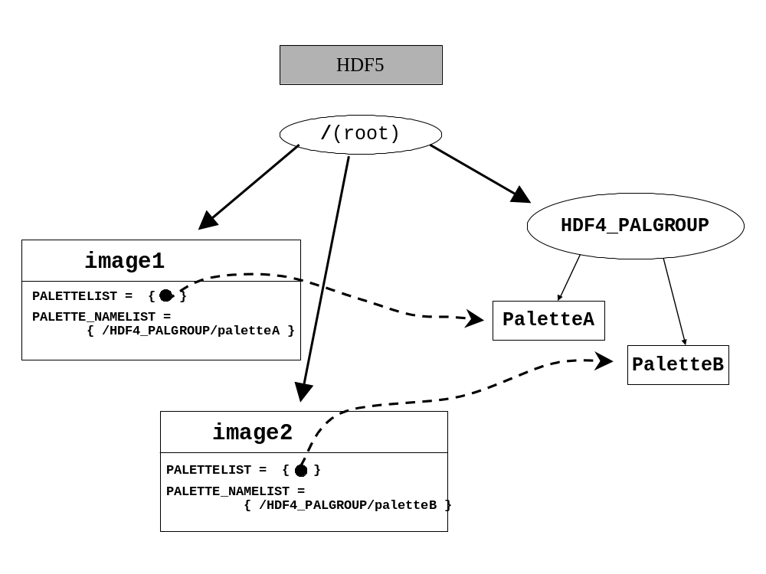
GR global attributes
A special case is the GR global attribute, which is an attribute that applies to all of the GR in a file. A GR global attribute is to be stored in HDF5 as an attribute on the root group with the suffix “GLO_GR.” Other than these differences, a GR global attribute is treated the same as a normal GR attribute.

3.4.1. Storage of GR images in HDF5
RI and GR Dimensions and the HDF5 Dataspace
For images with one component, the dataspace for the HDF5 dataset should be constructed with dimensions that correspond to the actual stored dimensions of the RI or GR in HDF4, which is the same order for all HDF5 datasets, including those converted from HDF4 SDSs. The last dimension is the fastest changing dimension in both cases. It is very important to note that the correct order for HDF5 is not the order of dimenstions reported by the DFR8getdims() or GRgetiminfo(). Figure 4 and Figure 5 show C code to read HDF5 RI and GR image dimensions and create the correct HDF5 dataspace.
Also note that the HDF4 calls SDgetinfo() and Grgetiminfo() calls look similar, but the dimensions returned must be used differnetly. See section 3.1 above.
Figure 4. HDF5 dataspace for an RI image.
int dims[2];
int width; /* the fastest changing dimension */
int height;
DFR8getdims(…, &width, &height, …) ;
dims[0] = height;
dims[1] = width; /* NOTE: width is the fastest changing dimension,
the second dimension */
/* To create the correct HDF5 data set, declare the data space as follows, using the values of ‘dims’ in the correct order */
H5Screate_simple(...,dims[], ..);

Figure 5. HDF5 dataspace for a GR image.
int h4dims[2];
GRgetiminfo(..., h4dims[], ...); /* h4dims[0] == ht; h4dims[1] == wid; */
/* To create the correct HDF5 data set, declare the data space as follows, using the values of ‘dims’ in the correct order */
dims[0] = h4dims[1];
dims[1] = h4dims[0]
H5Screate_simple(...,dims[], ..);

For images with more than one component (e.g., RI24 images), the HDF5 Dataset has a dataspace with three dimensions, height, width, and pixels. The height and width should be in the same relative order as for the two-dimensional case above. The pixel components will be either the first or third dimension, depending on the interleave. For INTERLACE_PIXEL, the pixels will be the third (fastest changing) dimension; for INTERLACE_PLANE, the pixels will be the first (slowest changing) dimension.
Table 8. Correct order of dimensions for a multi-component image.
Pixel Interlace | Plane Interlace
[height][width][ncomps] | [ncomps][height][width]

Note that images with one component can be conceived as a either two-dimensional or three-dimensional dataspace, with the ncomps = 1.
GR Storage Properties
In general, the HDF5 dataset is correct if it contains all the correct data values from the HDF4 GR image. However, if chunking and compression are used in HDF4 and not in HDF5, the HDF5 dataset may use much more storage and perform much poorer than the HDF4 GR. For these reasons, the HDF5 dataset should use storage properties analogous to the HDF4 GR.
The follow rules are recommended:
- If the HDF4 GR is chunked, the HDF5 dataset should be chunked with the same chunk sizes
- If the HDF4 GR is compressed, the HDF5 dataset should be compressed with the same compression method, if available.
- If the HDF4 GR is compressed by any method not available with HDF5, the HDF5 dataset should be compressed with GZIP.
If the HDF4 GR is compressed but not chunked, the HDF5 dataset should be “chunked” with the chunksize equal to the entire dataset. The HDF5 dataset should be compressed.
Table 9. Recommended conversion of chunking and compression
HDF4 storage | HDF5 storage
No chunking, No compression | No chunking, No compression
Chunking, No compression | Same chunking, no compression
Chunking, compression  - GZIP compression  - Other compression | Same chunking, same compression if available.  - GZIP  - GZIP
No chunking, compression  - GZIP  - Other compression | Chunk with chunk size = whole dataset, same compression if available.  - GZIP  - GZIP

Palette
Palettes are mapped to HDF5 datasets that are 2-D arrays of bytes with dimensions 256 x 3. The HDF5 Palette should conform to the HDF5 Image and Palette Specification.[4] All attributes required by the Palette Specification should be included, even if not specified here. Notice that the HDF5 palette conventions support additional information that is not supported in HDF4, such as color model and range index.
As indicated in section 3.4, it is recommended that in HDF5 all palette objects from an HDF4 file be stored in the group “/HDF4_PALGROUP/<palette_name>.” The HDF5 link <palette_name> can be given any name, but if no name is available <palette_name> should be assigned according to the guidelines in section 4.
Table 10. Palette mapping.
 | Palette | HDF5 object or component | Datatype, value, etc. | Notes
R | (Datatype) | Atomic datatype | <uint8>
R | (Data) | Data
R | (Rank & dimension sizes) | Dataspace |  | rank=2, dimension size = 256x3 (See note 1, and section 5.4)
O | (HDF4 object type) | Attr | HDF4_OBJECT_TYPE="palette"
O | <User-defined attribute> | Attr | <name> = <value> | rank = 1; size is fixed;
O | (Reference number) | Attr | HDF4_REF_NUM = <uint16>
R | (Class) | Attr | CLASS = "PALETTE"
R | (Palette type) | Attr | PAL_TYPE = "STANDARD8"
Note 1: The HDF5 palette specification requires that a palette dataset have dimensions (nentries by ncomponents), where 'nentries' is the number of colors (in this case 256) and 'ncomponents' is the number of values per color (in this case 3).

Annotation
Annotations are mapped to HDF5 attributes. There are four kinds of HDF4 annotations: file labels and descriptions, and object labels and descriptions. File annotations will be attributes of the root group. Although object annotations can be associated with any tag/ref supported by HDF4, this specification supports only object annotations that are associated with HDF4 SDS, Vgroups, Vdatas, images, and palettes. Annotations will have the following HDF5 attribute names: FILE_LABEL<n>, FILE_DESCRIPTION<n>, OBJECT_LABEL<n>, OBJECT_DESCRIPTION<n>, where <n> is an integer used to distinguish one annotation from another. For instance, if an object had two object labels, the corresponding attribute names would be OBJECT_LABEL1 and OBJECT_LABEL2. Table 11 summarizes these guidelines.
Table 11. Annotation mapping.
 | Annotation | HDF5 object or component | Datatype, value, etc. | Notes
R | (File label) | Attr | FILE_LABEL<n>  = <string> | Root group attribute.
R | (File description) | Attr | FILE_DESCRIPTION<n> = <string> | Root group attribute.
R | (Object label) | Attr | OBJECT_LABEL<n> = <string> | Attribute for corresponding HDF5 object. (See note 1.)
R | (Object description) | Attr | OBJECT_DESCRIPTION<n>  = <string> | Attribute for corresponding HDF5 object. (See note 1.)

Note 1. Although any HDF4 object that can be represented by a tag can have associated object labels and descriptions, this specification only requires that annotations be converted for the following tags:
- SDS-related tags DFTAG_SD, DFTAG_SDG, DFTAG_NDG
- Image-related tags DFTAG_RI, DFTAG_RI8, DFTAG_RIG
- Vgroup tag DFTAG_VG
- Vdata-related tags DFTAG_VH, DFTAG_VS
- Palette tag DFTAG_LUT

HDF4 and HDF5 File Organization

In addition to mapping individual objects, it is necessary to map the organization and name structure of the HDF4 file to the HDF5 file. The following guidelines are covered in this section:
- Object names should be translated in a standard way. Objects that have no name in HDF4 (such as palettes) must be assigned a default name in the HDF5 file. If two or more HDF4 objects have the same name, they must be assigned unique names in HDF5.
- The hierarchical structure of the HDF4 file should be accurately reproduced in the HDF5 file, but objects used internally by the HDF4 library (e.g., “CDF0.0”) should not be represented in the HDF5 file.
- Shared objects (such as Named Dimensions) should be stored once and shared in the HDF5 file.

Object Names
The treatment of object names in HDF 4 (and earlier versions) varies depending on the type of object. The HDF4 User’s Guide provides details on naming HDF objects. In summary:
- Palettes and annotations do not have names.
- Vgroup and Vdata names are optional.
- Images may or may not be assigned names, depending on the version of the library, and in any case are optional.
- SDS objects are treated differently by different versions of the library. Early versions of the HDF library (before HDF 3.2) did not require an SDS to have a name, and they allowed two or more SDSs to have the same name. In later versions every SDS was required to have a unique name, and in addition it was possible to assign a second name, called LONGNAME, that did not have to be unique.
- Objects of different classes may have the same name. For example, there might be a Vgroup named “DATA” and also an SDS with name “DATA”.

Hence, in HDF4, names may occur in a variety of ways:
- An HDF4 object may have a unique name
- An HDF4 object may have no name
- More than one HDF4 object may have the same name

For the purposes of this paper, we can think of the name of an object in HDF4 (if one exists) as a kind of object attribute. It may not be stored specifically as an attribute, but it nevertheless plays a similar role. We refer to this as NAME in this paper.
In HDF5, the name of an object is the final component of its path within the file. For instance, if an HDF5 object has the path /foo/bar, its HDF5 name is “bar.”

Objects with unique names
In general, if an HDF4 object has a unique NAME attribute, the corresponding HDF5 object’s path should use that name. In addition, as the tables in Section 3 indicate, that same name can be stored as an attribute of the HDF5 object with the name “HDF4_OBJECT_NAME.”

Objects with no name
When an HDF4 object with no name must be stored in HDF5, it can be assigned either a default name, or a name provided by an application. A default name should be constructed from a default string with the object’s reference number concatenated on the end. For instance, an unnamed Vgroup whose reference number is 2 would be named HDF4_VGROUP_2. Table 12 shows templates for the default HDF5 names for HDF4 objects.
Table 12. Default HDF5 names for HDF4 objects.
HDF4 Object Type | HDF5 Object Name
Vgroup | HDF4_VGROUP_<ref>
Vdata | HDF4_VDATA_<ref>
SDS | HDF4_SDS_<ref>
Image | HDF4_IMAGE_<ref>
Palette | HDF4_PALETTE_<ref>

Name Collisions
When two HDF4 objects have the same name and will be written to the same HDF5 group, it is necessary to change the pathname of one or both of the objects. For instance, suppose two HDF4 SDSs have the name “mouse”, and both belong to the top-level Vgroup “cat.” Using the rule suggested in section 4.1.1, these would both be stored as HDF5 datasets with the path “/cat/mouse.” Since no two objects in HDF5 can have the same path, it is necessary to change the pathname of one or both of these datasets. The following rules are used for dealing with this situation.
When there is a name collision, applications are free to change the names to anything they like. If no name is assigned, then all but one of the colligind objects in the HDF5 file should be given a default name, using the templates in Table 12.
Notice that the original non-unique HDF4 name can still be stored in the attribute HDF_OBJECT_NAME associated with the corresponding HDF5 object.

Organization of the HDF4 and HDF5 Files
The grouping structure of an HDF4 file should be represented in the corresponding HDF5 file, but with some exceptions, as described here.
In general, a user-defined HDF4 Vgroup should be mapped to an HDF5 Group with a corresponding path name. Lone Vgroups should be children of the HDF5 root group.
HDF4 grouping structures.
An HDF4 file can consist of a set of individual objects, but it may also be organized as a directed graph, with Vgroups as nodes and any HDF4 objects as nodes. Any HDF4 object may be a child of no Vgroup, one Vgroup, or more than one Vgroup. Since HDF5 can also be organized as a directed graph (using the HDF5 group structure), a mapping from HDF4 to HDF5 should replicate the graph structure as much as possible. Hence, as a general rule, HDF4 objects that are members of a Vgroup are stored as children of a corresponding HDF5 Group.
One difference between HDF4 and HDF5 is that there is always at least one group in HDF5, the root group, and all objects must be descendants of the root group. For purposes of the HDF4-to-HDF5 mapping, the root group in HDF5 can be thought of as the same as an HDF4 file. Hence, HDF4 objects that are not members of a Vgroup should be stored as children of the root group in the HDF5 file.
A special case of the HDF4 grouping structure that requires attention is a cyclic structure, where the links between groups form a cycle. In this case there is no “top” group, and hence no obvious rule for which group should be assigned to the HDF5 root group. The rule proposed for handling this situation is to arbitrarily choose any vgroup in the ring and place it under root group. That is, when Vgroups form a cycle, the cycle of groups should be converted into HDF5 by arbitrarily choosing any vgroup in the cycle and placing it under the root group.
An HDF4 file that contains SDS or GR objects is likely to contain extra Vgroups that were not defined by the application. These are special Vgroups and other structures used by the HDF library to organize the SDS and GR objects. These extra objects are hidden from the SDS and GR API, and are used only to help describe the internal organization of the HDF4 file. For example, Vgroups of class “CDF0.0” and “RI0.0” contain all of the SDSs and GRs in an HDF file, together with global SDS attributes and global GR attributes, respectively. Since these internal objects are not needed to describe HDF4 objects in HDF5, they should be ignored in the conversion process.
Figure 6 provides examples of how some of these structures occur in an HDF4 file:
- The normal Vgroups VgroupA and VGBa2 both contain the dataset SDS1. That relationship is replicated in the HDF5 file.
- The Vgroups CDF0.0 and RI0.0 are written by the HDF4 library, as a way of organizing the HDF4 file. If an application accesses the file using the SD or GR interfaces, the application never sees these two groups, and consequently they should be ignored in any conversion to HDF5.
- In the figure there is a Vgroup cycle between VgroupB and VGBa. When converting to HDF5, one of the groups in the cycle is attached to the root, in this case Vgroup B.

Figure 7 shows how the file in Figure 6 would look in HDF5 using these conventions.
Figure 6. HDF4 example, showing special internal groups (CDF0.0 and RI0.0), and cyclic grouping structure.
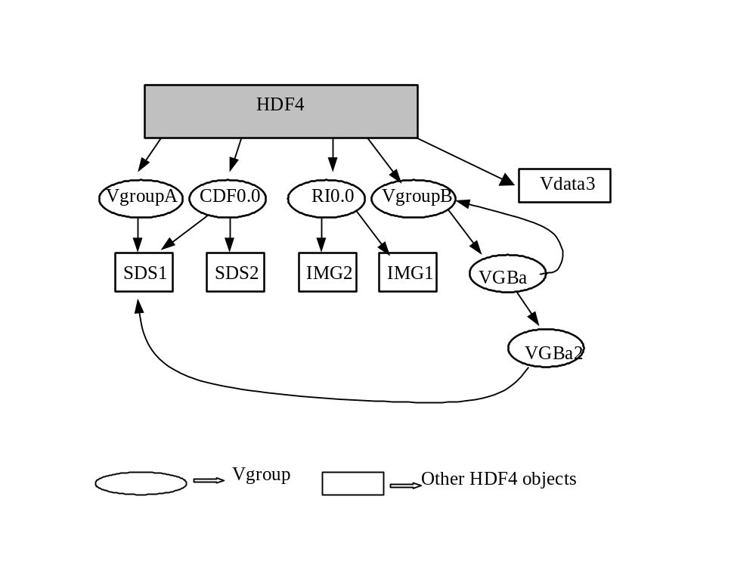
Figure 7. Illustrative Example of HDF5 Structure
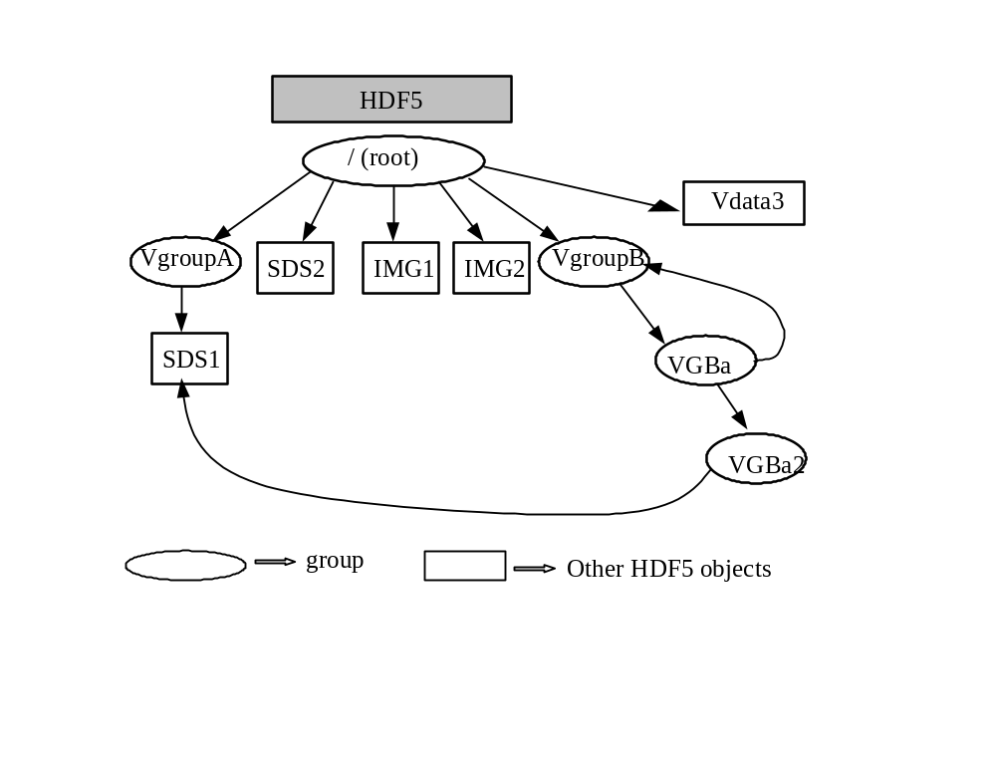

Shared HDF4 objects: dimensions and palettes
Dimension scales (coordinate variables) and palettes can be shared in HDF4. The following rules apply to storing these objects in HDF5.
- Two extra Groups are added to the HDF5 root group: “HDF4_DIMGROUP” and “HDF4_PALGROUP”. These groups are used to store the HDF5 datasets constructed for HDF4 Named Dimension Scales and Palettes, respectively. These objects are globally unique to the HDF4 file, so one copy of each object is stored in the respective group.
- Attributes that are global attributes of the SDS and GR interfaces are stored as attributes of the HDF5 root group.

See Section e.1 and 3.4 for more details of how these objects should be stored.

Other considerations
Most applications that deal with HDF4 files deal with the eight basic objects, but there is other information that sometimes must be considered.

Dealing with HDF4 reference numbers
Reference numbers should not, in general, be used by applications as identifiers for HDF4 objects. Nevertheless, since some applications use reference numbers in this way, it would be useful to have an unambiguous way to store equivalent identifiers with HDF5 objects. Hence, if an application must use a reference number in connection with an HDF5 object we propose using an attribute "REF_NUM" whose type is unsigned 16-bit integer to indicate that the corresponding object is to be interpreted as having the given reference number. It is the responsibility of the application to provide a method of assigning valid values for such reference numbers.

File-level information
HDF4 and HDF5 both have certain file-level information. This includes information that is stored in the file, such as version number, and information about the file, such as its size. It is recommended that the following types of file characteristics be treated as indicated:
- Version number: the library version number of the HDF5 file should be ignored.
- File size: HDF5 files that are larger than 2^31-1 cannot be fully represented in HDF4. It is the responsibility of the application to decide how to deal with HDF5 files that are larger than 2^31-1.
- HDF5 user-defined header: to be treated as an HDF4 file description.
- HDF5 offset datatype and other datatypes: should be ignored.

Storage properties
When translating an HDF4 object to HDF5, it may be possible to determine certain storage properties used for storing the HDF4 object. For example, valid storage properties for an SDS are compression, chunking, and external storage. If special storage properties are used in HDF4, and if those storage properties are available in HDF5, then they should be used to store the corresponding HDF5 object. For instance, if an HDF4 SDS is chunked, then the corresponding HDF5 datasets should be chunked in the same way. If it is not possible to determine an HDF4 storage property, then the HDF5 dataset can be stored without applying that property. See section 3.1.1 for details.

Dataspaces
The HDF5 “dataspace” concept generalizes and formalizes the ideas of dimensionality that are implicit in HDF4 objects. Determining the appropriate dataspace of the HDF5 object is straightforward. This mapping was given for each object in Section 2, and is summarized in Table 13.

Table 13. Summary of HDF5 dataspaces for HDF4 objects.
HDF4 Object | HDF5 Dataset | Notes
SDS: rank, dimensions | Simple dataspace, rank, dimensions. maxdims[0] = H5S_UNLIMITED or  maxdims[0] = dimsizes[0] | The first dimension of the HDF4 SDS may be UNLIMITED. In this case, the first dimension of the HDF5 dataspace would then have maxdims = H5S_UNLIMITED
GR, RI8, RI24 | Simple dataspace, rank = 2, dimensions = dimsizes | The HDF5 dimensions should be the reverse of the dimensions returned by the GR interface. See section 3.4.
Palette | Simple dataspace, rank = 2, dimensions= {256, 3}
Vdata | Simple dataspace, rank = 1, dimension = H5S_UNLIMITED or dimension = <maximum records> | Datatype is compound.

Datatypes
When converting SDSs, Vdatas, and images from HDF4 files to HDF5 files, the HDF4 data elements need to be converted to appropriate corresponding HDF5 data types. The following rules describe how HDF4 datatypes should be converted to HDF5:
5.5.1. “Standard” numeric datatypes. HDF4 standard integer and floating point datatypes should be converted to corresponding HDF5 datatypes. The size, type (integer vs. float), “endianness,” etc., should be maintained. Table 14 describes the correspondence between standard HDF4 type definitions and HDF5 type definitions.
Table 14. Correspondence between standard numeric datatypes.
HDF4 type | Corresponding HDF5 type
DFNT_INT8 | H5T_STD_I8BE
DFNT_UINT8 | H5T_STD_U8BE
DFNT_LINT8 | H5T_STD_I8LE
DFNT_LUINT8 | H5T_STD_U8LE
DFNT_INT16 | H5T_STD_I16BE
DFNT_UINT16 | H5T_STD_U16BE
DFNT_LINT16 | H5T_STD_I16LE
DFNT_LUINT16 | H5T_STD_U16LE
DFNT_INT32 | H5T_STD_I32BE
DFNT_UINT32 | H5T_STD_U32BE
DFNT_LINT32 | H5T_STD_I32LE
DFNT_LUINT32 | H5T_STD_U32LE
DFNT_FLOAT32 | H5T_IEEE_F32BE
DFNT_LFLOAT32 | H5T_IEEE_F32LE
DFNT_FLOAT64 | H5T_IEEE_F64BE
DFNT_LFLOAT64 | H5T_IEEE_F64LE

5.5.2. “Native” datatypes (e.g. DFNT_NINT16) . Because HDF4 files contain no information about the actual architecture that a native type was written from, it may not be possible for an application to decipher the value of an HDF4 native type for conversion. Therefore, HDF4 native format types should be treated with caution. If a converter can determine the value of a native type, it should choose a corresponding HDF5 type and perform the conversion. If it can not, the proper strategy is left to the discretion of the application.
5.5.3. Character datatype. For the HDF4 datatypes DFNT_CHAR8 and DFNT_UCHAR8, there is no corresponding datatype in HDF5. If the values in an HDF4 SDS, raster image, palette or dimensional scale data of sds are of one of these two types, it is recommended that they be converted to H5T_STD_I8BE or H5T_STD_U8BE. If the values of a Vdata field or attribute are of one of these types, it is recommended that those values be interpreted as constituting a string, and that they be converted to H5T_STRING.

Interpreting HDF5 files as HDF4 files when there is no explicit metadata
Sections 3-5 deal with how to represent HDF4 objects in HDF5. If these guidelines are followed in creating HDF5 files, it should be possible for an “HDF4 application” to make reasonable use of data stored in HDF5. But what happens if an HDF4 application encounters an HDF5 file that does not contain the extra information specified in these guidelines? This section provides guidelines on how an HDF4 application can interpret a “raw” HDF5 file.
If an HDF4-based application encounters and object in an HDF5 file that does not contain the metadata described in the previous sections, three possible outcomes can occur:
- No HDF4 counterpart exists to the HDF5 object
- There are more than one possible HDF4 counterparts to the HDF5 object (the ambiguous case)
- The HDF5 object has an unambiguous corresponding HDF4 counterpart

Case 1: No HDF4 counterpart
Only HDF5 datasets, attributes and groups can have HDF5 counterparts. All other HDF5 objects should be assumed to have no HDF4 counterpart. For instance, the HDF5 "named datatype" object has no HDF4 counterpart.
Certain HDF5 datasets, attributes and groups also have no HDF4 counterpart. These include
- Any HDF5 dataset or attribute whose datatype is not equivalent to an HDF4 datatype. HDF4 datatypes include unsigned and signed 8-, 16-, 32- and 64-bit integers, and 32- and 64-bit IEEE floats.
- Datasets with datatypes of multiplicity greater than 1, unless they map to Vdatas.
- Any HDF5 object whose size is greater than 2^31-1.
- Any HDF5 attribute that is associated with an HDF5 dataset whose HDF4 counterpart is a palette.
- Any HDF5 soft link that does not point to a corresponding HDF4-compatible object.

Case 2: The ambiguous case
There are a number of cases where an HDF5 object could be interpreted as any of a number of HDF4 objects. Here are some such cases.

HDF5 "datasets"
According to Table 1 HDF5 datasets can represent SDS, images, palettes, and Vdatas. This can lead to certain ambiguities. For example, a 2-D HDF5 dataset of some HDF4-compatible datatype could be converted either to an HDF4 SDS, GR raster, or Vdata. We propose the following convention to resolve this ambiguous case:
Unless there is metadata to indicate otherwise, an HDF5 datasets with
an HDF4-compatible scalar datatype is assumed to be an HDF4 SDS.

The root group
Another ambiguous case is the HDF5 root group, which has no precise counterpart in HDF4. The HDF5 root group could always be mapped to a corresponding HDF4 Vgroup, with all HDF4 objects descending from that group, but this might in some cases create a view that was unnatural for a particular application. It might be more natural, for instance, to ignore the root group and to treat all of its attributes as HDF4 file annotations. Therefore, with respect to the root group, we propose the convention:
An application can treat an HDF5 root group in whatever way best fits with its view of HDF4 files.

Strings
Since strings are not explicitly supported in HDF4, it is recommended that any HDF5 string be mapped into an array of characters in HDF4. Thus, for example, an HDF5 one-dimensional array of H5T_STRING should be translated to an HDF4 two-dimensional array of type ‘char.’
HDF5 strings may be null-terminated, or may have padding (0-padding or space-padding.) In general, a corresponding HDF4 array should be terminated or padded in the equivalent fashion, if the HDF4 application can handle it. Otherwise, the treatment of an HDF5 string is left to the application.

Case 3: The mapping is unambiguous
Any HDF5 dataset that is not covered in case 1 or case 2 should map to and HDF4 SDS or Vdata. HDF5 groups map to Vgroups, with the exception of the root group, covered above.
Any HDF5 dataset or group attribute becomes an attribute to the corresponding HDF4 object, if the object supports attributes. Otherwise it is interpreted as an HDF4 annotation for the corresponding HDF4 object.

References
- HCR (HDF Configuration Record) Specification.
ftp://ftp.ncsa.uiuc.edu/HDF/pub/HCR/Doc/HCR-Definitions/
- HDF4 Documentation. http://hdf.ncsa.uiuc.edu/doc.html
- HDF5 Documentation. http://hdf.ncsa.uiuc.edu/HDF5/doc/
- HDF5 Image and Palette Specification. http://hdf.ncsa.uiuc.edu/HDF5/doc/ImageSpec.html

