Using SZIP and GZIP compression for HDF Datasets

July, 2005
1. Introduction
This note presents some examples of using SZIP [1] and GZIP [2] compression via HDF4 and HDF5 with real NASA datasets. Ths study used the h4_compress_test.sh and h5_compress_test.sh (see [5]) to compress example HDF-EOS (HDF4 and HDF5) data from NASA satellites. This script runs hrepack [3] (h5repack [4]) to copy all the objects in a file to a new file. In this project, hrepack (h5repack) was run repeatedly to apply GZIP [2] or SZIP [1] compression with all combinations of parameters that can be set for HDF4 (HDF5). The hrepack (h5repack) tool applied compression to every object that could be compressed, essentially arrays with numeric data that were larger than 1KB. The size of the output file was recorded for each setting. The time to run hrepack (h5repack) and the time to ‘unpack’ the compressed file were also recorded.
In all, there were 40 runs, 8 settings for GZIP, and 32 combinations of settings for SZIP. Table 1 shows the settings for GZIP, and Table 2 shows the settings for SZIP.
Two sets of data were used, MODIS L1B (HDF-EOS2/HDF4) and OMI L2 (HDF-EOS5/HDF5). One representative case of each is presented in this document.

Table 1. GZIP Compression Settings (see [2])
Parameter | Values | Description
Level | 1-9 | 1= less compression, 9 = more compression

Table 2. SZIP Compression Settings (See [1,3,4]).
Parameter | Values | Description
Coding | Entropy Coding, Nearest Neighbor | See [1]
Pixels Per Block | Even number, from 2-32 | Blocking factor

2. HDF4: MODIS Data
2.1. The Input Data: MODIS L1B data
This project used MODIS L1B data from 2004. These files all have the same structure, and the data values should be statistically similar across files. This paper presents the results for one file. We assume that other datasets from this data product would produce similar results.
This paper reports one file in detail,
MOD02QKM.A2004317.0000.004.2004317072459.hdf
The total size of the uncompressed file is 286,058,198 bytes. The file contains 16 objects, along with 50 global attributes, and 27 object attributes. Table 3 shows the objects and their sizes. There are 8 SDS arrays that can be compressed, for a total of 285,822,782 bytes (99.9%) that could be compressed. Note that the file contains 50 global attributes, amounting to at least 76,474 bytes, which cannot be compressed by the HDF4 library. Table 4 shows the global attributes.
2.3. Results
Figure 1 shows the size of the output file for the 40 conditions. The first 32 bars are SZIP, running from 2-32 Pixels per Block. The next 8 bars are GZIP, level 1-9. The rightmost bar is the size of the original uncompressed file, for reference.
For this dataset, GZIP achieved better compression than SZIP, with the expected slight improvement for higher values of the ‘level’ parameter.
For SZIP, it is clear that the ‘Entropy coding’ produced less compression than the ‘Nearest Neighbor’ for the same block size (at least for this dataset). Increasing the pixels per block increased the amount of compression. However, SZIP did not match or beat GZIP for the amount of compression.
Figure 2 shows the compression and decompression times. The first 32 bars are SZIP, and the next 8 are GZIP. The dark bars are the decompression time, and the light bars are the compression time. Overall, the decompression times were similar for all settings and for GZIP and SZIP. However, SZIP was uniformly much faster for compression than GZIP. ‘Entropy Coding’ gave slightly faster times than ‘Nearest Neighbor’ for equivalent block size.
2.4. Discussion
Overall, SZIP appears to run much faster than GZIP when compressing, but yields less compression for this sample dataset.
It should be noted that SZIP is designed to work best for floating point numbers. The majority of the data in the MODIS file is one or two byte integers.

Table 3. HDF4 objects in MOD02QKM.A2004317.0000.004.2004317072459.hdf (original size: 286,058,198).
Attr: global attributes, VG: VGroup, VD: Vdata table, SDS: Datasets, (*) means can be compressed (!) meas compressible but too small to bother with. VG, VD, and attributes cannot be compressed by HDF4.
Type | Object | Dimensions | Number type | Size (bytes) | Attrs
Attr | Global attributes (50) |  |  | 76,474
VG | MODIS_SWATH_Type_L1B
VG | MODIS_SWATH_Type_L1B/Geolocation Fields
SDS* | MODIS_SWATH_Type_L1B/Geolocation Fields/Latitude | 2030x1345 | Float 32 | 10,921,400 | (3 attrs)
SDS * | MODIS_SWATH_Type_L1B/Geolocation Fields/Longitude | 2030x1345 | Float 32 | 10,921,400 | “
VG | MODIS_SWATH_Type_L1B/Data Fields
SDS * | MODIS_SWATH_Type_L1B/Data  Fields/EV_250_RefSB | 2 x 8120 x 5416 | Uint 16 | 175,911,680 | (14 attrs)
SDS * | MODIS_SWATH_Type_L1B/Data Fields/EV_250_RefSB_Uncert_Indexes | 2x8120x5416 | Uint 8 | 87,955,840 | (7 attrs)
VD | MODIS_SWATH_Type_L1B/Data Fields/Band_250M | 1 |  | 32
VG | MODIS_SWATH_Type_L1B/Swath Attributes
SDS*! | Noise in Thermal Detectors | 16x10 | Uint8 | 160
SDS*! | Change in relative responses | 16x10 | Uint8 | 160
SDS * | DC Restore Change for Thermal Bands | 203x16x10 | Uint8 | 32,480
SDS * | DC Restore Change for Reflective 250m Bands | 203x2x40 | Int8 | 16,240
SDS * | DC Restore Change for Reflective 500m Bands | 203x5x20 |  | 20,300
SDS * | DC Restore Change for  Reflective 1km Bands | 203x15x10 |  | 30,450
VD | Level 1B Swath Metadata | 203 | 64 bytes/ rec | 12,992
 | Total Compressible |  |  | 285,822,782 (99.9%)

Table 4. Global Attributes in MOD02QKM.A2004317.0000.004.2004317072459.hdf (not compressible)
HDFEOSVersion | 11 | char
StructMetadata.0 | 32,000 | char
CoreMetadata.0 | 16,515 | char
ArchiveMetadata.0 | 2,921 | char
Number of Scans | 1 | Int32
Number of Day mode scans | 1 | Int32
Number of Night mode scans | 1 | Int32
Incomplete Scans | 1 | Int32
Max Earth View Frames | 1 | Int32
%Valid EV Observations | 38 | Int32
%Saturated EV Observations | 38 | Float32
% L1A EV All Scan Data are Missing | 1 | Float32
% L1A EV RSB DN Not in Day Mode | 490 | Float32
% L1A EV DN Missing Within Scan | 490 | Float32
% Dead Detector EV Data | 490 | Float32
% Sector Rotation EV Data | 490 | Float32
% Saturated EV Data | 490 | Float32
% TEB EV Data With Moon in SVP | 490 | Float32
% EV Data Where Cannot Compute BG DN | 490 | Float32
% RSB EV Data With dn** Below Scale | 490 | Float32
% EV Data Where Nadir Door Closed | 490 | Float32
% EV Data Not Calibrated | 490 | Float32
Bit QA Flags Last Value | 1 | Uint32
Bit QA Flags Change | 1 | Uint32
Granule Average QA Values | 50 | Float32
Electronics Redundancy Vector | 2 | Uint32
Electronics Configuration Change | 2 | Uint32
Reflective LUT Serial Number and Date of Last Change | 21 | char
Emissive LUT Serial Number and Date of Last Change | 21 | char
QA LUT Serial Number and Date of Last Change | 21 | char
Focal Plane Set Point State | 1 | Int8
Doors and Screens Configuration | 1 | Int8
Reflective Bands With Bad Data | 22 | Int8
Emissive Bands With Bad Data | 16 | Int8
Noise in Black Body Thermistors | 12 | Int8
Noise in Average BB Temperature | 1 | Uint8
Noise in LWIR FPA Temperature | 1 | Uint8
Noise in MWIR FPA Temperature | 1 | Uint8
Noise in Scan Mirror Thermistor #1 | 1 | Uint8
Noise in Scan Mirror Thermistor #2 | 1 | Uint8
Noise in Scan Mirror Thermistor Average | 1 | Uint8
Noise in Instrument Temperature | 1 | Uint8
Noise in Cavity Temperature | 1 | Uint8
Noise in Temperature of NIR FPA | 1 | Uint8
Noise in Temperature of Vis FPA | 1 | Uint8
Dead Detector List | 490 | Int8
Noisy Detector List | 490 | Int8
Detector Quality Flag | 490 | Uint8
Earth-Sun Distance | 490 | Float32
Solar Irradiance on RSB Detectors over pi | 330 | Float32

Figure 1. Size of output file with different compression (MODIS HDF4)
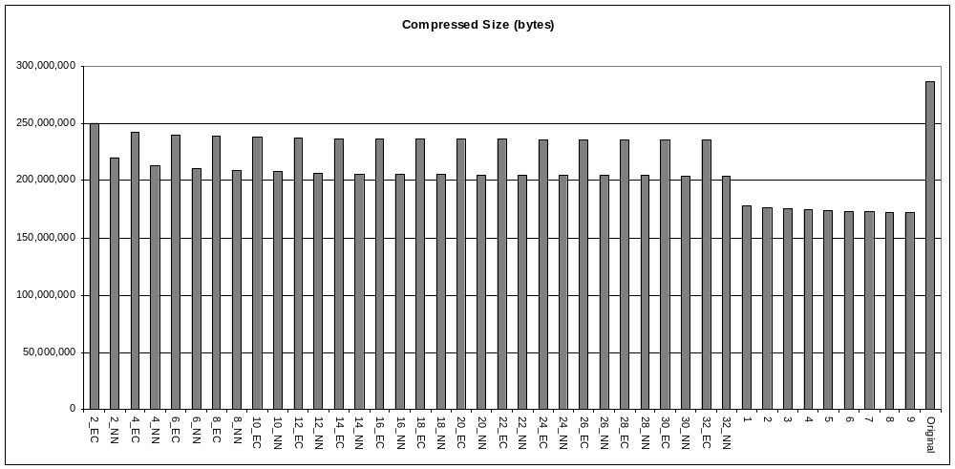

SZIP
GZIP

Figure 2. Time to Compress/Decompress the file (MODIS HDF4).
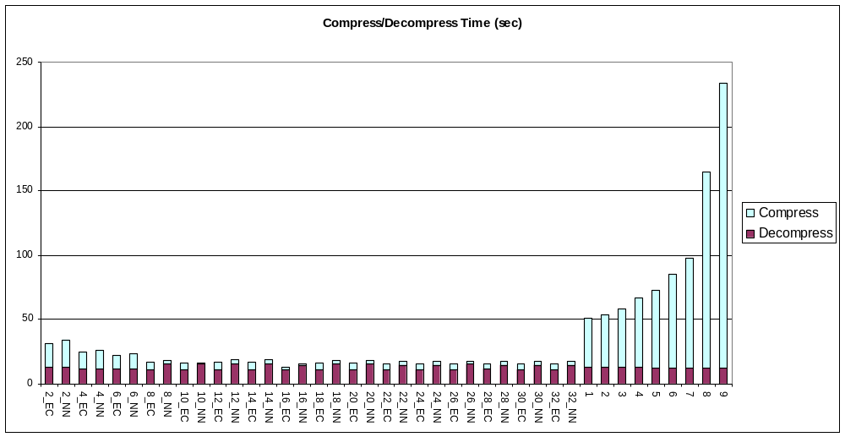

GZIP
SZIP

3. HDF5: OMI L2 Data
3.1. Input Data: OMI
This project used “OMI/Aura Ozone (O3) Total Column 1-Orbit L2 Swath 13x24km” data from 2005. These files all have the same structure, and the data values will be reasonably consistent. This paper presents the results for one file. We assume that other datasets from this data product would produce similar results.
This paper reports one file in detail,
OMI-Aura_L2-OMTO3_2005m0515t2259-o04437_v002-2005m0516t183605.he5
The total size of the uncompressed file is 40,383,606 bytes. The file contains 53 objects, along with 900 attributes.
Table 5 and Table 6 show the objects and their sizes. There are 41 Datasets that can be compressed, for a total of 40,166,104 bytes (99.4%) that could be compressed. Three datasets cannot be compressed, for a total of 163,110 bytes.
Each numeric dataset has six attributes (67 bytes per Dataset). Table 7 lists these attributes. There are 20 group attributes on several groups, for a total of 2,638 bytes. Table 8 lists the group attributes. These attributes are not compressed by HDF5.
3.2. Results
Figure 3 shows the size of the output file for the 40 conditions. The first 32 bars are SZIP, running from 2-32 Pixels per Block. The next 8 bars are GZIP, level 1-9. The rightmost bar is the size of the original uncompressed file, for reference.
For this dataset, GZIP achieved slightly better compression than SZIP, with the almost no improvement for higher values of the ‘level’ parameter.
For SZIP, it is ‘Entropy coding’ produced less compression than the ‘Nearest Neighbor’ for equivalent block size (for this dataset). Increasing the pixels per block increased the amount of compression. SZIP with entropy coding and 32 pixels per block was almost equivalent compression to GZIP.
Figure 4 shows the compression and decompression times. The first 32 bars are SZIP, and the next 8 are GZIP. The dark bars are the decompression time, and the light bars are the compression time. Overall, the decompression times were similar for all settings and for GZIP and SZIP. However, SZIP was uniformly much faster for compression than GZIP.
There was no clear pattern in the compression or decompression times for ‘Entropy Coding’ versus ‘Nearest Neighbor’ for equivalent block sizes.

Table 5. HDF5 objects in OMI-Aura_L2-OMTO3_2005m0515t2259-o04437_v002-2005m0516t183605.he5 (original size: 40,383,606). 1 of 2. (G: Group, D: Dataset, (*) means can be compressed (!) means compressible but too small to bother with. Groups, scalar datasets, attributes cannot be compressed by HDF5).
Type | Object | Elements | DT | Size
G | /
G | /HDFEOS
G | /HDFEOS/ADDITIONAL
G | /HDFEOS/ADDITIONAL/FILE_ATTRIBUTES
G | /HDFEOS/SWATHS
G | /HDFEOS/SWATHS/OMI Column Amount O3
G | /HDFEOS/SWATHS/OMI Column Amount O3/Data Fields
D* | APrioriLayerO3 | 1496x60x11 | F32 | 3,949,440
D* | AlgorithmFlags | 1496x60 | U8 | 89,760
D* | CloudFraction | 1496x60 | F32 | 359,040
D* | CloudTopPressure | 1496x60 | F32 | 359,040
D* | ColumnAmountO3 | 1496x60 | F32 | 359,040
D* | InstrumentConfigurationId | 1496 | U8 | 1,496
D* | LayerEfficiency | 1496x60x11 | F32 | 3,949,440
D* | MeasurementQualityFlags | 1496 | U8 | 1,496
D* | NValue | 1496x60x10 | F32 | 3,590,400
D* | NumberSmallPixelColumns | 1496 | U8 | 1,496
D* | O3BelowCloud | 1496x60 | F32 | 359,040
D* | QualityFlags | 1496x60 | U16 | 179,520
D* | Reflectivity331 | 1496x60 | F32 | 359,040
D* | Reflectivity360 | 1496x60 | F32 | 359,040
D* | Residual | 496x60x10 | F32 | 3,590,400
D* | ResidualStep1 | 1496x60x10 | F32 | 3,590,400
D* | ResidualStep2 | 1496x60x10 | F32 | 3,590,400
D* | SO2index | 1496x60 | F32 | 359,040
D* | Sensitivity | 1496x60x10 | F32 | 3,590,400
D* | SmallPixelColumn | 1496 | I16 | 2,992
D* | StepOneO3 | 1496x60 | F32 | 359,040
D* | StepTwoO3 | 1496x60 | F32 | 359,040
D* | TerrainPressure | 1496x60 | F32 | 359,040
D* | UVAerosolIndex | 1496x60 | F32 | 359,040
D*! | Wavelength | 10 | F32 | 40
D* | dN_dR | 1496x60x10 | F32 | 3,590,400
D* | dN_dT | 1496x60x10 | F32 | 3,590,400

Table 6. HDF5 objects in OMI-Aura_L2-OMTO3_2005m0515t2259-o04437_v002-2005m0516t183605.he5 (original size: 40,383,606). 2 of 2. (G: Group, D: Dataset, (*) means can be compressed (!) means compressible but too small to bother with. Groups, scalar datasets, attributes cannot be compressed by HDF5).
Type | Object | Elements | DT | Size
G | /HDFEOS/SWATHS/OMI Column Amount O3/Geolocation Fields
D* | GroundPixelQualityFlags | 1496x60 | U16 | 179,520
D* | Latitude | 1496x60 | F32 | 359,040
D* | Longitude | 1496x60 | F32 | 359,040
D* | RelativeAzimuthAngle | 1496x60 | F32 | 359,040
D* | SecondsInDay | 1496 | F32 | 5,984
D* | SolarAzimuthAngle | 1496x60 | F32 | 359,040
D* | SolarZenithAngle | 1496x60 | F32 | 359,040
D* | SpacecraftAltitude | 1496 | F32 | 5,984
D* | SpacecraftLatitude | 1496 | F32 | 5,984
D* | SpacecraftLongitude | 1496 | F32 | 5,984
D* | TerrainHeight | 1496x60 | I16 | 179,520
D* | Time | 1496 | F64 | 11,968
D* | ViewingAzimuthAngle | 1496x60 | F32 | 359,040
D* | ViewingZenithAngle | 1496x60 | F32 | 359,040
G | /HDFEOS/HDFEOS INFORMATION
D*! | ArchivedMetadata | 1 | String 65,535 | 65,535
D*! | CoreMetadata | 1 | String 65,535 | 65,535
D* ! | StructMetadata.0 | 1 | string 32,000 | 32,000
 | Compressible Data |  |  | 40,166,104 (99.4%)

Table 7. Each numeric dataset has 6 attributes.
Attribute | Rank | DT | Size  (bytes)
Units | 1 | String 2 | 2
Title | 1 | String 22 | 22
UniqueFieldDefinition | 1 | String 15 | 15
ScaleFactor | 1 | F64 | 8
Offset | 1 | F64 | 8
ValidRange | 2 | F32 | 8
MissingValue | 1 | F32 | 4

Table 8. Group attributes.
Attribute | Rank | DT | Size
GranuleDay | 1 | F32 | 4
GranuleMonth | 1 | F32 | 4
GranuleYear | 1 | F32 | 4
TAI93At0zOfGranule | 1 | F64 | 4
InputVersions | 1 | String 25 | 25
PGEVERSION | 1 | String 8 | 8
ProcessingCenter | 1 | String 8 | 8
InstrumentName | 1 | String 3 | 3
ProcessingHost | 1 | String 41 | 41
ProcessLevel | 1 | String 1 | 1
AuthorAffiliation | 1 | String 9 | 9
AuthorName | 1 | String 21 | 21
OrbitData | 1 | String 10 | 10
WavelengthOfAdjustment | 10 | F32 | 40
NVXAdjustment | 600 | F32 | 2,400
HDFEOSVersion | 1 | String 32 | 32
NumTimes | 1 | F32 | 4
NumTimesSmallPixel | 1 | F32 | 4
EarthSunDistance | 1 | F32 | 4
VerticalCoordinate | 1 | String 12 | 12

Figure 3. Size of output file with different compression (OMI HDF5).
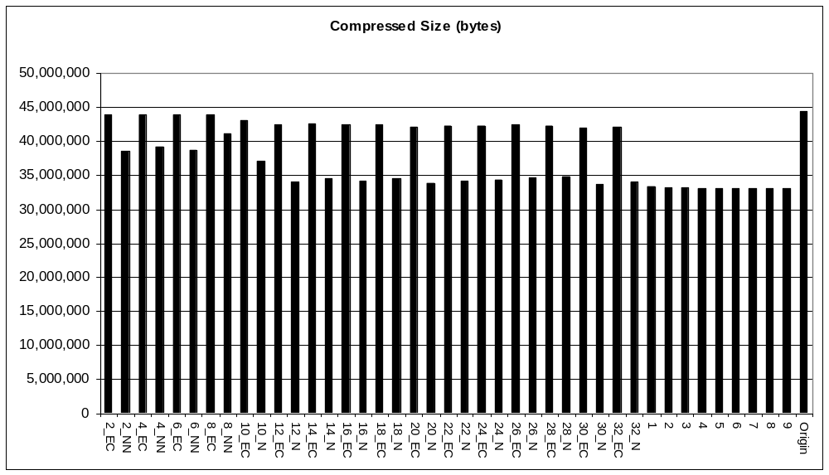

SZIP
GZIP

Figure 4. Time to Compress/Decompress the file (OMI HDF5).
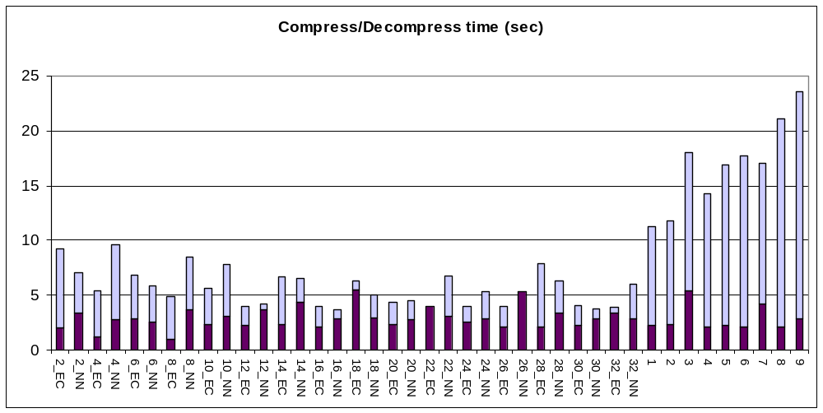

GZIP
SZIP

3.3. Discussion

This example achieved relatively little compression with either method.

There are relatively many, relatively small datasets, no more than 4 MB in a single dataset. Since HDF5 compresses each dataset individually, the compression was applied to each of these small blocks, with corresponding overhead.

4. Summary

Overall, SZIP produced similar amounts of compression compared to GZIP, and was generally much faster in compressing.
The HDF4 example performed slightly better than the HDF5 example overall (e.g., when adjusted for the total size of the datasets). However, the HDF4 file contained one very large array, while the HDF5 example had no large arrays. This is likely the reason for the difference in compression size and speed.
It should be noted that these examples did not examine other parameters that might affect the compression, especially chunking. Also, it would be possible to write custom programs to compress the datasets individually, rather than using the repack utilities.
These examples illustrate the variability that may be encountered when compressing data with HDF. It can be very difficult to guess a priori what compression method or settings will work best for given data, or how well compression will work.
References
1. “Szip Compression in HDF Products”, http://hdf.ncsa.uiuc.edu/doc_resource/SZIP.
2. “Zlib”, http://www.zlib.net/
3. “NCSA HDF Tools”, http://hdf.ncsa.uiuc.edu/hdftools.html
4. “HDF5 Tools”, http://hdf.ncsa.uiuc.edu/HDF5/doc/Tools.html#Tools-Repack
5. “Compression Performance Evaluation Using Repack”

