HDF5 Data Model, File Format and Library – HDF5 1.6

Status of this Memo
This is a description of a Draft ESE Community Standard.
Distribution of this Draft ESE Community Standard is unlimited.

Change Explanation
This is a first draft. There are no changes at this point.

Copyright Notice
Copyright © NASA (2005). All Rights Reserved.

Abstract
This document defines HDF5, a data model, file format and I/O library designed for storing, exchanging, managing and archiving complex data including scientific, engineering, and remote sensing data.

Table of Contents
1 Status of this Memo 1
2 Change Explanation 1
3 Copyright Notice 1
4 Abstract 1
Table of Contents 2
5 Introduction 4
5.1 What is HDF5? 4
5.2 Motivation for Proposing Standardization 5
6 HDF5 Data Model 7
6.1 Introduction 7
6.2 Overview of HDF5 Objects 7
6.3 File Object 8
6.3.1 Definition, organization and storage layouts. 8
6.3.2 Structural metadata 9
6.3.3 Operations on File 10
6.4 Link Object 10
6.4.1 Definition 10
6.4.2 Operations on Links 11
6.5 Group Object 11
6.5.1 Definition 11
6.5.2 Group structural metadata 11
6.5.3 Operations on Group 12
6.6 Datatype Object 12
6.6.1 Definition and types of Datatype Objects 12
6.6.2 Structural metadata 14
6.6.3 Common operations on Datatype object 14
6.6.4 Atomic Datatypes 14
6.6.4.1 Basic Atomic Datatypes 14
6.6.4.1.1 Integer type 15
6.6.4.1.2 Floating-point type 16
6.6.4.1.3 String type 17
6.6.4.1.4 Bitfield type 18
6.6.4.1.5 Opaque type 18
6.6.4.1.6 Reference type 19
6.6.4.2 Derived atomic types 19
6.6.4.2.1 Variable length type 19
6.6.4.2.2 Enumeration type 20
6.6.4.2.3 Array type 21
6.6.5 Composite datatype 21
6.6.5.1 Compound datatype 22
6.7 Dataspace Object 22
6.7.1 Definition 22
6.7.2 Dataspace structural metadata 22
6.7.3 Operations on Dataspace 23
6.8 Dataset Object 24
6.8.1 Definition 24
6.8.2 Structural metadata 24
6.8.3 User-defined metadata (Attribute) 25
6.8.4 Operations on Dataset Object 25
6.9 Attribute Object 26
6.9.1 Definition 26
6.9.2 Structural metadata 26
6.9.3 Operations on Attribute Object 27
7 HDF5 File Format 28
7.1 HDF5 File Format internal structures 28
7.2 Mapping between HDF5 Objects and File Format low-level objects 29
8 HDF5 I/O Library 30
8.1 Introduction to the HDF5 Programming Model 30
8.2 HDF5 APIs 31
8.3 The HDF5 Library I/O features 32
8.3.1 Partial I/O 32
8.3.2 Filters 33
8.3.3 Virtual File Layer 33
9 Authors' Address 35
10 Appendix A – HDF5 File Format Specification 35
11 Appendix B – HDF5 API Reference Manual 35
12 Appendix C – Glossary of acronyms 35
13 Appendix D – Errata 35
14 Appendix E – HDF5 copyright 36

Introduction
HDF5 was created to address the data management needs of scientists and engineers working in high performance, data intensive computing environments.
Scientific and engineering applications must deal with increasingly large datasets, a variety of different data types and structures, and many different forms of metadata. This data must be available on a broad range of operating systems and computing environments. It must be easy to move data from place to place, and to share the data among widely differing applications.
Applications and tools must be available for creating and accessing the data, and the basic software for storing and accessing the data must work in as many different computing environments as possible.
Because the amount of scientific data is increasing rapidly, efficient storage is critical. Finally, many applications require extremely efficient and flexible I/O in order to deal with the volume of the data being processed, the frequent need to access small subsets from large data sets, and the variety of architectures and file systems in use.

What is HDF5?
HDF5 has three components: (1) a general purpose data model, (2) an I/O library and (3) a file format.
The HDF5 data model provides structures and operations to allow creation, storage, and access to almost any kind of scientific data structure or collection of structures. In addition the HDF5 file object, the data model includes two primary objects (datasets and groups), a number of supporting objects (e.g. attributes, datatypes), and metadata describing how HDF5 files and objects are to be organized and accessed.
The HDF5 file format describes how the HDF5 data structures are represented in storage, in memory, or on other media. Because HDF5 is designed for managing large data objects and complex heterogeneous collections easily and efficiently, the HDF5 format allows for alternate representations of many objects. The format is self-describing in the sense that the structures of HDF5 objects are describe within the file.
The HDF5 I/O library implements the data model in a number of programming languages, including C, Fortran, C++, and Java. These API’s are designed for flexibility – they give applications full access to available HDF5 storage structures, and provide features for tuning applications for particular platforms, storage requirements, or I/O access patterns.
Complementing these three technical components are the approaches of the HDF5 project to intellectual property and community standards.
The HDF5 library, which is owned by the University of Illinois, is open source, and the HDF5 copyright allows it to be used at no cost by all applications, including commercial applications. The HDF5 project and its sponsors work closely with vendors, as well as non-commercial applications, to enable their products to support HDF5 effectively and to make sure that HDF5 meets the demands of these products for quality and performance.
As for community standards, the HDF5 project and its sponsors dedicate significant resources to developing, supporting, and enforcing standard uses of HDF5. Adherence to standards makes it possible to share data easily, and also to build and share tools for accessing and analyzing data stored in HDF5. Standardization activities include establishing conventions for the use of HDF5 for particular applications. For example, HDF-EOS defines a data model built for earth science data, and the HDF-EOS API implements that data model. As another example, the HDF5 project defines standard ways to store raster images, tables, and other complex objects in HDF5, and provides APIs to encourage adherence to these standards.

Motivation for Proposing Standardization
HDF5 is the underlying format for HDF-EOS 5. HDF-EOS is the standard format and I/O library for the Earth Observing System (EOS) Data and Information System (EOSDIS). EOSDIS is the data system supporting a coordinated series of polar-orbiting and low inclination satellites for long-term global observations of the land surface, biosphere, solid Earth, atmosphere, and oceans. HDF-EOS 5 is the standard for the Aura mission, which is the final EOS mission.
HDF5 is also to be the distribution format for the National Polar Orbiting Environmental satellite system (NPOESS), a satellite system to be used to monitor global environmental conditions, and collect and disseminate data related to weather, atmosphere, oceans, land and near-space environment.
EOS data stored in HDF-EOS 5 and NPOESS data to be stored in HDF5 are of fundamental importance to current and future research on global climate change, and scores of other applications of national and international importance.
ESE standardization of HDF5 will help to accelerate its adoption among the EOS and NPOESS communities, and many others as well, both through an increase in the number of developers writing to the specification and using the I/O library, and through an increase in the number of those providing their data in HDF5.
ESE standardization will also validate HDF5 to vendors of software that is important to users of EOS and NPOESS data, increasing the likelihood that these vendors will support HDF5 in their products.
ESE standardization will also validate HDF5 to government agencies and other organizations that have considered standardizing on HDF5 but have been reluctant to do so because of the lack of standardization. This will increase the likelihood of adoption of HDF5 by these organizations, in turn broadening the support for HDF5. Greater support and adoption of HDF5 would very likely result in improved usability of HDF5, more software for working with data in HDF5, and more useful data stored in HDF5.
Finally, ESE standardization will pave the way for broader standardization of HDF5, both at the national (ANSI) and international (ISO) levels. If this happens, the results of standardization described above will extend even more broadly, across a broad range of science and engineering domains. Many of these results will return dividends for the ESE community as well.

HDF5 Data Model

Introduction
The HDF5 data model describes the organization and structure of data stored in a computer system, and operations that can be performed on data.
An application program that uses HDF5 for storing and organizing data, maps its data structures to the HDF5 objects defined by the data model. The mapping is independent of storage medium, computational system and computational environment.
A potential complexity of an Application Program’s objects, and the richness of data structures and data types used to describe the objects, may present a challenge for any data model. The HDF5 Data Model has proved to be adequate for describing data objects used in scientific and engineering applications. It uses arrays of structures to describe object’s data and metadata, and grouping mechanism to describe relationships between the objects.
This chapter defines HDF5 objects, their structural metadata and operations on the HDF5 objects.

Overview of HDF5 Objects
The HDF5 Data Model defines seven objects: File, Group, Link, Dataset, Datatype, Dataspace, and Attribute.
Group and Dataset objects are stored in a File.
Dataspace and Datatype objects are parts of a Dataset definition.
A Datatype can be also stored in a File as a “standalone” object shared by many Datasets.
The HDF5 objects in a File are called persistent objects. Each persistent object has one or more Link objects associated with it. Links provide a mechanism for locating persistent objects in a File and for sharing persistent objects between Groups.
An Attribute is a means of attaching user-defined metadata to a persistent object.
Sections 6.3-6.9 define each of HDF5 objects.

File Object

Definition, organization and storage layouts.
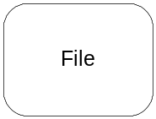
The HDF5 Data Model defines a File as a container for the HDF5 persistent objects.
Objects in a File are organized as a directed graph with a designated entry node. Every node is represented by an HDF5 persistent object. Node that has outgoing edges is always a Group. Entry node is called a Root Group. Node that has incoming edges is any of the HDF5 persistent objects.
Each edge is represented by a Link object.
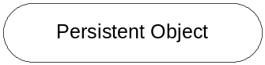
An HDF5 persistent object in a File can be identified by any of the paths that connect the object with its ancestor nodes. The path that connects a persistent object with a Root Group is called an absolute path. The path that connects a persistent object with any other parent Group is called a local path.

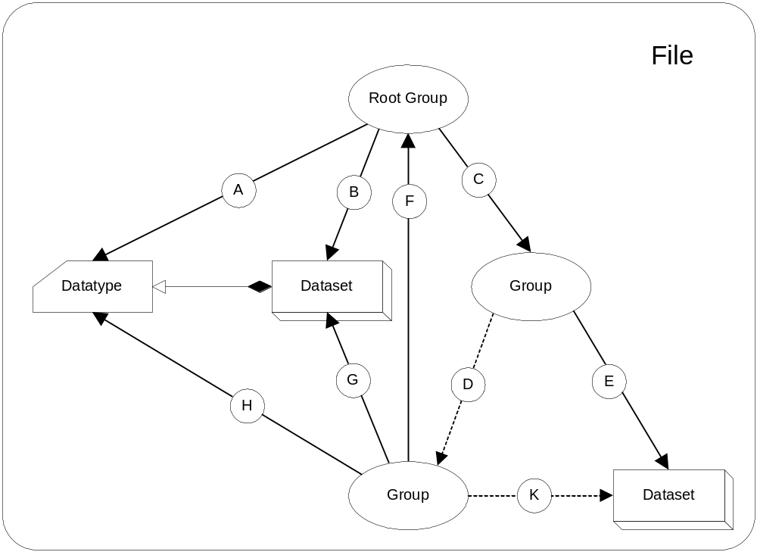
Figure 1: The HDF5 File serves as a container for HDF5 objects.
The HDF5 Data model does not define File’s physical storage layout on a computer system. The HDF5 file format specification defines the types of physical storage layout that are valid. The format allows users to define alternate forms of physical storage beyond those described in the specification. For instance, a File can be stored as a single file or as a set of files. It may also exist in Application Program’s memory only. HDF5 1.6 has the following predefined storage layouts for a File object:

Storage layout | Description
Single file | A single file on a file system
Family of files | The logical space of HDF5 file is partitioned among a set of the single files that have the same size. This storage layout makes it possible to store HDF5 files larger than 2GB on a file system that doesn’t support large files.
Multi file | A set of single files that represent an HDF5 file. Each of the files stores one or more predefined types of internal structures (global and local heaps, B-trees, objects headers, raw data) used to describe persistent objects in an HDF5 file.
Core (memory) file | An HDF5 file stored in memory of an Application Program.

Structural metadata
File structural metadata is described in Appendix A,”HDF5 File Format Specification’, section II “File Metadata”.
Structural metadata sets File object’s properties and cannot be modified after File is created.
Structural metadata contains version information and parameters of internal data structures used for storing HDF5 objects. It also contains information about how a File is accessed for different File’s storage layouts on a computer system (drivers’ information). For more information on File access drivers see section 8.3.3 Virtual File Driver.
HDF5 1.6 defines the following elements of File structural metadata that can be defined by an Application Program:

Name | Description
Size of offsets | Number of bytes used to store addresses in an HDF5 file
Size of lengths | Number of bytes used to store the size of an HDF5 object
Group leaf node K | Each leaf node of a Group B-tree will have at least K entries but not more than 2K entries. Single leaf node may have fewer entries.
Group internal node K | Each internal node of a Group B-tree will have at least K entries but not more than 2K entries. Single internal node may have fewer entries.
Index Storage Internal Node K | Each internal node of an indexed storage. B-tree will have at least K entries but not more than 2K entries. Single internal node may have fewer entries.
Driver information | Information about a file driver needed to reopen an HDF5 file.

Operations on File
The following operation can be performed on File

Name | Description
Create | Creates a File with defined properties
Open | Opens an existing File
Reopen | Reopens an already open File
Close | Closes a File
Mount/Unmount | Includes/removes File graph structure in another File’s graph structure
Flush | Flushes the contents of a File
Query if HDF | Determines whether a file is an HDF5 File.

Link Object

Definition
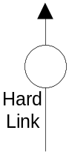
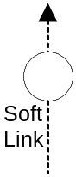
A Link represents an edge in a File graph structure and has a (Name, Value) pair associated with it. Name is defined as ASCII null terminated string and is stored in a Group structural metadata (see section 6.5.2) Name is used as key for the object search in a File. Value is an address of an object pointed by Link.
There are two types of Link objects in the HDF5 Data Model: a Soft Link and a Hard Link. Hard Link always points to a persistent object. Soft Link can point to no object. For Soft Link a Value may be missing. Any persistent object in a File has at least one Hard Link pointing to it.
Link is created when a member is added to a Group and removed when a member is removed from a Group.

Operations on Links
The following operations can be performed on a Link object:

Name | Description
Insert | Inserts Link to a Group (adds new member to a Group)
Remove | Removes Link from a Group (removes a member from a Group)
Note: When an object is created in a Group, Hard Link is inserted to the Group’s structural metadata, therefore there is no explicit create operation for Hard Links.

Group Object

Definition
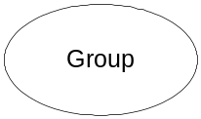
Group object is a container within a File that has zero or more HDF5 persistent objects including the Group itself. Each persistent object is a member of at least one Group in a File with exception of the Root Group that may not be a member of any Group. An HDF5 persistent object may be included in multiple Groups. Such object is called a shared object.
Group membership is implemented via the Link object. A Hard Link object is added to a Group every time a persistent object is created. Hard or Soft Link object can also be added to a Group to include already existing persistent object. When Link is removed from a Group, the corresponding persistent object pointed by Link is excluded from the Group members.

Group structural metadata
Group structural metadata is described in Appendix A “HDF5 File Format Specification”, section II “Level 1- File Infrastructure, Level 1A, 1B”.
The following structural metadata can be defined by an Application Program:

Name | Description
Data Segment Size of Local Heap | Total amount of space allocated for Local Heap data

Operations on Group
The following operation can be performed on Group:

Name | Description
Create | Creates a Group with defined properties
Open | Opens an existing Group
Close | Closes a Group
Iterate | Iterates through group members
Get information about members | Gets number of members, member’s object type and name of a Link pointed to a member

Datatype Object

Definition and types of Datatype Objects
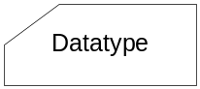
A Datatype object describes an individual data element of a Dataset or an Attribute.
The structural metadata of a Datatype object defines a layout of a single data element and provides complete information for data conversion to and from a Datatype.
The HDF5 Data Model defines two types of the Datatype objects: persistent Datatype and transient Datatype.
A Persistent Datatype is stored in a File as a separate object. It always has a Hard Link associated with it. Persistent Datatype can be used to define multiple Attributes and/or Datasets.
A Transient Datatype is used to define a Dataset or an Attribute. When a Dataset or an Attribute object is created, a transient Datatype’s structural metadata becomes a part of the Dataset’s or Attribute’s structural metadata. It can be accessed only by accessing the structural metadata of that object.
Both persistent and transient Datatypes fall into two categories: atomic and composite. Those categories describe if the element of a particular Datatype is treated as an atomic unit during I/O operations on a Dataset or an Attribute, or if it is composed of other atomic units that can be accessed independently.
The Current HDF5 Data Model defines only one composite Datatype – Compound Datatype. Compound Datatypes are similar to C structures or Fortran 95 derived datatypes and may have multiple members of any types.
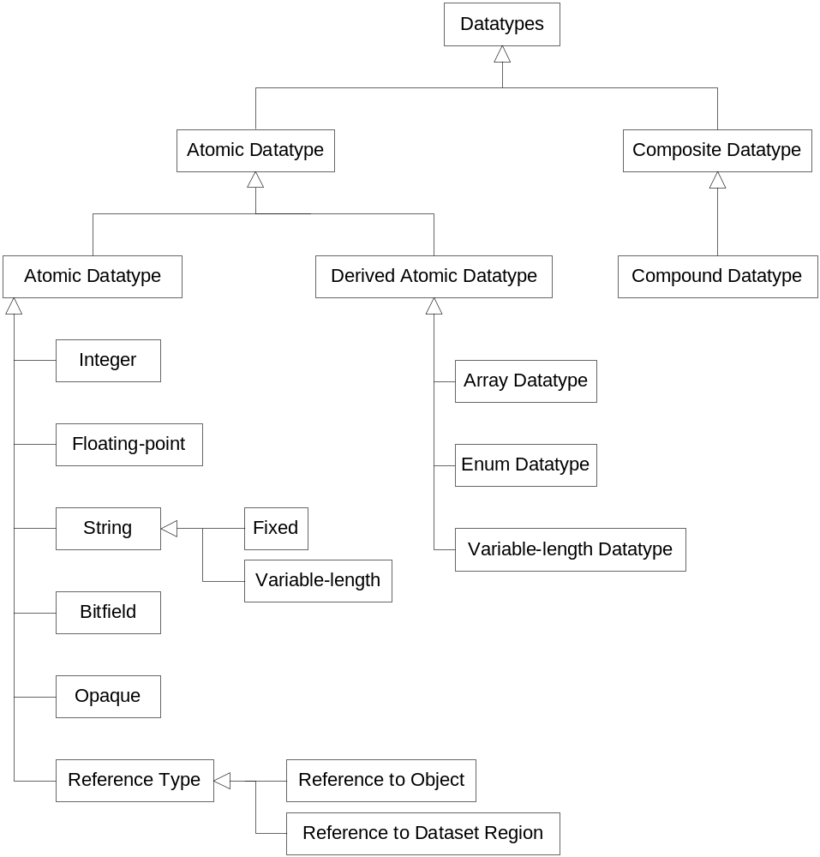
Figure 2: The hierarchy of atomic and composite HDF5 datatypes.

Member of a Compound Datatype can be any of atomic Datatypes described in the section 6.9.4 or of a Compound Datatype. There is no restriction on a number of members or depth of the structure.
Both persistent and transient atomic Datatype objects are created from the pre-defined atomic Datatypes by copying and modifying them. Persistent and transient composite Datatype objects are created using atomic or composite Datatypes. Pre-defined Datatypes of each class are described in the section 6.9.4
Datatype structural metadata and operations on a Datatype depend on whether a Datatype is persistent or transient, and if it is atomic or composite. The next sections describe structural metatdata of the HDF5 Datatypes and operations on them.

Structural metadata
Structural metadata of Datatype object is described in Appendix A “HDF5 File Format Specification”, section IV “Disk Format Level 2- Data Objects”. It defines properties of a Datatype. Since properties depend on the type of Datatype, they will be discussed under the corresponding subsections of 6.6.4

Common operations on Datatype object
The following operations can be performed on a Datatype object; operations marked with * are the operations that are not allowed on pre-defined atomic types:

Name | Description
Create* | Creates a Dadatype of particular class
Open* | Opens a persistent Datatype
Copy | Copies a Datatype
Close* | Closes a Datatype
Commit | Stores a Datatype in a File
Query if committed | Finds if a Datatype is stored in a File
Compare | Finds if two Datatypes are the same
Get/set size | Get/sets the size of a Datatype
Get class | Finds a class to which Datatype belongs

Atomic Datatypes
Atomic Datatypes describe the smallest possible raw data element of Dataset or Attribute that I/O operations can be performed on. The HDF5 Data Model defines a rich collection of atomic Datatypes that include integer, floating-point, string, enumeration, bitfield datatypes along with the HDF5 specific datatypes such as array, reference, opaque, and variable length datatypes. The next sections talk about basic and derived atomic Datatypes.

Basic Atomic Datatypes
Basic atomic Datatypes are used in definitions of derived and compound Datatypes. Basic Datatypes include integer, floating-point, string, opaque, bitfield, and reference datatypes.

Integer type
Integer Datatype describes integer number formats. It is created by copying pre-defined integer type and setting up size, sign, and order (endianess) properties.
Operations on Integer Datatype include:

Name | Description
See section 6.6.3 | All operations described in 6.6.3 can be performed
Set/get sign | Defines if integer is signed or not
Set/get order | Defines byte order in which integer is stored
Set/get precision | Identifies a number of significant bits
Set/get offset | Identifies a location of significant bits
Conversion | Converts Integer Datatype to Integer or Floating-point Datatype

Pre-defined Integer Datatypes describe most commonly used integer type formats. There are two types of pre-defined integer datatypes: standard and native.
Description of pre-defined standard Integer Datatype is computer system independent and is used in the definitions of the persistent objects in the file.
Description of pre-defined native Integer Datatype depends on a computer system and on a computational environment (compiler settings). It is provided for the convenience of Application Program to avoid discovery of integer types’ properties needed for describing Integer Datatype in a File. Each pre-defined native Integer Dataype has a corresponding pre-defined standard Integer Datatype that is used for such description.
Pre-defined standard Integer Datatypes have names associated with them of the form H5T_STD_<base>, where <base> is a letter “I” for signed integers, and “U” for unsigned integers, followed by one of the numbers 8,16,32, or 64 that correspond to the number of bits representing the integer type, followed by strings “LE” or “BE” for little-endian or big-endian byte order.
Examples:
H5T_SDT_I32LE represents 32-bit, little-endian, signed two’s complement integer
H5T_SDT_U64BE represents 64-bit, big-endian, unsigned integer.
Pre-defined native Integer Datatypes have names associated with them of the forms H5T_NATIVE_<language_type>, where <language_type> is a string that corresponds to a computer language specific datatype definition.
Examples:
H5T_NATIVE_INT corresponds to C “int” type
H5T_NATIVE_ULLONG corresponds to C “unsigned long long” type
H5T_NATIVE_INTEGER corresponds to Fortran “INTEGER” type
For complete list of pre-defined Integer Datatypes see Appendix B, RM, Predefined datatypes)

Floating-point type
Floating-point Datatype describes the floating-point type formats that satisfy the following conditions:
- Bits of the exponent are contiguous and stored as biased positive number
- Bits of the mantissa are contiguous and stored as a positive magnitude
- Sign bit exists which is set for negative values

Floating-point Datatype is created by copying pre-defined atomic Floating-point Datatype and modifying its properties.
Operations on Floating-point Datatype include:

Name | Description
See section 6.6.3 | All operations described in 6.6.3 can be performed
Set/get sign, exponent, and mantissa | Defines position of sign, exponent and mantissa, and their sizes
Set/get bias | Defines exponent bias
Set/get normalization methods for mantissa | Determines the normalization method of the mantissa
Set/get padding | Identifies padding for unused bits in datum
Set/get order | Defines byte order in which floating-point number is stored
Conversion | Converts Floating-point Datatype to Integer or Floating-point Datatype

Pre-defined Floating-point Datatypes describe most commonly used floating-point type formats. There are two types of pre-defined Floating-point Datatypes: standard and native.
Description of pre-defined standard Floating-point Datatype is computer system independent and is used in the definitions of persistent objects in the file.
Description of pre-defined native Floating-point Datatype depends on a computer system and on a computational environment (compiler settings). It is provided for the convenience of Application Program to avoid discovery of floating-point types’ properties needed for describing a Floating-point Datatype in a File. Each pre-defined native Floating-point Dataype has a corresponding pre-defined standard Floating-point Datatype that is used for such description.
Pre-defined standard Floating-point Datatypes have names associated with them of the form H5T_IEEE_<base>, where <base> is a letter “F” indicating floating-point datatype, followed by one of the numbers 8,16,32, or 64 that correspond to the number of bits representing the floating-point datatype, followed by strings “LE” or “BE” for little-endian or big-endian byte order.
Examples:
H5T_IEEE_F32LE represents 32-bit, little-endian, IEEE floating-point
H5T_IEEE_F64BE represents 64-bit, big-endian, IEEE floating-point
Pre-defined native Floating-point Datatypes have names associated with them of the forms H5T_NATIVE_<language_type>, where <language_type> is a string that corresponds to a computer language specific datatype definition.
Examples:
H5T_NATIVE_FLOAT corresponds to C “float” type
H5T_NATIVE_DOUBLE corresponds to C “double” type
H5T_NATIVE_REAL corresponds to Fortran “REAL” type
For complete list of pre-defined Floating-point Datatypes see Appendix B, RM, Predefined datatypes.

String type
The HDF5 Data Model provides String Datatype object. String Datatype is a sequence of characters that is interpreted as an ASCII text. It is created by copying pre-defined String Datatype object and setting its size to a fixed length or to a variable length.
Pre-defined String Datatype has a language specific name associated with it: H5T_C_S1 (C String objects corresponds to C null terminated string) and H5T_FORTARN_S1 (Fortran space padded string).
Operations on String Datatype include:

Name | Description
See section 6.6.3 | All operations described in 6.6.3 can be performed
Set/get a type of string storage | Sets/gets a method of string storage to accommodate a language specific storage options such as padding and termination character.

Bitfield type
The HDF5 Data Model defines Bitfield Datatype as a sequence of bits packed in one of the Integer Datatypes. Bitfield Datatype is created by copying a pre-defined Bitfield Datatype and setting precision, offset, and padding.
Pre-defined Bitfield Datatypes have a name associated with them of the form H5T_<arch>_B<8,16,32,64>, where <arch> is “NATIVE” or “SDT” string.
Example:
- H5T_NATIVE_B64 – native 8-byte bit field
- H5T_SDT_B16 – standard 2-byte bit field.

Operations on Bitfield Datatype include:

Name | Description
See section 6.6.3 | All operations described in 6.6.3 can be performed
Set/get padding | Identifies padding for unused bits in datum
Set/get precision | Identifies a number of significant bits
Set/get offset | Identifies a location of significant bits
Conversion | Converts Bitfield Datatype to another Bitfiled Datatype

Opaque type
The HDF5 Data Model provides Opaque Datatype for describing data that cannot be otherwise described by HDF5. Element of an Opaque Datatype is treaded as a blob and is not interpreted by the HDF5 library.

Opaque Datatype is identified by its size and a tag (ASCII string). Operations on the Opaque datatype include:

Name | Description
See section 6.6.3 | All operations described in 6.6.3 can be performed
Set/get tag | Defines the tag (ASCII string) for Opaque Datatype identification

Reference type
The HDF5 Data Model defines two types of HDF5 “pointers” called “Object Reference” and “Dataset Region Reference”.

Object reference type
Element of “Object Reference” datatype points to a persistent HDF5 Object.
“Object Reference” Datatype is created by copying a pre-defined “Object Reference” Datatype that has a name of the form H5T_STD_REF_OBJ.
Operations on “Object Reference” datatype include all operations listed in 6.6.3

Datset region reference type
Element of “Datset Region Reference” datatype points to a selected region of a Dataset.
“Dataset Region Reference” Datatype is created by copying a pre-defined “Dataset Region Reference” Datatype that has a name of the form H5T_STD_REF_DSETREG.
Operations on “Object Reference” Datatype include all operations listed in 6.8.3

Derived atomic types
Derived atomic Datatypes are built from basic atomic Datatypes or composite atomic Datatypes.
Element of derived atomic Datatype is treated as one unit during I/O operations. The HDF5 Data Model defines three derived atomic Datatypes: Variable length Datatype, Enumeration Datatype and Array Datatype that are described in the following sections.

Variable length type
The HDF5 Data Model defines Variable length Datatype for describing data elements that are one dimensional arrays of some base type element. Size of arrays may differ from element to element. Datatype of a base type element can be of any HDF5 atomic or composite types including Variable length Datatypes.

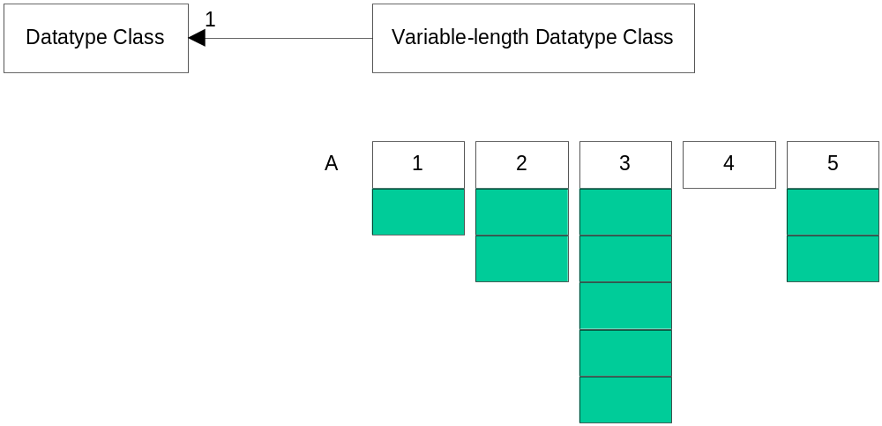
Figure 3: Data element of a dataset with a variable-length datatype can be of a different size.

Operations on Variable length Datatype include:

Name | Description
See section 6.6.3 | All operations described in 6.6.3 can be performed
Get datatype of base element | Discovers a Datatype of a base element

Enumeration type
The HDF5 Data Model defines Enumeration Datatype as a one-to-one mapping between a set of Symbols (ASCII character strings) and a set of Values that have Integer Datatype, i.e. as a set of
(Symbol, Value) pairs.
Since Enumeration Datatype is derived from Integer Datatype, operations on Enumeration Datatype include:

Name | Description
See section 6.6.4.1.1 | All operations described in 6.6.4.1.1 can be performed
Get number of mapping pairs | Gets the numbers of member pairs in a Enumeration Datatype
Get Value of a Symbol | Gets numeric value for a symbol name
Get Symbol for a Value | Gets a symbol name for a numeric value
Conversion | Converts Enumaeration Datatype to another Enumeration Datatype

Array type
The HDF5 Datatype Model provides Array Datatype for describing elements that are homogeneous multi-dimensional arrays of the same base datatype. Base datatype may be of any HDF5 datatypes including Array Datatype.

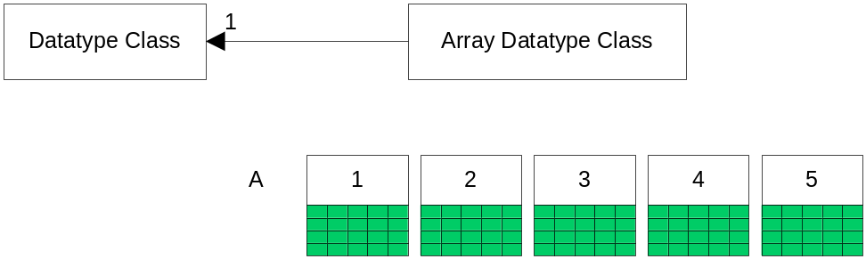
Figure 4: In an HDF5 dataset with an array datatype, each data element is itself an array.

The following operations are allowed on Array datatype:

Name | Description
See section 6.6.3 | All operations described in 6.6.3 can be performed
Get datatype of base element | Discovers a Datatype of a base element
Get number of dimensions | Gets the number of array dimensions
Get sizes of dimensions | Gets sizes of array dimensions
Conversion | Converts Array Datatype to another Array Datatype if Datatype of base elemenst allows conversion

Composite datatype
Current version of the HDF5 Data Model defines only one type of composite datatype – Compound Datatype.

Compound datatype
A Compound Datatype is a datatype that combines one or more datatypes, called fields, into a more complex datatype. A Compound Datatype is similar to a C structure or Fortran derived datatype. The Datatype of each field can be of any HDF5 Datatype, including a Compound Datatype. Each field of a Compound Datatype has a name (an ASCII string) and byte offset indicating its position within the Compound Datatype.
A Compound Datatype is created by defining the total size of the Datatype and then adding its members.
I/O operations can be performed on a selected member of each element of a Compound Datatype. This property distinguishes Compound Datatypes from any subtypes of atomic Datatype.
Operations on Compound Datatypes include:

Name | Description
See section 6.6.3 | All operations described in 6.6.3 can be performed
Get number of members | Gets number of members of a Compound Datatype
Get member’s info | Gets offset, Datatype and a name of a Compound Datatype member
Conversion | Converts Compound Datatype to another Compound Datatype if Datatype of members allows conversion

Dataspace Object

Definition
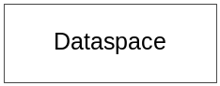
A Dataspace object describes the logical spatial layout of raw data associated with a Dataset or Attribute object.
HDF5 1.6 supports Simple Dataspace objects: a point and a multi-dimensional array
Application Program uses Dataspace object to create Datasets and/or Attributes, and to define the elements that participate in I/O operation when data is moved between Application Program’s memory and File.

Dataspace structural metadata
Structural metadata of Simple Dataspace is described in Appendix A, “HDF5 File Format Specification”, section IV, “Disk Format Level 2- Data Objects”. The following structural metadata information is provided by an Application Program:

Name | Description
Rank N | Number of dimensions of a Dataset
Sizes of dimensions 0 to N-1 | Current and maximum sizes for each of N dimensions

Current dimension sizes define an extent of Dataset.

Operations on Dataspace
The following operations can be performed on Dataspace:

Name | Description
Create | Creates a Dataspace
Set dimensions | Sets sizes of current and maximum dimensions
Close | Close a Dataspace
Copy | Creates a copy of a Dataspace
Get rank and dimensions | Gets Dataspace rank and sizes of current and maximum dimensions
Set/get selection | Defines points in a Dataspace for partial I/O (see section 8.3.1)

Dataset Object

Definition
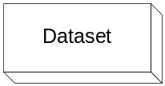
The HDF5 Data Model defines Dataset as a multidimensional array of elements along with the structural metadata that includes the descriptions of elements’ Datatype, spatial information about an array (Dataspace) and storage properties (how actual raw data is stored in a File).

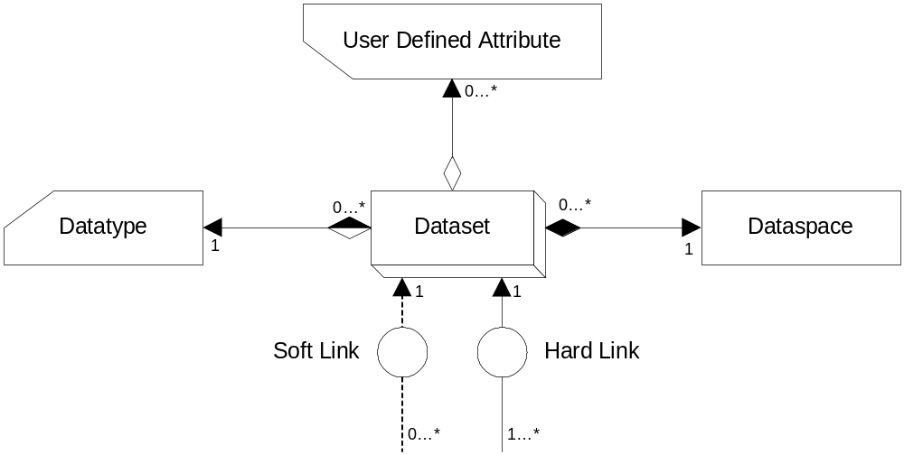
Figure 5: A dataset has a datatype and dataspace, optional attributes, and can be linked into the file hierarchy with both soft and hard links.

Structural metadata
Dataset’s structural metadata is described Appendix Appendix A, “HDF5 File Format Specification”, section IV “Disk Format Level 2- Data Objects”. Structural metadata that is defined by and Application Program includes:

Name | Description
Dataspace | Describes spatial information about a Dataset
Datatype | Datatype of of a Datatset element
Fill value | Value returned to an Application Program for uninitialized data
Data storage layout | How raw data is stored in a File
- Compact  - Contiguous  - Chunked  - External | Raw data is stored in an object header  Raw data is stored as a contiguous blob  Raw data is stored in chunks  Raw data is stored in an external file
Filter Pipeline | Description of transformations to be applied to the data stream during I/O operation
User-defined metadata | Atributes attached to a Dataset

User-defined metadata (Attribute)
Dataset may have Application defined metadata (Attribute). Attribute is a part of the Dataset structural metadata. For more information on the Attribute object see section 6.9

Operations on Dataset Object
Operation s on the Dataset object includes:

Name | Description
Create | Creates a Dataset with defined properties
Open | Opens an existing Dataset
Close | Closes a Dataset
Iterate | Iterate over elements of a Dataset
Read/Write | Reads/writes raw data to a File
Extend | Increases current dimensions’ sizes
Query structural metadata | Gets Datatypes, Dataaspace, storage layout and filter pipeline
Fill | Fills an initialized data with a fill value

Attribute Object

Definition
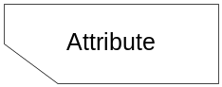
The HDF5 Data Model defines Attribute as a user-defined metadata. It comes in the form of name-value pairs, where a name is an ASCII string, and value is a scalar or a multi-dimensional array of elements.
Attribute is a part of a Group, Dataset or persistent Datatype definition.

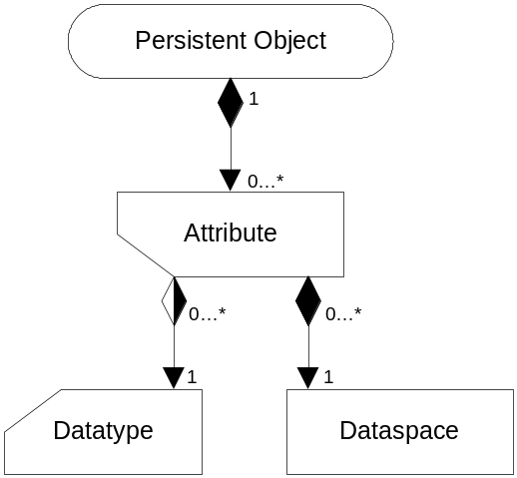
Figure 6: An attribute is attached to a persistent object.

Structural metadata
Attribute structural metadata is described in Appendix Appendix A, “HDF5 File Format Specification”, section IV “Disk Format Level 2- Data Objects”. Structural metadata defined by an Application Program includes:

Name | Description
Name | Attribute’s name (an ASCII string)
Datatype | Datatype of Attribute’s data element
Dataspace | Dataspace of Attribute’s data

Operations on Attribute Object
The following operations are defined on Attribute:

Name | Description
Create | Creates an Attribute with defined properties and attaches it to a persistent object
Open | Opens an existing Attribute
Close | Closes an Attribute
Iterate | Iterate over elements of an Attribute
Delete | Deletes an Attribute
Query structural metadata | Finds name, Datatype, and Dataspace of an Attribute
Read/Write | Reads/writes raw data to a File

HDF5 File Format
This section gives a brief introduction to the HDF5 File Format. The complete description can be found in Appendix A, “HDF5 File Format Specification.”

HDF5 File Format internal structures
The HDF5 File Format defines the low-level objects in terms of a sequence of bytes. The HDF5 persistent objects are described in terms of the low-level objects, thus creating a mapping from the HDF5 data model to the set of byte sequences (the HDF5 logical space).
For each HDF5 File, the layout of the byte sequences on the storage media depends on the File driver used to create the File, and on the structural metadata of the persistent objects stored in the File. In other words, the HDF5 File Format doesn’t define how HDF5 logical space is mapped to the physical storage; this is done by the HDF5 Library described in section 8.

The table below defines the low-level objects. For a full description of the byte sequences corresponding to each object see Appendix A, “HDF5 File Format Specification.”

Name | Description
Super block | Contains the structural metadata about the File; for byte sequence see section II
B-tree node | Implements B-link trees used to store persistent objects that can grow; for byte sequence see section III
Global Heap | Stores information about an object that cannot be stored in the fixed size object header message (see below). The information is usually shared between several objects in the file. For byte sequence see section III.
Local Heap | Stores information about an object that cannot be stored in the object header fixed size message (see below); for byte sequence see section III.
Object header | Information needed to identify an object and to interpret its raw data and metadata. Each object header is a set of object header messages. Byte sequence corresponding to each header message is given in section IV.

Mapping between HDF5 Objects and File Format low-level objects
Sections III and IV of the “HDF5 File Format Specification” describe how HDF5 persistent objects, groups, datasets and datatypes are represented by B-trees, global and local heaps, and object headers.
A group object is represented by an object header that contains a message that points to a local heap and to a B-tree which points to the object headers of the group members.
A dataset is represented by an object header that contains messages that describe the datatype, dataspace, layout and other structural metadata, and a message that points to either a raw data chunk, or to a B-tree that points to raw data chunks.
A datatype is represented by an object header that contains a datatype message.
While object headers, heaps, and B-tree nodes are represented by contiguous byte sequences, the complete description of a persistent object may not be a contiguous set of byte sequences. Therefore, in general, there is no way to discover an object in an HDF5 file by specifying a file offset and a size of the object; a special library is needed.
Section 8 describes the HDF5 Library and the set of application programming interfaces that provide access to an HDF5 file and objects stored in the file.

HDF5 I/O Library
The HDF5 Library implements the HDF5 Data Model and storage model according to the specifications given in sections 6 and 7 and in Appendix A. The next sections introduce the HDF5 programming model and the HDF5 application programming interfaces (APIs). For a complete set of the HDF5 APIs, see Appendix B “HDF5 Reference Manual.”

Introduction to the HDF5 Programming Model
The HDF5 programming model defines how operations are performed on HDF5 objects. It consists of five steps as described in the table below. Steps marked with an asterisk (*) are optional.

Step | Description | Example
1* | Properties of an HDF5 object are defined. | Properties are set to create an extendible dataset in step 2.
2 | The HDF5 object is accessed (opened or created). | Dataset is created; operations can be performed on the dataset.
3* | Properties of operations on the HDF5 objects are defined. | Size of type conversion buffer is set to tune performance.
4 | Operations on the HDF5 object are performed. | Dataset is written to the file.
5 | Access to the HDF5 object is terminated. | Access to the dataset is terminated; any further operation on it will fail.

The order of the steps is important. Step 1 has to be done before steps 2 – 5 (i.e. immutable structural metadata has to be defined before an object is created and accessed); obviously step 3 has to be performed before step 4; step 5 can be performed only if step 2 is complete; step 4 cannot be performed if access to an object was terminated (step 5).
The HDF5 Library refers to an object via an object identifier. An identifier is created when the object is opened or created. The identifier is used to invoke subsequent operations on the object. The identifier is also used to specify dependencies between objects. For example, a dataset is always created under some group; the creation operation on the dataset therefore uses the group identifier to specify the location of the dataset in the File hierarchy.

HDF5 APIs
The HDF5 APIs enforce the HDF5 Data Model and the HDF5 programming model. An application program uses HDF5 APIs to map its data structures to HDF5 objects and to perform operations on those objects.
The complete set of the HDF5 APIs is implemented in the C language; a subset of the APIs is also implemented in the Fortran 90, C++ and Java languages. This proposal describes the HDF5 C APIs only.
The names of the C HDF5 APIs follow the following convention: H5<A,D,E,F,G,I,P,R,S,T,Z><string>, where <string> is a sequence of lower case characters “a – z” and “_”; <string> always starts with a character. Each of the capital letters corresponds to the set of APIs that implements operations on a particular HDF5 object or on an HDF5 Library object. The table below summarizes the HDF5 APIs.

Prefix | Description (examples)
H5A | Operations on an Attribute object (H5Acreate, H5Awrite, H5Aclose)
H5D | Operations on a Dataset object (H5Dopen, H5Diterate)
H5E | Error handling operations (H5Eprint, H5Eclear)
H5F | Operations on a File object (H5Fis_hdf5, H5Fmount)
H5G | Operations on Group objects (H5Gcreate, H5Gunlink)
H5I | Operations on object identifiers (H5Iget_name, H5Iget_type)
H5P | Operations to set and modify object properties and properties of operations on objects (H5Pcreate, H5Pset_fapl_family, H5Pset_chunk)
H5R | Operations on References to Objects and References to Dataset Regions (H5Rcreate, H5Rdereference, H5Rget_obj_type)
H5S | Operations on Dataspace objects (H5Screate_simple, H5Sselect_hyperslab)
H5T | Operations on Datatype objects (H5Tcopy, H5Tget_size)
H5Z | Operations on user-defined filters

Appendix B includes lists of all HDF5 C and Fortran90 APIs and complete descriptions of each.

The HDF5 Library I/O features
The next sections introduce the main three features of the HDF5 I/O library: spatial transformation of raw data during I/O operations (partial I/O), data transformation operations on each element of the raw data during I/O operations (HDF5 filters), and special-purpose I/O mechanisms to specify physical storage layouts (Virtual File Layer or VFL).

Partial I/O
The HDF5 Library provides a mechanism for spatial transformation.
Spatial transformations define complex selections of the dataset elements on which the I/O operation will be performed.
HDF5 defines two types of selections:

Selection type | Description
Point selection | One element of a dataset identified by array indices
Simple hyperslab selection | Contiguous sub-array identified by an offset from the beginning of the array in each dimension, and the size in each dimension

All selections are built from one of those two types using set operations:
- union
- difference
- intersection
- complement
Set operations on hyperslab or point selections allow the definition of very complex, irregularly shaped subsets of an N-dimensional array. During I/O operations, the shape and the dimensionality may not be preserved, i.e. a 2-dimensional sub-array from a dataset in a file (source) may be scattered to an irregularly shaped subset of a 3-dimensional array in memory (destination) during the read operation, as long as the number of elements in both selections is the same.
Elements in each selection are ordered according to the C ordering rule (row-column). The i-th element in the source selection is transformed (read/written) to the i-th element in the destination selection.

Filters
The HDF5 Library defines transformation (filters) on each element of a dataset that participates in I/O operation. Filters may be combined together to create a filter pipeline. When an element goes through the filter pipeline, the result of a transformation becomes an input to the transformation next in the pipeline.
Permanent transformations on elements are defined when a dataset is created and cannot be removed after that. Transient transformations are defined on every I/O operations. The HDF5 Library standard defines only permanent transformations given in the table below. Transformations marked with an asterisk (*) may be performed on the elements of chunked datasets only.

Transformation type | Description
Datatype conversion | Conversion of the numeric values of the same class (integer to integer, or floating-point to floating-point)
Raw data shuffling* | Rearranging bits in each element to achieve better compression ratio
Raw data compression* | Raw data is stored in compressed form; two types of compressions are supported:  - GNU zlib compression  - NASA szip compression
Raw data error detection* | Error-detecting codes (EDC) provide a way to identify data that has been corrupted during storage or transmission; HDF5 supports Fletcher32 algorithm

Virtual File Layer
The HDF5 file format describes how HDF5 data structures and dataset raw data are mapped to a linear format address space (HDF5 logical file). The HDF5 Library implements the mapping in terms of an API. However, the HDF5 format specifications do not indicate how the format address space is mapped onto storage and how the data in the storage is accessed. The Virtual File Layer allows an application to design and implement its own mapping between the HDF5 logical file and storage. It also allows defining the type of access. The proposed standard defines four different storage layouts (see 6.3.1) and corresponding access methods:

Storage layout | Access method
Single file on a storage media | POSIX unbuffered I/O  POSIX buffered I/O  MPI I/O
Multi files | POSIX unbuffered I/O
Family of files | POSIX unbuffered I/O
Core (memory) file | Memory access

Authors' Address
Mike Folk, Elena Pourmal , The HDF Group 605 E. Springfield Ave, Champaign, IL 6182 USA Tel: 217-333-0238 fax 217-244-1987, email: mfolk@hdfgroup.org , epourmal@hdfgroup.org

Appendix A – HDF5 File Format Specification

Appendix B – HDF5 API Reference Manual

Appendix C – Glossary of acronyms
Acronym Description
HDF5 Hierarchical Data Format, version 5
CCSDS: Consultative Committee for Space Data Systems
ECS: EOSDIS Core System
EOSDIS: Earth Observing System Data and Information System

Appendix D – Errata
There are no errata for the document.

Appendix E – HDF5 copyright

Copyright Notice and Statement for NCSA Hierarchical Data Format (HDF)
Software Library and Utilities

NCSA HDF5 (Hierarchical Data Format 5) Software Library and Utilities
Copyright 1998, 1999, 2000, 2001, 2002, 2003, 2004, 2005 by the Board of
Trustees of the University of Illinois. All rights reserved.

Contributors: National Center for Supercomputing Applications (NCSA) at the
University of Illinois at Urbana-Champaign (UIUC), Lawrence Livermore
National Laboratory (LLNL), Sandia National Laboratories (SNL), Los Alamos
National Laboratory (LANL), Jean-loup Gailly and Mark Adler (gzip library).

Redistribution and use in source and binary forms, with or without
modification, are permitted for any purpose (including commercial purposes)
provided that the following conditions are met:

1. Redistributions of source code must retain the above copyright notice,
this list of conditions, and the following disclaimer.

2. Redistributions in binary form must reproduce the above copyright notice,
this list of conditions, and the following disclaimer in the documentation
and/or materials provided with the distribution.

3. In addition, redistributions of modified forms of the source or binary
code must carry prominent notices stating that the original code was
changed and the date of the change.

4. All publications or advertising materials mentioning features or use of
this software are asked, but not required, to acknowledge that it was
developed by the National Center for Supercomputing Applications at the
University of Illinois at Urbana-Champaign and to credit the contributors.

5. Neither the name of the University nor the names of the Contributors may
be used to endorse or promote products derived from this software without
specific prior written permission from the University or the Contributors,
as appropriate for the name(s) to be used.

6. THIS SOFTWARE IS PROVIDED BY THE UNIVERSITY AND THE CONTRIBUTORS "AS IS"
WITH NO WARRANTY OF ANY KIND, EITHER EXPRESSED OR IMPLIED. In no event
shall the University or the Contributors be liable for any damages
suffered by the users arising out of the use of this software, even if
advised of the possibility of such damage.

--------------------------------------------------------------------------
Portions of HDF5 were developed with support from the University of
California, Lawrence Livermore National Laboratory (UC LLNL).
The following statement applies to those portions of the product
and must be retained in any redistribution of source code, binaries,
documentation, and/or accompanying materials:

This work was partially produced at the University of California,
Lawrence Livermore National Laboratory (UC LLNL) under contract no.
W-7405-ENG-48 (Contract 48) between the U.S. Department of Energy
(DOE) and The Regents of the University of California (University)
for the operation of UC LLNL.

DISCLAIMER:
This work was prepared as an account of work sponsored by an agency
of the United States Government. Neither the United States
Government nor the University of California nor any of their
employees, makes any warranty, express or implied, or assumes any
liability or responsibility for the accuracy, completeness, or
usefulness of any information, apparatus, product, or process
disclosed, or represents that its use would not infringe privately-
owned rights. Reference herein to any specific commercial products,
process, or service by trade name, trademark, manufacturer, or
otherwise, does not necessarily constitute or imply its endorsement,
recommendation, or favoring by the United States Government or the
University of California. The views and opinions of authors
expressed herein do not necessarily state or reflect those of the
United States Government or the University of California, and shall
not be used for advertising or product endorsement purposes.
--------------------------------------------------------------------------

See Appendix E for HDF5 copyright.

