**Introduction to HDF5**

**HDF5 Description**

HDF5 consists of a *file format* for storing HDF5 data, a *data model* for logically organizing and accessing HDF5 data from an application, and the *software* (libraries, language interfaces, and tools) for working with this format.

**File Format**

The HDF5 File Format is defined by and adheres to the HDF5 File Format Specification, which specifies the bit-level organization of an HDF5 file on storage media. *In general users do not need to know details about it*.

**Data Model**

The HDF5 Data Model, also known as the HDF5 Abstract (or Logical) Data Model consists of the building blocks for data organization and specification in HDF5.

An HDF5 file (an object in itself) can be thought of as a container (or group) that holds a variety of heterogeneous data objects (or datasets). The datasets can be most anything: images, tables, graphs, or even documents, such as PDF or Excel:

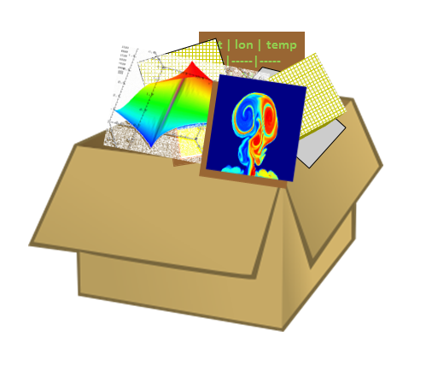

The two primary objects in the HDF5 Data Model are *groups* and *datasets*.

There are also a variety of other objects in the HDF5 Data Model that support groups and datasets, including *datatypes*, *dataspaces*, *properties* and *attributes*.

Groups

HDF5 groups (and links) organize data objects. Every HDF5 file contains a root group that can contain other groups or be linked to objects in other files.

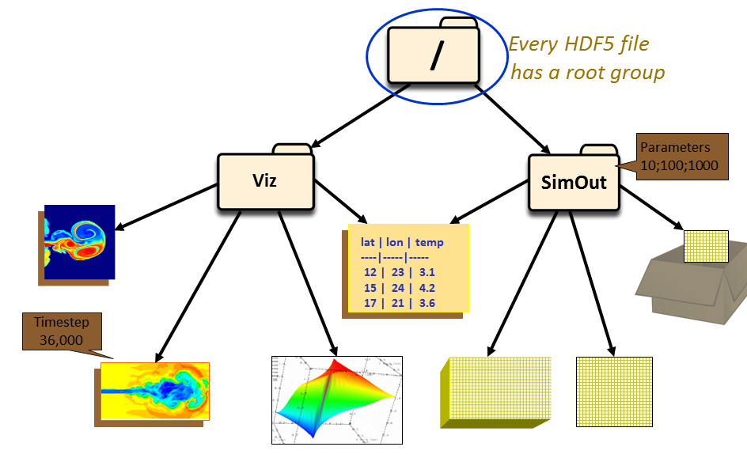

There are two groups in the HDF5 file depicted above: Viz and SimOut. Under the Viz group are a variety of images and a table that is shared with the SimOut group. The SimOut group contains a 3-dimensional array, a 2-dimensional array and a link to a 2-dimensional array in another HDF5 file.

Working with groups and group members is similar in many ways to working with directories and files in UNIX. As with UNIX directories and files, objects in an HDF5 file are often described by giving their full (or absolute) path names.

/ signifies the root group.

/foo signifies a member of the root group called foo.

/foo/zoo signifies a member of the group foo, which in turn is a member of the root group.

Datasets

HDF5 datasets organize and contain the “raw” data values. A dataset consists of metadata that describes the data, in addition to the data itself:

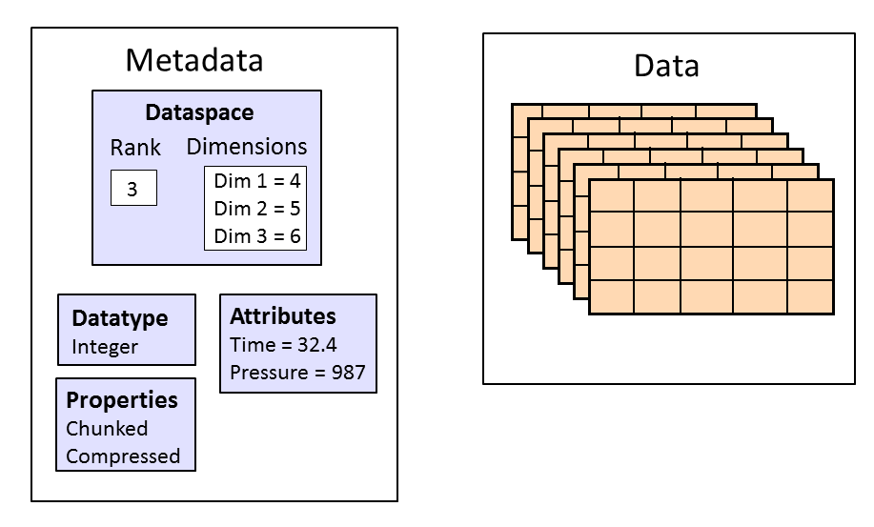

In the picture above, the data is stored as a three dimensional dataset of size 4 x 5 x 6 with an integer datatype. It contains attributes, *Time* and *Pressure*, and the dataset is chunked and compressed.

Datatypes, dataspaces, properties and (optional) attributes are HDF5 objects that describe a dataset. The datatype describes the individual data elements.

Datatypes, Dataspaces, Properties and Attributes

*Datatypes*

The datatype describes the individual data elements in a dataset. It provides complete information for data conversion to or from that datatype.

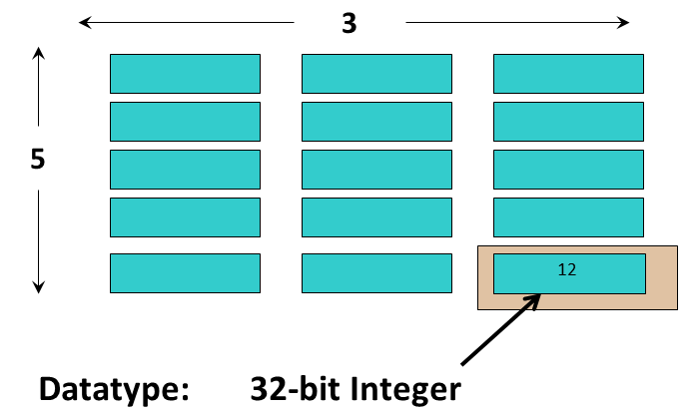

In the dataset depicted above each element of the dataset is a 32-bit integer.

Datatypes in HDF5 can be grouped into:

*Pre-Defined Datatypes***:**   These are datatypes that are created by HDF5. They are actually opened (and closed) by HDF5 and can have different values from one HDF5 session to the next. There are two types of pre-defined datatypes:

* Standard datatypes are the same on all platforms and are what you see in an HDF5 file. Their names are of the form H5T_ARCH_BASE where ARCH is an architecture name and BASE is a pro­gramming type name. For example, H5T_IEEE_F32BE _IEEE indicates standard floating point types where F32BE signifies 32-bit Big Endian floating point.
* Native datatypes are used to simplify memory operations (reading, writing) and are NOT the same on different platforms.

*Derived Datatypes:*   These are datatypes that are created or derived from the pre-defined datatypes. An example of a commonly used derived datatype is a *string* of more than one character. Nested compound datatypes are also derived types.

A compound datatype can be used to create a simple *table*. A compound datatype can also be *nested*, in which it includes one more other compound datatypes.

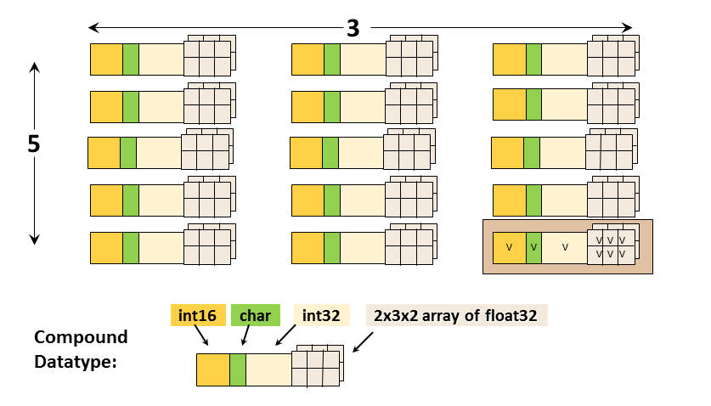

This is an example of a dataset with a compound datatype. Each element in the dataset consists of a 16-bit integer, a character, a 32-bit integer, and a 2x3x2 array of 32-bit floats (the datatype). It is a 2-dimensional 5 x 3 array (the dataspace). The datatype should not be confused with the dataspace.

*Dataspaces*

A dataspace describes the layout of a dataset’s data elements. It can consist of no elements (NULL), a single element (scalar), or a simple array.

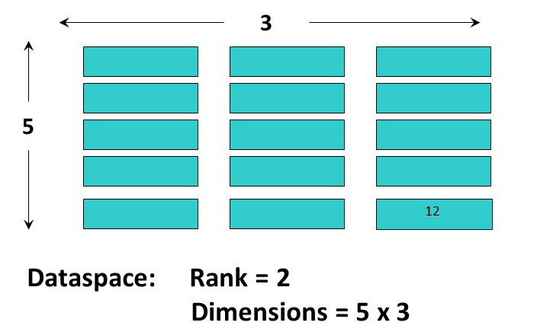

This image illustrates a dataspace that is an array with dimensions of 5 x 3 and a rank (number of dimensions) of 2.

A dataspace can have dimensions that are fixed (unchanging) or *unlimited*, which means they can grow in size (i.e. they are extendible).

There are two roles of a dataspace:

* It contains the spatial information (logical layout) of a dataset stored in a file. This includes the rank and dimensions of a dataset, which are a permanent part of the dataset definition.
* It describes an application’s data buffers and data elements participating in I/O. In other words, it can be used to select a portion or subset of a dataset.

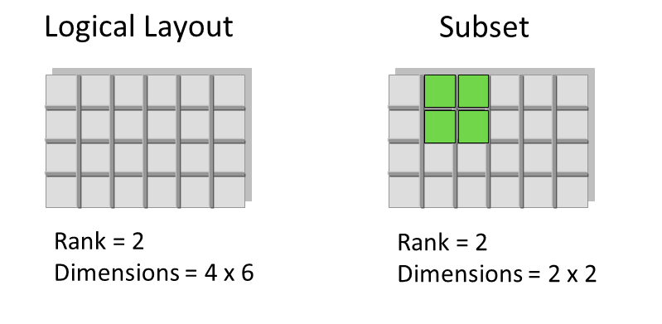

The dataspace is used to describe both the logical layout of a dataset and a subset of a dataset.

*Properties*

A property is a characteristic or feature of an HDF5 object. There are default properties which handle the most common needs. These default properties can be modified using the HDF5 Property List API to take advantage of more powerful or unusual features of HDF5 objects.

For example, the data storage layout property of a dataset is contiguous by default. For better performance, the layout can be modified to be *chunked* or *chunked and compressed*:

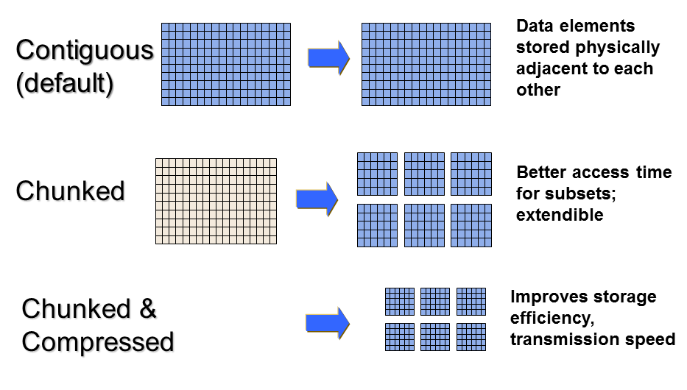

*Attributes*

Attributes can optionally be associated with HDF5 objects. They have two parts: a name and a value. Attributes are accessed by opening the object that they are attached so are not independent objects. Typically an attribute is small in size and contains user metadata about the object that it is attached to.

Attributes look similar to HDF5 datasets in that they have a datatype and dataspace. However, they do not support partial I/O operations, and they cannot be compressed or extended.

**HDF5 Software**

The HDF5 software is written in C and includes optional wrappers for C++, FORTRAN (90 and F2003), and Java. The HDF5 binary distribution consists of the HDF5 libraries, include files, command-line utilities, scripts for compiling applications, and example programs.

HDF5 APIs and Libraries

There are APIs for each type of object in HDF5. For example, all C routines in the HDF5 library begin with a prefix of the form H5*, where * is one or two uppercase letters indicating the type of object on which the function operates:

H5A **A**ttribute Interface

H5D **D**ataset Interface

H5F **F**ile Interface

The HDF5 High Level APIs simplify many of the steps required to create and access objects, as well as providing templates for storing objects. Following is a list of the High Level APIs:

* HDF5 Lite (H5LT) – simplifies steps in creating datasets and attributes
* HDF5 Image (H5IM) – defines a standard for storing images in HDF5
* HDF5 Table (H5TB) – condenses the steps required to create tables
* HDF5 Dimension Scales (H5DS) – provides a standard for dimension scale storage
* HDF5 Packet Table (H5PT) – provides a standard for storing packet data

**Tools**

Useful tools for working with HDF5 files include:

*h5dump:* A utility to dump or display the contents of an HDF5 File

*h5cc, h5c++, h5fc:*  Unix scripts for compiling applications

*HDFView:* A java browser to view HDF (HDF4 and HDF5) files

h5dump:

The h5dump utility displays the contents of an HDF5 file in Data Description Language (DDL).Below is an example of h5dump output for an HDF5 file that contains no objects:

$ h5dump file.h5

HDF5 "file.h5" {

GROUP "/" {

}

}

With large files and datasets the output from h5dump can be overwhelming. There are options that can be used to examine specific parts of an HDF5 file. Some useful h5dump options are included below:

-H, --header Display header information only (no data)

-d <name> Display a dataset with a specified path and name

-p Display properties

-n Display the contents of the file

h5cc, h5fc, h5c++:

The built HDF5 binaries include the h5cc, h5fc, h5c++ compile scripts for compiling applications. When using these scripts there is no need to specify the HDF5 libraries and include files. Compiler options can be passed to the scripts:

h5cc myprog.c

./a.out

HDFView:

The HDFView tool allows browsing of data in HDF (HDF4 and HDF5) files.

**Introduction to the HDF5 Programming Model and APIs**

The HDF5 Application Programming Interface is extensive, but a few functions do most of the work.

To introduce the programming model, examples in Python and C are included below. The HDF5 Python APIs (h5py) are included for their simplicity of use. However, they were not created and are not maintained by The HDF Group.

The general paradigm for working with objects in HDF5 is to:

* Open the object.
* Access the object.
* Close the object.

The library imposes an order on the operations by argument dependencies. For example, a file must be opened before a dataset because the dataset open call requires a file handle as an argument. Objects can be closed in any order. However, once an object is closed it no longer can be accessed.

Keep the following in mind when looking at the example programs included in this section:

* C routines begin with the prefix “H5*” where * is a single letter indicating the object on which the operation is to be performed. FORTRAN routines are similar; they begin with “h5*” and end with “_f”. For example:

File Interface: H5Fopen (C) and h5fopen_f (FORTRAN)

Dataset Interface: H5Dopen (C) and h5fdopen_f (FORTRAN)

Dataspace interface: H5Sclose (C) and h5sclose_f (FORTRAN)

The HDF5 Python APIs use methods associated with specific objects.

* For portability, the HDF5 library has its own defined types. Some common types that you will see in the example code are:

hid_t is used for object handles

hsize_t is used for dimensions

herr_tis used for many return values

* Language specific files must be included in applications:

Python:Add “import h5py” / “import numpy”

C: Add “#include hdf5.h”

FORTRAN: Add “USE HDF5”

Call h5open_f and h5close_f to initialize and close the HDF5 FORTRAN interface

**Steps to create a file:**

To create an HDF5 file you must:

1. Specify property lists (or use the defaults).
2. Create the file.
3. Close the file (and property lists if needed).

Example:

This example creates a file, file.h5, and then closes it:

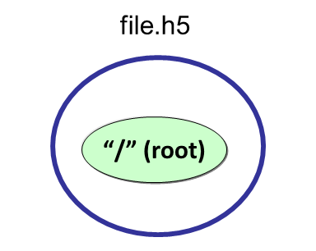

Following are examples to create a file file.h5 using Python, C, and FORTRAN.

Python:

Calling h5py.File with ‘w’ for the file access flag will create a new HDF5 file and overwrite an existing file with the same name. “file” is the file handle returned from opening the file. When finished with the file, it must be closed. When not specifying property lists, the default property lists are used:

import h5py

file = h5py.File (‘file.h5’**, ‘**w’)

file.close ()

C:

The H5Fcreate function creates an HDF5 file. H5F_ACC_TRUNC is the file access flag to create a new file and overwrite an existing file with the same name, and H5P_DEFAULT is the value specified to use a default property list.

#include “hdf5.h”

int main() {

hid_t file_id;

herr_t status;

file_id = H5Fcreate ("file.h5", H5F_ACC_TRUNC,

H5P_DEFAULT, H5P_DEFAULT);

status = H5Fclose (file_id);

}

**Steps to create a dataset:**

As described previously, an HDF5 dataset consists of the raw data, as well as the metadata that describes the data (datatype, spatial information, and properties). To create a dataset you must:

1. Define the dataset characteristics (datatype, dataspace, properties).
2. Decide which group to attach the dataset to.
3. Create the dataset.

4. Close the dataset handle from step 3.

Example:

The code excerpts below show the calls that need to be made to create a 4 x 6 integer dataset “dset” in a file “dset.h5”:

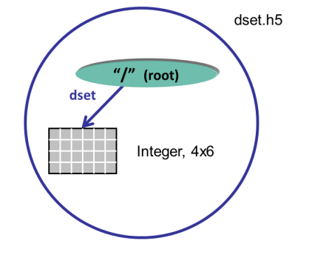

Python:

With Python, the creation of the dataspace is included as a parameter in the dataset creation method. Just one call will create a 4 x 6 integer dataset “dset”. A pre-defined Big Endian 32-bit integer datatype is specified. The create_dataset method creates the dataset in the root group (the file object). The dataset is close by the Python interface.

dataset = file.create_dataset("dset",(4, 6), h5py.h5t.STD_I32BE)

C:

To create the same dataset in C, you must specify the dataspace with the H5Screate_simple function, create the dataset by calling H5Dcreate, and then close the dataspace and dataset with calls to H5Dclose and H5Sclose. H5P_DEFAULT is specified to use a default property list. Note that the file identifier (file_id) is passed in as the first parameter to H5Dcreate, which creates the dataset in the root group.

/* Create the dataspace for the dataset. */

dims[0] = 4;

dims[1] = 6;

dataspace_id = H5Screate_simple(2, dims, NULL);

/* Create the dataset. */

dataset_id = H5Dcreate (file_id, "/dset", H5T_STD_I32BE,

dataspace_id, H5P_DEFAULT, H5P_DEFAULT,

H5P_DEFAULT);

/* Close the dataset and dataspace */

status = H5Dclose(dataset_id);

status = H5Sclose(dataspace_id);

**Writing to or reading from a dataset:**

Once you have created or opened a dataset you can write to it:

Python:

data = np.zeros((4,6))

for i in range(4):

for j in range(6):

data[i][j]= i*6+j+1

dataset[...] = data 🡨 Write data to dataset

data_read = dataset[...] 🡨 Read data from dataset

C:

H5S_ALL is passed in for the memory and file dataspace parameters to indicate that the entire dataspace of the dataset is specified. These two parameters can be modified to allow subsetting of a dataset. The native predefined datatype, H5T_NATIVE_INT, is used for reading and writing so that HDF5 will do any necessary integer conversions:

status = H5Dwrite (dataset_id, H5T_NATIVE_INT, H5S_ALL, H5S_ALL,

H5P_DEFAULT, dset_data);

status = H5Dread(dataset_id, H5T_NATIVE_INT, H5S_ALL, H5S_ALL,

H5P_DEFAULT, dset_data);

**Steps to create a group:**

An HDF5 group is a structure containing zero or more HDF5 objects. Before you can create a group you must obtain the location identifier of where the group is to be created. Following are the steps that are required:

1. Decide where to put the group – in the “root group” (or file identifier) or in another group. Open the group if it is not already open.
2. Define properties or use the default.
3. Create the group.
4. Close the group.

Example:

This example illustrates how to create a group MyGroup that is attached to the root group. If the file identifier is specified for the location of the group it will be created in the root group.

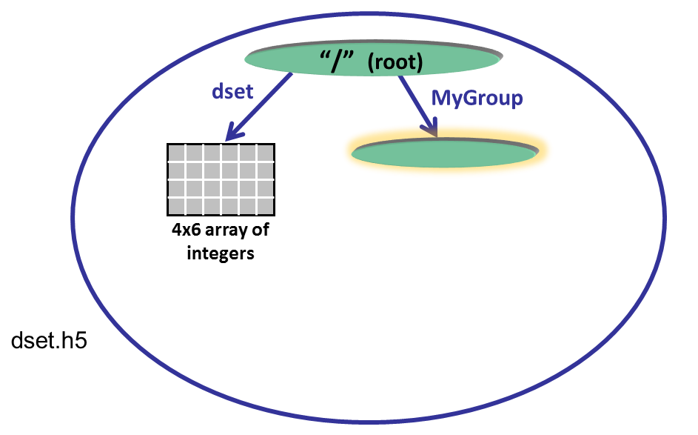

Python:

The code below opens the dataset dset.h5 with read/write permission and creates a group MyGroup in the root group. Properties are not specified so the defaults are used:

import h5py

file = h5py.File('dset.h5', 'r+')

group = file.create_group ('MyGroup')

file.close()

C:

To create the group MyGroup in the root group, you must call H5Gcreate, passing in the file identifier returned from opening or creating the file. The default property lists are specified with H5P_DEFAULT. The group is then closed:

group_id = H5Gcreate (file_id, "MyGroup", H5P_DEFAULT, H5P_DEFAULT,

H5P_DEFAULT);

status = H5Gclose (group_id);

**Steps to create and write to an attribute:**

To create an attribute you must open the object that you wish to attach the attribute to. Then you can create, access, and close the attribute as needed:

1. Open the object that you wish to add an attribute to.
2. Create the attribute.
3. Write to the attribute.
4. Close the attribute and the object it is attached to.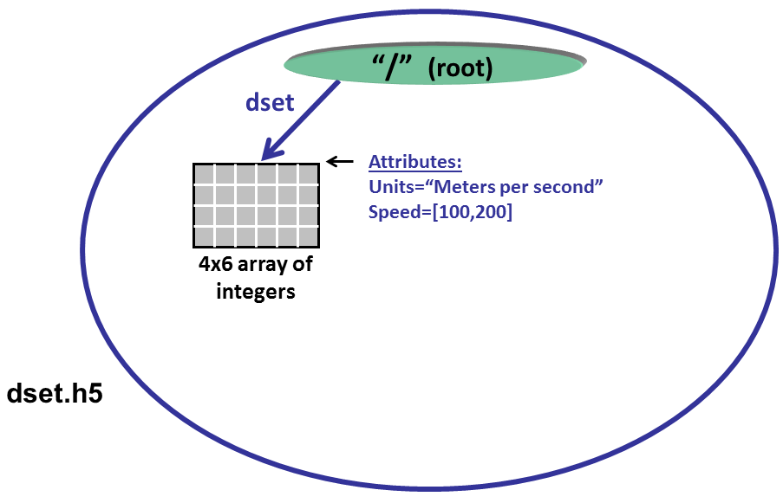

Python:

The dataspace, datatype, and data are specified in the call to create an attribute in Python:

dataset.attrs["Units"] = “Meters per second” 🡨 **Create string**

attr_data = np.zeros((2,))

attr_data[0] = 100

attr_data[1] = 200

dataset.attrs.create("Speed", attr_data, (2,), “i”) 🡨 **Create Integer**

C:

To create an integer attribute in C, you must create the dataspace, create the attribute, write to it and then close it in separate steps:

hid_t attribute_id, dataspace_id; /* identifiers */

hsize_t dims;

int attr_data[2];

herr_t status;

…

/* Initialize the attribute data. */

attr_data[0] = 100;

attr_data[1] = 200;

/* Create the data space for the attribute. */

dims = 2;

dataspace_id = H5Screate_simple(1, &dims, NULL);

/* Create a dataset attribute. */

attribute_id = H5Acreate2 (dataset_id, "Units", H5T_STD_I32BE,

dataspace_id, H5P_DEFAULT, H5P_DEFAULT);

/* Write the attribute data. */

status = H5Awrite(attribute_id, H5T_NATIVE_INT, attr_data);

/* Close the attribute. */

status = H5Aclose(attribute_id);

/* Close the dataspace. */

status = H5Sclose(dataspace_id);