Flush Dependency Testing

HDF5

Version 1.1

This document considers how to design tests for flush dependencies of metadata cache items during phase 1 of the Single-Writer/Multiple-Reader (SWMR) project.

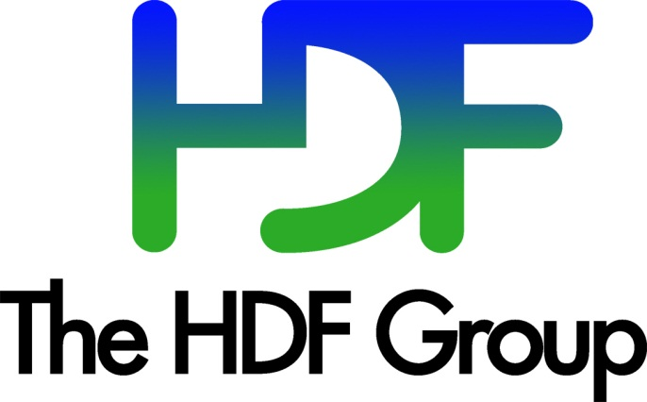

<http://www.HDFGroup.org>

Copyright 2013 by The HDF Group.

All rights reserved.

This document is part of HDF5. For HDF5 copyright and license information, see this page on The HDF Group website: <http://www.hdfgroup.org/HDF5/doc/Copyright.html>.

Contents

1. Testing Architecture 4

2. Adding a Test 7

2.1. Forcing Cache Flushes 7

2.2. Specific Conditions Tested by Data Structure 8

3. Revision History 9

# Testing Architecture

The flush dependency testing harness will be designed to exercise the flush dependencies between the various metadata cache items. Unlike the acceptance test nature of the existing single-writer/multiple-reader (SWMR) tests, the flush dependency tests are designed to act more like unit tests with much more fine-grained control over the states of both the reader and the writer. This architecture will also serve as the core of the future debugging harness, which will allow for more efficient debugging of SWMR failures.

The testing architecture, depicted in the figure below, consists of a single SWMR writer, one or more SWMR readers, and a centralized controller. Each element in the testing architecture will run in a separate process. In this setup, the controller contains the test logic while the reader and writer processes simply execute various test harness I/O calls as directed. Communication between the processes will take place via messages passed over TCP/IP. A mechanism for launching the various processes on local or remote machines will be provided and this will be configurable to match the user's environment. Additionally, logging functions will be added to the existing metadata cache code in the library so that the order of cache flushes can be verified.

|  |
| --- |
| Writer  Reader  HDF5 file  Controller  Metadata cache log file  Log file writes  SWMR writes  SWMR reads  Log inspection  Reader commands  Writer commands and metadata cache control  Local file I/O  TCP/IP |
| Figure 1. Flush dependency test architecture schematic |

The overall test plan is that each data structure is tested under any condition that creates a new type of flush dependency. For example, the fixed array chunk index would be tested under both paged and unpaged configurations[1]. Additionally, data structures that can be used in multiple contexts will be tested individually and in each context in which they are used. As an example, the fractal heap would be tested on its own as well as in the context of its uses for dense attribute storage and dense group storage.

For each test, the controller will invoke a test-specific function that will send messages to the writer and readers causing them to perform operations on the common file. For some data structures, these reader and writer functions will use the internal HDF5 C API in order to generate specific states that can be tested. Since these states will be somewhat artificial (in other words, these states may not be realizable via the current C API), all data structures will also be tested via the external HDF5 C API. For low-level extensible array testing purposes, for example, we may run through several configurations of data blocks and superblocks. These would then be flushed to ensure that they arrive on the disk in the correct order. Configurations would be set up via internal API calls; some may be theoretical, but it is important to test them all for completeness. Additionally, the extensible array would also be tested via standard H5D API calls. This “two level” coverage is to ensure that the flush dependencies are very thoroughly tested.

For each test, success will be verified by the reader finding correct file objects and data after each writer flush, as well as by finding the correct flush order in the log file.

At this time, the flush dependency test harness has not been implemented and its architecture is subject to change.

# Adding a Test

Writing a new flush dependency test will require adding functions to all components:

* Controller
  + Write a new test-specific function in the controller that spells out the required order of writer, reader, and writer metadata cache commands. This may also require adding new TCP/IP messages to the test architecture.
* Writer
  + Map any new or modified TCP/IP messages to callback functions that implement the data structure or metadata cache changes.
  + Write these new callback functions.
* Reader
  + Map any new or modified TCP/IP messages to callback functions that verify the file objects and inspect the log.
  + Write these new callback functions.

All components of this testing harness will be written in C to avoid adding extra dependencies to HDF5 users. Invocation of the controller, reader(s), and writer could initially be via a shell script but will need to be something more portable in the future[2].

## Forcing Cache Flushes

Flush dependencies are implemented by identifying the parent in the relationship so that it cannot be evicted before the child. During normal cache operation, as the cache approaches capacity, metadata elements will be evicted via a cyclical LRU-like algorithm where parents are flushed after children are flushed. It is possible to have chains of dependencies. The flushing of members of a chain will also follow the rule that parents are flushed after children. Suppose a chain of flush dependencies exists where A is the parent of B, B is the parent of C, and C is the parent of D. This chain will cause the elements to be flushed in reverse order. D will be flushed first, then C, then B, and finally A.

In order to realistically emulate the behavior of the cache, the flushing of elements with both simple parent-child relationships and more complicated chains of dependencies need to be simulated. This could be done either with a simple flush call that writes out all cache objects or a more complicated function that puts pressure on the cache in a more realistic manner. For the purposes of this document, the writer's cache action is simply listed as 'flush'.

## Specific Conditions Tested by Data Structure

This section lists the basic conditions that should trigger the creation of a new type of flush dependency. Since this document only pertains to the first phase of the project where only dataset appends are supported, only chunk index data structures are considered.

| Table 1. Conditions that trigger the creation of flush dependencies | |
| --- | --- |
| Data Structure | Trigger Conditions |
| B-tree (version 1) | The version 1 B-tree will not be supported under SWMR due to the lack of a node checksum, which does not allow readers to detect torn writes. |
| B-tree (version 2) | * After initial construction * After adding an element * After adding enough elements to split the root * After adding elements such that the nodes rebalance * After adding enough elements to split the root again (longer node chain) |
| Extensible Array | * After initial construction * After adding an element (stored in index block) * After adding more elements (stored in data block) * After adding still more elements (stored in data block pages via super blocks) |
| Fixed Array | * After initial construction * After adding an element * After adding an element on a different page (if a paged array)   Both paged and unpaged fixed arrays must be tested. |

# Revision History

Use the table below to hold revision history information.

|  |  |
| --- | --- |
| *June 30, 2013* | Version 1. Initial version. |
| August 2013 | Version 1.1. Editing and formatting. |
|  |  |
|  |  |
|  |  |
|  |  |

1. See the HDF5 file format and SWMR design documents for details about these data structures.
2. This is mainly a Windows issue. We could either write a PowerShell script or use a small embedded language like Lua to control invocation (Lua is very small and easy to build on systems where it does not exist).