

Technical Note:

Working with the Foursquare API

NIH Proposal for Food Environment

Project conducted by:

San Diego State University

5500 Campanile Drive

San Diego, CA 92182-4493

Report prepared by:

Jiue-An (Jay) Yang

Department of Geography, San Diego State University

February 2015

***Abstract***

This report introduces the Foursquare API, which allows developer to connect to the Foursquare database for retrieval of users and venues information. This report covers details about using the API, from getting started with applying the API keys to using the API method and retrieving data. There are many methods can be used from an endpoint application, however, this report will only focus on how to search and obtain information about venues using spatial parameters. The data retrieved from Foursquare with the API has potential to be used for mapping and analyzing accessibility to food.

This report covers the following items:

# Sign up for Foursquare account

# Register your Foursquare application

# Search for a *Starbucks venue* within 1000 meters radius of the San Diego State university.

***Working with the Foursquare API***

Introduction

Foursquare is a local search and discovery service mobile app that provides a personalized local search experience for its users. The Foursquare API (from now on as “FQ API”) is the official application programming interface (API) developed and provided by Foursquare. The FQ API allows developer to access the Foursquare database and retrieve information about users or venues. There are four major actions can be performed with the API:

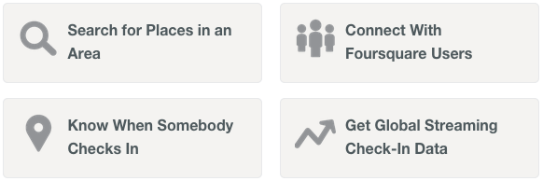

In this report, we will focus on the first function Search for Places in an Area, and demonstrate step by step to obtain the information about venues. To demonstrate the use of FQ API, we will use ***Python***as the programming language. This report uses the ***Foursquare API client for Python*** created and maintained by Mike Lewis(<https://pypi.python.org/pypi/foursquare/>) to access the FQ API. Documentation of this Python library can be found at <https://github.com/mLewisLogic/foursquare>.

Create Your Application

To get started, the first thing to do is to sign up for a Foursquare account and create you own app. FQ API requires all apps to be authenticated before they can connect to the database and retrieve data. To do so, developers need register their apps with Foursquare. Follow these steps to create your application.

1. Sign up for a Foursquare account at: <https://foursquare.com/signup>

2. Go to the Foursquare Developer site: <https://developer.foursquare.com/>

3. Click on ***My Apps***, log in, and create a new application

4. Make sure to give your application a name and a URL

5. After you successfully register your application with Foursquare, you should be able to see the *Client ID* and *Client Secret* of your application as in Figure 1.

6. If possible, save and store the *Client ID* and *Client Secret* for later use.

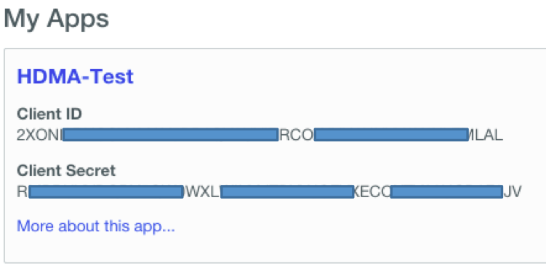

Figure 1, The *Client ID* and *Client Secret* of your application

Good, we have the application ready and we are good to go and search for venues around a defined area with the FQ API.

Search for Places in an Area: using the *Search Venues* Method

One powerful function in the FQ API is to explore a defined area and retrieve a list of venues. This is the same as using the search function in the Foursquare mobile phone application. The method is officially called *Search Venues* in the FQ API (). To use this method, you will need your *client ID* and *client secret* to make a userless venue search. The client ID and client secret can be found at your application at the Foursquare Developer 🡪 My Apps (Figure 1). This is essentially the simplest way to interact with the Foursquare API because there is no need to use *OAuth*. The request you send through the API will return a JSON response object to your endpoint.

There are many parameters can be used during the search query. Figure 2 lists out several important spatial parameters for the venue search method.

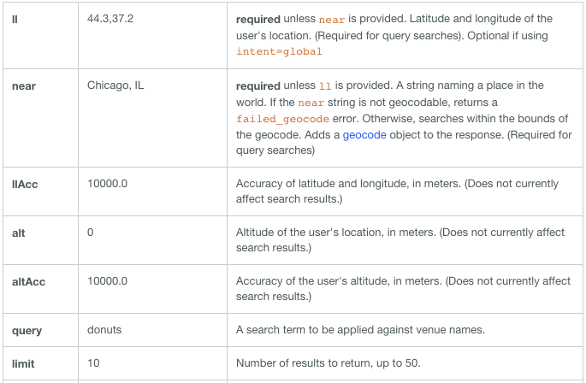

Figure 2, spatial parameters for the *Venue Search* method

To demonstrate the use of this method, we perform a *venue search* for Starbucks venue within 1,000 meters radius from the center of San Diego State University. The following Python codes will connect to the Foursquare API with your *Client ID* and *Client Secret*, and perform the *venue search*.

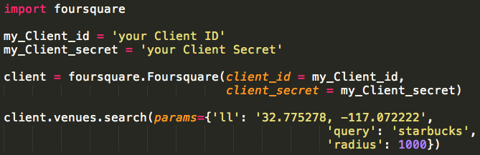

If you have you endpoint setup correctly. You should be able to retrieve the venue information with a JSON (JavaScript Object Notation) object.

Some attributes of a venue:

# Name of the venue

# Venue ID

# Location and address

# Menu

# Contact information

# Numbers of Check-ins

# Category of the venue on Foursquare

Figure 3 (next page) indicates an example of a return venue from this API call.

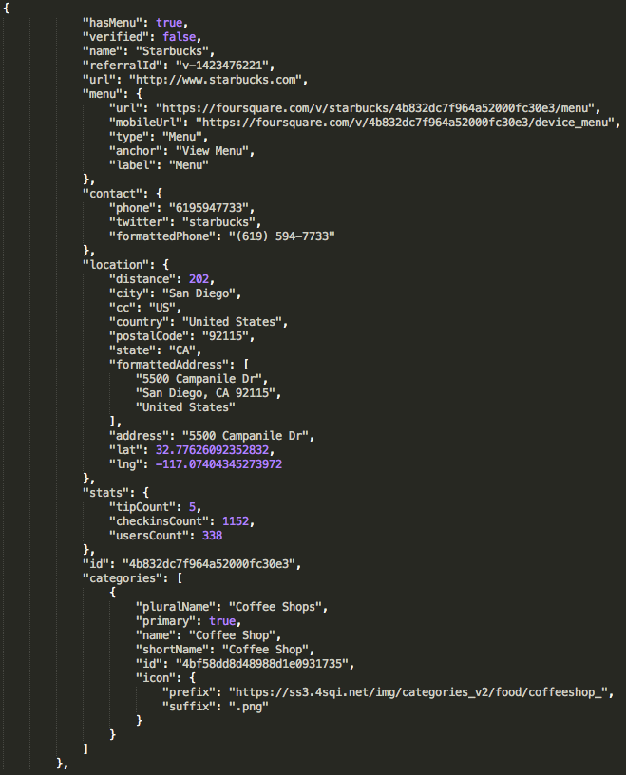

Figure 3, An JSON response of a Starbuck venue at SDSU