CODE
%{
#include<stdio.h>
int nc=0;
%}

%%
"/*"[a-zA-Z0-9\n\t ]*"*/" {nc++;}
"//"[a-zA-Z0-9\t ]*"\n" {nc++;}
%%
int yywrap( ){}

int main(int argc ,char* argv[])
{
yyin=fopen(argv[1],"r");
yyout=fopen("output.c","w");
yylex( );
printf("The number of comment lines=%d\n",nc);
}

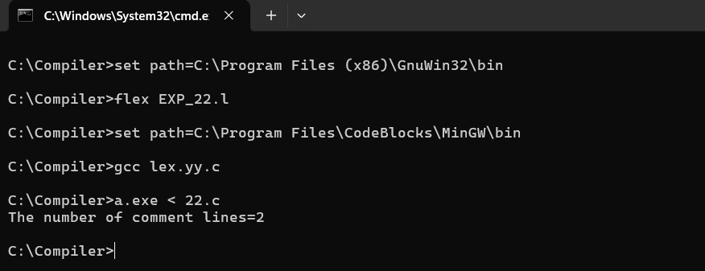
SCREENSHOT

