CODE
%{
#include<stdio.h>
%}

%%
[A-Z]+ { printf("Capital word: %s\n", yytext); }
.|\n { /* ignore other characters */ }
%%

int yywrap() { return 1; }

int main() {
yylex();
return 0;
}
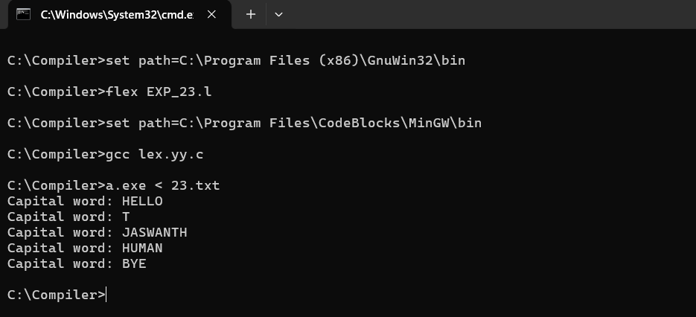
SCREENSHOT

