CODE
%{
#include <stdio.h>
%}

/* Basic regex for email: username@domain.extension */
%%
[a-zA-Z0-9._]+@[a-zA-Z0-9]+\.(com|in|org|net) { printf("It is a valid email: %s\n", yytext); }
.+ { printf("It is not valid: %s\n", yytext); }
%%

int yywrap() { return 1; }

int main() {
printf("Enter the email: ");
yylex(); // takes input directly from keyboard
return 0;
}
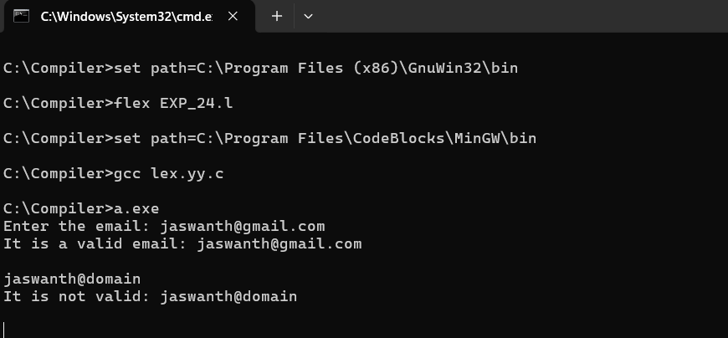
SCREENSHOT

